Supplementary material for

Distribution of antibiotic resistant bacteria in different soil types following manure application

Tingting Song^{1,2}, Muhammad Fahad Sardar², Xuerong Wang², Binxu Li², Zhuoyi Zhang³, Dimei Wu³, Changxiong Zhu^{2,4}, Hongna Li^{2*}

Affiliations and addresses:
1. College of Engineering, Jilin Normal University, Siping, Jilin 136000, P.R.China
2. Institute of Environment and Sustainable Development in Agriculture, Chinese Academy of Agricultural Sciences, Beijing 100081, P.R. China
3. Beijing General Station of Animal Husbandry, Beijing 100081, P.R. China
4. College of Environment Science and Engineering, Hebei University of Science and Technology, Hebei, 050000, PR China

Total number of pages: 4
Number of tables: 1
Number of figures: 2
Table S1 Changes of physical and chemical properties of different soil types
Treatments | pH | EC (μS/cm) | TN (g/kg) | TP (mg/kg) | OM (g/kg) | CTC (μg/kg)
S1 | 8.31±0.07a | 103.17±9.32a | 1.23±0.00a | 3.29±0.01b | 37.45±0.26a | -
S1M | 8.33±0.02a | 106.43±3.23a | 1.30±0.01a | 3.36±0.03a | 35.83±0.12c | -
S1MA | 8.35±0.03a | 112.27±8.15a | 1.17±0.12a | 3.36±0.00a | 36.57±0.37b | 24.48±1.67
S2 | 8.36±0.04a | 85.23±5.42b | 0.66±0.05a | 1.86±0.03b | 14.03±0.41a | -
S2M | 8.36±0.04a | 72.03±6.75c | 0.57±0.02ab | 1.91±0.02ab | 14.05±0.16a | -
S2MA | 8.36±0.04a | 99.70±7.37a | 0.52±0.06a | 1.94±0.02a | 13.90±0.01a | 16.87±0.54
S3 | 5.67±0.03a | 39.43±2.75a | 0.62±0.06a | 1.46±0.01c | 12.86±0.21b | -
S3M | 5.58±0.02a | 30.80±0.44b | 0.63±0.02a | 1.57±0.00a | 13.91±0.07a | -
S3MA | 5.56±0.03a | 29.20±2.52b | 0.57±0.02a | 1.53±0.01b | 13.70±0.32a | 2.26±0.51
Note: “-” indicates no detection.

Bracket
Diameter 25 cm
Quartz sand
Gauze
Height 45 cm

Figure S1 Design of soil column device

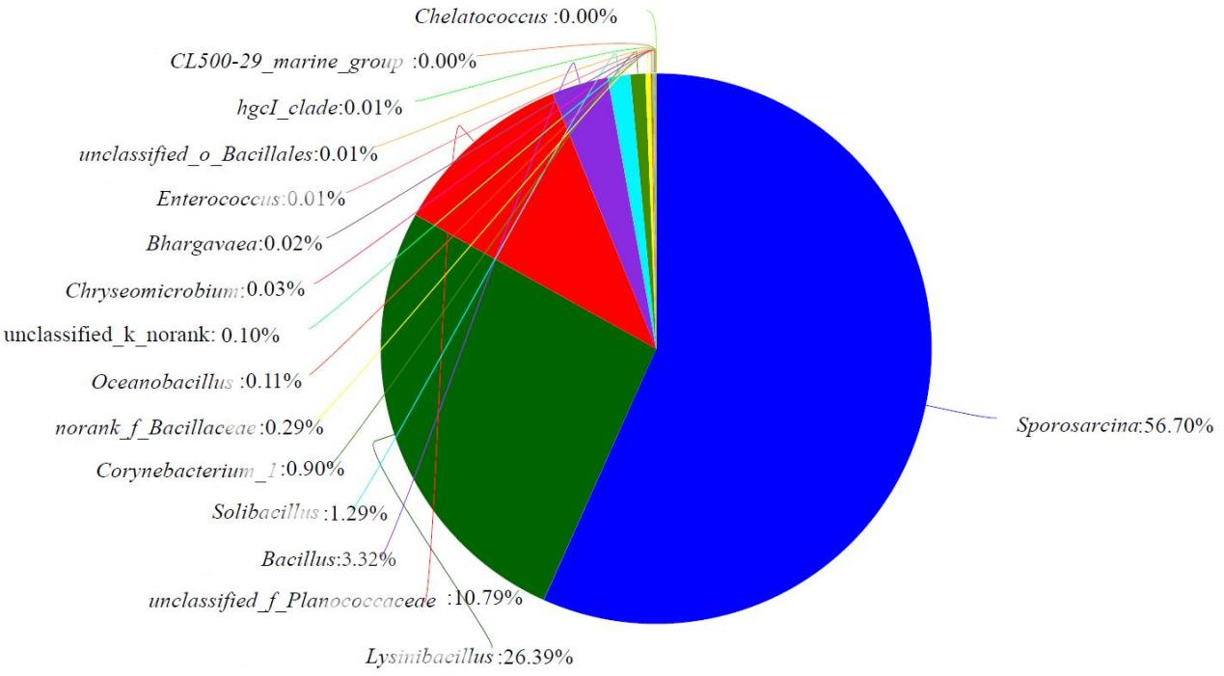
Figure S2 Relative abundance of chlortetracycline-resistant bacteria in manure

