Supplementary Fig. 1 Garza - Williamson index values for each population
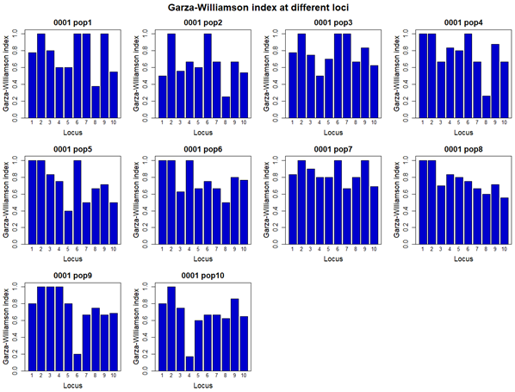

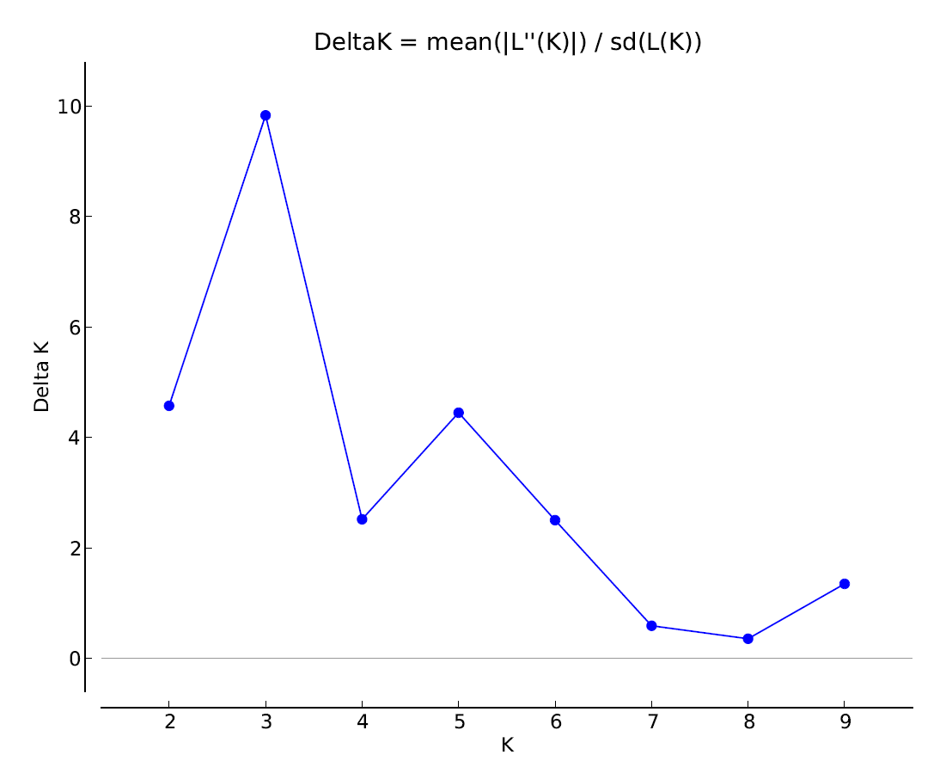
Supplementary Fig. 2 ΔK versus K graph (ΔK: The number of genetically homogeneous groups, K : The number of studied populations)

example data |  | Pairwise Kafkasorulation Matrix of Mean Fst Values Over Loci
Eynesil | Kafkasor | Surmene | Besikduzu | Köprübasi | Borcka | Sacinka | Yusufeli | Iskenderli | Hattila
0,000 |  |  |  |  |  |  |  |  |  | Eynesil
0,116 | 0,000 |  |  |  |  |  |  |  |  | Kafkasor
0,129 | 0,092 | 0,000 |  |  |  |  |  |  |  | Surmene
0,087 | 0,079 | 0,078 | 0,000 |  |  |  |  |  |  | Besikduzu
0,134 | 0,163 | 0,092 | 0,069 | 0,000 |  |  |  |  |  | Köprübasi
0,152 | 0,119 | 0,131 | 0,096 | 0,124 | 0,000 |  |  |  |  | Borcka
0,145 | 0,119 | 0,159 | 0,103 | 0,160 | 0,078 | 0,000 |  |  |  | Sacinka
0,151 | 0,139 | 0,149 | 0,106 | 0,131 | 0,083 | 0,109 | 0,000 |  |  | Yusufeli
0,111 | 0,082 | 0,080 | 0,060 | 0,076 | 0,103 | 0,102 | 0,117 | 0,000 |  | Iskenderli
0,127 | 0,084 | 0,101 | 0,088 | 0,089 | 0,075 | 0,092 | 0,093 | 0,078 | 0,000 | Hattila
Mean sHua values below the diagonal.
example data |  | Pairwise Kafkasorulation Matrix of Mean Nm Values Over Loci
Eynesil | Kafkasor | Surmene | Besikduzu | Köprübasi | Borcka | Sacinka | Yusufeli | Iskenderli | Hattila
0,000 |  |  |  |  |  |  |  |  |  | Eynesil
0,867 | 0,000 |  |  |  |  |  |  |  |  | Kafkasor
0,708 | 1,371 | 0,000 |  |  |  |  |  |  |  | Surmene
1,540 | 1,854 | 1,911 | 0,000 |  |  |  |  |  |  | Besikduzu
0,655 | 0,440 | 1,381 | 2,429 | 0,000 |  |  |  |  |  | Köprübasi
0,506 | 0,822 | 0,683 | 1,282 | 0,759 | 0,000 |  |  |  |  | Borcka
0,557 | 0,829 | 0,463 | 1,096 | 0,455 | 1,899 | 0,000 |  |  |  | Sacinka
0,513 | 0,602 | 0,524 | 1,039 | 0,679 | 1,684 | 0,989 | 0,000 |  |  | Yusufeli
0,951 | 1,725 | 1,825 | 3,198 | 2,034 | 1,111 | 1,121 | 0,859 | 0,000 |  | Iskenderli
0,721 | 1,665 | 1,147 | 1,515 | 1,480 | 2,081 | 1,393 | 1,350 | 1,912 | 0,000 | Hattila
Supplementary Table 1 Pairwise Fst value for the studied goat willow populations

