Supplementary Materials for

In Situ Assembly of Bioresorbable Organic Bioelectronics in the Brain

Martin Hjort¹, Abdelrazek H. Mousa², David Bliman², Muhammad Anwar Shameem², Karin Hellman¹, Amit Singh Yadav¹, Peter Ekström¹, Fredrik Ek¹, and Roger Olsson^{1,2}*
¹Chemical Biology and Therapeutics, Department of Experimental Medical Science, Lund University, SE-221 84 Lund, Sweden,
²Department of Chemistry and Molecular Biology, University of Gothenburg, SE-405 30 Gothenburg, Sweden.
*Corresponding author. Email: roger.olsson@med.lu.se

Materials and Methods
Evaluation of the A5–ETE-S agarose mold
A solution of A5 (20 mg mL⁻¹) and ETE-S (40 mg mL⁻¹) in H₂O was injected into an agarose mold (0.5% agarose in Ringer solution). Diffusion of the ETE-S was monitored using a UV lamp at 365 nm. After 2 h, one of the Au-coated W-electrodes were connected to the A5 aggregate (and one in the agarose mold to electropolymerize ETE-S to get 100% coverage (Fig. 2). ETE-S was electropolymerized using 1.5 V (Keithley 2612B). The agarose was imaged using brightfield microscopy (10x and 40x objective).
The conductivity of the A5 and A5–ETE-S in agarose was measured using a two-terminal setup in which 25 µm Au-coated tungsten microprobes (Signatone, Gilroy, CA) were connected to the polymer embedded in the agarose. By sweeping an applied electric potential and registering the resulting current over different distances, conductivity can be estimated using the transmission line model.

Evaluation of cell–polymer interaction
The experiment was performed according to the procedure above, except that A549 cells with or without a fluorescent label (DiI) were dispersed in agarose before molding.

Cell culturing
Human lung fibroblast (HLF-1) cells were maintained in DMEM (Gibco) supplemented with 10% FBS (Gibco), 100 units penicillin and 100 μg ml⁻¹ streptomycin (Gibco) and 1% NEAA (Gibco) in a humidified CO2 incubator at 5% CO2 and 37 °C. Human lung adenocarcinoma cells (A549) were maintained in F-12K medium (Gibco) supplemented with 10% FBS (Gibco), 100 units penicillin and 100 μg ml⁻¹ streptomycin (Gibco) in a humidified CO2 incubator at 5% CO2 and 37 °C .

MTT assay
The MTT cell viability assay was conducted to determine in vitro toxicity of A5, ETE-S and ETE-PC. Briefly, HLF-1 (2x10⁴ cells well⁻¹) were plated in a 96-well flat-bottom microplate and grown for 24 h. Cells were treated with A5, ETE-S, or ETE-PC (0-1000 μg ml⁻¹) for 24 h. Post-treatment, 200μL of MTT (0.5 mg mL⁻¹) was added into each well and incubated at 37 °C for 4 h. After incubation, 200 μL of isopropanol was added to dissolve formazan crystals. The optical density of formazan solution, as a measure of live cells, was obtained using a microplate reader at 570 nm (Spark Cyto, Tecan). The formazan signal (live cell count) was normalized to the control samples not exposed to A5 or ETE-Rs. 3 biological and 3 technical replicates were used for each setting. Each well contained up to 200 µg of our compound (1 mg mL⁻¹, 200 µL) which can be compared to a typical in vivo injection of 400 ng (40mg mL⁻¹, 10 nL).

In vivo—tail fin assay
Before microinjection, fish were anesthetized with tricaine (ethyl 3-aminobenzoate methanesulfonate; 0.2 mg mL⁻¹) until opercular movements had ceased and the fish did not respond to vibrations caused by tapping close to the tricaine container. An anesthetized fish was placed on its side on a plate filled with 1% agarose (Agarose, LE, Analytical Grade, Promega Corporation) in E3 medium that had been allowed to solidify. A piece of moist tissue paper was placed over the fish to keep the body from drying but still exposing the caudal fin. The plate was then transferred to the microinjection setup, and a glass capillary with a 30 µm diameter bevelled tip (cat. No. BM100T-15. Bevelled, straight, shortened + firepolished ends from Biomedical-Instruments GMBH) filled with polymer solution was used to inject the inter-rays of the caudal fin. The total injection volume per inter-ray was estimated to be in the 100 nL range. After injection, the fish were revived directly by flushing the gills with fresh aquarium water and transferred to a post-op aquarium for observation.

In vivo—brain. Surgery and microinjection
Before surgery and microinjection, fish were anesthetized with tricaine (ethyl 3-aminobenzoate methanesulfonate; 0.2 mg mL⁻¹) until opercular movements had ceased and the fish did not respond to tail pinching. For surgery, the anesthetized fish was placed in a mold made of moist tissue paper for stabilization. Then, a small hole was made in the parietal bone just above the corpus cerebelli and immediately left of the midline with the tip of a 30G needle. The fish was then transferred, in its tissue paper mold, to the microinjection setup, and a capillary filled with polymer solution (see below) with a 30 µm diameter bevelled tip (cat. No. BM100T-15. Bevelled, straight, shortened + firepolished ends from Biomedical-Instruments GMBH) was inserted through the hole in the skull roof to a depth of 700 µm. Then, three injections were made: one each at 700 µm, 500 µm, and 300 µm depths. The total injection volume was estimated to be 10 nL. After injection, fish were either revived directly by flushing the gills with fresh aquarium water and transferred to a post-op aquarium for observation or subjected to electropolymerization.

In vivo—brain. Electropolymerization
When the polymer injection was followed by electropolymerization, a counter electrode was placed on the skin at one of the nostrils, and an iridium coated polymer-containing capillary served as the electrode. Injections were performed as described above; after the injection, the capillary was left in place in the brain. After 1 min—allowing the polymer solution to diffuse—the injected polymer was electropolymerized by applying 1.5 V (current around 1–3 µA) over the electrodes for 5 min using a Keithley sourcemeter (Keithley Instruments). One side of the 30 µm diameter glass injection capillary (cat. No. BM100T-15. Bevelled, straight, shortened + firepolished ends from Biomedical-Instruments GMBH) was pre-coated with 50nm Ir in a Quorum sputterer (QT 150, Quorum technologies) resulting in a conductive capillary with maintained backside optical access to verify liquid levels before injection.
When experiments were of longer out-of-water duration than 10 min, the fish was intubated for superfusion of the gill chambers with aerated aquarium water containing 0.1 mg mL⁻¹ tricaine, using a Peri-Star Pro peristaltic pump (World Precision Instruments). Initially, we experimented with diffusion and electropolymerization durations longer than 5 min each. This did improve polymer spread and polymerization, but did also affect the fish more negatively.

Polymer formulations for microinjections
The following polymer formulations were used for microinjections into the brain (all dissolved in Millipore water): A5 (20 mg mL⁻¹); A5 (20 mg mL⁻¹) + ETE-S (40 mg mL⁻¹); A5 (20 mg mL⁻¹) + ETE-PC (40 mg mL⁻¹).

Post-experiment tissue processing
After polymer injection, with or without electropolymerization, the fish was allowed to recover as described above and then transferred to aquaria for different post-injection survival times. Fish were sacrificed for histological examination or conductivity measurements after 1 h, 2 h, 3 h, 4 h, 1 day, 2 days, 3 days, 7 days, 8 days, or 9 days. The fish were euthanized by immersion in ice-cold water for 10 min and then decapitated. The brains were either excised directly without fixation for freezing on dry ice in TissueTek OCT (Brand) or processed immediately for redox staining (see below), or the skull roof was opened and the head (jaws removed) fixed overnight in 4% paraformaldehyde in 0.1 M phosphate buffer.
Fresh frozen brains were cryosectioned in the sagittal plane (20–50 µm section thickness, depending on subsequent processing) in a Cryostar NX70 cryostat. Sections were mounted on Superfrost Gold microscope slides for microscopy, or on interdigitated gold electrodes for conductivity measurements.
Paraformaldehyde-fixed brains were excised from the skull, rinsed in phosphate-buffered saline (PBS), cryoprotected in PBS with 25% (w/v) sucrose, and frozen on dry ice in TissueTek OCT. The brains were cryosectioned in the sagittal plane (30–50 µm section thickness, dependent on subsequent processing). Sections were mounted on Superfrost Gold slides for further processing.

Redox staining
For redox staining (protocol modified from Horowitz et al. ¹), the excised brains were placed in a solution containing 4 % paraformaldehyde, 1 mM N-ethyl maleimide, 2 µM Alexa647-maleimide, and 0.05 % Triton X-100 in PBS for incubation overnight (ca. 16 h) at 8 °C. Then, the brains were rinsed in PBS (4 x 30 min), incubated in 5 mM TCEP in PBS for 6 h, rinsed in PBS (5 x 15 min), and placed in a solution containing 1 mM N-ethyl maleimide and 2 µM Alexa555-maleimide in PBS for incubation overnight (ca. 16 h) at 8 °C. Then, the brains were rinsed in PBS, cryoprotected in PBS with 25 % (w/v) sucrose, and frozen on dry ice in TissueTek OCT. The brains were cryosectioned in the sagittal plane (30 µm section thickness). Sections were mounted on Superfrost Gold slides and coverslipped with ProLong Gold antifade reagent with DAPI (InVitrogen/Molecular Probes) as the mounting medium. In the presented figures, fluorescence microscopy of the sections shows the extent of oxidized thiols (magenta), indicating tissue damage against a background of reduced thiols (cyan).

Histology
For histological staining, we used 30 µm cryosections of paraformaldehyde-fixed and cryoprotected brains (see above). Slides with cryosections were air dried for at least 2 h at room temperature before histological staining. We used two standard staining protocols: Cresyl Violet (Nissl) stain and Methylene Blue–Thionin (Nissl) stain. After staining, the slides were dehydrated in ethanol, cleared in xylene, and coverslipped using Pertex as the mounting medium.

NeuroTrace 640/660 staining
For selective fluorescent staining of neuronal cell bodies, slides with 30 µm thick cryosections were incubated with the fluorescent Nissl stain NeuroTrace 640/660 (InVitrogen/Molecular Probes) diluted 1:50 in PBS for 30 min. After rinsing in PBS, the slides were coverslipped with ProLong Gold antifade reagent with DAPI (InVitrogen/Molecular Probes) as the mounting medium.

Imaging
Freshly made cryosections were inspected without coverslipping for the presence of polymer and ETE-S monomer fluorescence using an Olympus CKX 41 microscope with 10x/0.40 and 20x/0.75 UPlanSApo, and 40x/0.85 UPlanApo objectives. For better resolution of the polymer structure in the unmounted sections, we used a 40x/0.80 W water immersion objective, with a drop of water directly on the brain section as an immersion medium. Images were obtained with a DMK 33UX174 monochrome camera (The Imaging Source). For multifluorescence imaging, we used either an Olympus IX73 fluorescence microscope with 10x/0.40 and 20x/.75 UPlanSApo objectives, and a Hamamatsu Orca R2 camera or a Nikon Ti2 fluorescence microscope with 40x/0,95 Plan Apochromate objective and a Nikon DS-Qi2 camera. For inspection and documentation of histologically stained sections, we used an Olympus CX33 microscope with E3CMOS (PIN:EP106300A) camera.

Electrical measurements
Brain sections with polymer were placed on interdigitated Au electrodes connected to a Keithley sourcemeter. Two of the interdigitated electrodes were contacted using external microelectrodes. An applied voltage was swept and the resulting current was registered. This was repeated for all interdigitated electrode leads covering the conductive polymer. Distance between adjacent electrodes was 15 µm, and the width was 2.5 mm. Additional in vitro measurements of the ETE-Rs in organic electrochemical transistor setups can be found in main article reference 16 (Gerasimov et al.).

Injection and brain slice preparation
A mixture of A5 and ETE-S was microinjected and electropolymerized in the brain, as described above, in adult zebrafish Casper mutants (Tg(elav3:GCaMP6f)). For these experiments, the capillary was cut immediately above the skull roof and left with the tip superficially in the brain. One day post-injection, the fish were euthanized by immersion in ice-cold aquarium water and decapitated. The brains were rapidly dissected and embedded in 3 % low melting point agarose dissolved in Zebrafish normal Ringer solution. The blocks were cooled on a metal plate and transferred to NMDG cutting solution on ice, trimmed and mounted for vibratome sectioning. 300 and 400 µm sagittal sections containing the capillary tip and the polymer electrode in the tissue were cut from each brain, transferred to HEPES recovery solution and allowed to reach room temperature (ca 24 °C). See Asrican and Song for detailed protocol². The vibratome section was then transferred to artificial (zebrafish) cerebrospinal fluid (aCSF) ³, inspected for GFP positivity, and prepared for electrical stimulation and Ca²⁺-imaging.

Ca²⁺ imaging in brain slices
Contacted brain slices were imaged in aCSF imaging medium using a 4x/0.10 Nikon objective with 30 mm working distance to allow simultaneous imaging and electrical stimulation. A 475 nm LED was used for excitation during the fluorescent imaging and a DFK 33UX264 camera connected to the IC Measure software was used to capture the images.

Electrical stimulation in brain slices
10 µm tungsten microelectrodes (Signatone, Gilroy CA) were allowed to contact the A5 in the brain slices, either directly or by contacting the injection capillary which in turn was contacted to the A5. A Grass S48 stimulator (Astro Med) was used to supply the stimulating square voltage pulses with the following settings: 2 trains per second, 200 ms train duration, 20 pulses per second, and 2 ms pulse duration. The magnitude of the voltage pulses as dialed in on the Grass stimulator ranged between 6–14 V. Large losses, including contact resistances, stray currents in buffers surrounding the tissue slices, poor impedance matching, and others motivate the need for a reasonably high stimulating voltage. We did not observe extensive bubble formation around the electrodes, which would be the case at high input powers.

Preparation of vibratome slices for labelling and iDisco optical clearing
After Ca²⁺ imaging, the vibratome slices were fixed in 4% paraformaldehyde in 0.1 M phosphate buffer overnight at 4 °C. After 2 x 30 min rinses in phosphate-buffered saline (PBS), the slices were permeabilized in PBS + 0.25% TritonX-100 + 20% DMSO (1h), PBS + 0.1% TritonX-100 + 20 % DMSO (1h), and PBS + 0.1% TritonX-100 (2 x 30 min). The slices were then incubated with the fluorescent Nissl stain NeuroTrace 640/660 (2 %) dissolved in PBS + 0.1 % TritonX-100, for 3 days in the dark at 4 °C.
The slices were then rinsed in PBS (4 x 30 min) and embedded in 1 % agarose blocks (for mounting in the light sheet microscope). After an additional rinse in PBS the samples were dehydrated in a graded methanol series (20 %, 40 %, 60 %, 80 % methanol in MQW; 30 min in each step), transferred to 100 % methanol (2 x 30 min), and stored in 100 % methanol overnight. Then, the samples were infiltrated with 66 % dichloromethane + 33 % methanol for 3h, rinsed in 100% dichloromethane (2 x 15 min), and transferred to 100 % dibenzylether (DBE) for oxygen-free storage in the dark at 4 °C until microscopy.

3D imaging
Samples were imaged in a chamber filled with DBE. The cleared brain slice embedded in agarose was imaged on an Ultra Microscope II (LaVision Biotec) equipped with an sCMOS camera (Andor Neo, model 5.5-CL3) and 4x objective lenses (LaVision LVMI-Fluor 4x/0.3). We used two laser configurations (488 nm and 640 nm) with the following emission filters: 525/50 for endogenous background (blood vessels) and visualization of ETEs monomer and 680/30 nm for visualization of neurons (Neurotrace 640/660). Stacks were acquired with ImspectorPro64 (LaVision Biotec) using 3 μm z-steps to acquire the volume in 3D. This image stack was stitched to visualize the brain slice in 3D with Arivis Vision 4D 3.5.0 (Arivis AG). Rendered movie was compiled in Final Cut Pro 10.4.3 (Apple Inc.).

Mechanical measurements
0.6% agarose molded in Ringer buffer was injected with 3µl A5 [20mg ml⁻¹] + ETE-PC [40mg ml⁻¹] using a Hamilton syringe. The A5–ETE-PC was electropolymerized at 1.75V for 20min. Cross-sections were cut and placed in a Biomomentum Mach-1 mechanical tester. The test was performed in indentation mode, with a 0.5mm diameter spherical indenter at a speed of 0.01mm/s. Indenter depth: 0.15, 0.3 and 0.45mm. The test profile consisted of the following steps:
- Contact (0.1gf)
- 10 min wait to recover from contact
- 3 stress-relaxations
- 3 sinusoidal test at 0.1, 1 and 4Hz, respectively
The data was processed using a custom Matlab script based on papers by Babaei⁴ and Wang⁵.
The resulting moduli and relaxation parameters are displayed in Table S1.
 | Shear Modulus (kPa) | Standard error | Poroelastic Relaxation (s) | Standard error | Viscoelastic relaxation (s) | Standard err
Agarose | 1.27 | 0.76 | 1931.65 | 62.83 | 11.05 | 1.82
A5–ETE-PC | 0.57 | 0.10 | 1258.30 | 618.25 | 7.34 | 4.90
Table S1. Results from the mechanical measurements of electropolymerized A5–ETE-PC in an agarose matrix.

For the sinusoid at 0.45mm depth. Moduli are in gf/mm (gram force/mm). The signal at 4Hz was unreliable and excluded. The table below summarizes the results.
 | 0.1Hz |  |  |  | 1Hz
 | Phase | Modulus | Elastic Modulus (E') | Storage modulus (E") | Phase | Modulus | Elastic Modulus (E') | Storage Modulus (E")
Agarose | 16.4 | 0.61 | 0.58 | 0.17 | 30.9 | 1.0 | 0.86 | 0.52
A5–ETE-PC | 18.3 | 0.5 | 0.48 | 0.17 | 27.2 | 0.58 | 0.52 | 0.27
Table S2. Dynamical mechanical indentation measurements. The phase is the shift in response relative to the excitation frequency. The modulus is defined as E = E + iE

The agarose and A5–ETE-PC were indistinguishable at 0.1Hz. At 1Hz, the A5–ETE-PC had a lower modulus. Looking at the component of the Modulus, the agarose showed a higher elastic response, whereas the A5–ETE-PC may have become more viscous.

References
1 Horowitz, M. P. et al. Single-Cell Redox Imaging Demonstrates a Distinctive Response of Dopaminergic Neurons to Oxidative Insults. Antioxidants & Redox Signaling 15, 855-871 (2011). https://doi.org:10.1089/ars.2010.3629
2 Asrican, B. & Song, J. Extracting meaningful circuit-based calcium dynamics in astrocytes and neurons from adult mouse brain slices using single-photon GCaMP imaging. STAR Protocols 2, 100306 (2021). https://doi.org:https://doi.org/10.1016/j.xpro.2021.100306
3 Vargas, R., Jóhannesdóttir, I. þ., Sigurgeirsson, B., þorsteinsson, H. & Karlsson, K. Æ. The zebrafish brain in research and teaching: a simple in vivo and in vitro model for the study of spontaneous neural activity. Advances in Physiology Education 35, 188-196 (2011). https://doi.org:10.1152/advan.00099.2010
4 Babaei, B., Davarian, A., Pryse, K. M., Elson, E. L. & Genin, G. M. Efficient and optimized identification of generalized Maxwell viscoelastic relaxation spectra. Journal of the Mechanical Behavior of Biomedical Materials 55, 32-41 (2016). https://doi.org:https://doi.org/10.1016/j.jmbbm.2015.10.008
5 Wang, M. et al. Characterizing poroelasticity of biological tissues by spherical indentation: An improved theory for large relaxation. Journal of the Mechanics and Physics of Solids 138, 103920 (2020). https://doi.org:https://doi.org/10.1016/j.jmps.2020.103920

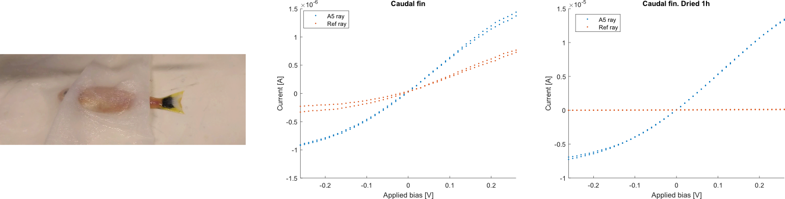

Figure S1. A5 injection into zebrafish caudal fin. Current–voltage measurements of A5 injected in between caudal fin rays immediately after injection and in a dried fin, respectively.

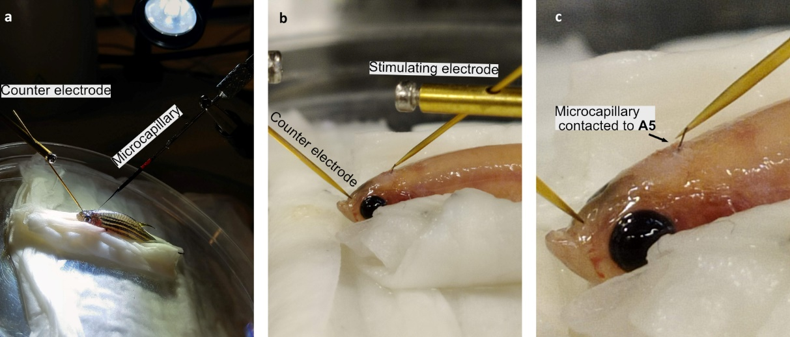
Figure S2. Electropolymerization in brains. (A) Anesthetized zebrafish injected with A5 and ETE-S using an iridium-coated microcapillary. Following injection, the microcapillary is connected to an external power source and used to electropolymerize the ETE-S. (B,C) Zebrafish after electropolymerization with a broken-off microcapillary still inside the brain and connected to the A5–ETE-S electrode. A gold microelectrode can be used to contact the protruding microcapillary.

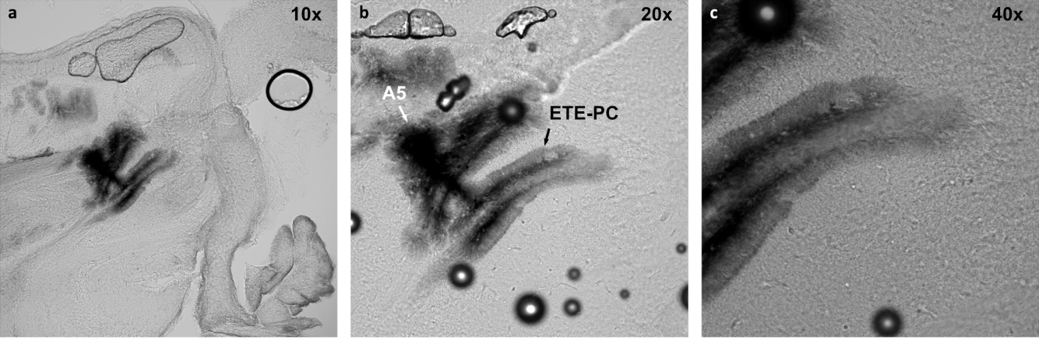
Figure S3. Electropolymerized A5–ETE-PC in zebrafish brain slices. Brain sections depicting A5–ETE-PC 1 d after electropolymerization. The objectives used in the imaging are indicated in the figure.

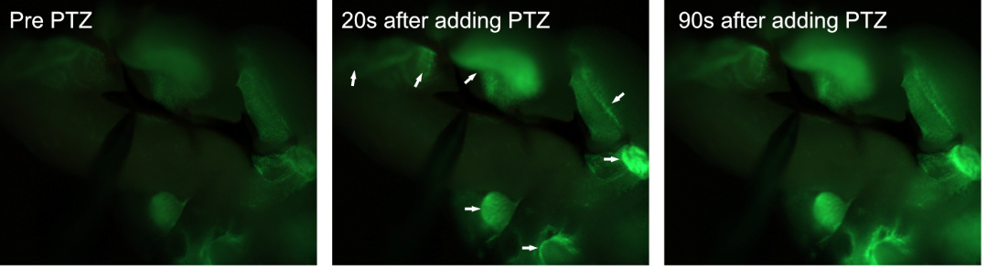
Figure S4. PTZ stimulation in brain slices: After repeated electrical stimulation in the brain slice depicted in Fig. 5, we added pentylenetetrazole (PTZ) to the imaging medium at a final concentration of about 10mM. PTZ is a GABA-A receptor antagonist stimulating unspecific neural activity by blocking GABAergic inhibitory signaling.

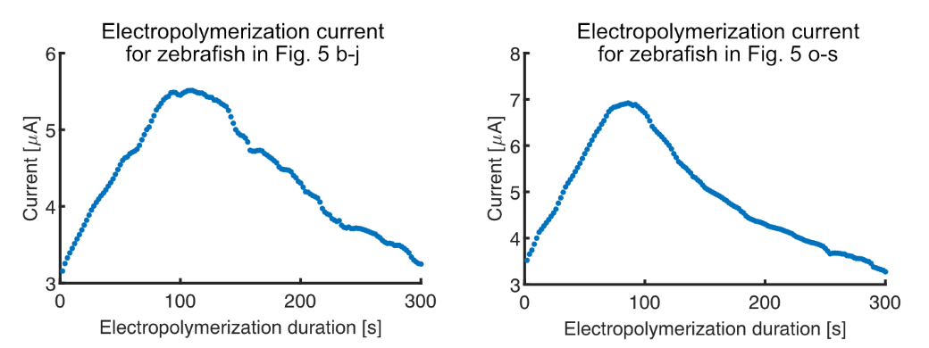
Figure S5. Current flow during in vivo electropolymerization of A5+ETE-S. 1.5 V was applied between the microcapillary and counter electrode during polymerization.

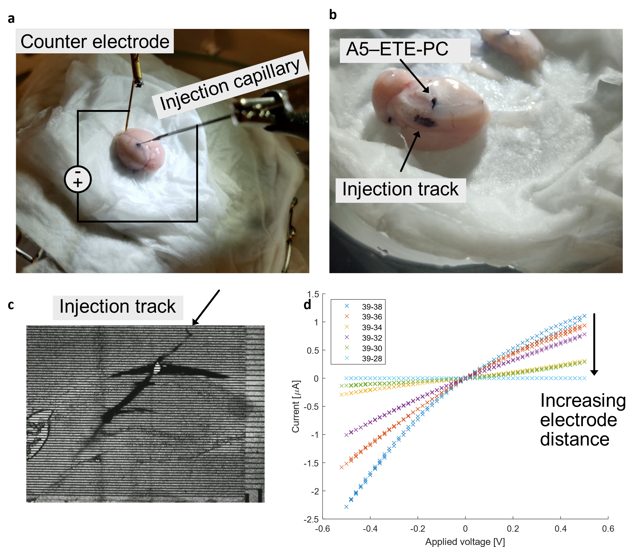
Figure S6. Ex vivo electropolymerization of A5+ETE-PC in a mouse brain. (A) Setup for injection and subsequent electropolymerization. An Ir-coated microinjection capillary (same as was used for the zebrafish brain injections) was used to inject ETE-PC+A5 and as the anode for electropolymerization at 1.5 V. (B) After electropolymerization, a dark polymer gel electrode was found along the injection track, similar to what was observed in the Zebrafish studies. (C) Sectioned PFA-fixed mouse brain put onto interdigitated gold electrodes. The dark A5–ETE-PC track extends into the tissue in a similar fashion to the zebrafish brain. (D) Current–voltage characteristics when mapping the interdigitated electrodes in (C). High currents which decrease with increased electrode distance was observed.

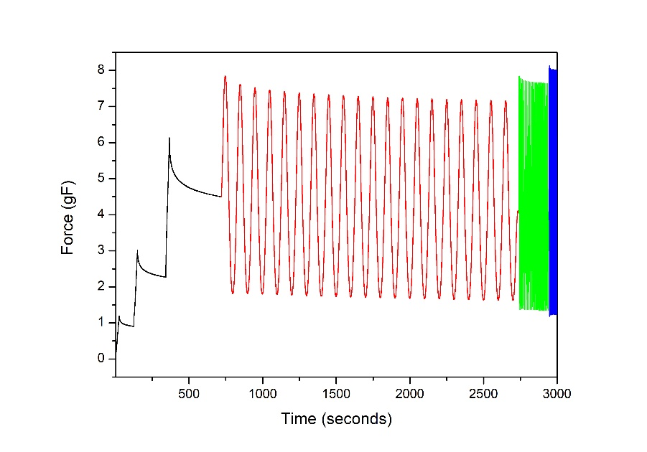

Figure S7. Mechanical testing of electropolymerized A5–ETE-PC. Indentation measurement setup. In black, the 3 stress-relaxations (indentation step followed by relaxation). In red is the dynamic test at 0.1Hz, green at 1Hz and blue at 4Hz.

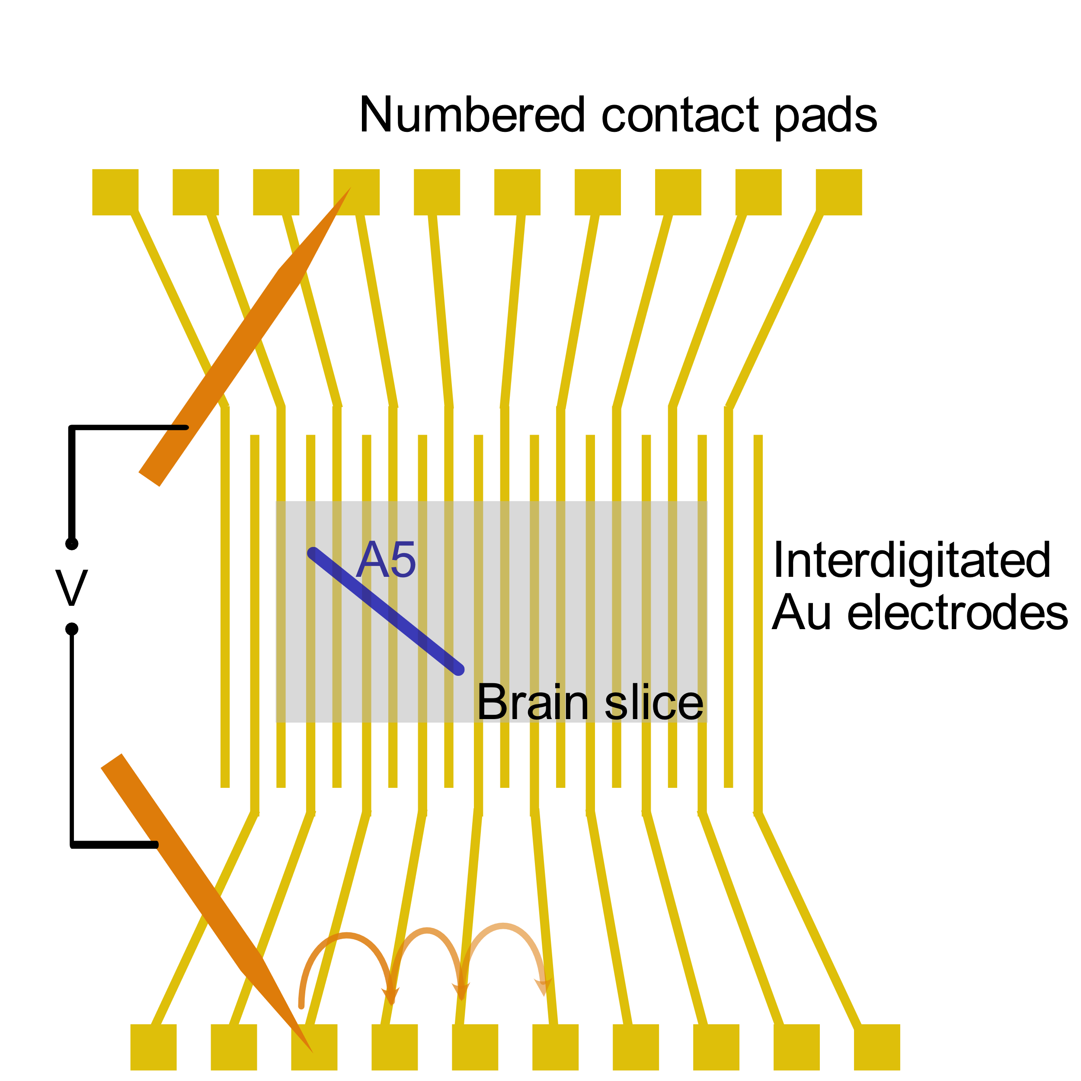
Figure S8. Schematic description of the electrical measurements. Movable external electrodes (orange) are connected to numbered contact pads outside of the brain slice area. The brain slice (light grey) with the injected polymer (dark blue) is placed on the interdigitate Au electrodes. An external voltage is supplied through the external electrodes while the resulting current is registered. The voltage is ramped at up to +-0.5V in a cyclic fashion. Once mapped, the external electrodes are moved to different contact pads to map other regions (and the distance dependence) of the injected polymer.

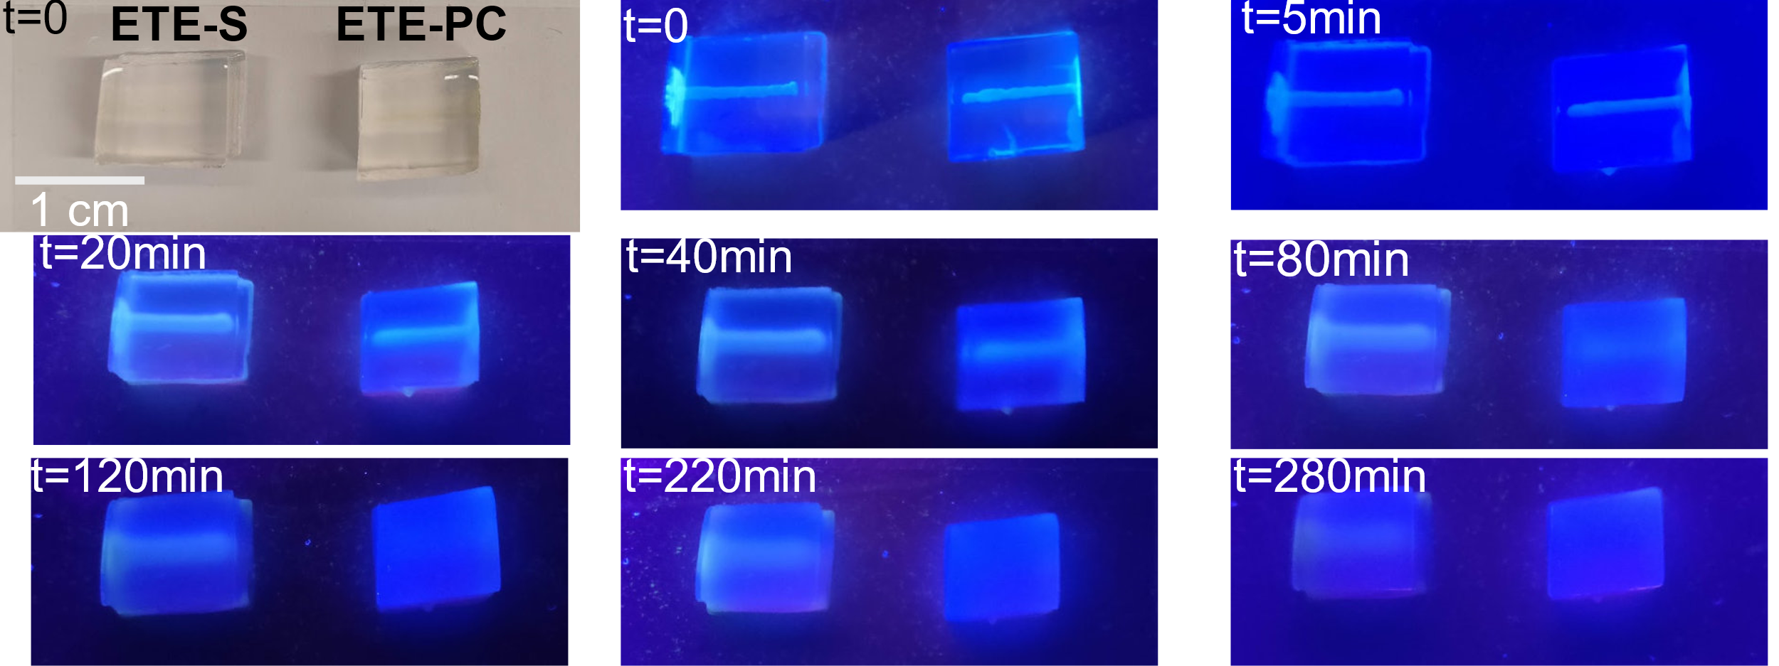
Figure S9. Diffusion of ETE-S and ETE-PC in brain mimicking agarose. 3.5µl ETE-R was injected into 0.6% ringer-agarose using a Hamilton syringe and left to diffuse. The ETE-R can be traced by its fluorescence (excited at 365nm). After 80min, the ETE-PC had diffused to the point where it was homogenously distributed in the agarose block. ETE-S presented slower diffusion. Images acquired using a cell phone camera.

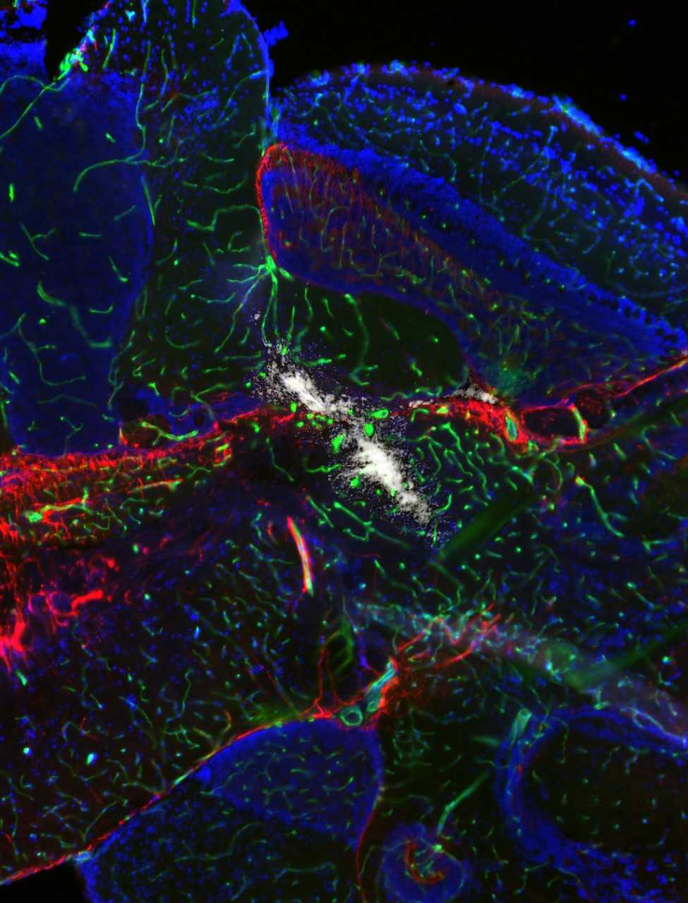
Figure S10. Fluorescence microscopy image (10x objective) of immunostained zebrafish brain section. Brain injected with A5 [40mg/ml] + ETE-PC [40mg/ml] and electropolymerized at 1.5V for 5min. Radial glia (anti-GFAP) in red, blood vessels (Fli-GFP) in green, cell nuclei (DAPI) in blue, and polymer electrode in white.

Movie S1.mp4.
Movie showing stimulation in brain slices when the A5 is contacted by an external 10 µm tungsten microelectrode. Each stimulation pulse was applied for 5 s and are indicated by a lightning symbol in the movies. 1 frame per second was acquired and the movies are shown at 10x speed. Voltages used for the different stimulation pulses: 11 V, 9 V, and 9 V.

Movie S2.mp4.
Stimulation is similar to the above, albeit in a different brain slice coming from another fish. Voltages used for the different stimulation pulses: 9 V, 9 V, and 9 V. 1 frame per second, shown at 10x speed.

Movie S3.mp4.
Movie showing spontaneous firing in the regions which were previously stimulated in Movie_S1. The spontaneous firing is stochastic in nature. No stimulation pulses were applied in this movie. 1 frame per second, shown at 10x speed.

Movie S4.mp4.
Movie showing stimulation in brain slices when the external 10 µm tungsten microelectrode contacted the microcapillary outside the brain slice. The capillary was in turn contacting the conductive polymer in the slice. Each stimulation pulse was applied for 5seconds and are indicated by a lighting in the movies. 1 frame per second was acquired and the movies are shown at 10x speed. Voltages used for the different stimulation pulses: 11 V, 9 V, and 9 V.

Movie S5.mp4.
Fish swimming around with the capillary still inside the skull. Movie acquired one day after ETE-PC electropolymerization. Real time movie.

Movie S6.mp4.
Movie showing electropolymerization of A5–ETE-S in an agarose gel. 1.5 V applied bias. Total movie time was 100 min.

Movie S7.mp4.
3D rendered visualization of the light sheet microscopy presented in Fig. 5.

