Table 3. Accurate masses, elemental compositions, and major fragment ions of izencitinib and its metabolites from the human mass balance and human liver microsome stability studies
Metabolites | Retention Time (min) | Molecular ion (M+H) ⁺ | Proposed Structure | Characteristic Product Ions (observed) | Elemental Composition of Product Ions | Matrix
Izencitinib | 18.8 | 403.2353  (C₂₂H₂₇N₈) ⁺ | 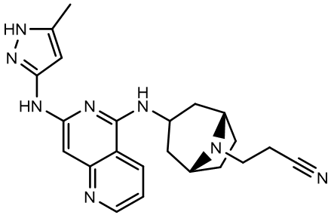 | 163.1234  224.0931  241.1202  283.1673  350.2098  362.2080 | (C₁₀H₁₅N₂) ⁺ (C₁₂H₁₀N₅) ⁺ (C₁₂H₁₃N₆) ⁺ (C₁₅H₁₉N₆) ⁺ (C₁₉H₂₄N₇) ⁺ (C₂₀H₂₄N₇) ⁺ | Plasma, Urine, Feces, HLM
M1 | 17.7 | 350.2088  (C₁₉H₂₄N₇) ⁺ | 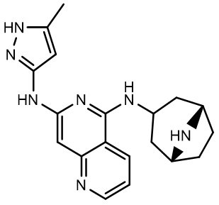 | 224.0927 241.1195 283.1664 333.1818 | (C₁₂H₁₀N₅) ⁺ (C₁₂H₁₃N₆) ⁺ (C₁₅H₁₉N₆) ⁺  (C₁₉H₂₁N₆) ⁺ | Plasma, Urine, HLM
M2 | 11.6 | 402.2275*  (C₄₄H₅₂N₁₆) ⁺⁺ | 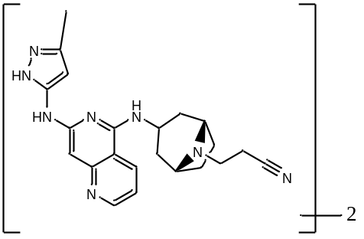 | 163.1234 224.0922 241.1190 283.1657 350.2077 353.6942 362.2082  706.3813 | (C₁₀H₁₅N₂) ⁺ (C₁₂H₁₀N₅) ⁺ (C₁₂H₁₃N₆) ⁺ (C₁₅H₁₉N₆) ⁺ (C₁₉H₂₄N₇) ⁺ (C₄₀H₄₅N₁₃) ⁺⁺ (C₂₀H₂₄N₇) ⁺ (C₄₀H₄₄N₁₃) ⁺ | HLM
M3 | 10.8 | 375.7142*  (C₄₁H₄₉N₁₅) ⁺⁺ | 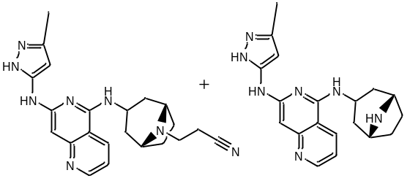 | 163.1224 327.1812 653.3549 | (C₁₀H₁₅N₂) ⁺ (C₃₇H₄₂N₁₂) ⁺⁺ (C₃₇H₄₁N₁₂) ⁺ | HLM
M6 | 20.3 | 419.2302  (C₂₂H₂₇ON₈) ⁺ | 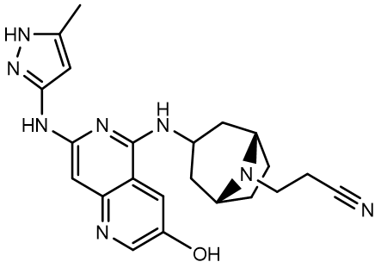 | 163.1223 240.0875 257.1138 299.1596 366.2022 | (C₁₀H₁₅N₂) ⁺ (C₁₂H₁₀ON₅) ⁺ (C₁₂H₁₃ON₆) ⁺ (C₁₅H₁₉ON₆) ⁺ (C₁₉H₂₄ON₇) ⁺ | Plasma, Urine
M9 | 39.8 | 413.2197  (C₂₃H₂₅N₈) ⁺ | 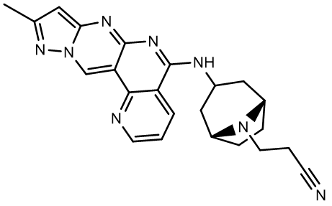 | 163.1234 251.1046 360.1941 372.1941 | (C₁₀H₁₅N₂) ⁺ (C₁₃H₁₁N₆) ⁺ (C₂₀H₂₂N₇) ⁺ (C₂₁H₂₂N₇) ⁺ | Plasma, Urine, Feces
M10 | 37.8 | 415.2353  (C₂₃H₂₇N₈) ⁺ | 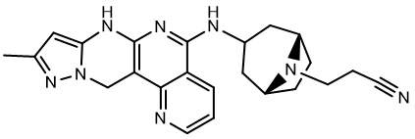 | 163.1228 253.1190 362.2080 374.2079 | (C₁₀H₁₅N₂) ⁺ (C₁₃H₁₃N₆) ⁺ (C₂₀H₂₄N₇) ⁺ (C₂₁H₂₄N₇) ⁺ | Plasma
M11 | 42.5 | 409.2353*  (C₄₅H₅₄N₁₆) ⁺⁺ | 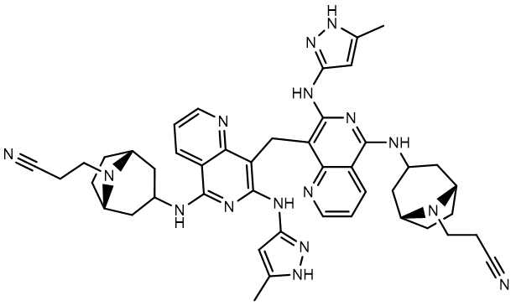 | 163.1223 253.1189 362.2073  403.2338  415.2335 | (C₁₀H₁₅N₂) ⁺ (C₁₃H₁₃N₆) ⁺ (C₂₀H₂₄N₇) ⁺  (C₂₂H₂₇N₈) ⁺  (C₂₃H₂₇N₈) ⁺ | Plasma, Urine, Feces, HLM
M12 | 13.8 | 419.2302  (C₂₂H₂₇ON₈) ⁺ | 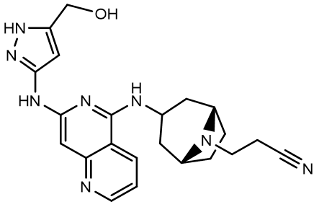 | Fragmentation data could not be obtained |  | Plasma, Urine
M18 | 6.5 | 435.2260  (C₂₂H₂₇O₂N₈) ⁺ | 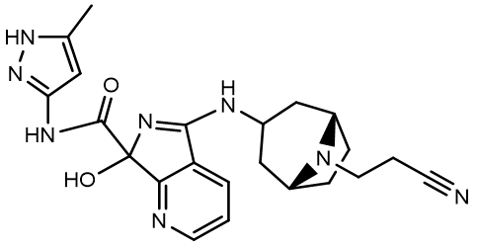 | 163.1226 238.0716 255.0983 294.1726 320.1501  417.2149 | (C₁₀H₁₅N₂) ⁺ (C₁₂H₈ON₅) ⁺ (C₁₂H₁₁ON₆) ⁺ (C₁₇H₂₀N₅) ⁺ (C₁₈H₁₈ON₅) ⁺ (C₂₂H₂₅ON₈) ⁺ | Plasma, Urine, Feces, HLM
M19 | 22.7 | 457.2469  (C₂₅H₂₉ON₈) ⁺ | 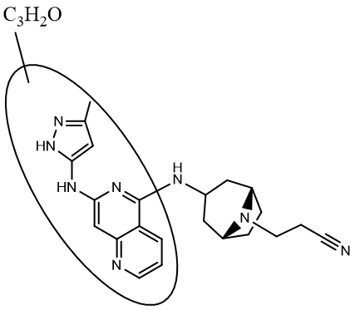 | 163.1243 295.1327 337.1802 404.2229 416.2228 | (C₁₀H₁₅N₂) ⁺ (C₁₅H₁₅ON₆) ⁺ (C₁₈H₂₁ON₆) ⁺ (C₂₂H₂₆ON₇) ⁺ (C₂₃H₂₆ON₇) ⁺ | Feces
M28 | 22.8 | 419.2303  (C₂₂H₂₇ON₈) ⁺ | 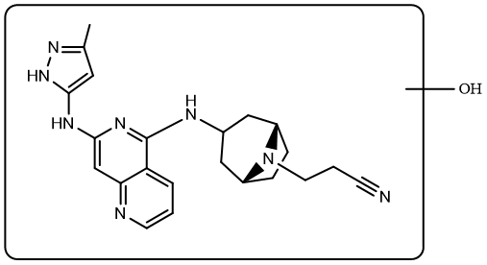 | Fragmentation data could not be obtained |  | Feces
Accuracy of the observed (M+H)⁺ ion and MS/MS fragment ions for izencitinib and all metabolites (except M19) were within 5 ppm. Assigned elemental compositions for M19 fragment ions are tentative since they fall outside the 5 ppm tolerance.
HLM, human liver microsomes
* Refers to doubly charged ion

