Supporting Information
Some properties of TENG with the structure of ITO/c-TiO₂/m-TiO₂/CABB - PTFE/Al.
Figure.S1 Cross-section scale of positive triboelectric material ITO/c-TiO₂ (compact TiO₂)/m-TiO₂ (mesoporous TiO₂)/CABB fabricated through a spin-coating and b spraying method.
Figure.S2 Untreated spin-coated film.
Figure.S3. AFM picture of a spin-coated film. b sprayed film. c The surface roughness.
Figure.S4. The $V_{oc}$ and $J_{sc}$ growth rate of spinning-coating film on a Mechanical frequency, and b Contact area.
Figure.S5. The $V_{oc}$ and $J_{sc}$ growth rate of sprayed film on a Mechanical frequency, and b Contact area.
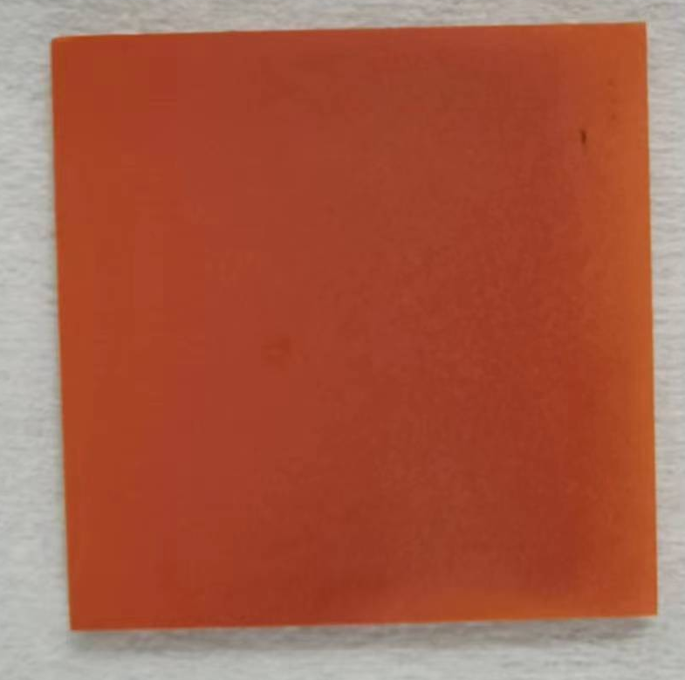
Figure.S6 The Physical image of 50 mm X 50 mm CABB sprayed film.
Figure.S7 The charging speed of sprayed CABB TENG using 100nF capacitor at 10Hz motion frequency.

