Supplementary Information

Interplay Between Superworm and its Gut Microbiome in Facilitating Polyethylene Biodegradation by Host Transcriptomic Analysis: Insights from Xenobiotic Metabolism

Hong Rae Kimª, Chaerin Leeª, Hyeyoung Shinª, Hye Yeon Kohª, Sukkyoo Lee^{b}, Donggeon Choi^{a,}*
ªDepartment of Research and Development, Repla Inc., Suwon 16679, Republic of Korea
^{b}Department of Brain Sciences, Daegu Gyeonbuk Institute of Science and Technology, Daegu 42988, Republic of Korea

*Corresponding author
Mailing address: Department of Research and Development, Repla Inc., 237, Yeongtong-ro, Yeongtong-gu, Suwon-si, Gyeonggi-do, Republic of Korea (16679), Phone: (+82) 31-895-4310. Fax: (+82) 70-4667-0230. E-mail: dgchoi@repla.co.kr
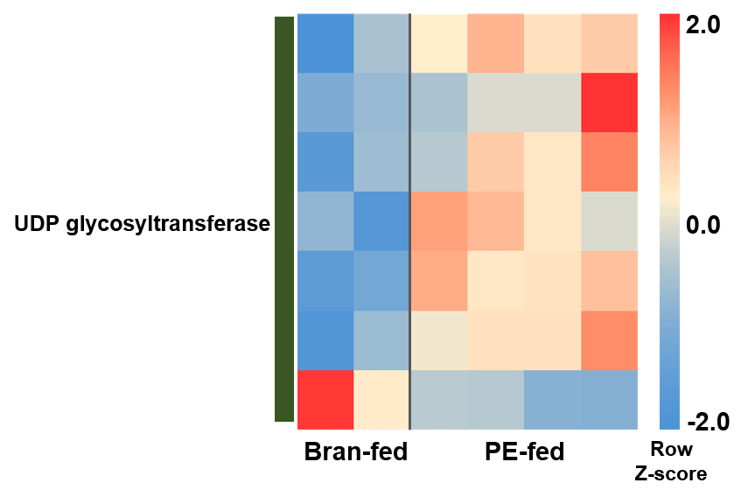
Fig. S1. Expression level of UDP glycosyltransferase.
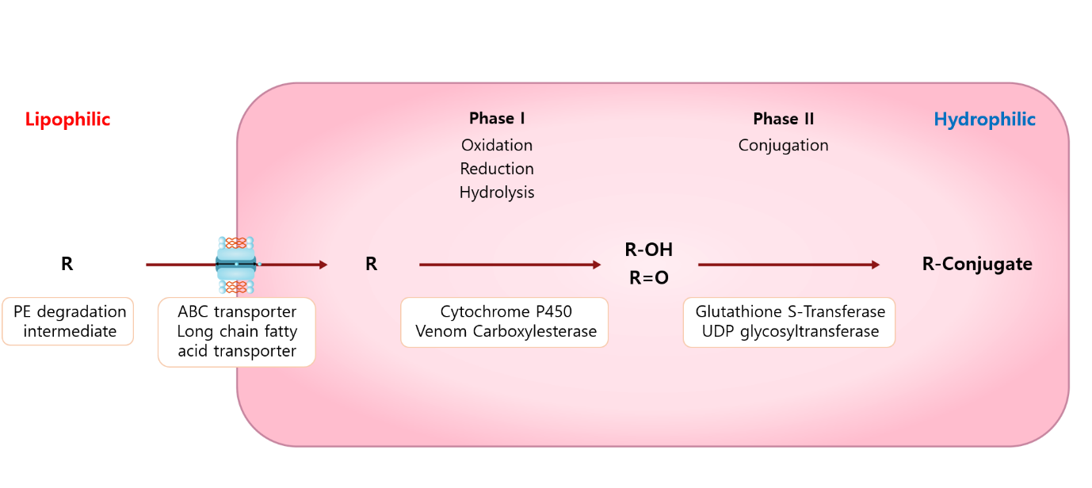Fig. S2. Xenobiotic metabolism and related enzymes.

