Electronic supplementary information
Microbially synthesised agriculturally useful urea nanoparticles have no phytotoxicity and show enhanced fertilising effects in Kharif (monsoon) paddy
Ayushi Priyam¹, Prerna Seth ^{1,2}, Sadhana Shukla¹, U. Vineetha³, Palash Kumar Manna¹, Pushplata Prasad Singh^{1,2*}
¹ National Centre of Excellence for Advanced Research in Agricultural Nanotechnology, TERI - Deakin Nanobiotechnology Centre, Sustainable Agriculture Division, The Energy and Resources Institute (TERI), New Delhi, 110003, India
²Department of Biotechnology, TERI School of Advanced Studies, New Delhi, 110070, India
³Agriculture Research Station, Acharya N.G. Ranga Agricultural University, Nellore, 524003, India

- Presence of lipid around TNU nanoparticles
ESI Figure 1. Total lipid content in the synthesised TNU. Data is presented as mean ± SEM. Different letters (a, b, c, d, and e) show significant differences at p<0.05 when treatments are compared to each other.
(MQ: MiliQ de-ionised water, NB: Nutrient broth, C1: Bacillus culture 1 extract, C2: Bacillus culture 2 extract, TNU: urea nanoparticles, SEM: standard error of mean)

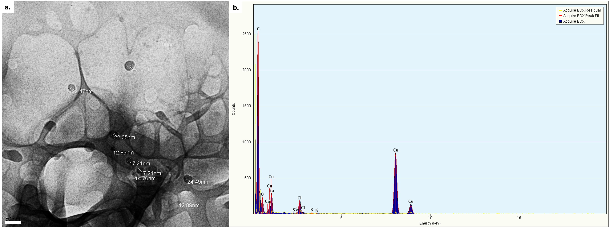
ESI Figure 2. (a.) TEM micrograph (scale = 50 nm) for TNU around the lipid globules due to microbial assisted synthesis. (b.) EDX spectra showing elemental distribution.
(TEM: transmission electron microscopy, TNU: urea nanoparticles, EDX: Energy dispersive X-ray spectroscopy)

- Physicochemical characterisation of bulk urea
ESI Figure 3. a. DLS information for bulk urea (data presented as data ± SEM), (b.) UV-Vis spectrum for bulk urea, (c.) FTIR peaks for bulk urea and (d.) 3D - comparative XRD patterns for Bulk urea and Nano urea (TNU) - * marks the most prominent peak at 22.5°).
(DLS: Dynamic light scattering, UV: ultraviolet, FTIR: Fourier transformed infrared, XRD: X-ray diffraction, SEM: standard error of mean).

- Number of seminal roots in maize after germination

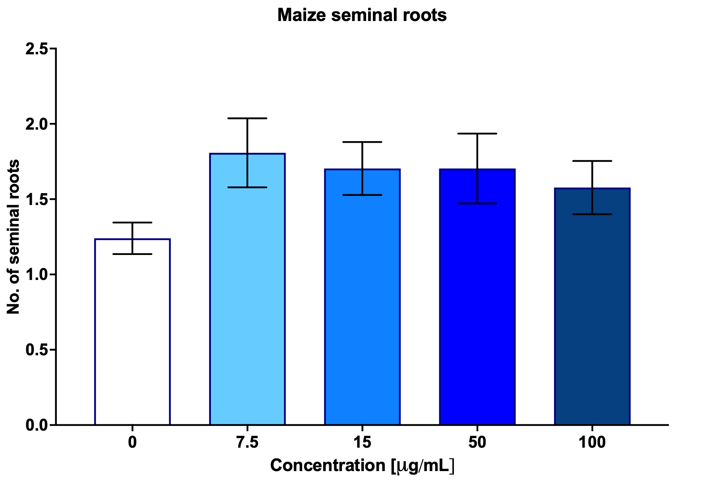
ESI Figure 4. No. of seminal roots in maize after germination on treatment with different concentrations of TNU. Data is presented as mean ± SEM.
(TNU: urea nanoparticles, SEM: standard error of mean).

- Shoot length in tomato
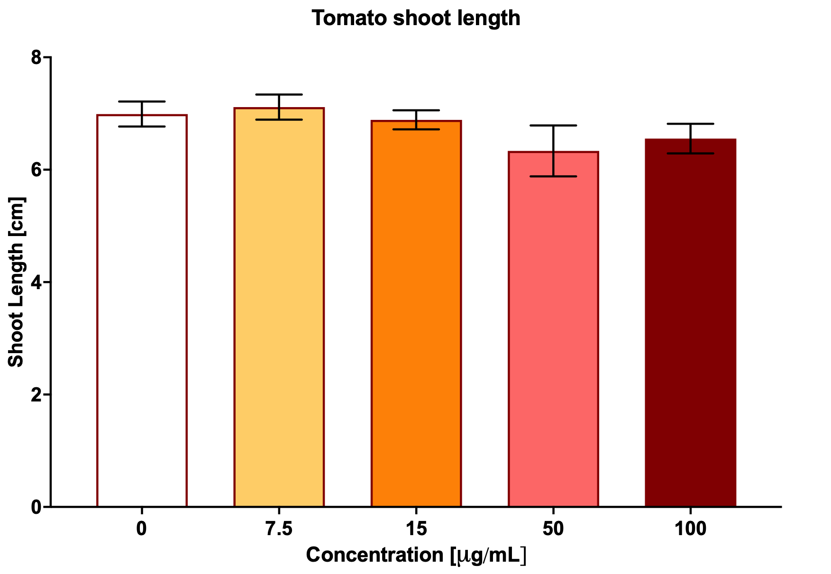
ESI Figure 5. Shoot length in tomato after germination on treatment with different concentrations of TNU. Data is presented as mean ± SEM.
(TNU: urea nanoparticles, SEM: standard error of mean).

