cPT Name (Descriptive Name) | R1  (Trp Indole) | R2  (Benzotriazole-Pro) | k_{a}  (M⁻¹s⁻¹) ×10⁻⁵ | k_{d}  (s⁻¹)×10² | t_{1/2}  (min) | App K_{D} (nM) | Eq K_{D}  (nM) | JRFL IC₅₀ (nM)
AAR029N2  (N2) | 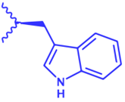 | 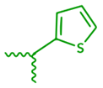 | 5.6 ± 0.15 | 5.9 ± 0 | 12.0 | 107 ± 4 | 111 ± 9 | 116.4 ± 29.9
MG-I-13  (N2-Br) | 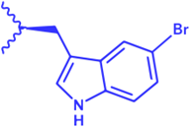 |  | 34.0 ± 17.1 | 30.25 ± 14.05 | 3.0 ± 1.4 | 91.69 ± 4.41 | 110 ± 9.55 | 144.4 ± 27.0
MG-II-39  (N2-Me) | 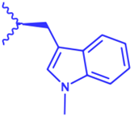 |  | 13.7 ± 3.7 | 45.3 ± 23.6 | 2.1 ± 1.1 | 307 ± 91.5 | 462.95 ± 54.05 | 399.9 ± 33.1
MG-I-33  (N14) |  | 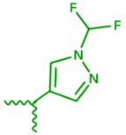 | 5.28 ± 1.78 | 12.4 ± 5.4 | 7.69 ± 3.82 | 219.5 ± 32.5 | 297.5 ± 117.5 | 690.2 ± 88.4
MG-II-20  (N14b) |  | 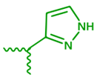 | 10.45 ± 2.55 | 11.0 ± 2.8 | 6.75 ± 1.75 | 105.2 ± 1.2 | 111.5 ± 6.5 | 43.7 ± 16.4
MG-II-55  (N14b-Br) |  |  | 40.8 ± 0.1 | 55.55 ± 9.35 | 1.28 ± 0.22 | 136 ± 23.5 | 142 ± 42 | 87.1 ± 12.3

Table 1: Kinetics of macrocyclic peptide triazole variant binding to YU2 gp120 and, in the last column, infection inhibition potency against JRFL pseudovirus. Kinetic parameters were obtained by fitting the binding profiles globally to a 1:1 model. Fitted Rmax ranged from 5.3 to 9.6 RU (median 7.2 RU) or 40-50% of expected capacity of coupled gp120; values report average ± SD fitted data from n=3-7 independent binding assays with 2 and 5% DMSO. Apparent affinities were calculated from the kinetic parameters. Equilibrium affinities were determined from the steady state responses, plotted as a function of cPT concentration, and fit to a simple binding isotherm. Inhibition potencies of cPTs were determined against infection of HOS.T4.R5 cells by JRFL pseudoviruses (Figure 4), and presented as the IC₅₀ ± the standard error of the IC₅₀, replicate wells = 4, independent experiments = 3.

