Supplementary Materials

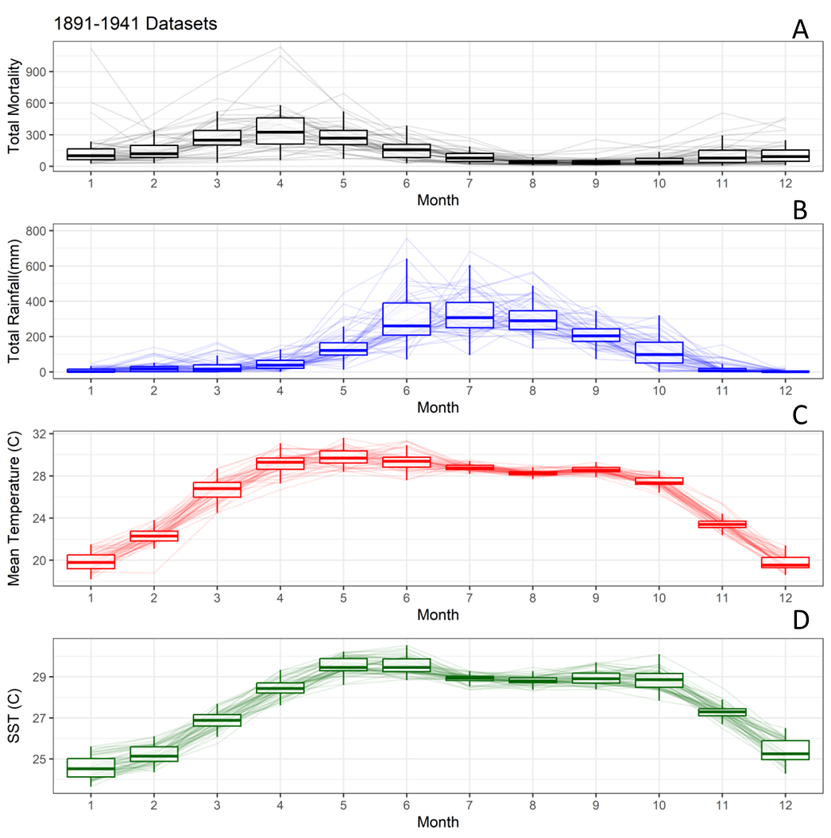
Figure. S1 – Boxplots showing seasonal mean and variance during the historical interval (1891-1941) in Calcutta of A) Total Cholera mortality, B) Total monthly rainfall, C) Mean temperature, and D) SST (in BoB coast south of Calcutta).

