Supplemental Table 1. Results of Shapiro-Wilk test for flowering ratio, the number of potential seed per reproductive shoot and ratio of mature to potential seeds in the three experiments. The table includes the results before log transformation and after log transformation. Log transformation was accomplished by applying the log(x+1) to data set.
 | Community | Treatment | Flowering ratio |  |  | Number of potential seeds  per reproductive shoot |  |  | Ratio of mature to potential seeds
 |  |  | Shapiro-Wilk test | Shapiro-Wilk test  (log transformation) |  | Shapiro-Wilk test | Shapiro-Wilk test  (log transformation) |  | Shapiro-Wilk test | Shapiro-Wilk test  (log transformation)
CO₂ experiment | C₃ | Control | 0.12 | 0.12 |  | 2.0E-04 | 0.025 |  | 7.6E-08 | 1.7E-07
 |  | Ambient CO₂ | 0.86 | 0.83 |  | 0.027 | 8.3E-05 |  | 3.1E-07 | 2.8E-06
 |  | Elevated CO₂ | 0.085 | 0.091 |  | 0.044 | 0.014 |  | 6.3E-12 | 1.2E-11
 | C₄ | Control | 0.039 | 0.039 |  | 0.64 | 0.83 |  | <2.2E-16 | <2.2E-16
 |  | Ambient CO₂ | 0.44 | 0.45 |  | 0.021 | 0.16 |  | 5.9E-04 | 0.0014
 |  | Elevated CO₂ | 0.14 | 0.15 |  | 0.072 | 2.5E-04 |  | 0.018 | 0.025
 | Mixed | Control | 0.16 | 0.17 |  | 0.38 | 5.5E-04 |  | 3.7E-04 | 3.2E-04
 |  | Ambient CO₂ | 0.12 | 0.11 |  | 1.2E-05 | 0.0048 |  | 5.3E-05 | 1.3E-04
 |  | Elevated CO₂ | 0.54 | 0.54 |  | 7.5E-07 | 1.4E-04 |  | 2.7E-10 | 9.2E-10
CO₂ x N experiment | C₃ | Control | 5.9E-12 | 7.0E-12 |  | 0.13 | 0.030 |  | 0.037 | 0.050
 |  | Amb CO₂ | 3.8E-05 | 1.8E-04 |  | 1.3E-05 | 4.9E-09 |  | 6.3E-15 | 3.3E-13
 |  | Amb CO₂ + N | 0.0017 | 0.0036 |  | 2.9E-06 | 2.1E-06 |  | <2.2E-16 | 1.5E-15
 |  | Elev CO₂ | 0.030 | 0.040 |  | 5.5E-04 | 2.5E-10 |  | <2.2E-16 | <2.2E-16
 |  | Elev CO₂ + N | 0.0038 | 0.0072 |  | 1.9E-05 | 7.3E-08 |  | <2.2E-16 | 3.8E-16
Warming experiment | C₃ | +0ºC | 3.4E-05 | 3.4E-05 |  | 0.042 | 1.0 |  | 0.053 | 0.069
 |  | +1.7ºC | 0.0023 | 0.0087 |  | 0.011 | 2.4E-06 |  | 4.0E-07 | 2.1E-06
 |  | +3.4ºC | 0.10 | 0.097 |  | 0.0024 | 3.3E-07 |  | 3.9E-10 | 3.7E-08
 |  | +5.1ºC | 0.35 | 0.52 |  | 0.0032 | 4.3E-06 |  | 1.4E-09 | 8,7E-08

Supplemental Table 2. Mean and standard error of flowering ratio, the number of potential seed per reproductive shoot and ratio of mature to potential seeds in the three experiments.
 | Community | Treatment | Flowering ratio | Number of potential seeds  per reproductive shoot | Ratio of mature  to potential seeds
CO₂ experiment | C₃ | Control | 0.034 + 0.0086 | 14 + 2.6 | 0.078 + 0.034
 |  | Ambient CO₂ | 0.066 + 0.020 | 39 + 4.4 | 0.14 + 0.033
 |  | Elevated CO₂ | 0.057 + 0.0095 | 43 + 3.6 | 0.028 + 0.0091
 | C₄ | Control | 0.0055 + 0.0035 | 11 + 2.6 | 0.095 + 0.095
 |  | Ambient CO₂ | 0.13 + 0.064 | 54 + 6.7 | 0.33 + 0.061
 |  | Elevated CO₂ | 0.10 + 0.059 | 47 + 6.2 | 0.40 + 0.063
 | Mixed | Control | 0.079 + 0.041 | 14 + 1.7 | 0.27 + 0.061
 |  | Ambient CO₂ | 0.071 + 0.022 | 28 + 4.5 | 0.30 + 0.054
 |  | Elevated CO₂ | 0.046 + 0.011 | 29 + 3.8 | 0.091 + 0.026
CO₂ x N experiment | C₃ | Control | 0.0072 + 0.0036 | 37 + 6.9 | 0.16 + 0.037
 |  | Amb CO₂ | 0.15 + 0.019 | 52 + 2.2 | 0.16 + 0.012
 |  | Amb CO₂ + N | 0.092 + 0.017 | 33 + 2.0 | 0.11 + 0.015
 |  | Elev CO₂ | 0.084 + 0.011 | 47 + 2.3 | 0.11 + 0.015
 |  | Elev CO₂ + N | 0.068 + 0.012 | 48 + 2.9 | 0.083 + 0.012
Warming experiment | C₃ | +0ºC | 0.012 + 0.0046 | 22 + 4.4 | 0.10 + 0.035
 |  | +1.7ºC | 0.11 + 0.020 | 40 + 2.7 | 0.23 + 0.026
 |  | +3.4ºC | 0.14 + 0.025 | 41 + 2.4 | 0.21 + 0.022
 |  | +5.1ºC | 0.14 + 0.025 | 44 + 2.6 | 0.18 + 0.021

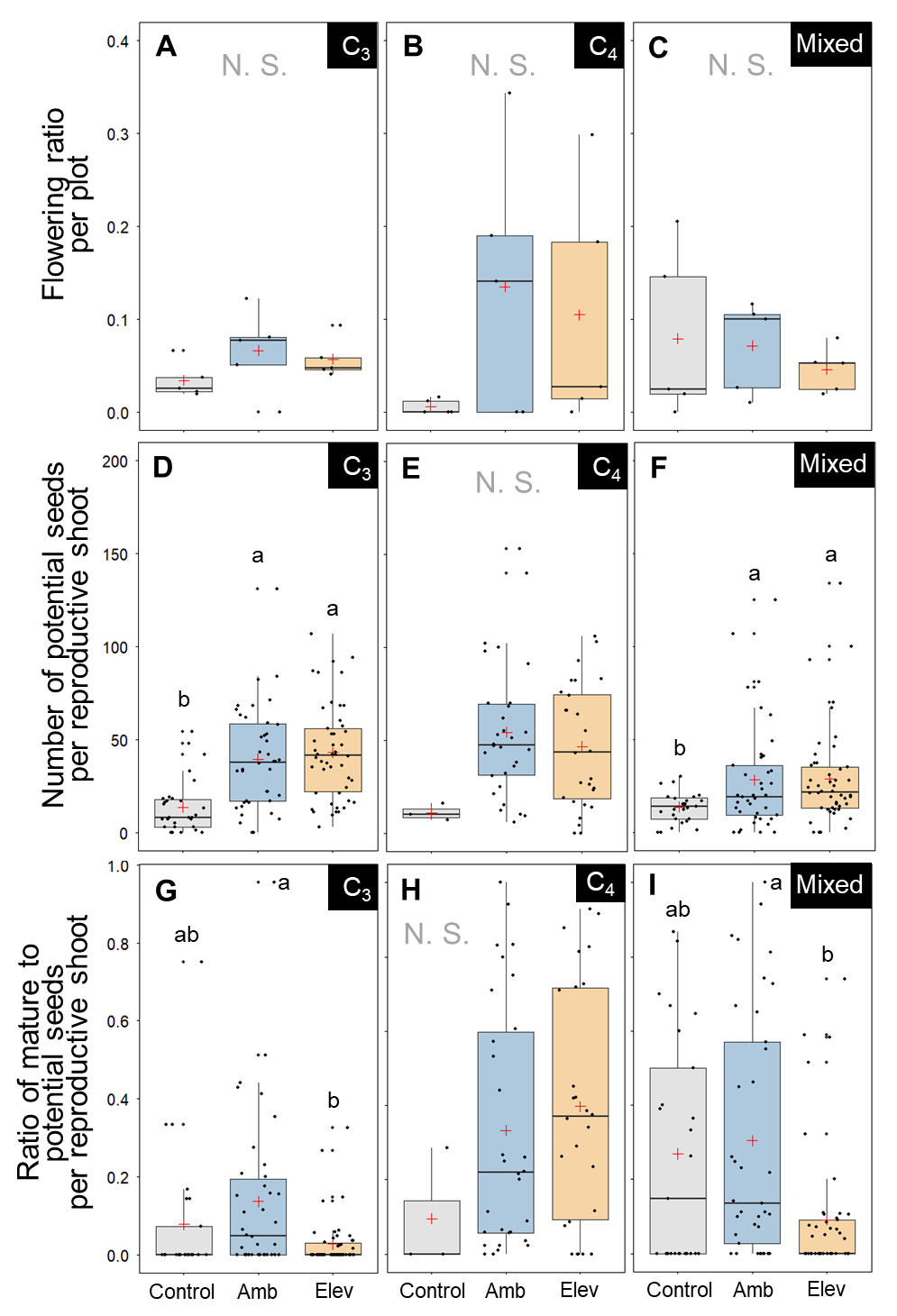
Supplemental Figure 1. Comparison of treatment effects in the CO₂ experiment. (A–C) = Flowering ratio, (D–F) = Number of potential seeds per reproductive shoot, (G–I) = Ratio of mature to potential seeds. The error bars indicate the SE. Means were compared using Steel-Dwass test. Values with the same letter indicate no significant difference at α = 0.05. The black boxes indicate the community type as described in the Methods.

