Supplementary Table
Supplementary Table 1 Parameters for MRI of Cynomolgus monkeys and Humans
 | Parameters | Cynomolgus monkey |  |  | Human
 | Parameters | T1WI | T2WI |  | T1WI | T2WI
 | Pulse sequence | FSE | FSE |  | Spin echo | Spin echo
 | Repetition time (ms) | 500 | 2000 |  | 448 | 3228
 | Echo time (ms) | 8 | 102 |  | 8 | 100
 | Field of view (mm) | 20×20 | 20×20 |  | 250×250 | 250×250
 | Pixel bandwidth (Hz) | 390.6 | 325.5 |  | 320 | 348
 | Voxel size (mm) | 0.8×0.8 | 0.8×0.8 |  | 0.9×1.25 | 0.9×1.25
 | Slice thickness (mm) | 3 | 3 |  | 3 | 3
 | Interslice gap (mm) | 0.6 | 0.6 |  | 0.3 | 0.3
 | Number of slices | 7 | 7 |  | 15 | 15
 | Turbo factor | 3 | 16 |  | 4 | 45
 | Acquisition time (s) | 70 | 100 |  | 208 | 160
 | T1WI = T1-weighted imaging, T2WI = T2-weighted imaging.

Supplementary Figure

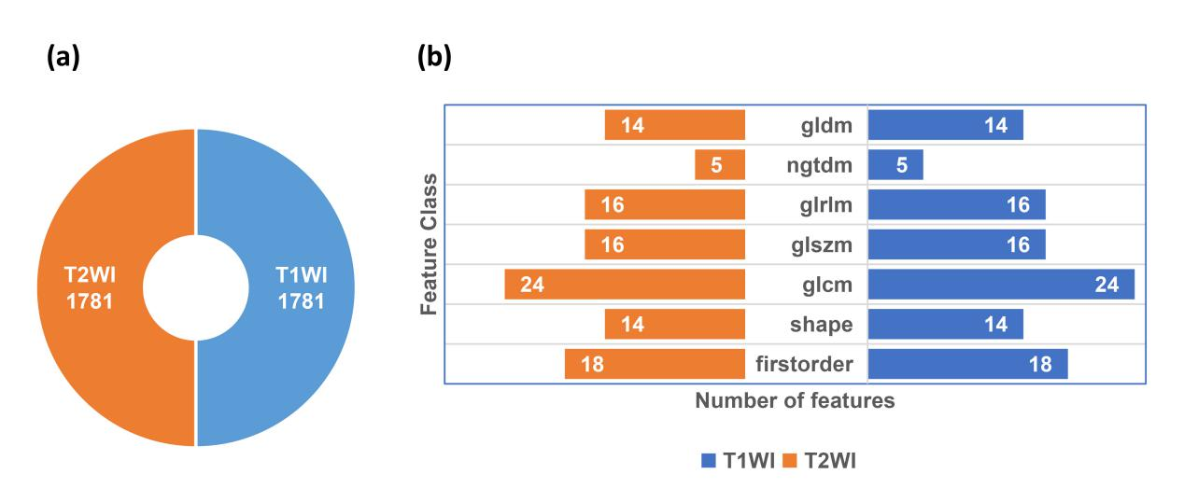
Supplementary Fig. 1 Distribution of radiomics features. (a) The same number of features was extracted from the T1WI and T2WI sequences (n=3562). (b) The distribution of Feature Classes on the original images (n=214). T1WI = T1-weighted imaging, T2WI = T2-weighted imaging.

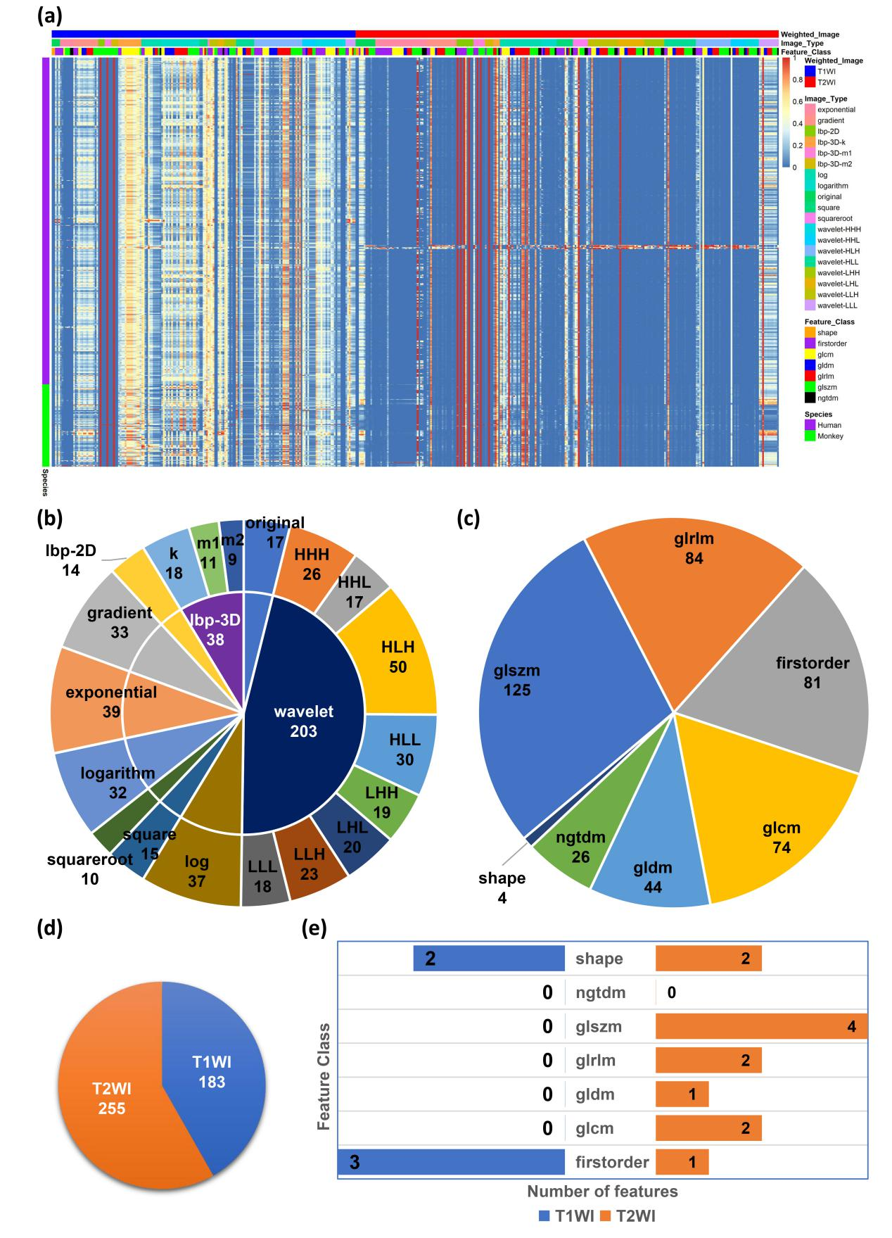
Supplementary Fig. 2 Distribution pattern of reproducible features between species screened by t test combined with LASSO. (a) Heatmap showing the 438 radiomics features that are reproducible between humans and cynomolgus monkeys. (b) The feature set B is distributed across 10 major and 19 minor Image Type. (c) The feature set B is distributed into 7 Feature Classes. (d) Distribution of the feature set B for the two sequences. (e) The distribution of Feature Classes on the original image. n=438 in (a-d), n=17 in (e). T1WI = T1-weighted imaging, T2WI = T2-weighted imaging.

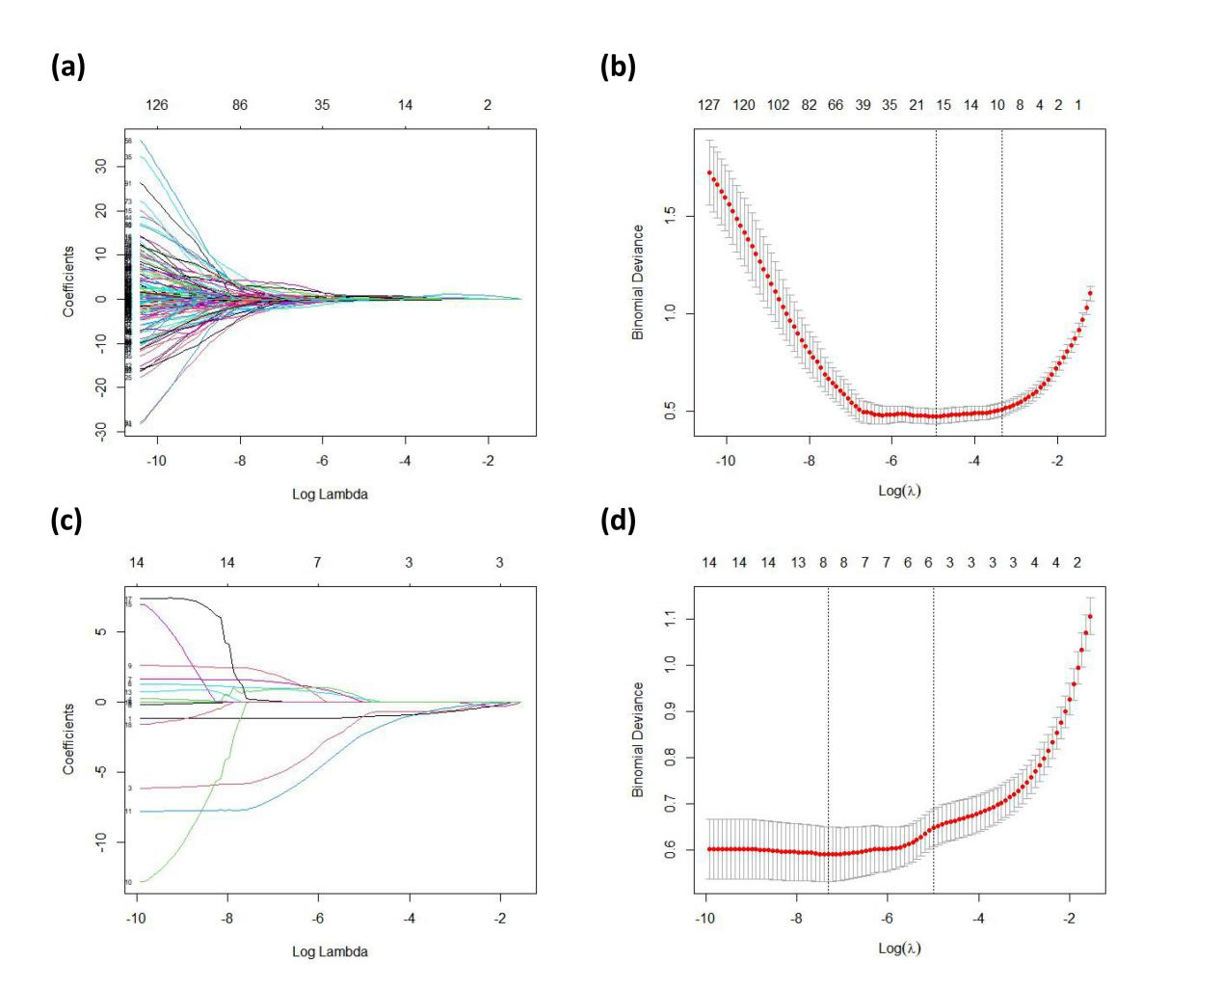
Supplementary Fig. 3 Dimensionality reduction. The radiomics features of feature set A1 (a-b), and feature set B1 (c-d) were screened using LASSO, and the optimal model parameters λ were selected using cross-validation. LASSO = least absolute shrinkage and selection operator.

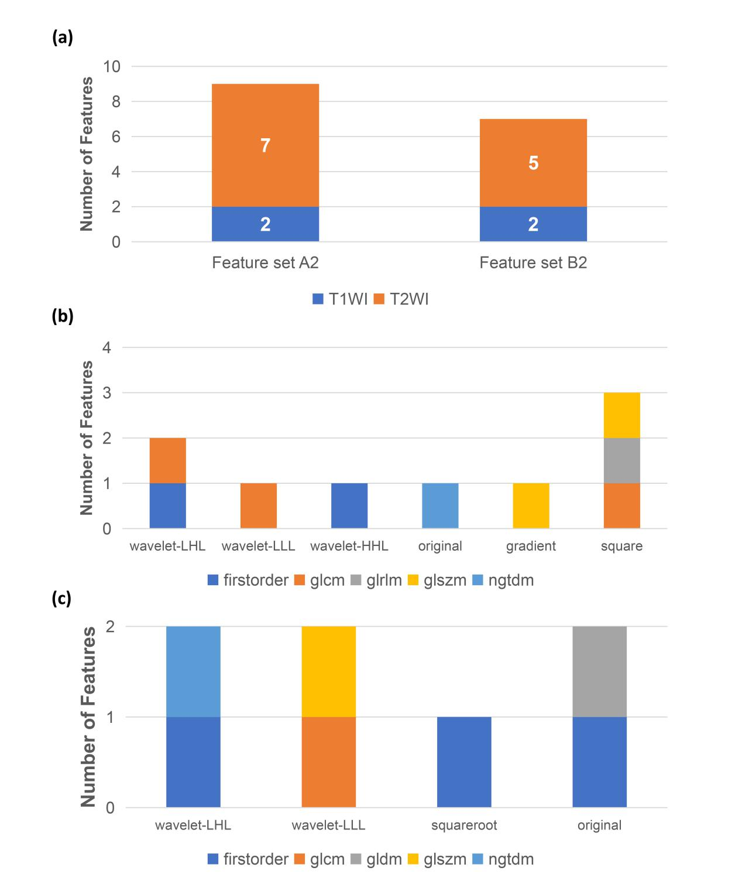
Supplementary Fig. 4 Distribution pattern of feature set A2 and feature set B2. (a) The distribution of feature set A2 and feature set B2 on T1WI and T2WI. (b) The distribution characteristics of feature set A2 in terms of Image Type and Feature Class. n=9. (c) The distribution characteristics of feature set B2 in terms of Image Type and Feature Class. n=7. T1WI = T1-weighted imaging, T2WI = T2-weighted imaging.

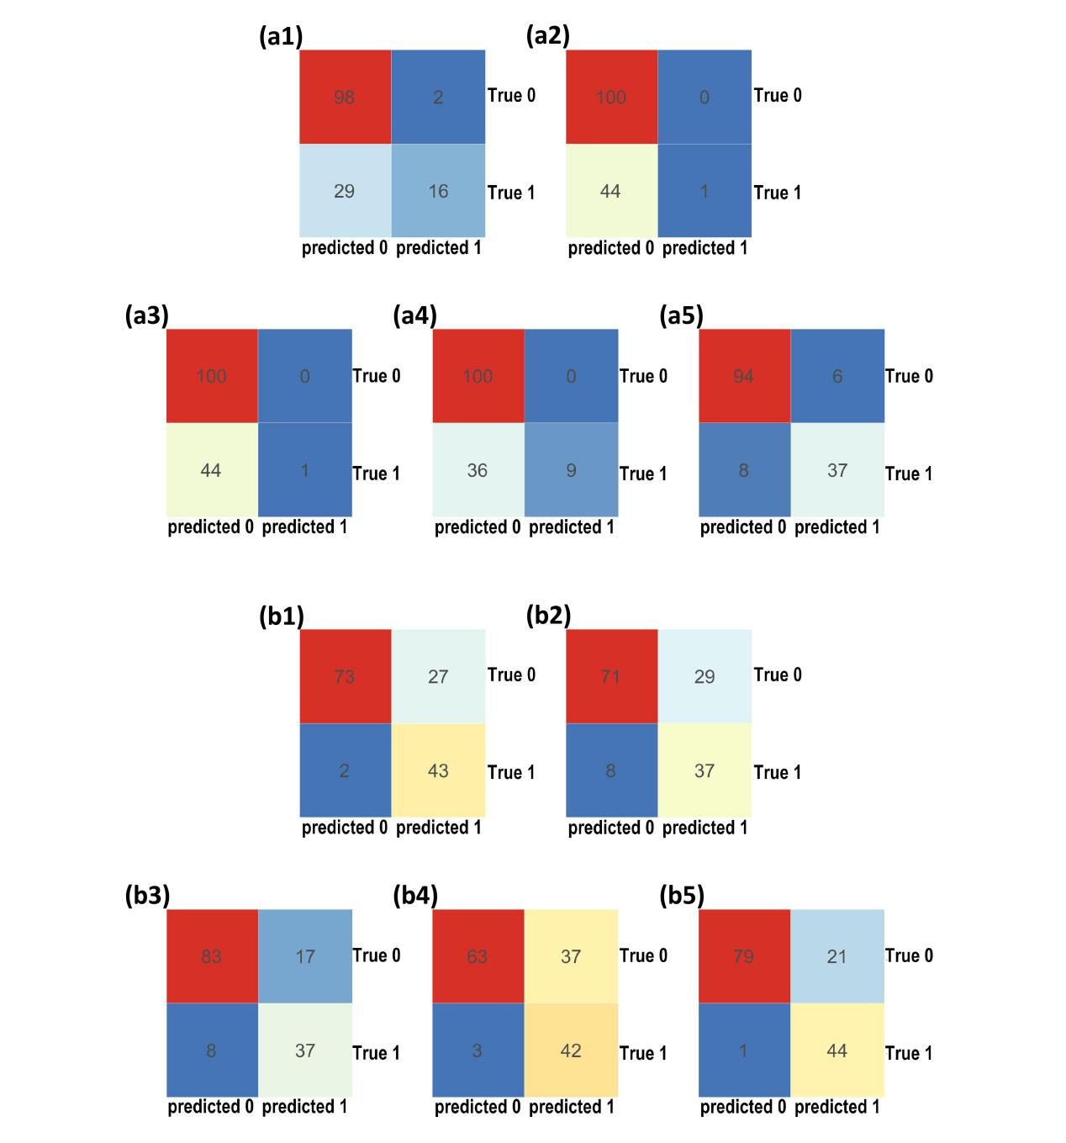
Supplementary Fig. 5 Confusion matrix. Confusion matrix of the radiomics models based on feature set A2 (a) and feature set B2 (b) in the test set. Model number: 1 - Support Vector Machine (SVM); 2 - Decision Tree Classifier; 3 - Random Forest Classifier; 4 - Logistic Regression; 5 - Naive Bayes Classifier. Classification of intervertebral discs: 0 - Healthy intervertebral discs; 1 - Degenerated intervertebral discs.

