Appendix
CONTENT
Supplementary Annex 1 (inference methodology) ….…………………………………………………… | page 2
Supplementary Table S1 (prior distribution of model parameters) ……………………………… | page 4
Supplementary Table S2 (posterior distribution of model parameters) ………………………. | page 5
Supplementary Figures ……………………………………………………………………………………………….. | page 6
References ………………………………………………………………………………………………………………….. | page 16

Supplementary Annex 1
Inference methodology and prior distributions
The analysis was conducted using Bayesian hierarchical model fitting with the program JAGS,¹, interfaced with the statistical environment R,² via the package rjags.³ To inform the parameters in both the state and the observation processes, we used a mix of expert-based priors and empirical data combined with the semi-qualitative data collected via health centre interviews.⁴ These are described in the following paragraphs and summarised in Table S1.
Parameters and priors of the State process
In equation (3), for the expected endemic cases, we set ${α_{0}}_{j}$ to be large and negative a-priori, so that when the covariates and autocovariates in that expression have small values or effects, the rate of endemic cases should also be close to zero. For $α_{1}$ and $α_{2}$, the terms that regulate the temporal autoregression component of the equation, we chose diffuse, normal priors centred at zero. For the Gaussian term $ε_{i,j}\sim Norm\left(0 , {1/τ}_{E}\right)$, that controls extra-Poisson dispersion, we used a wide prior for the precision parameter $τ_{E}\sim Gamma\left(1, 1\right)$.
We used naive priors to model incoming cases' contributions in equation (4). We hypothesised that the proportion of incoming cases in a catchment area can be only a small proportion of the endemic cases in the surrounding areas, hence we used a $Beta\left(1,10\right)$ prior for $q$ in equation (6), corresponding to 0.09±0.08 mean±sd. To model $γ$, the decay rate in equation (7), we used a $Gamma\left(1,0.1\right)$ prior, based on the assumption that the health facilities have a higher chance of being affected by neighbouring facilities at shorter distances (e.g. a value of $γ=1$ would imply that the connectivity drops to 50% of its maximum at 0.7 km distance.
Parameters and priors of the Observation process
In our model, we allowed for some flexibility in the parameter $r_{j}$, the monthly proportion of ill people (of any non-malaria disease). In particular, we used a $Beta\left(1, 10\right)$ prior and we indexed it by $j$, to enable it to vary with the health facility. We based this choice on the assumption that other diseases besides malaria can drive the number of people attending a health facility with different intensities in space.
We assumed $P_{CLINICAL}$, the proportion of symptomatic malaria cases to be fixed in time and space. To model it in equations (9) and (11), we based our prior on previous studies,⁵ and used a $Beta\left(50.4, 12.6\right)$ prior, corresponding to a mean of 0.8 and sd of 0.05.
Based on our previous finding in the same setting, we assumed the probability of care-seeking, $P_{{SEEK}_{j}}$ in equation (9), varying between health facilities.⁴ In particular, we found that clinics that regularly provide antimalarial drugs are more likely to be attended for care-seeking. In addition, we found a negative effect of antimalarial drug stock-out episodes. We also found a negative effect of the average travel time in the catchment area, indicating that accessibility plays a major role in the probability of care-seeking.⁴ Hence, we modelled ${P_{SEEK}}_{j}$ as
 | $$logit \left(P_{{SEEK}_{j}}\right)= α_{SEEK}+\sum_{k=1}^{S}{β_{k}X_{j,k}}$$ | (15)
where and the linear predictor on the right-hand-side of the expression comprises a set of $S$ coefficients $β$ and n explanatory variables $X$ collected at $j^{th}$ health centre via the survey questionnaires. In particular, based on our previous findings,⁴ we used as explanatory variables whether the health centre provides antimalarial drugs ($antimal_provided$), and whether the health centre has experienced a recent stockout of antimalarial drugs ($antimal_stockout$). These were treated as “dummy” variables and codes as “Yes”:1 and “No”: 0. In addition, we included as covariate the average travel time ($t_time$) to each health in the catchment area. To calculate this, we followed the approach proposed by ⁶ and modified by ⁷ and ⁴ (please refer to the latter citation for more details on the methodological approach). For the intercept $α_{SEEK}$ all the $β$s coefficients in equation (15), we chose diffuse normal priors centred at zero, corresponding to a null hypothesis of no-effect for each covariate. This model was not developed independently, but as part of the full state-space model fitting.
To model $s$, the proportion of people ill with any other non-malaria fever-inducing disease in equation (11), we used a $Beta\left(1, 10\right)$ prior.
The probability of testing for malaria at health facilities can vary depending on the characteristics of the national malaria monitoring protocols, ⁸ and the intrinsic capabilities of the given health facility. Following the approach we have previously proposed, ⁴ we modelled ${P_{TEST}}_{j}$ as
 | $$logit \left(P_{{TEST}_{j}}\right)= α_{TEST}+\sum_{k=1}^{T}{β_{k}X_{j,k}}$$ | (16)
Similar to equation (15), and based again on previous findings ⁴, we used as explanatory variables whether the health centre has functioning microscopy equipment ($microscopy_function$), whether functioning counting meters were available ($microscopy_meters$), whether there was a recent stockout of microscopy materials ($microscopy_stockout$), whether a copy of the national malaria treatment guidelines or standard operating procedures on malaria case management were available for staff in the facility ($treatment_sops$), and whether the facility received supervisory visits from a district health officer or consultant in the last year ($supervision$). In addition, to capture the seasonality of malaria cycle, we added the month (1: January to 12: December) with a cubic spline effect. For the intercept $α_{TEST}$ and all the $β$s coefficients in equation (16), we chose diffuse normal priors centred at zero, corresponding to a null hypothesis of no effect for each covariate.

Table S1 – Description and choice of priors for parameters of the state and the observation process for modelling the probability of freedom from malaria.
Process | Parameter | Description | Prior
State | $${α_{0}}_{j}$$ | Average endemic cases | $$\sim Gamma\left(1, 1\right)$$
State | $$α_{1}$$ | Autoregressive term 1 | $$\sim Norm\left(0 , 1000\right)$$
State | $$α_{2}$$ | Autoregressive term 2 | $$\sim Norm\left(0 , 1000\right)$$
State | $$ε_{i,j}$$ | Overdispersion parameter | $$\sim Norm\left(0 , {1/τ}_{E}\right)$$  $$τ_{E}\sim Gamma\left(1, 1\right)$$
State | $$φ_{i,j}$$ | Overdispersion parameter | $$\sim Norm\left(0 , {1/τ}_{I}\right)$$  $$τ_{I}\sim Gamma\left(1, 1\right)$$
State | $$q$$ | Synchrony parameter | $$\sim Beta\left(1,10\right)$$
State | $$γ$$ | Decay rate | $$\sim Gamma\left(1,0.1\right)$$
Observation | $$r_{j}$$ | Proportion of ill people (non-malaria) | $$\sim Beta\left(1, 10\right)$$
Observation | $$s$$ | Proportion of ill people (non-malaria) with fever | $$\sim Beta\left(1, 10\right)$$
Observation | $${P_{SEEK}}_{j}$$ | Probability of care seeking | Modelled as a function of covariates measured at the health facility ⁴
Observation | $$P_{CLINICAL}$$ | Probability of symptomatic malaria | $\sim Beta\left(50.4, 12.6\right)$, corresponding to a mean of 0.8 and sd 0.05 ⁵
Observation | $$P_{{TEST}_{i,j}}$$ | Probability of being tested | Modelled as a function of covariates measured at the health facility ⁴

Supplementary Annex 2
Table S2 – Posterior distribution of parameters of the state and the observation process for modelling the probability of freedom from malaria.
Parameter | Posterior (mean and 95% credible intervals |  | Parameter | Posterior (mean and 95% credible intervals
$$α_{0,j}$$ | -13∙81 (-19∙474 / -7∙891) |  | $$r_{j}$$ | 0∙22 (0∙150 / 0∙287)
$$α_{0,j}$$ | -21∙29 (-29∙355 / -14∙903) |  | $$r_{j}$$ | 0∙16 (0∙109 / 0∙208)
$$α_{0,j}$$ | -0∙33 (-1∙262 / 0∙672) |  | $$r_{j}$$ | 0∙23 (0∙160 / 0∙291)
$$α_{0,j}$$ | -1∙29 (-2∙796 / 1∙204) |  | $$r_{j}$$ | 0∙26 (0∙164 / 0∙348)
$$α_{0,j}$$ | -3∙91 (-6∙873 / -1∙848) |  | $$r_{j}$$ | 0∙37 (0∙254 / 0∙486)
$$α_{0,j}$$ | -7∙4 (-11∙266 / -4∙457) |  | $$r_{j}$$ | 0∙29 (0∙187 / 0∙390)
$$α_{0,j}$$ | -19∙65 (-28∙842 / -12∙35) |  | $$r_{j}$$ | 0∙34 (0∙238 / 0∙453)
$$α_{0,j}$$ | -22∙27 (-32∙926 / -15∙309) |  | $$r_{j}$$ | 0∙41 (0∙283 / 0∙540)
$$α_{0,j}$$ | -2∙98 (-4∙060 / -1∙554) |  | $$r_{j}$$ | 0∙32 (0∙230 / 0∙411)
$$α_{0,j}$$ | -10∙61 (-15∙673 / -6∙703) |  | $$r_{j}$$ | 0∙29 (0∙202 / 0∙387)
$$α_{0,j}$$ | -21∙7 (-31∙167 / -14∙733) |  | $$r_{j}$$ | 0∙23 (0∙161 / 0∙308)
$$α_{0,j}$$ | -11∙77 (-16∙683 / -8∙836) |  | $$r_{j}$$ | 0∙22 (0∙156 / 0∙300
$$α_{0,j}$$ | -13∙29 (-18∙369 / -10∙224) |  | $$r_{j}$$ | 0∙20 (0130 / 0∙280)
$$α_{0,j}$$ | -10∙72 (-14∙525 / -6∙806) |  | $$r_{j}$$ | 0∙32 (0∙221 / 0∙424)
$$α_{0,j}$$ | -18∙63 (-30∙312 / -11∙256) |  | $$r_{j}$$ | 0∙41 (0∙284 / 0∙541)
$$α_{0,j}$$ | -12∙21 (-19∙063 / -8∙387) |  | $$r_{j}$$ | 0∙24 (0∙169 / 0∙326)
$$α_{0,j}$$ | -2∙38 (-4∙517 / -0∙121) |  | $$r_{j}$$ | 0∙52 (0∙361 / 0∙661)
$$α_{0,j}$$ | -9∙08 (-13∙58 / -5∙865) |  | $$r_{j}$$ | 0∙17 (0∙118 / 0∙200)
$$α_{0,j}$$ | -2∙73 (-5∙264 / -0∙651) |  | $$r_{j}$$ | 0∙19 (0∙129 / 0∙253)
$$α_{0,j}$$ | -1∙1 (-2∙865 / 0∙687) |  | $$r_{j}$$ | 0∙53 (0∙353 / 0∙705)
$$α_{0,j}$$ | -8∙76 (-12∙239 / -5∙588) |  | $$r_{j}$$ | 0∙22 (0∙150 / 0∙294)
$$α_{0,j}$$ | -0∙21 (-0∙766 / 0∙247) |  | $$r_{j}$$ | 0∙39 (0∙220 / 0∙580)
$$α_{0,j}$$ | -10∙26 (-17∙173 / -4∙375) |  | $$r_{j}$$ | 0∙17 (0∙113 / 0∙215)
$$α_{0,j}$$ | -13∙16 (-17∙978 / -9∙482) |  | $$r_{j}$$ | 0∙03 (0∙011 / 0∙042)
$$α_{0,j}$$ | -1∙15 (-3∙47 / 1∙271) |  | $$r_{j}$$ | 0∙38 (0∙259 / 0∙508)
$$α_{0,j}$$ | -0∙6 (-1∙655 / 0∙301) |  | $$r_{j}$$ | 0∙41 (0∙288 / 0∙609)
$$α_{0,j}$$ | -0∙42 (-0∙936 / 0∙003) |  | $$r_{j}$$ | 0∙01 (0∙007 / 0∙009)
$$α_{0,j}$$ | -20∙83 (-29∙551 / -14∙11) |  | $$r_{j}$$ | 0∙17 (0∙115 / 0∙218)
$$α_{0,j}$$ | -14∙39 (-18∙797 / -11∙537) |  | $$r_{j}$$ | 0∙14 (0∙105 / 0∙198)
$$α_{0,j}$$ | -0∙66 (-0∙95 / -0∙357) |  | $$r_{j}$$ | 0∙12 (0∙083 / 0∙165)
$$α_{0,j}$$ | -4∙51 (-6∙412 / -2∙647) |  | $$r_{j}$$ | 0∙14 (0∙068 / 0∙205)
$$α_{0,j}$$ | -15∙01 (-20∙807 / -10∙342) |  | $$r_{j}$$ | 0∙37 (0∙255 / 0∙488)
$$α_{0,j}$$ | -21∙16 (-31∙839 / -15∙075) |  | $$r_{j}$$ | 0∙52 (0∙358 / 0∙684)
$$α_{0,j}$$ | -18∙32 (-25∙826 / -12∙423) |  | $$r_{j}$$ | 0∙24 (0∙164 / 0∙314)
$$α_{0,j}$$ | -19∙47 (-31∙356 / -12∙064) |  | $$r_{j}$$ | 0∙71 (0∙494 / 0∙925)
$$α_{0,j}$$ | 0∙16 (-0∙411 / 0∙644) |  | $$r_{j}$$ | 0∙20 (0∙115 / 0∙252)
$$α_{0,j}$$ | -1∙9 (-4∙299 / -0∙04) |  | $$r_{j}$$ | 0∙12 (0∙026 / 0∙195)
$$α_{0,j}$$ | -0∙76 (-2∙055 / 0∙233) |  | $$r_{j}$$ | 0∙84 (0∙618 / 0∙975)
$$α_{0,j}$$ | 0∙21 (-0∙58 / 1∙121) |  | $$r_{j}$$ | 0∙19 (0∙115 / 0∙248)
$$α_{0,j}$$ | -0∙66 (-1∙774 / 0∙938) |  | $$r_{j}$$ | 0∙19 (0∙116 / 0∙251)
$$α_{0,j}$$ | -0∙51 (-1∙007 / 0∙057) |  | $$r_{j}$$ | 0∙21 (0∙150 / 0∙287)
$$α_{0,j}$$ | -2∙82 (-5∙209 / -0∙006) |  | $$r_{j}$$ | 0∙55 (0∙386 / 0∙724)
$$α_{0,j}$$ | -14∙32 (-26∙511 / -5∙662) |  | $$r_{j}$$ | 0∙10 (0∙008 / 0∙130)
$$α_{0,j}$$ | -3∙04 (-4∙979 / -1∙025) |  | $$r_{j}$$ | 0∙24 (0∙150 / 0∙330)
$$α_{0,j}$$ | -10∙36 (-13∙182 / -6∙709) |  | $$r_{j}$$ | 0∙10 (0∙058 / 0∙134)
$$α_{0,j}$$ | -0∙96 (-1∙937 / 0∙251) |  | $$r_{j}$$ | 0∙22 (0∙150 / 0∙287)
$$α_{0,j}$$ | -13∙81 (-19∙474 / -7∙891) |  | $$r_{j}$$ | 0∙16 (0∙109 / 0∙208)
$$α_{1}$$ | 1∙61e-04 (0∙879e-05 / 3∙143e-04) |  | $$s$$ | 0∙037 (0∙027 / 0∙052)
$$α_{2}$$ | -4∙21e-04 (-6∙277e-04/-2∙321e-04)
$$q$$ | 2∙73e-05 (5∙66e-07 / 1∙29e-04)
$$γ$$ | 1∙61 (0∙360 / 4∙484)

Supplementary Annex 3
Figure S3 – Raw data and model’s estimates of malaria transmission and Health System Surveillance in 46 health facilities in Kulon Progo and Magelang districts. The first column shows the raw data on a log scale: attendees (black line), reported fever cases (grey line), tested cases (green line) and confirmed malaria cases (red line). The second column shows the reconstruction (blue dashed line) of endemic malaria cases with 95% credible intervals (blue ribbon) and imported cases (orange dashed line and ribbon) according to our model (cases/10K people). The third column shows the probability of freedom from malaria infection (PFree: <1 case/10,000 people).
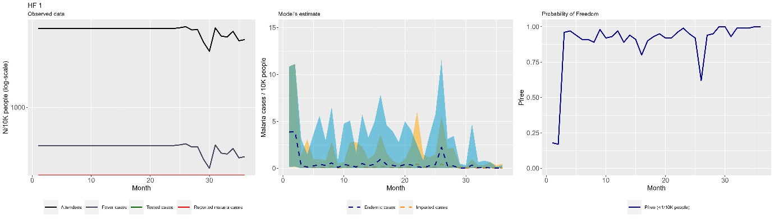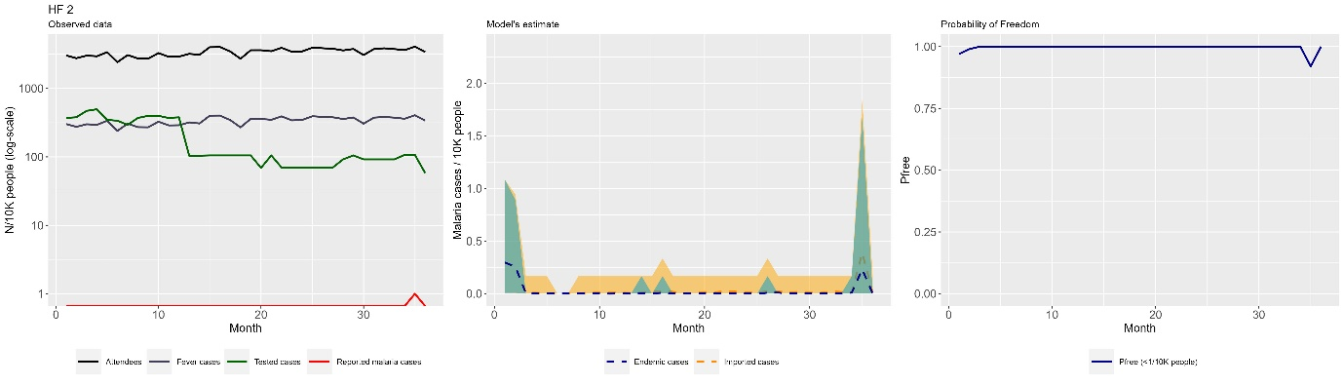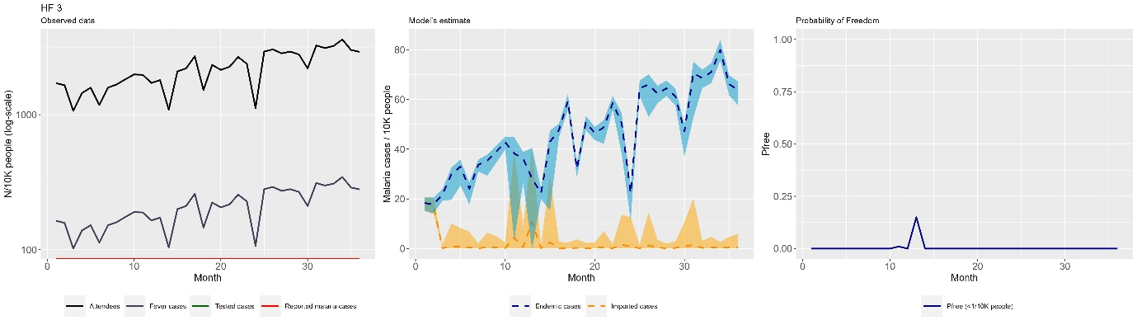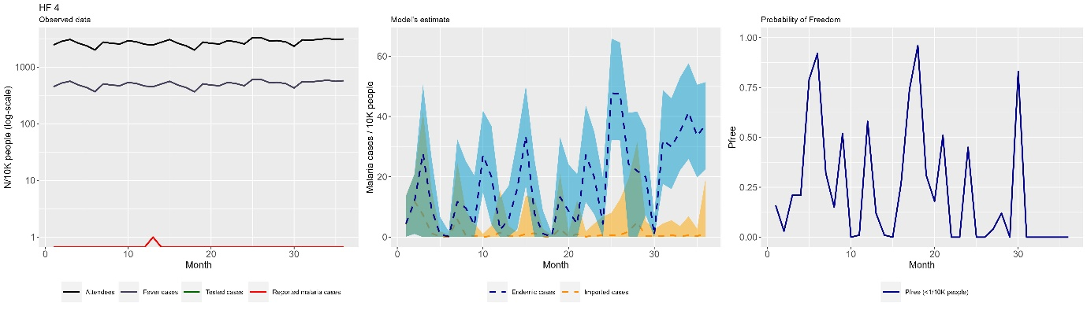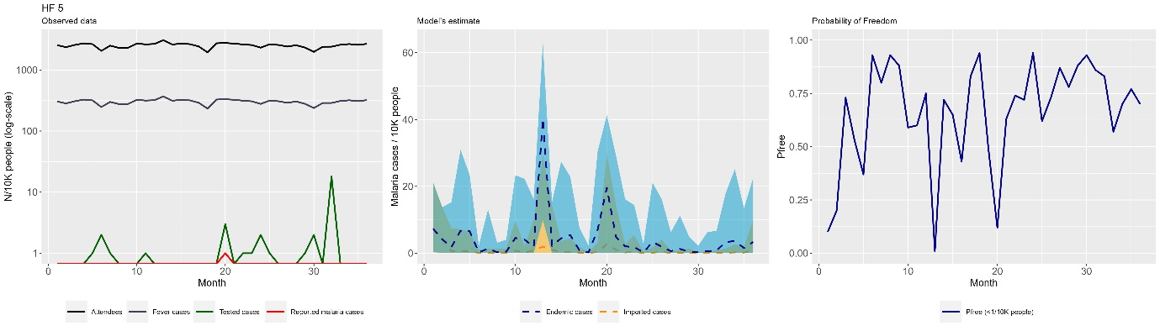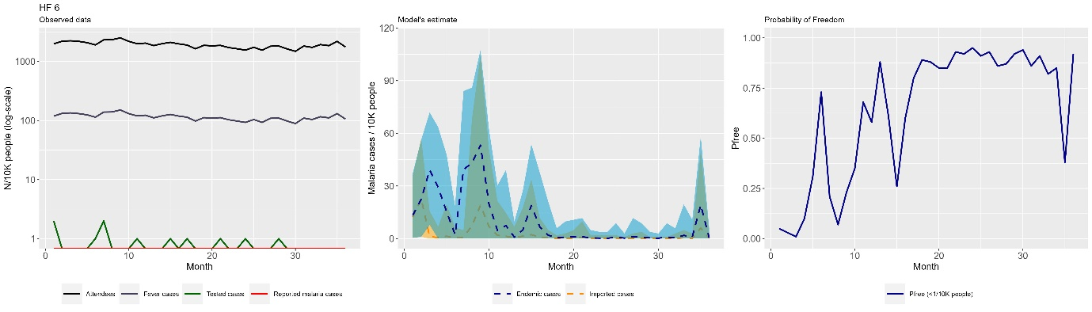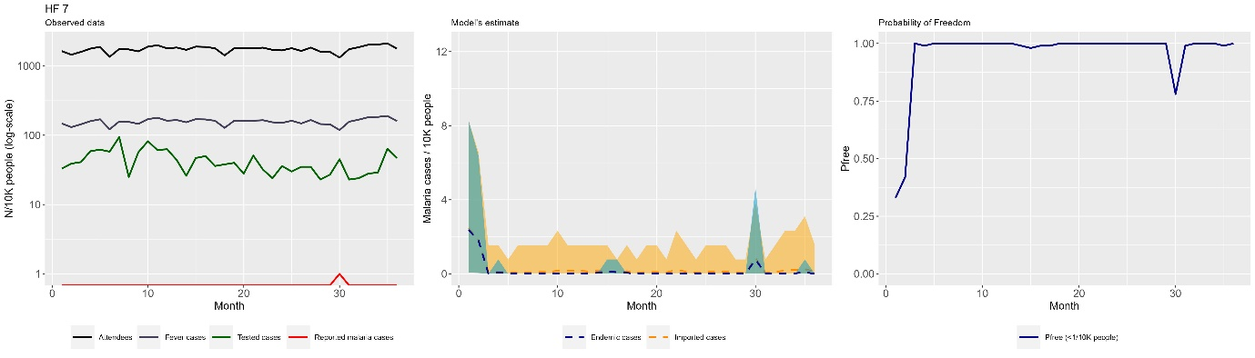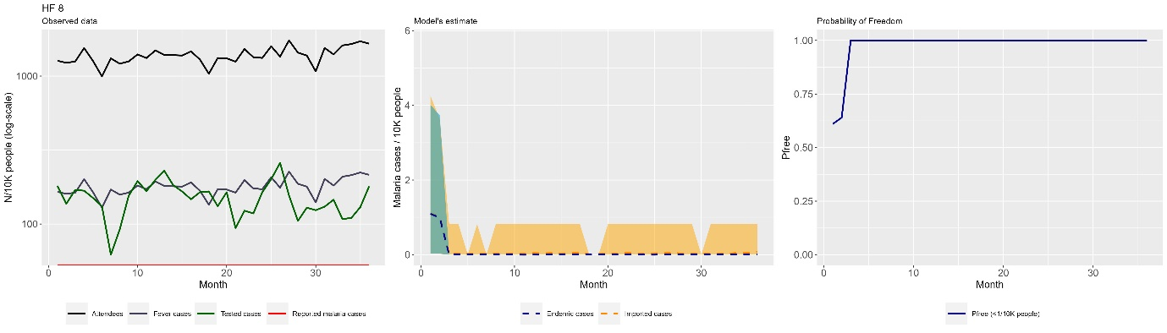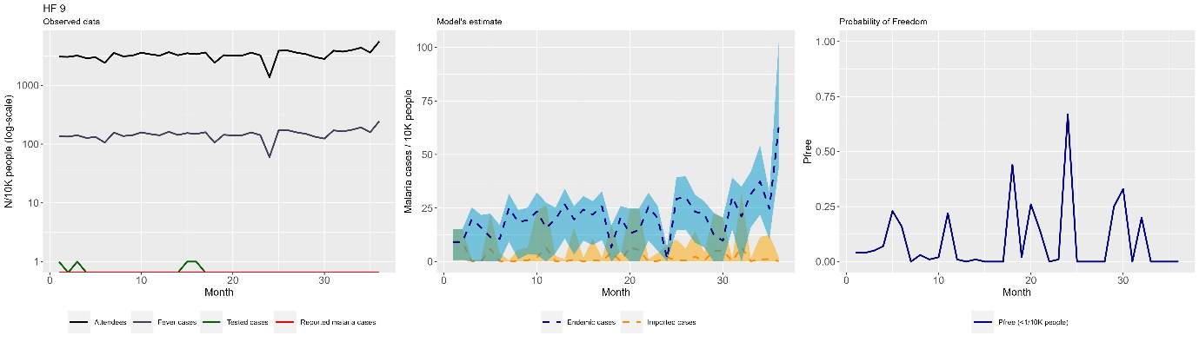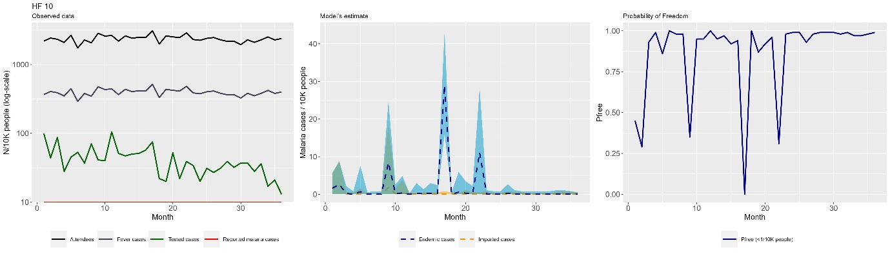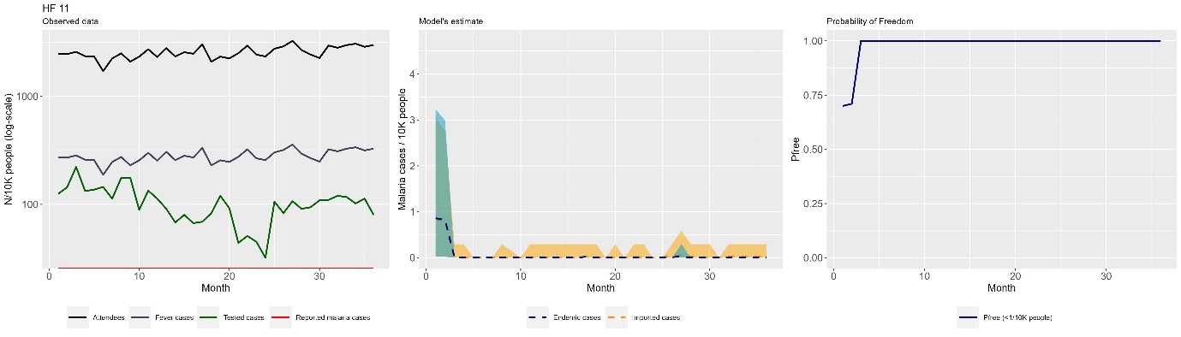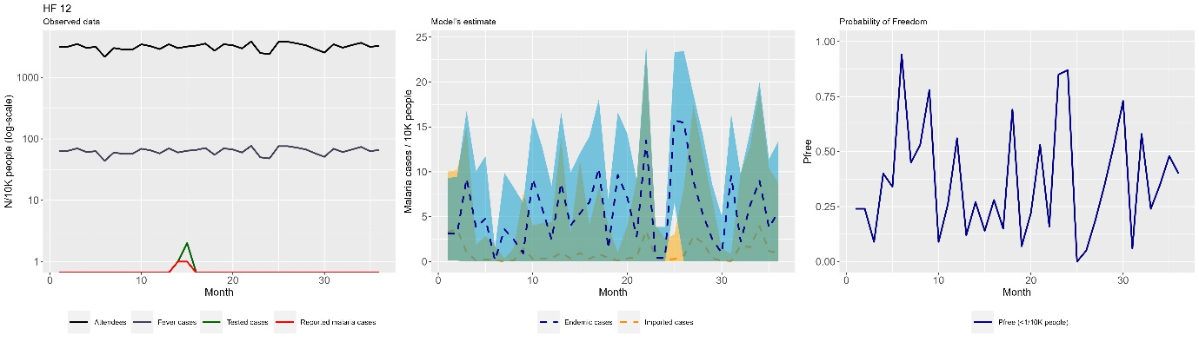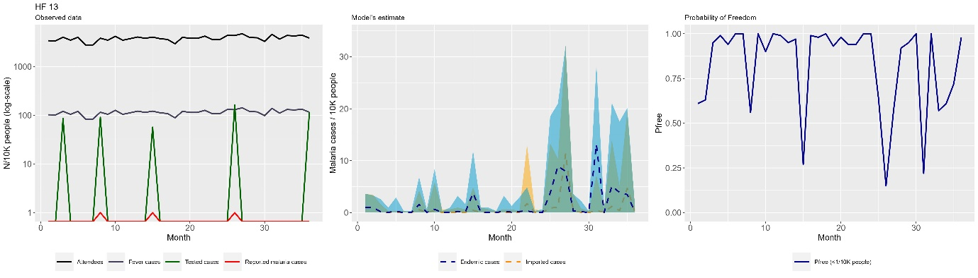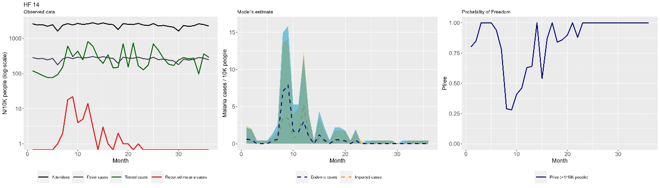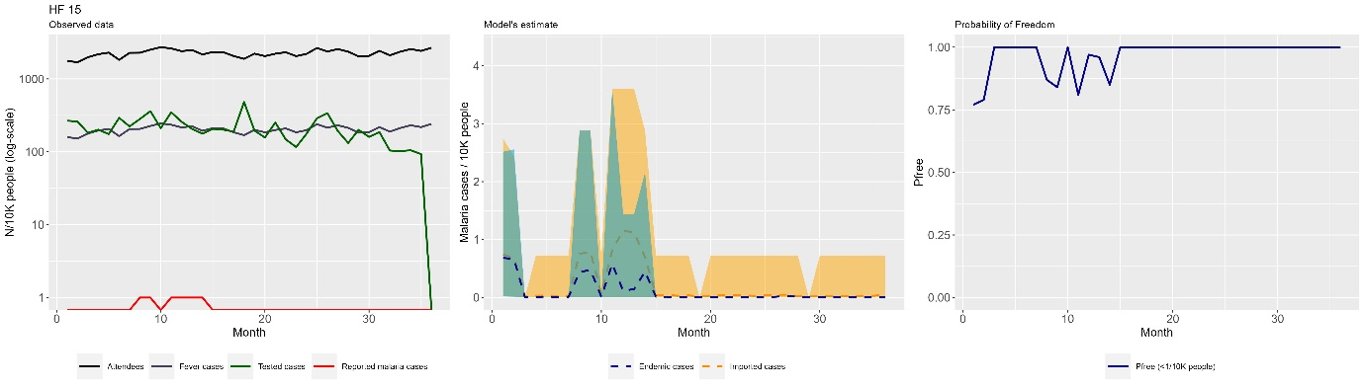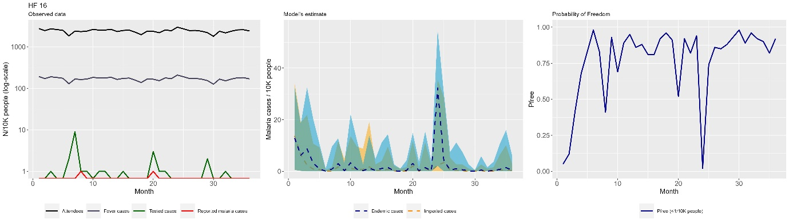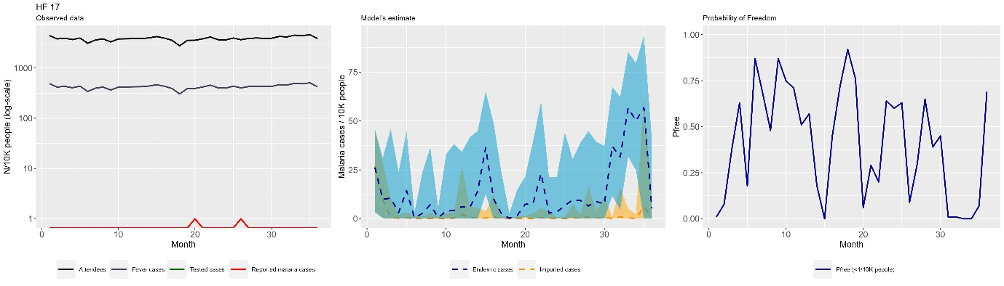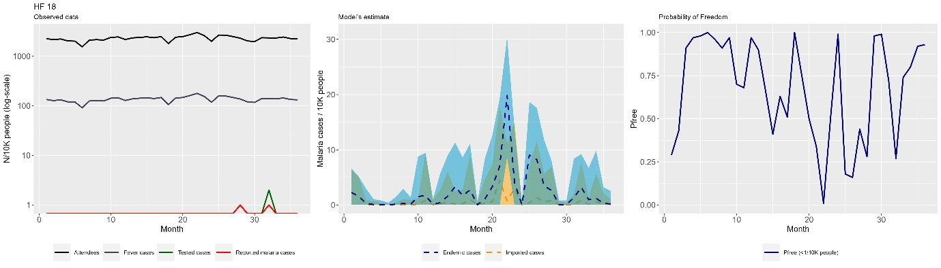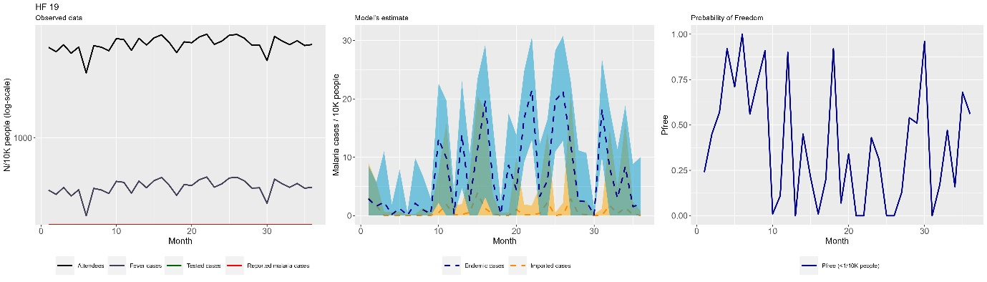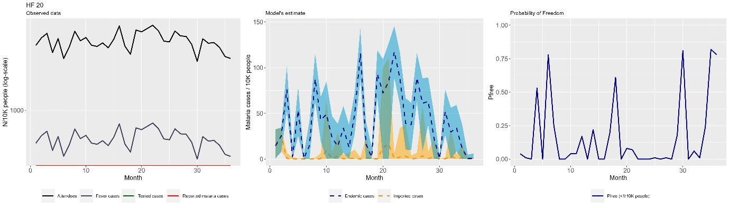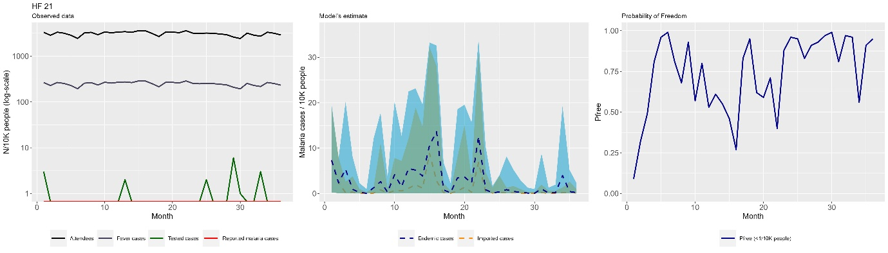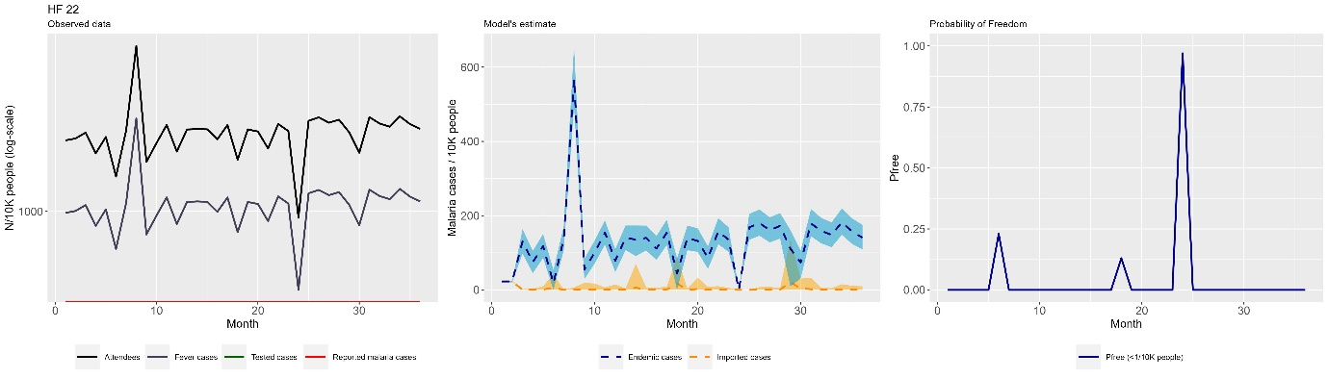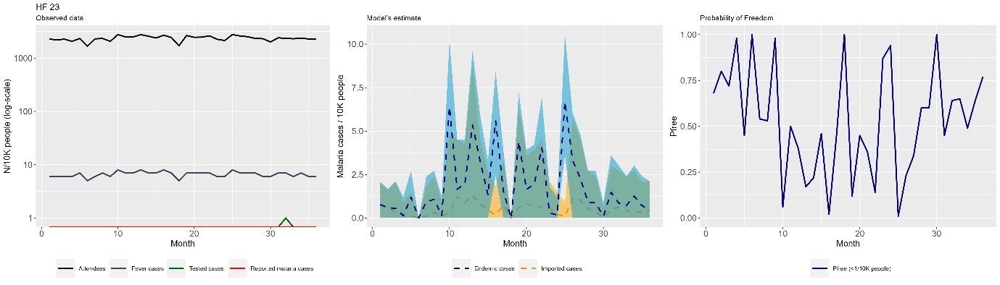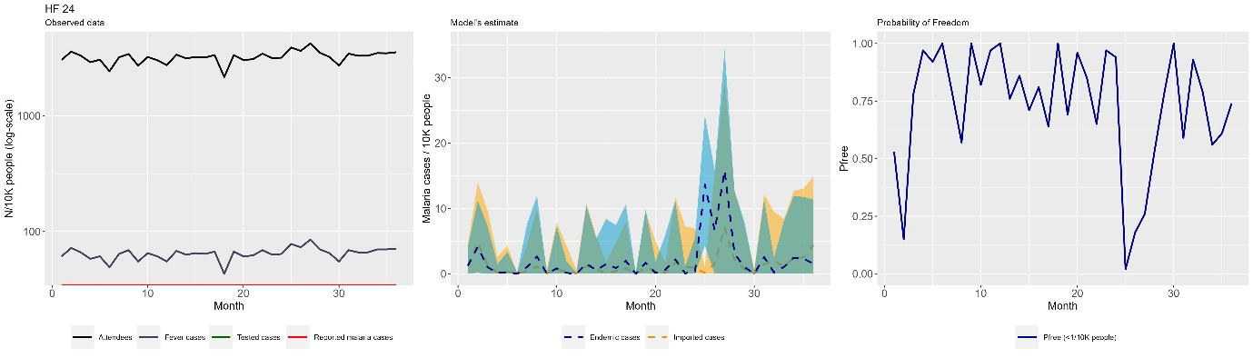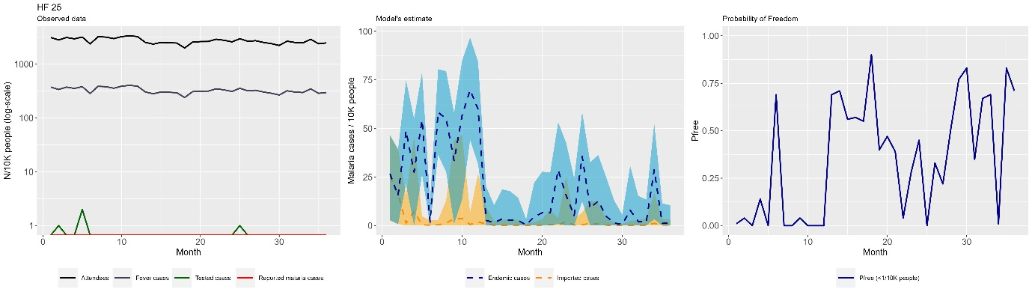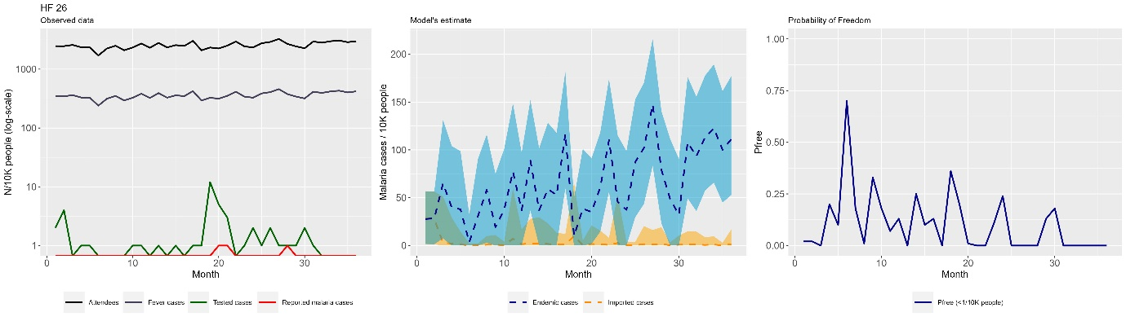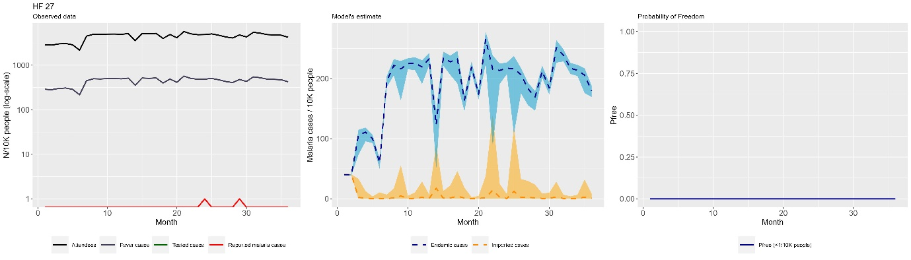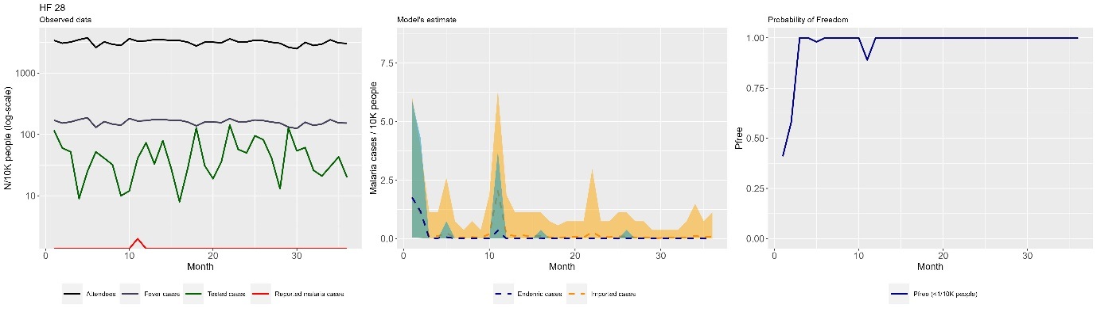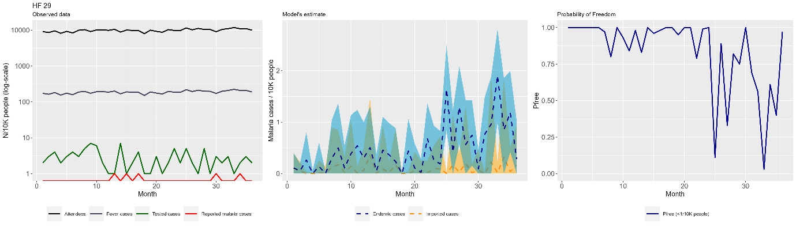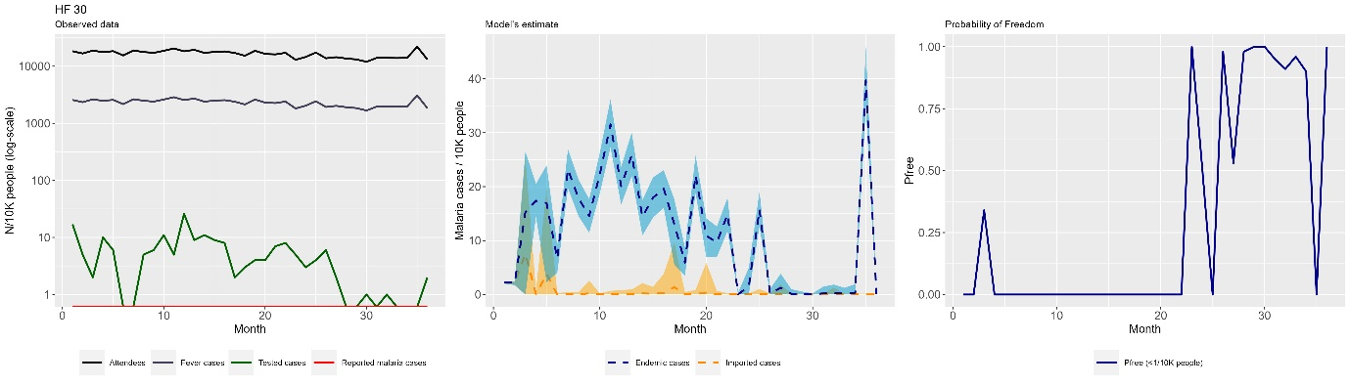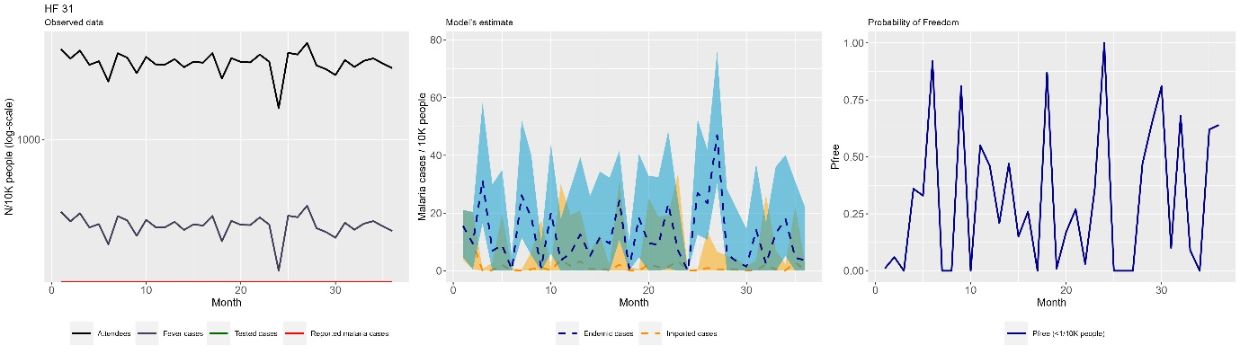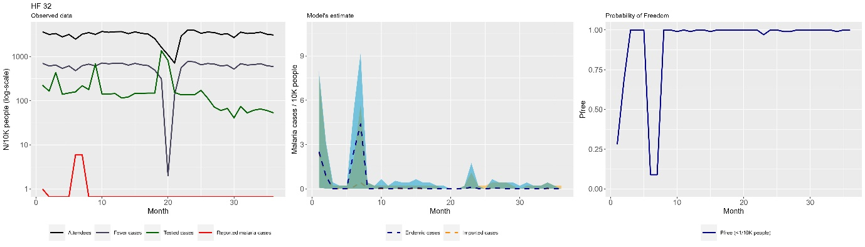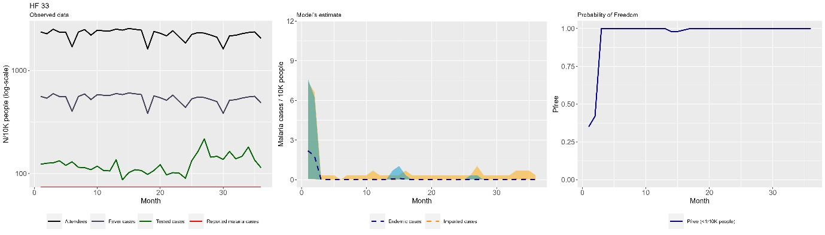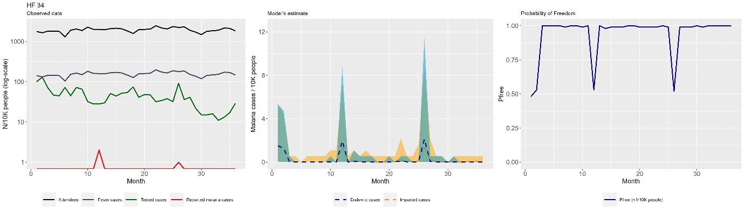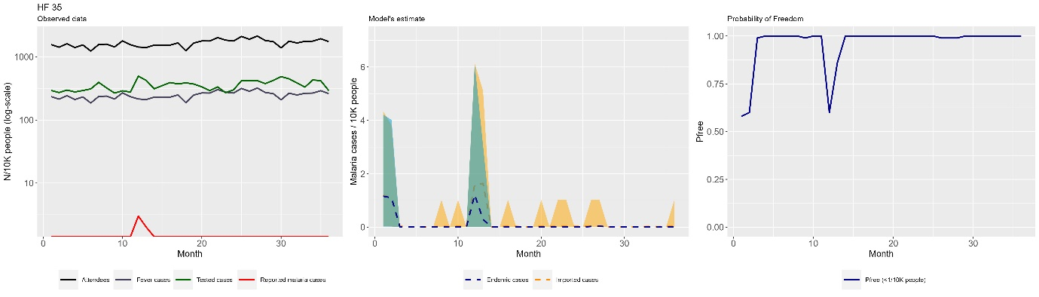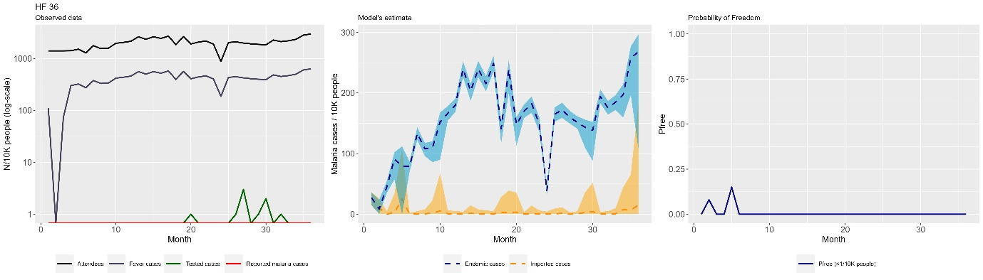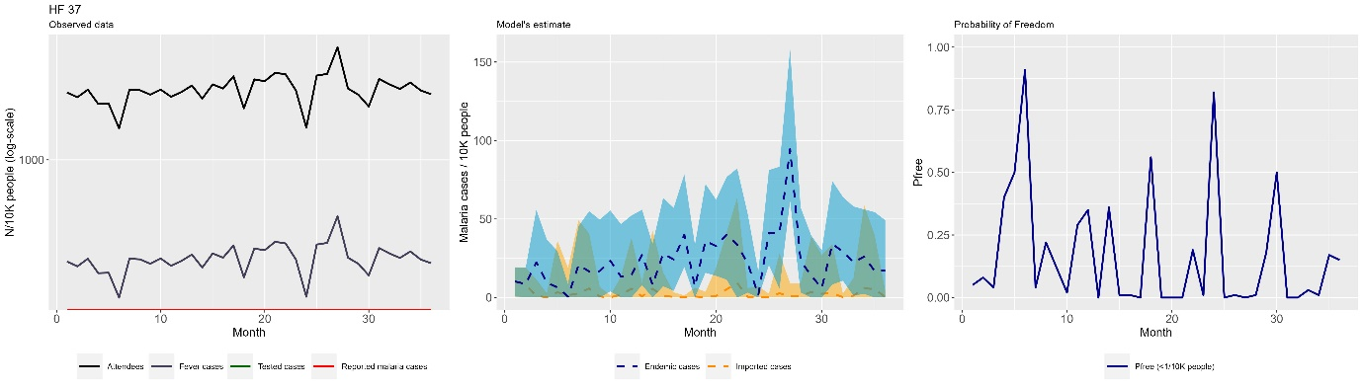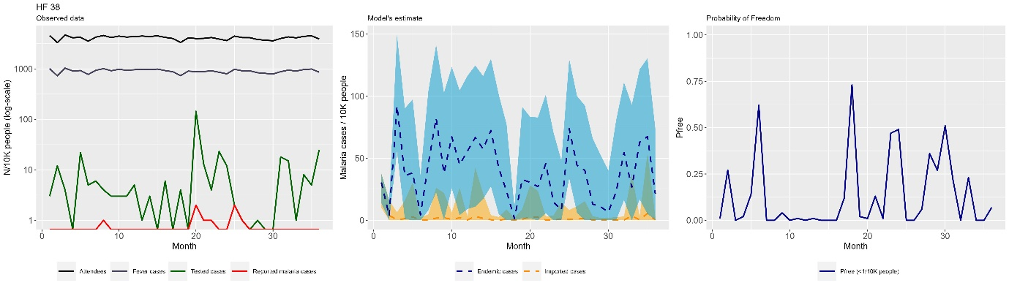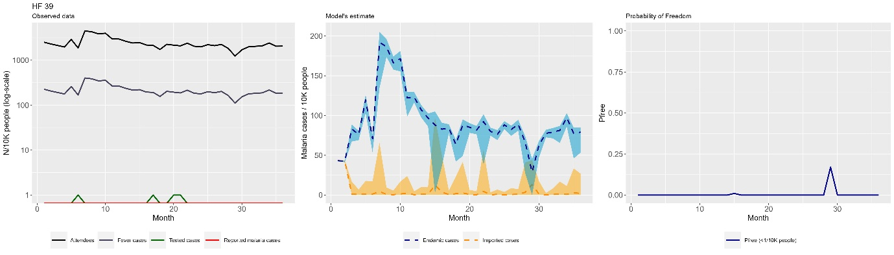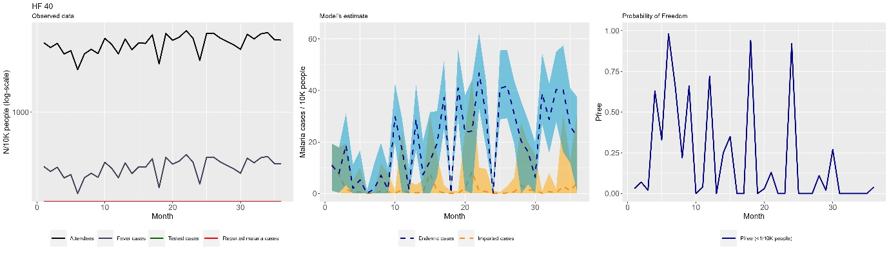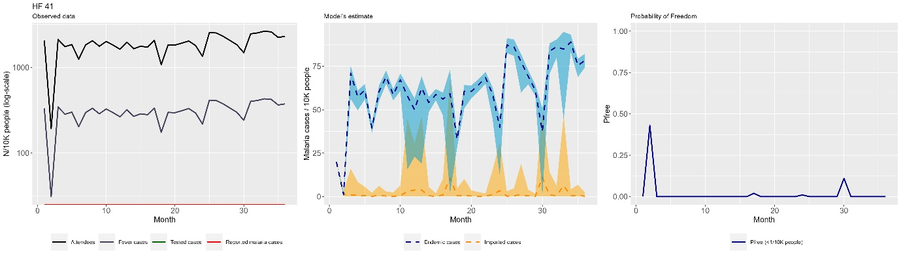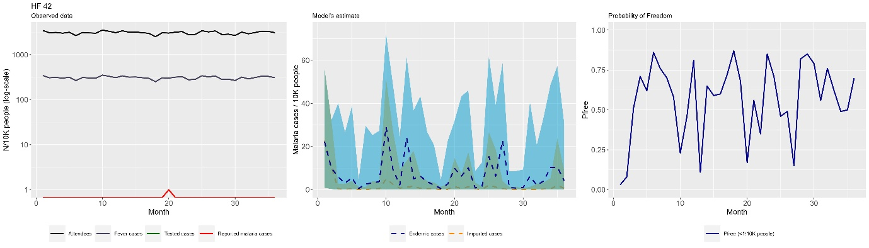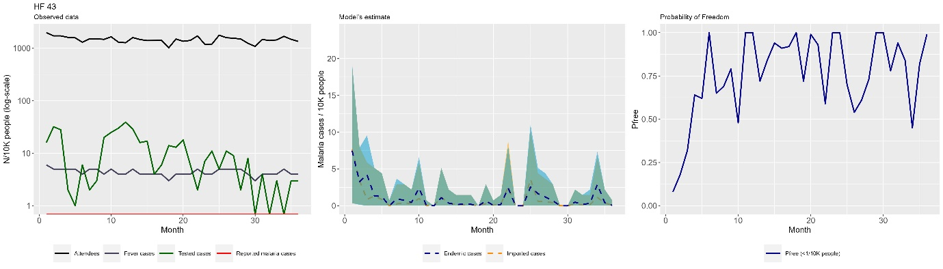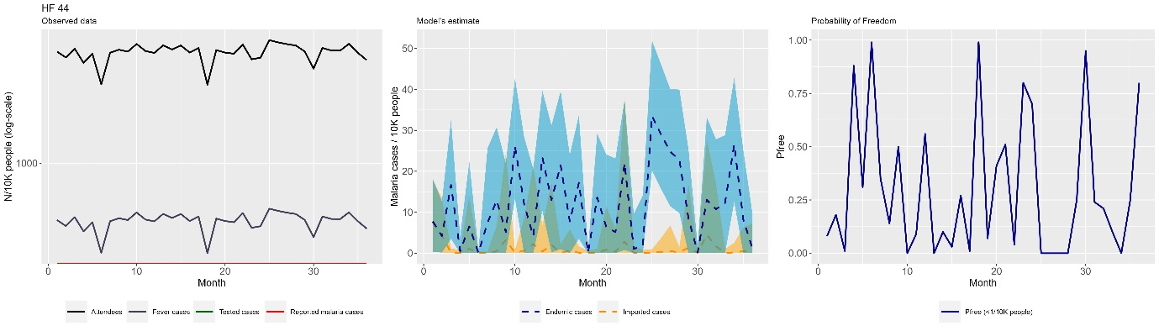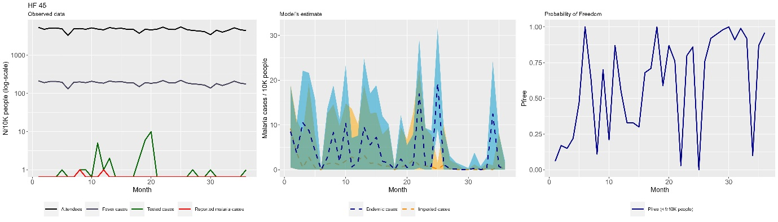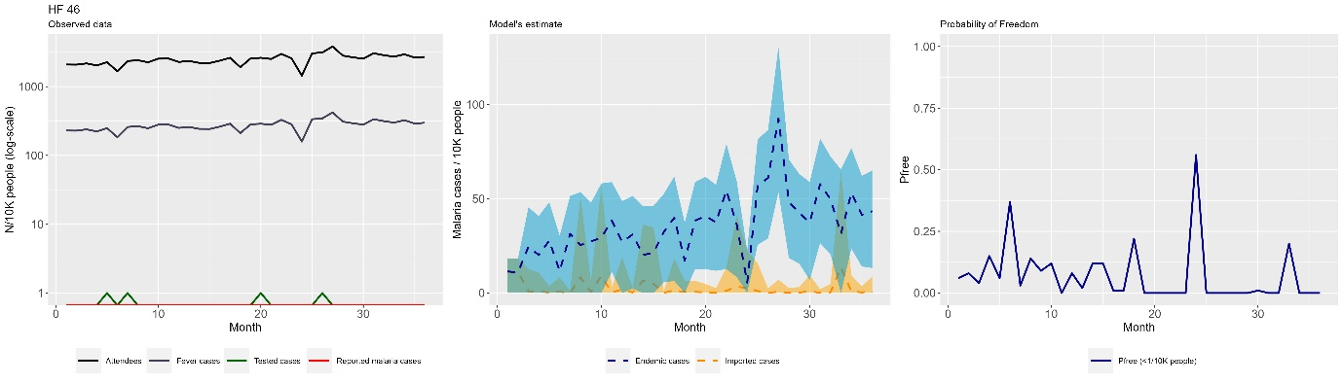

REFERENCES
1. Plummer M. JAGS: A program for analysis of Bayesian graphical models using Gibbs sampling. Proceedings of the 3rd international workshop on distributed statistical computing; 2003: Vienna, Austria; 2003. p. 125.
2. R Development Core Team. R: A language and environment for statistical computing. Vienna, Austria: R Foundation for Statistical Computing; 2022.
3. Plummer M, Stukalov A, Denwood M. rjags: Bayesian Graphical Models using MCMC. Version 4.6. Downloaded from https://cranr-projectorg/web/packages/rjags/indexhtml 2016.
4. Ahmad RA, Nelli L, Surendra H, et al. A framework for evaluating health system surveillance sensitivity to support public health decision-making for malaria elimination: a case study from Indonesia. BMC Infectious Diseases 2022; 22(1): 619.
5. Koepfli C, Nguitragool W, de Almeida ACG, et al. Identification of the asymptomatic Plasmodium falciparum and Plasmodium vivax gametocyte reservoir under different transmission intensities. 2021; 15(8): e0009672.
6. Weiss DJ, Nelson A, Gibson HS, et al. A global map of travel time to cities to assess inequalities in accessibility in 2015. Nature 2018; 553: 333.
7. Nelli L, Guelbeogo M, Ferguson HM, et al. Distance sampling for epidemiology: an interactive tool for estimating under-reporting of cases from clinic data. International Journal of Health Geographics 2020; 19: 1-14.
8. Rios-Zertuche D, Carter KH, Harris KP, et al. Performance of passive case detection for malaria surveillance: results from nine countries in Mesoamerica and the Dominican Republic. Malar J 2021; 20(1): 208.

