Supplementary Materials

Host phylogeny and environment shape the diversity of the salamander skin microbiome
Ramírez-Barahona S^{1,†}, González-Serrano FM^{2,†}, Martínez-Ugalde E², Soto-Pozos A^{2,3}, Parra-Olea G³, Rebollar EA^{2,}*

- This PDF file contains supplementary table S1–S4 and figures S1–S6.
- Supplementary data can be found in the accompanying files.

Supplementary data 1.Metadata for sampled salamander individuals.
Supplementary data 2. Relative abundances (per host) of shared bacterial orders.
Supplementary data 3. Relative abundances (per host) of shared bacterial families.
Supplementary data 4. Results of the LefSE analyses by host habitat.
Supplementary data 5. Results of the LefSE analyses by host family.
Supplementary data 6. Dated salamander phylogeny based on the best-scoring maximum likelihood tree.
Supplementary data 7. Fossil calibration list used to date the salamander phylogeny.

All other data is available at https://github.com/spiritu-santi/salamanders

Supplementary table S1. Fixed and random effects of climatic and host factors on alpha diversity estimated using Linear Mixed Models. The reference level for salamander family is Ambystomatidae and the reference level for host habitat is aquatic.
Type of effect | Term | Estimate | Std error | t statistic | Lower CI | Upper CI
fixed | Intercept | 4.02 | 0.56 | 7.22 | 2.93 | 5.11
fixed | Maximum temperature | 0.03 | 0.09 | 0.40 | -0.13 | 0.20
fixed | Precipitation | 0.16 | 0.08 | 1.92 | 0.00 | 0.32
fixed | elevation | 0.09 | 0.26 | 0.35 | -0.42 | 0.61
fixed | bio8 | -0.07 | 0.14 | -0.48 | -0.33 | 0.20
fixed | bio9 | -0.11 | 0.18 | -0.60 | -0.46 | 0.25
fixed | bio12 | -0.12 | 0.19 | -0.65 | -0.49 | 0.24
fixed | bio17 | -0.39 | 0.20 | -1.95 | -0.78 | 0.00
fixed | bio19 | -0.06 | 0.21 | -0.26 | -0.47 | 0.36
fixed | Terrestrial | 0.81 | 0.20 | 3.96 | 0.41 | 1.21
fixed | Cryptobranchidae | 2.12 | 0.84 | 2.52 | 0.47 | 3.76
fixed | Hynobiidae | -1.66 | 1.23 | -1.35 | -4.06 | 0.75
fixed | Plethodontidae | 1.36 | 0.67 | 2.04 | 0.05 | 2.66
fixed | Salamandridae | 1.42 | 0.65 | 2.18 | 0.14 | 2.69
random | Study | 0.77
random | Residual | 1.45

Supplementary table S2. Effect-sizes obtained with the distance based redundancy analyses of microbial beta diversity as a function of climate and host factors using the weighted Unifrac (wUF) distance matrix.
Term | Df | Sum of Squares | Pseudo-F | p-value
bio2 | 1 | 27.88 | 27.94 | 0.001
Host family | 4 | 108.67 | 27.22 | 0.001
bio16 | 1 | 26.38 | 26.43 | 0.001
bio19 | 1 | 25.37 | 25.43 | 0.001
bio8 | 1 | 21.99 | 22.03 | 0.001
bio9 | 1 | 19.89 | 19.93 | 0.001
bio17 | 1 | 18.48 | 18.52 | 0.001
Monthly precipitation | 1 | 16.13 | 16.17 | 0.001
Host habitat | 1 | 14.94 | 14.98 | 0.001
bio18 | 1 | 12.65 | 12.68 | 0.001
bio7 | 1 | 10.92 | 10.94 | 0.001
bio1 | 1 | 10.09 | 10.11 | 0.001
Maximum temperature | 1 | 5.51 | 5.52 | 0.001

Supplementary table S3. Effect-sizes obtained with the distance based redundancy analyses of microbial beta diversity as a function of climate and host factors using the unweighted Unifrac (uwUF) distance matrix.
Term | Df | Sum of Squares | Pseudo-F | p-value
bio2 | 1 | 5.83 | 18.9824 | 0.001
bio9 | 1 | 4.88 | 15.8940 | 0.001
Host family | 4 | 16.43 | 13.3708 | 0.001
bio8 | 1 | 3.77 | 12.2777 | 0.001
bio16 | 1 | 3.72 | 12.0991 | 0.001
bio17 | 1 | 3.67 | 11.9462 | 0.001
Host habitat | 1 | 3.38 | 11.0158 | 0.001
bio18 | 1 | 2.49 | 8.1175 | 0.001
bio19 | 1 | 2.45 | 7.9809 | 0.001
bio7 | 1 | 2.29 | 7.4476 | 0.001
Monthly precipitation | 1 | 1.94 | 6.3284 | 0.001
bio1 | 1 | 1.53 | 4.9805 | 0.001
Monthly maximum temperature | 1 | 1.27 | 4.1273 | 0.001

Supplementary figures
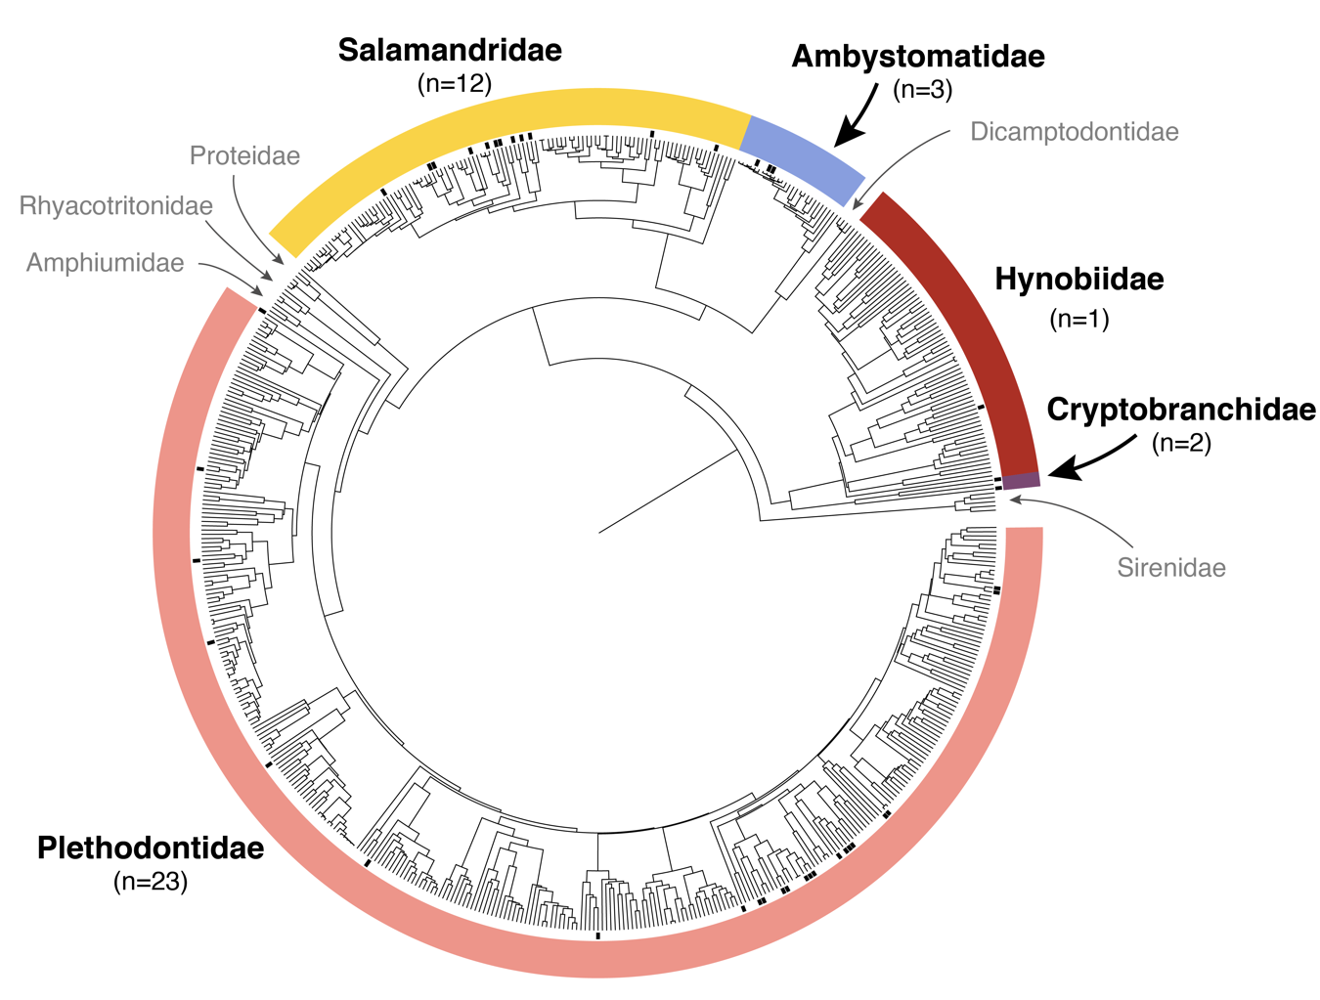
Supplementary figure S1. Species-level phylogeny for salamanders. Black squares at the tips of the phylogeny depict the salamander species with available skin microbiome data. Outer circle depicts the ten recognized salamander families and the names in bold represent families with available skin microbiome data (n = number of species with data).

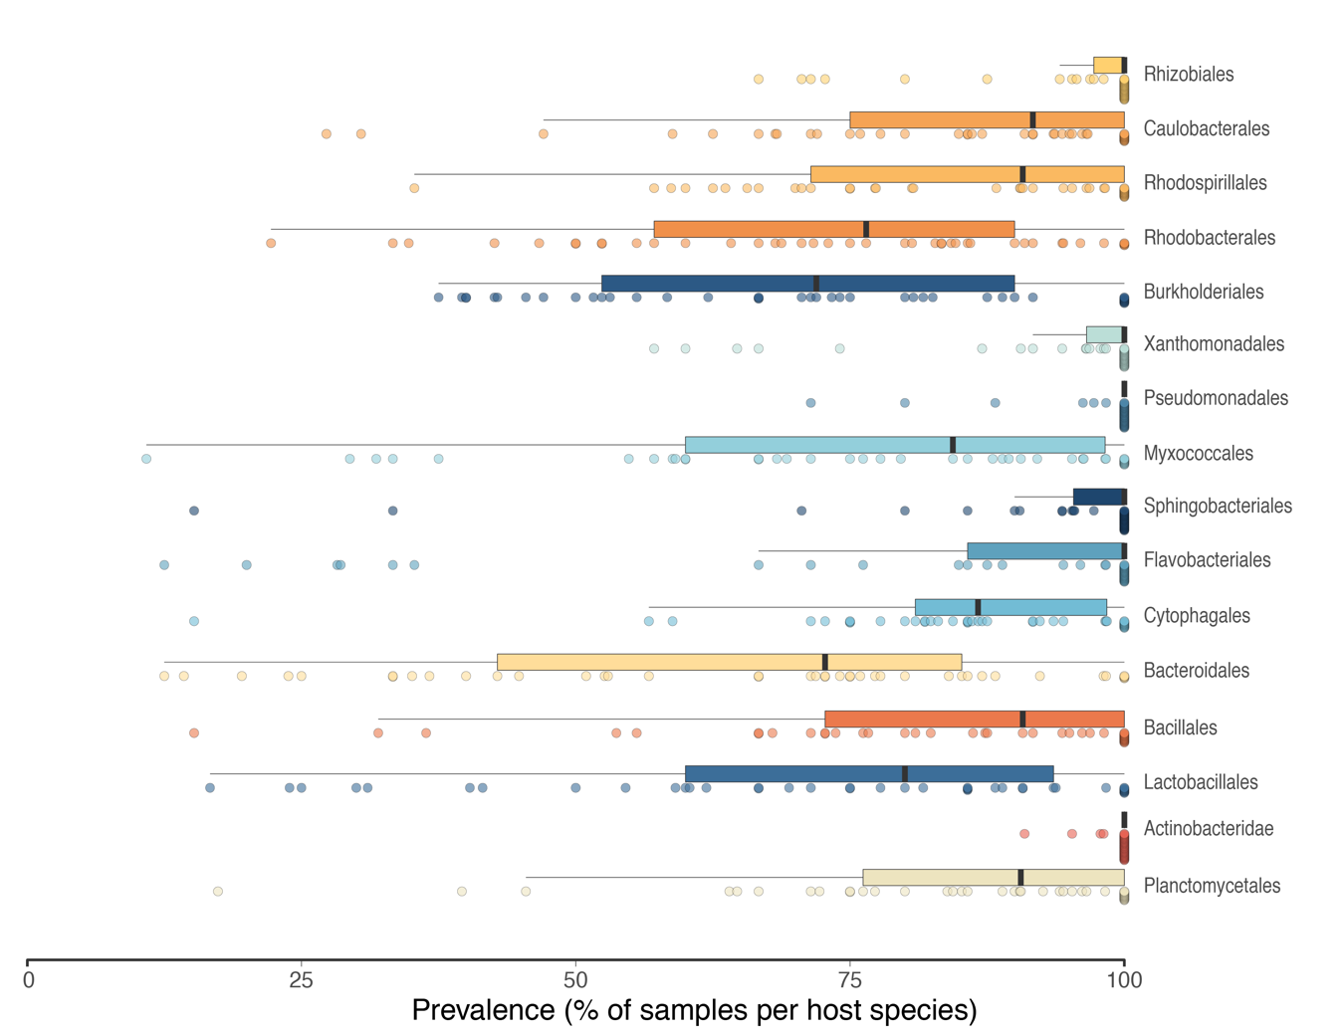
Supplementary figure S2. Prevalence of skin bacterial taxa (orders) shared among all salamander host species. Boxplots depict the distribution of estimated prevalence of the 16 shared bacterial orders across salamander host species. Filled circles correspond to bacterial prevalence estimated within each salamander host species.

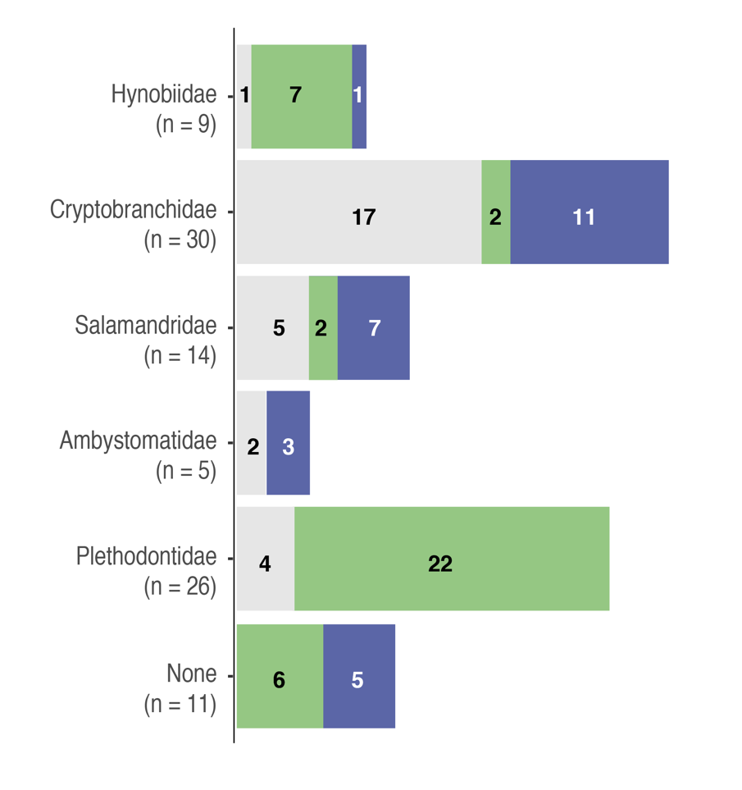
Supplementary figure S3. Enriched skin bacterial orders in each salamander host family. Bar plots depict the number of bacterial orders (n) identified as being enriched in each salamander family and colours depict the number of orders enriched in different host habitats (green = terrestrial; blue = aquatic; grey = none).

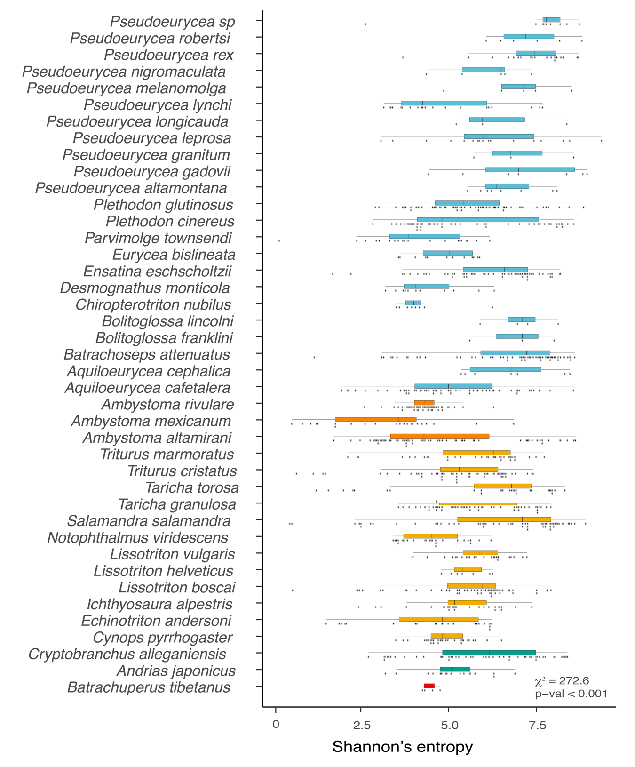
Supplementary figure S4. Skin microbial diversity of salamander species. Boxplots depicting the distribution of Shannon’s entropy estimates for skin microbiomes sampled across 41 salamander host species. Filled circles represent Shannon’s entropy estimated for each sampled individual. Salamander species are arranged following the phylogeny presented in figure 1.

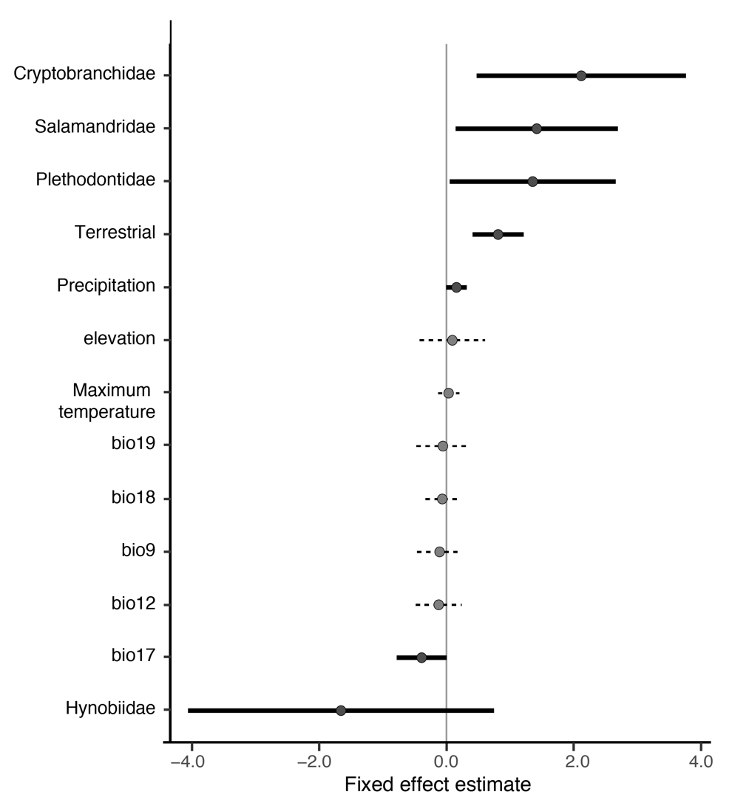
Supplementary figure S5. Influence of climatic and host factors on the alpha diversity of the salamander skin microbiota. a, fixed effects of climatic and host factors on alpha diversity estimated using Linear Mixed Models. Horizontal lines represent the confidence interval (95%) for individual fixed effects, with solid and dashed lines indicating significant and non-significant effects, respectively. The reference level for salamander family is Ambystomatidae and the reference level for host habitat is aquatic.

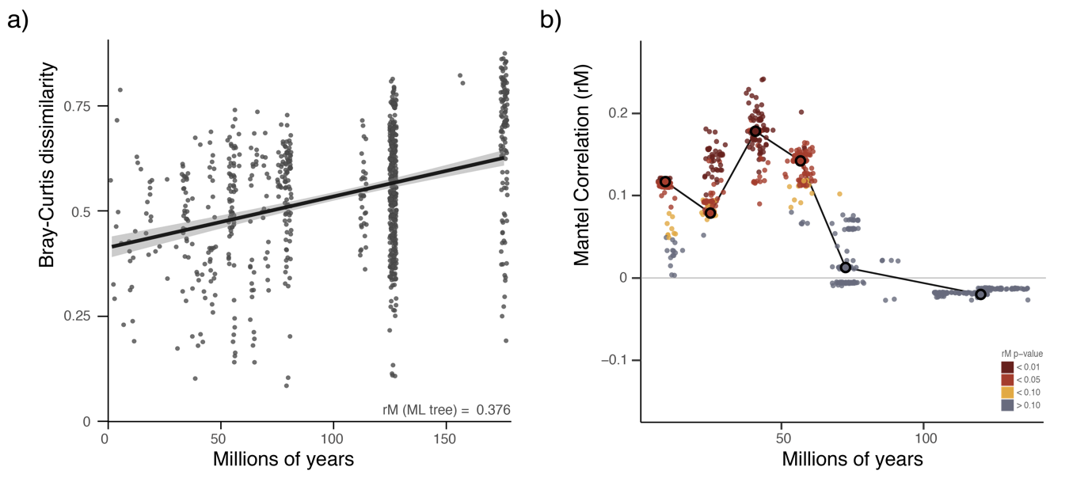
Supplementary figure S6. Association between host phylogenetic distances on microbial dissimilarity of the salamander skin microbiota. a) Microbial dissimilarity (Y-axis) at the family level as a function of host evolutionary distances (X-axis) estimated by fossil-based molecular dating of the best-scoring ML tree. The solid black line represents the slope estimated with a Mantel test between matrices. b) Correlogram showing the variation in the Mantel correlation coefficients across distance classes. Squares connected by a solid black line represent the correlations estimated with the best-scoring ML tree. Small circles represent the correlations estimated with evolutionary distances using the fossil-based molecular dating of the bootstrap trees. Colours are indicative of the corresponding p-values of correlations.

