Supplementary Material
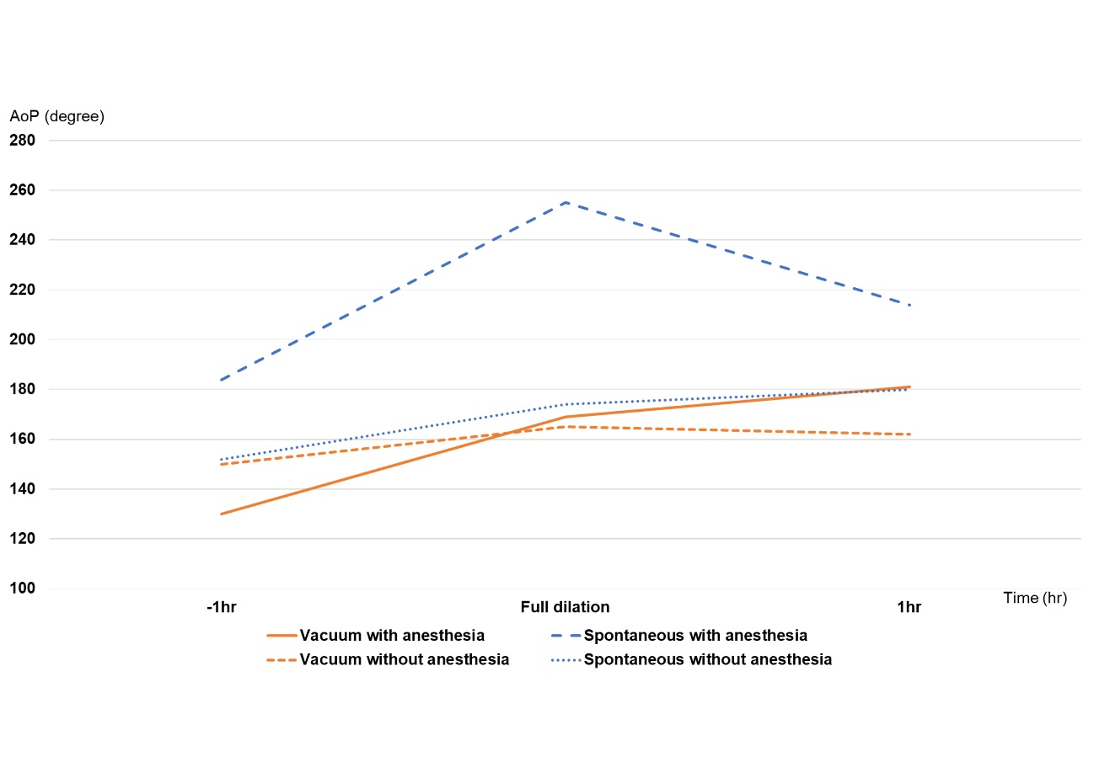
Supplementary Figure 1. This graph shows the intrauterine pressure. The horizontal axis represents time, and the vertical axis represents the Montevideo units. The group that had epidural anesthesia and delivered spontaneously had higher intrauterine pressure than the other groups.

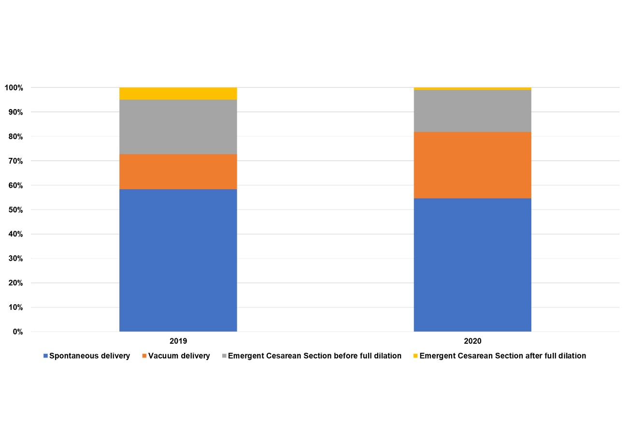
(A)
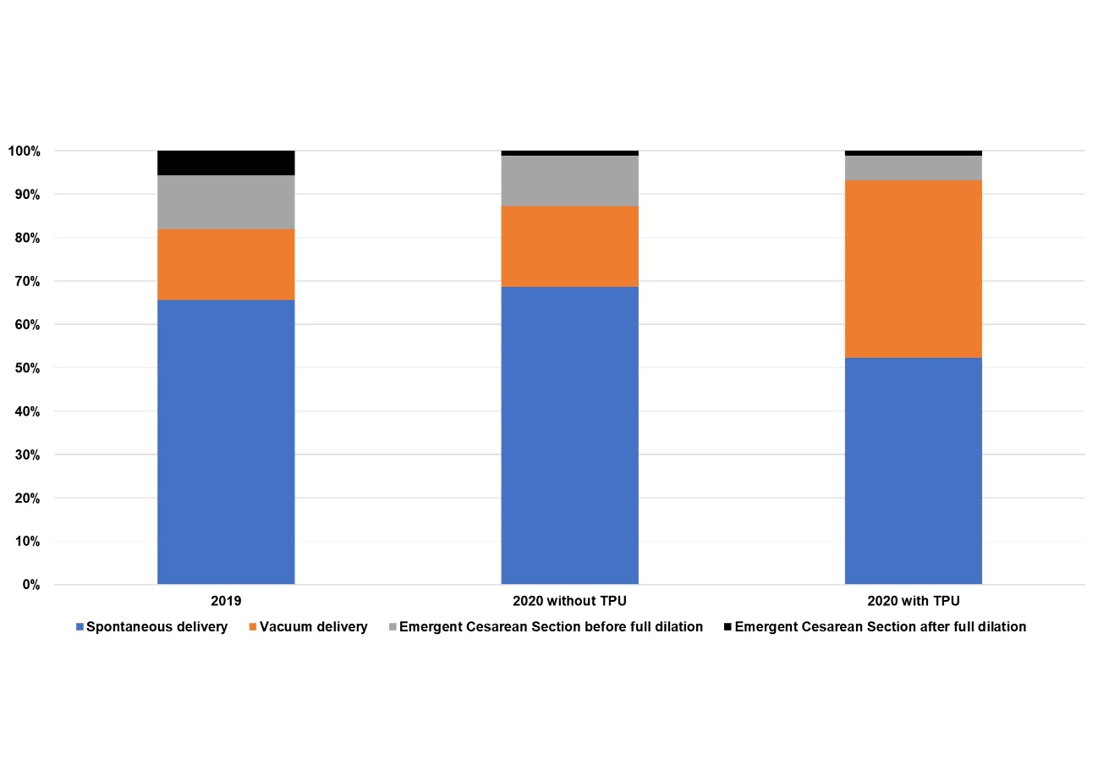
(B)
Supplementary Figure 2A. This graph shows that the rate of vaginal deliveries increased from 2019 to 2020. The graphs show the mode of delivery in 2019 and 2020. Transvaginal and vacuum deliveries increased.
Supplementary Figure 2B. This graph shows the mode of delivery in 2019, 2020 without TPU, and 2020 with TPU. When separated with or without TPU, the graph compositions of 2020 without TPU and 2019 were similar.

