Supplementary Tables
Table S1: Number of total barcode reads (x10⁶).
Cell line |  | MCF7 |  |  |  | T47D
Treatment |  | Initial | +E2 | TAMR | LTED | Initial | +E2 | TAMR | LTED
Replicate | 1 | 15.71 | 14.60 | 14.43 | 13.18 | 12.27 | 8.42 | 13.08 | 9.98
Replicate | 2 | 15.61 | 14.61 | 20.75 | 15.59 | 18.50 | 12.67 | 11.67 | 8.52
Replicate | 3 | 15.06 | 14.79 | 13.83 | 11.56 | 13.90 | 11.77 | 9.77 | 9.43
Replicate | 4 | 12.80 | 11.05 | 16.78 | 13.30 | 23.35 | 10.56 | 5.90 | 8.72
Replicate | 5 | 12.66 | 12.40 | 23.92 | 12.57 | 13.07 | 8.36 | 9.74 | 9.14

Supplementary Figures
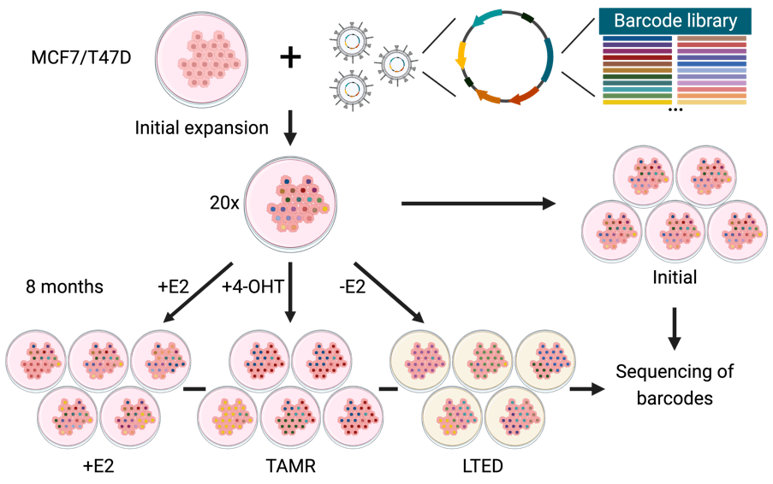
Figure S1: Bulk barcoding overview. MCF7 and T47D cells were transduced with the ClonTracer library ²⁴ at an MOI of 0.05. Purmocyin was used for selection and successfully transduced cells were initially expanded. Then, three different treatment conditions of five biological replicates were each established. One set of cells was kept under control growth conditions (+E2), treated with 4-hydroxytamoxifen (4-OHT) or deprived of estrogen (-E2) for eight months. Treatment with 4-OHT and estrogen deprviation (-E2) yielded Tamoxifen resistant (TAMR) and long-term estrogen deprived (LTED) cell lines, respectively. Addtionally, five biological replicates (Initial) were utilized without further treatment to assess the complexity of the transduced barcode libraries. Created with BioRender.com.
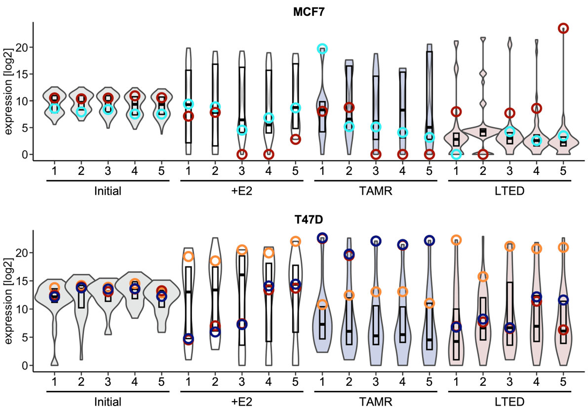
Figure S2: Barcode sequencing of replicates reveals an even barcode representation in the initial population, depletion of most, and enrichment of few barcodes after prolonged cultivation. Genomic DNA was isolated from barcoded MCF7 and T47D replicate cultures of the different conditions, i.e., initial cell pools (Initial), cells cultivated in media with estrogen (+E2), treated with 4-OHT (TAMR) or treated without estrogen (LTED). Then barcodes were PCR-amplified and sequenced. Violin plots of barcode reads whose sum were at least 5x10⁵ in all replicates are shown. Whisker plots represent the 25-75th percentile. For MCF7, one of the top five most enriched barcodes (bright blue) in the TAMR_1 replicate and the most enriched barcode for the LTED_5 replicate (red) are depicted. For T47D, the recurrently enriched orange (+E2 and LTED) and dark blue and dark red (TAMR replicates) barcodes are depicted. Color coding is according to Figure 1C.
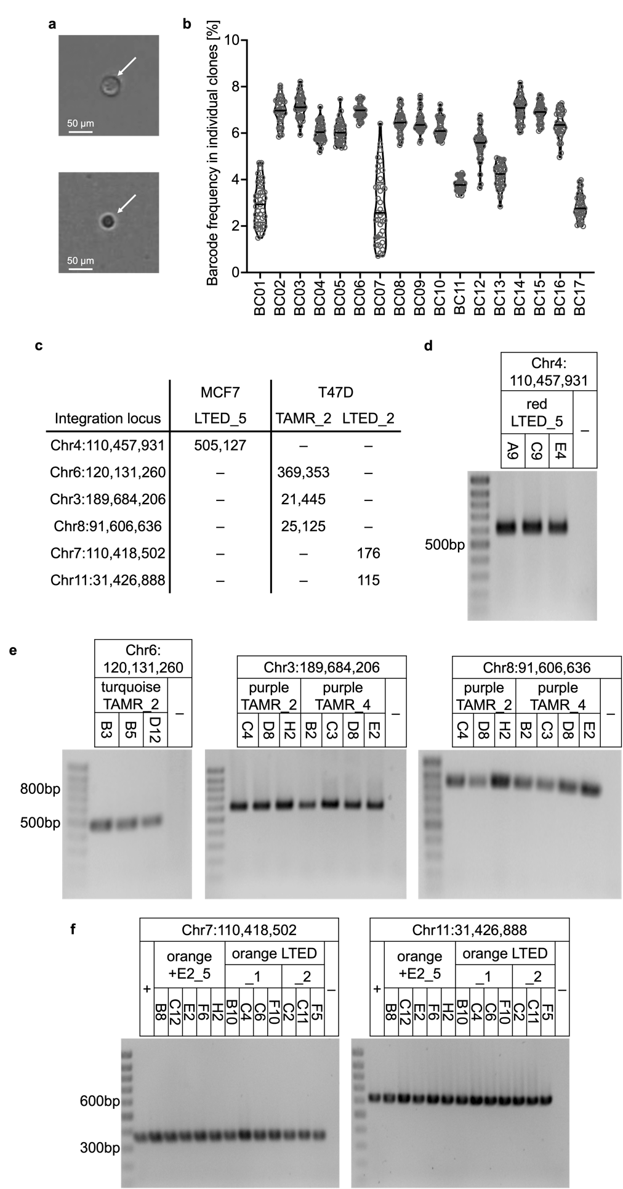
Figure S3: Verification of barcode integration sites in MCF7 and T47D clones. Single cells were sorted from selected replicates, spotted into 96well plates, and cultivated until clones had grown out. a Representative cell during spotting (top) and after having attached in a 96 well plate (bottom). b Sequencing of 37 individual clones isolated from the MCF7 blue TAMR_1 replicate finds 17 integration events (BC01-BC17) as depicted in violin plots for each sequenced barcode. c Barcode integration sites were identified for selected replicates with LAM-PCR ²⁹ followed by sequencing. These integration sites were associated with specific barcodes based on read count data. -: Integration site not found. Verification of integration sites was done by amplification of barcodes using primers extending into the respective genomic loci in (d) MCF7 red LTED_5 clones, (e) T47D light blue and purple TAMR clones, and (f) T47D orange clones. d-f: +: Positive control (T47D LTED_2 pool). -: H₂O.
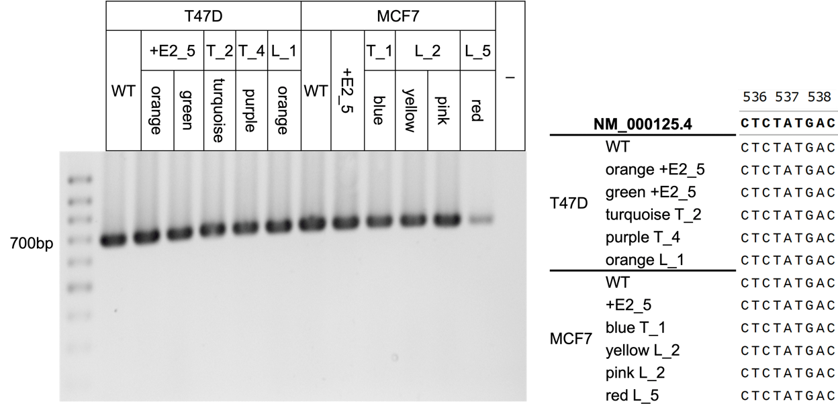
Figure S4: Endocrine therapy resistance is not driven by ESR1 hotspot mutations. Genomic sequence covering the ESR1 hotspot codons 536-538 (Reference sequence: NM_000125.4) was PCR-amplified from control cell lines and single clones representing each of the different isolated populations (left panel), and then subjected to Sanger sequencing (right panel). Sequences were aligned using Snapgene with NM_000125.4. WT: respective non-barcoded T47D and MCF7 cell lines. T_2: TAMR_2. T_4: TAMR_4. L_1: LTED_1. T_1: TAMR_1. L_2: LTED_2. L_5: LTED_5. -: H₂O.

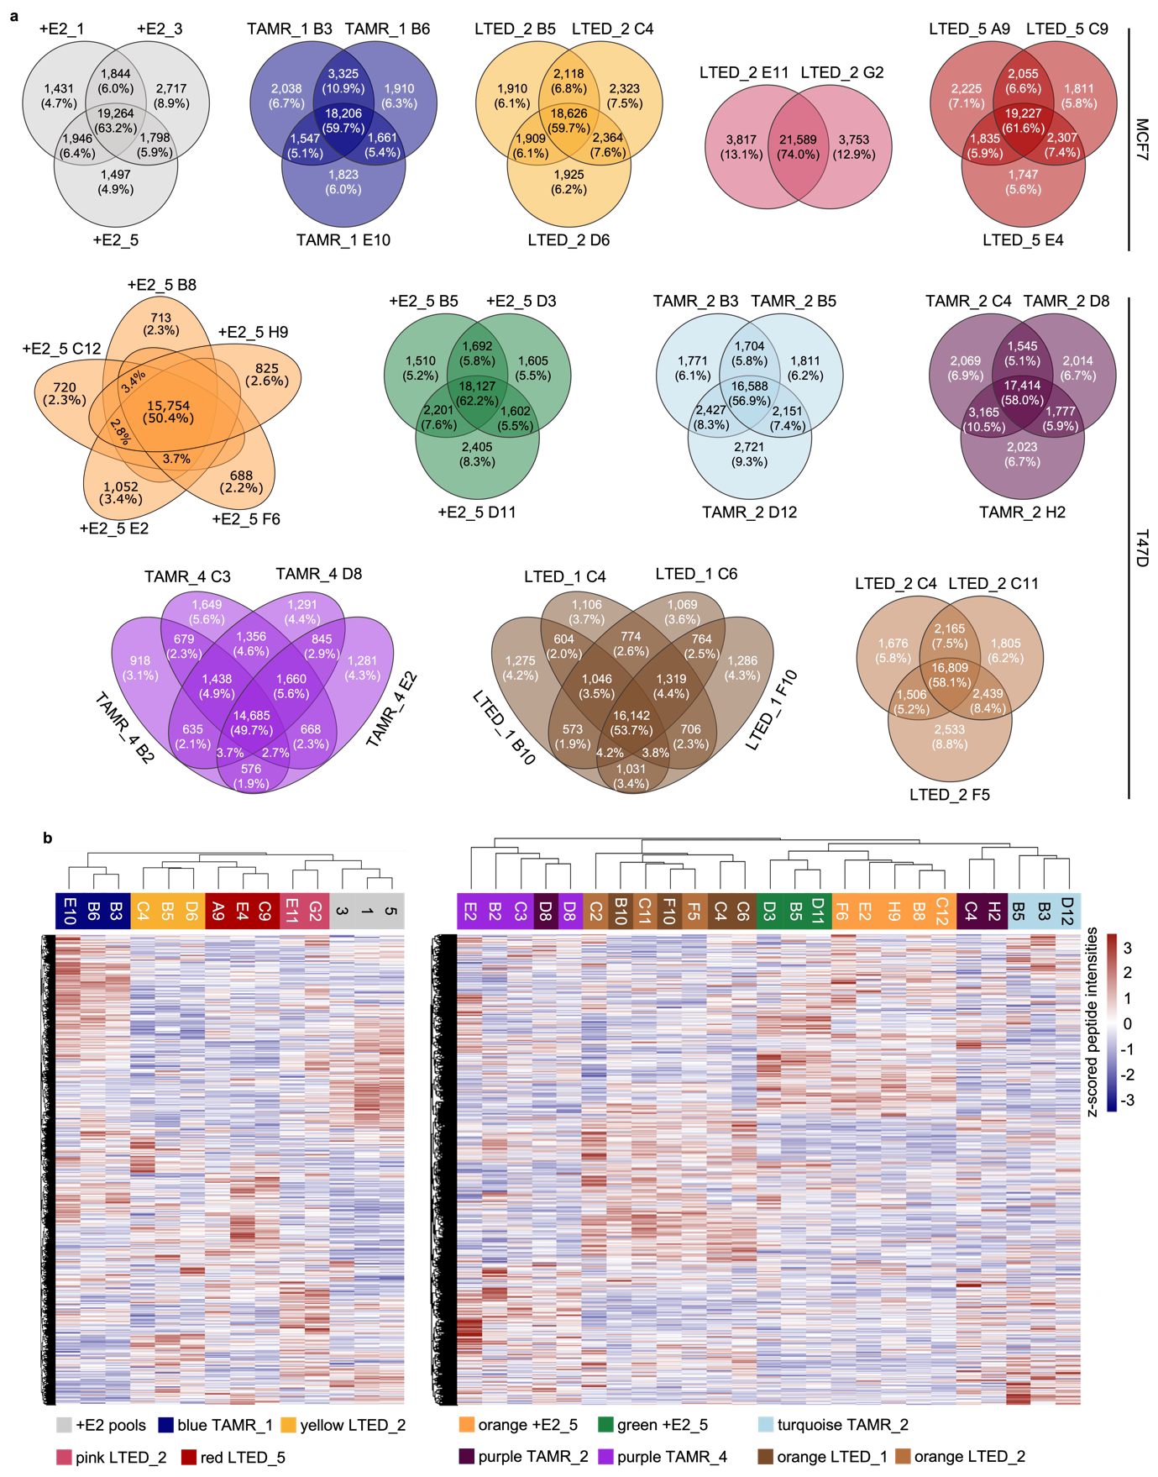
Figure S5: Phosphoprotein profiles are stable only in clones with shared barcodes. a Unbiased MS-based phosphoproteomic analysis was performed with the indicated bulk populations (+E2 for MCF7), and individual clones (+E2 for T47D, and respective endocrine therapy-resistant TAMR and LTED clones for MCF7 as well as T47D). Venn diagrams show the numbers and percentages of identified phosphosites in the indicated biological replicates. For T47D orange +E2_5 clones, only overlap larger than 2.0% are indicated and only selected number of phosphosites are indicated for better visualization. b Heatmaps presenting consistently identified phosphosites in rows and cell lines in columns were generated using the R package Pheatmap (version 1.0.12) for MCF7 (left panel) and T47D (right panel). Hierarchical clustering was applied in both phosphosites (rows) and cell lines (columns) (Euclidean distance). Shown are z-scored peptide intensities.

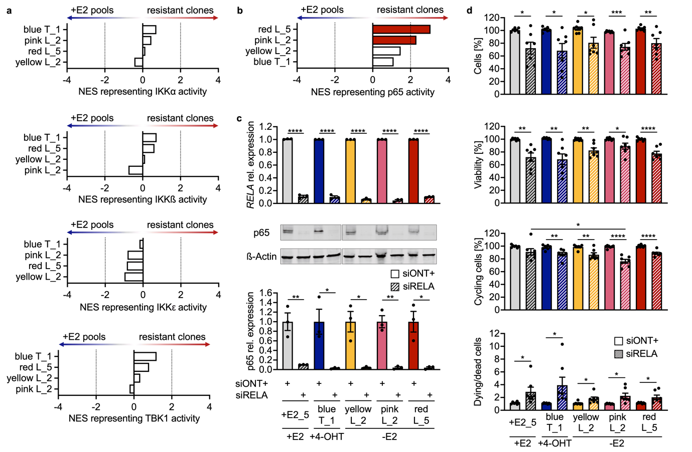
Figure S6: Knockdown of RELA/p65 affects endocrine therapy resistant, however, also sensitive cells. a Phosphoproteomic data of MCF7 +E2 cell pools and resistant clones was analyzed using Omnipath ⁵⁰ and decoupleR ⁴⁰ to infer relative activities of indicated kinases capable of phosphorylating IκBα, in respective resistant clones compared to control +E2 cell pools. b DoRothEA ⁴¹ and decoupleR ⁴⁰ analysis of RNA-seq data predicted elevated activity of p65 in MCF7 red LTED_5 and pink LTED_2 clones compared to +E2 control cell populations. c Validation of knockdown efficiency of RELA mRNA (upper panel) and p65 protein (lower panel) 6 days post transfection of RELA siRNA or non-targeting control (siONT+). Upper panel: RELA expression was normalized to the expression of the housekeeping genes ACTB and GAPDH. Relative expression was then normalized to the non-targeting controls (siONT+). n = 3 with 3 technical replicates each. Lower panel: Representative Western Blot and quantification of three biological replicates. p65 protein intensities were normalized to ß-Actin protein intensities. Shown are mean ± SEM. * p<0.05, ** p<0.01, **** p<0.0001 as determined by unpaired two-tailed t-test. MCF7 +E2_5 (□), TAMR_1 B6 (blue T_1, ), LTED_2 C4 (yellow L_2, ), LTED_2 E11 (pink L_2, ) and LTED_5 C9 (red L_5, ). d Phenotypic analysis of RELA/p65 effects. Indicated cell clones were transfected with siRELA or control (siONT+). Nuclear cell count and ATP levels were determined 6 days after transfection, while EdU and DAPI incorporation were assessed 4 days after transfection (n = 7 with ≥ 4 technical replicates each). Data was normalized to non-targeting control siRNA (siONT+). Shown are mean ± SEM. * p<0.05, ** p<0.01, *** p<0.001, **** p<0.0001 as determined by two-tailed t-tests (siONT+ vs. siRELA) or one-way ANOVA with Dunnett multiple comparisons test (siRELA transfected conditions).
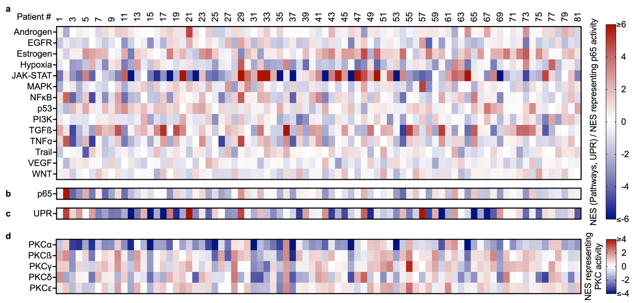
Figure S7: Activities in patients with ER+ disease. Patients with ER+ (n=81) disease were selected in the CPTAC-BRCA cohort and indicated activities were calculated on a per patient basis. For pathway (a), p65 (b) and UPR (c) activation, CPTAC RNA-seq data were z-scored before further analyses by PROGENy ^{38,39} (a), DoRothEA ⁴¹ and decoupleR ⁴⁰ (b) and ssGSEA ⁵⁵ (c). PKC activity estimates (d) were based on CPTAC phosphoproteomic data, the common reference sample as described by Krug et al. ⁵² and calculated using Omnipath ⁵⁰ and decoupleR ⁴⁰. a-d Significance is not indicated to improve visualization.

