Supplementary Information for
Decreased Western Tibet Snow Cover Amplifies the Increase in Summer Concurrent Compound Heatwaves in the Northern Hemisphere

Supplementary Notes
To determine that the results of the compound heatwaves (CHWs) discussed in the main text are insensitive to the threshold, we provide the results of CHWs for the 90th/95th percentile. Supplementary Fig. 1 and Supplementary Fig. 2 show that they have the same evolution patterns except for the magnitude. Therefore, our results are not sensitive to the CHWs threshold.

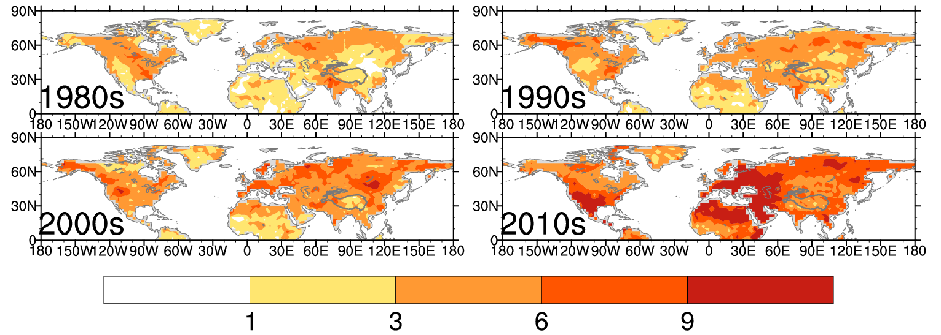
Supplementary Figure 1. Spatial variations in CCHWs. Average evolution of CCHWs per decade (based on the 90th percentile threshold, days/year).

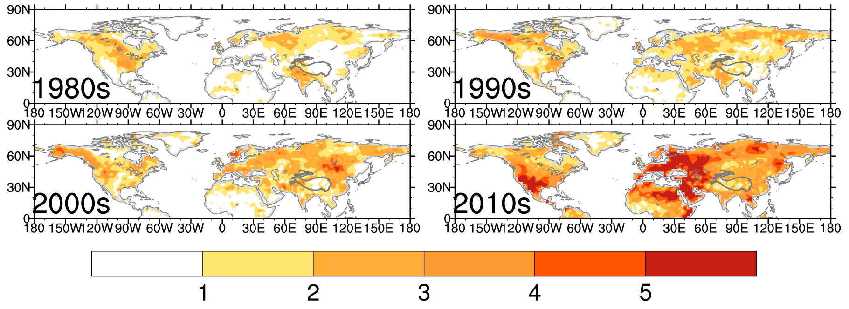
Supplementary Figure 2. Spatial variations in CCHWs. Same as Supplementary Figure 1 but based on the 95th percentile threshold.

Figure 2 in the main text shows a significant correlation between concurrent compound heatwaves (CCHWs) and the snow cover (SC) over the western Tibet Plateau (SC_WTP), so then, is this an important historical condition of the SC_WTP during the summer? Supplementary Fig. 3 shows the climatological mean and standard deviation of summer SC on the TP. The western TP presents the largest values of both the climatological mean and variation in SC in summer. This suggests that SC over the western TP in summer is meaningful as a driving factor.

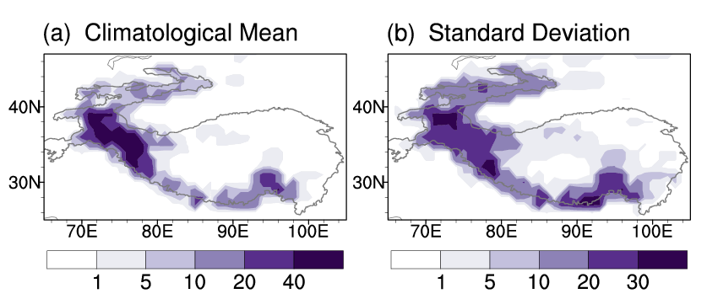
Supplementary Figure 3. Spatial distribution of snow cover. (a) climatological mean and (b) standard deviation of summer SC on the TP.

In Fig. 4a of the main text, we show a significant anomalous tripole Rossby wave source pattern (negative for TP, positive for upstream and downstream) prevailing in the central Eurasian continent. Supplementary Fig. 4 gives the details of how this tripole atmospheric circulation affects the global wave train through energy conversion. The results show that the tripole circulation pattern coupled with terrain elevation over the TP excites a global quasi-stationary planetary wave (Supplementary Fig. 4a), which is maintained and enhanced by extracting barotropic energy and baroclinic energy from the basic flow. Among them, energy conversion is dominated by barotropic energy conversion (the conversion of local kinetic energy from the basic flow to perturbations), and baroclinic energy conversion is auxiliary (obtaining perturbation available potential energy from the basic flow and then converting it into perturbation kinetic energy) (Supplementary Fig. 4b, c). The results of the PV gradient further confirm the above conclusions (Supplementary Fig. 5).
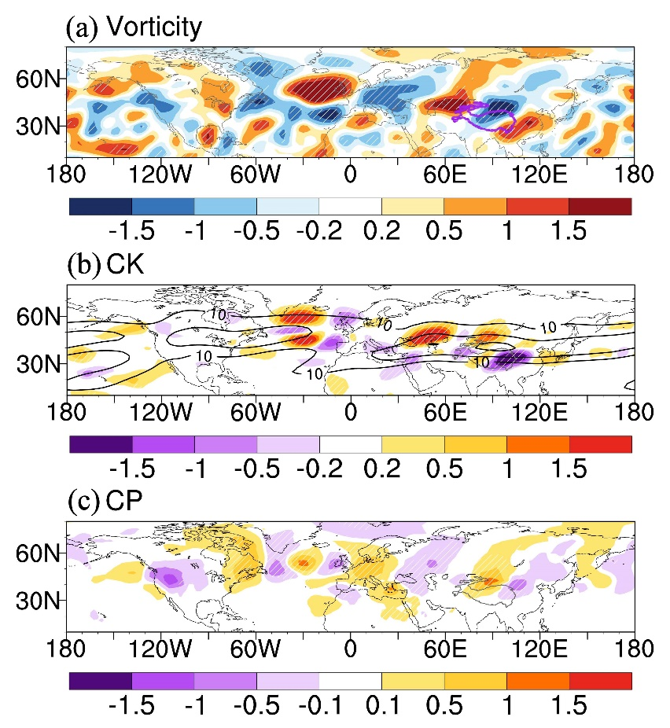
Supplementary Figure 4. Snow-related atmospheric energy conversion. Regressions of 200 hPa (a) vorticity (10⁶ s⁻¹), (b) barotropic energy conversion (CK, 10⁵ W/m²) and (c) baroclinic energy conversion (CP, W/m²) on the reversed SC_WTP index during summer. Black contours represent the climatological jet stream (m/s). White slashes represent p<0.01.

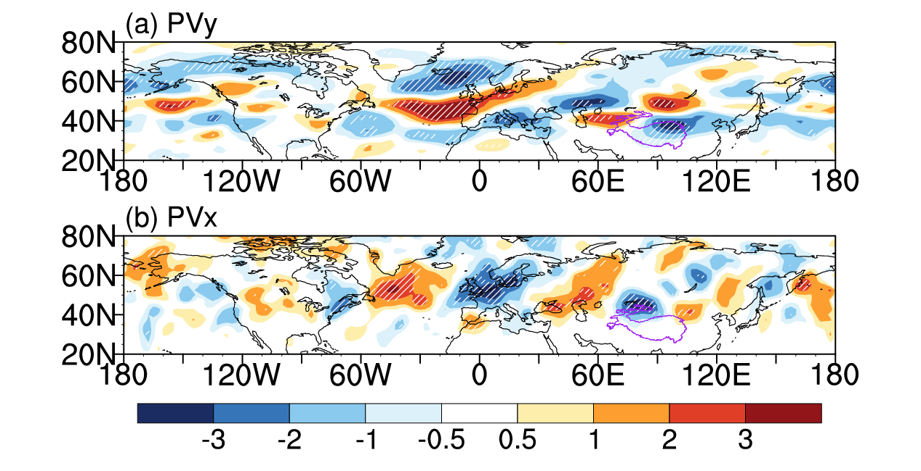
Supplementary Figure 5. Regressions of 200 hPa meridional (PVy) and latitudinal (PVx) potential vorticity gradients (PVU/m, 1 PVU = 1e⁻⁶ m² s⁻¹ K kg⁻¹) on the reversed SC_WTP index during summer. White slashes represent p<0.01.

To illustrate the vertical characteristics of circumglobal quasi-stationary waves 6–8 in response to the decreasing SC_WTP, Fig. 4d-i of the main text gives the distribution at 200 hPa, which represents the upper troposphere. Supplementary Fig. 6 and Supplementary Fig. 7 show the distribution at 500 hPa, which represents the middle troposphere. Together, this can reveal the quasi-barotropic vertical structure of waves 6-8 associated with snow cover anomalies and with CCHWs.

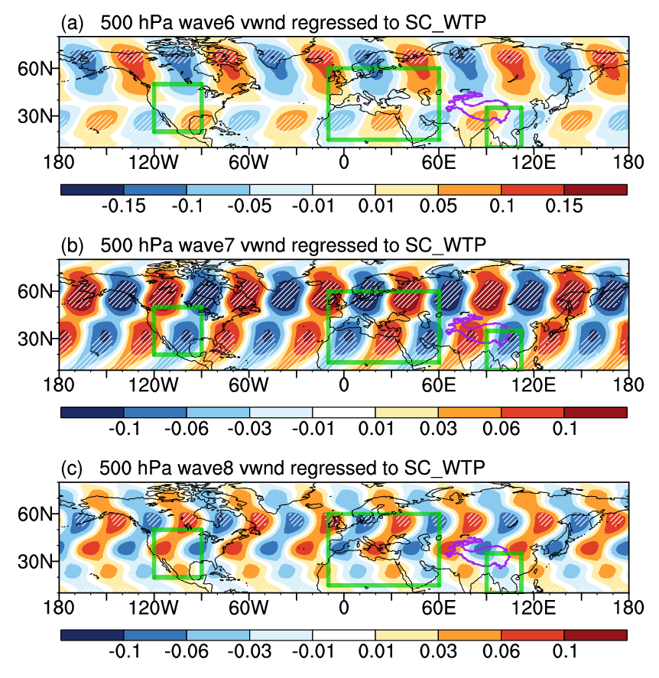
Supplementary Figure 6. Global atmospheric response to snow cover. Regressions of 500 hPa meridional wind (vwnd, shading, m/s) of waves 6-8 on the reversed SC_WTP index during summer. White slash lines represent p<0.01.
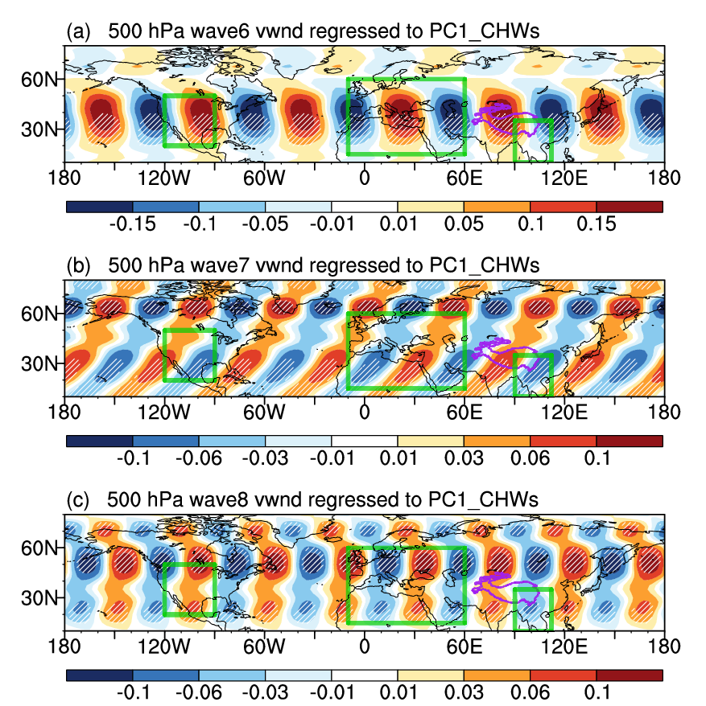
Supplementary Figure 7. CCHWs-related global atmospheric circulation. Regressions of 500 hPa meridional wind (vwnd, shading, m/s) for waves 6-8 on PC1 corresponding to the first EOF of CHWs during summer. White slashes represent p<0.01.

This paper highlights that the SC over the western TP is an important factor that regulates circumglobal quasi-stationary planetary waves at mid-latitudes. So then, what changes have these waves produced in recent decades? Supplementary Fig. 8 and Supplementary Fig. 9 show the proportion, amplitudes and phase of quasi-stationary wave 6-8 at 200 hPa in the Northern Hemisphere. During the summer months over the last two decades, not only is the amplitude of quasi-stationary planetary waves 6-8 increasing, but the proportion and phase also favor CCHWs (Supplementary Fig. 8). Among the waves, wave 6 is the primary source of the phase change (Supplementary Fig. 9), while waves 7-8 are main source of the increase in proportion and amplitude (Supplementary Figs. 10 and 11). The phase shift of wave 6 relative to the climate state reaches one phase (Supplementary Fig. 12a). Its long-term trend is shifting toward the atmospheric circulation pattern that favors CCHWs, and this pattern is also consistent with the meridional wind field associated with the SC_WTP. However, the phase change of waves 7-8 is smaller, which mainly represents the extension of wave amplitude toward the Arctic and the equator (Supplementary Fig. 12b, c).

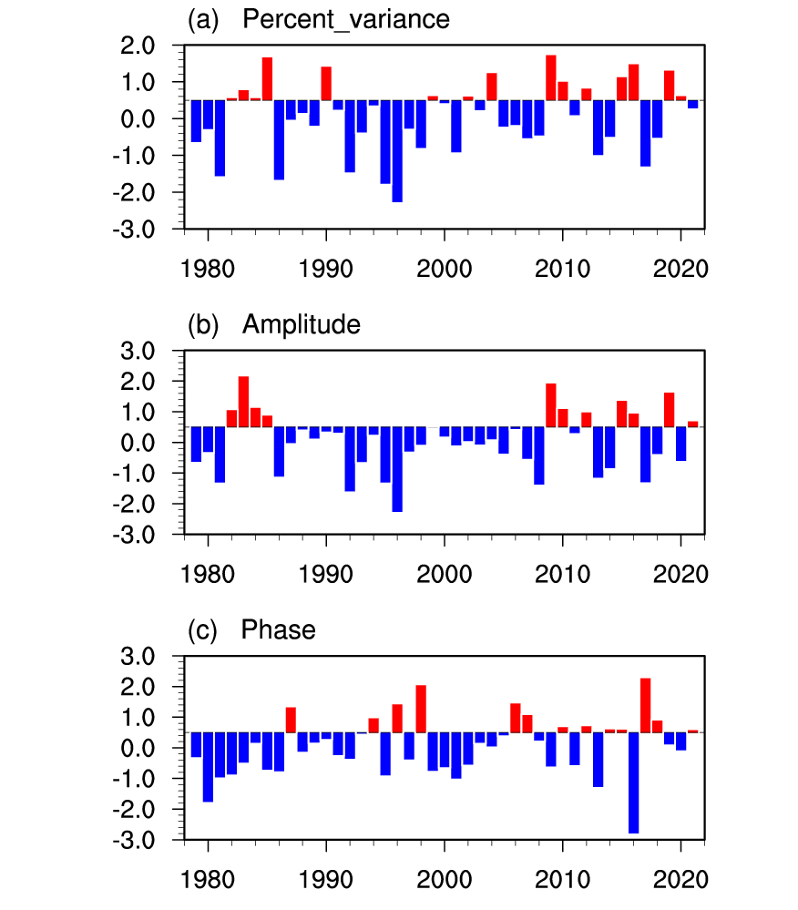
Supplementary Figure 8. Temporal variation of quasi-stationary waves 6-8. The normalized time series of the proportion, amplitudes and phase of quasi-stationary waves 6–8 averaged at 200 hPa in the Northern Hemisphere (10-70°N).

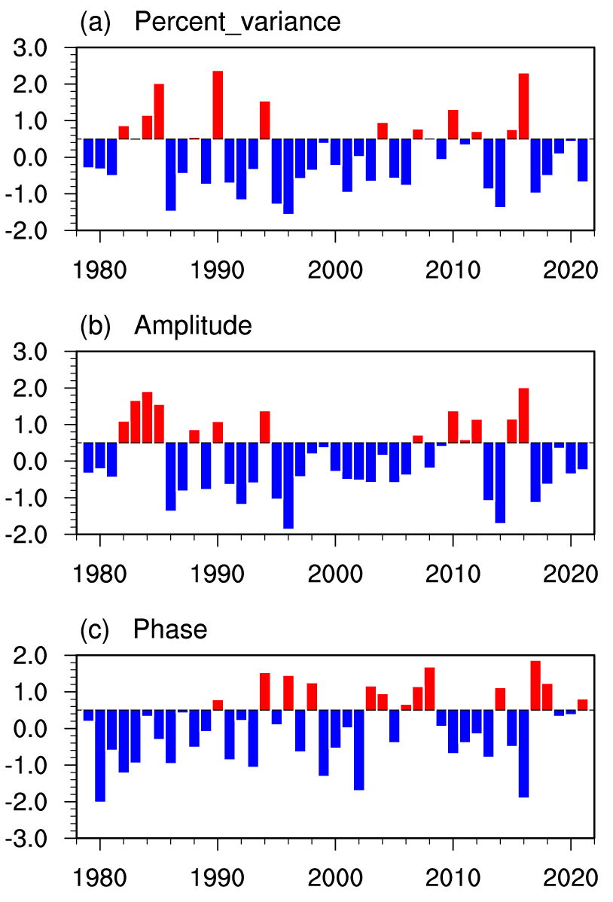
Supplementary Figure 9. Temporal variation of quasi-stationary waves 6. The normalized time series of the proportion, amplitudes and phase of quasi-stationary wave 6 at 200 hPa in the Northern Hemisphere (10-70°N).
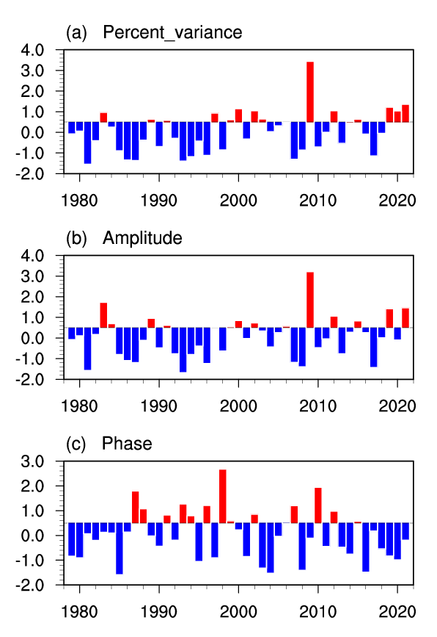
Supplementary Figure 10. Temporal variation of quasi-stationary waves 7. The normalized time series of the proportion, amplitudes and phase of quasi-stationary wave 7 at 200 hPa in the Northern Hemisphere (10-70°N).
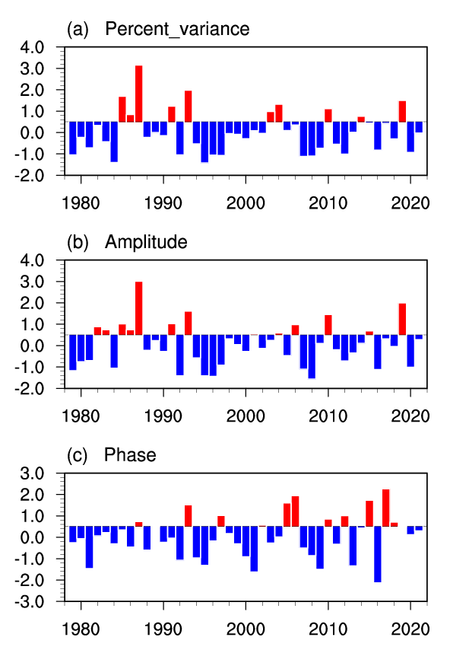
Supplementary Figure 11. Temporal variation of quasi-stationary waves 8. The normalized time series of the proportion, amplitudes and phase of quasi-stationary wave 8 at 200 hPa in the Northern Hemisphere (10-70°N).

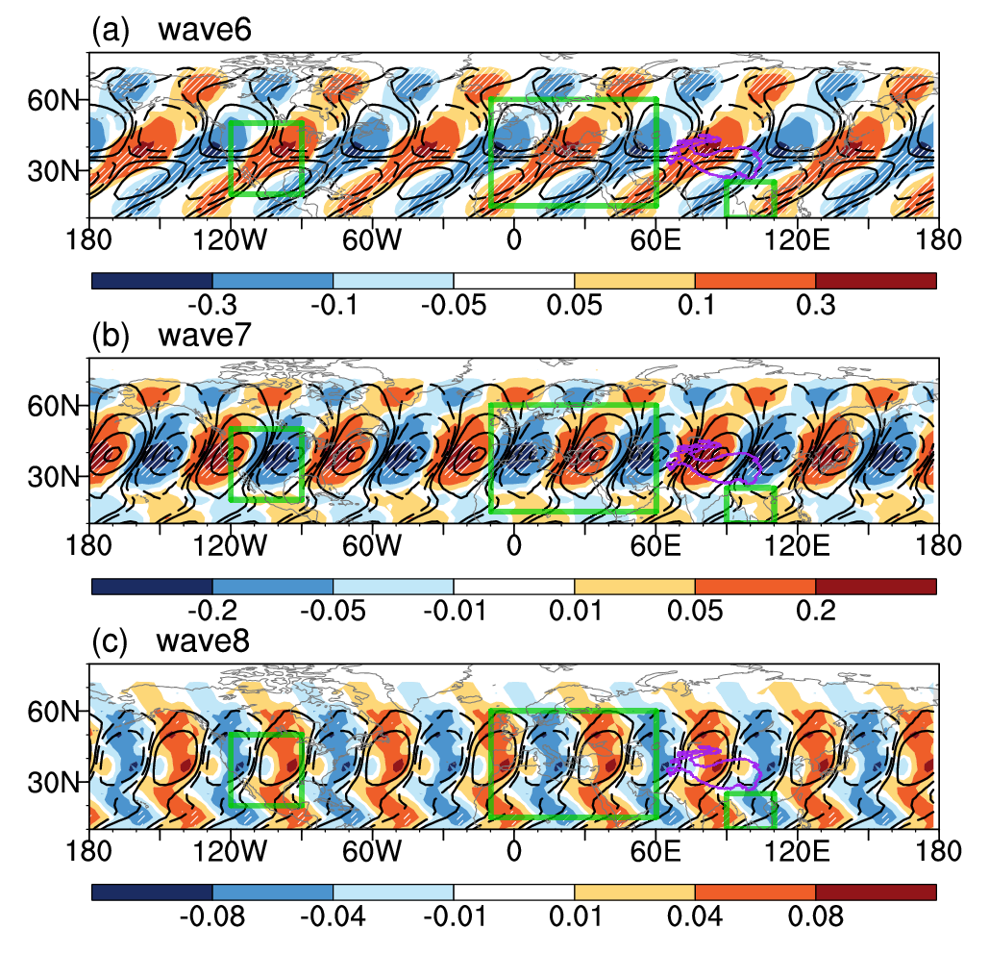
Supplementary Figure 12. Spatial variation of quasi-stationary waves 6-8. Trend (shading) and climatological (counters) maps of summer meridional winds of waves 6–8 in the Northern Hemisphere.

Supplementary Table 1. Information about the 24 CMIP6 models, √ indicates that SC or UTCI fields are available.
CMIP6 models | Institution | SC | UTCI
ACCESS-CM2 | Commonwealth Scientific and Industrial Research Organization, Australia | × | √
BCC-CSM2-MR | Beijing Climate Center, Beijing, China | √ | ×
CAS-ESM2-0 | Chinese Academy of Sciences, Beijing, China | √ | ×
CESM2-WACCM | National Center for Atmospheric Research, Climate and Global Dynamics Laboratory, 1850 Table Mesa Drive, Boulder, USA | √ | ×
CIESM | Department of Earth System Science, Tsinghua University, Beijing, China | √ | ×
CMCC-CM2-SR5 | Fondazione Centro Euro-Mediterraneo sui Cambiamenti Climatici, Lecce, Italy | √ | ×
CMCC-ESM2 |  | √ | ×
CanESM5 | Canadian Centre for Climate Modelling and Analysis, Environment and Climate Change Canada, Victoria, Canada | √ | √
EC-Earth3 | EC–EARTH consortium, Europe | √ | √
EC-Earth3-Veg |  | √ | √
FGOALS-f3-L | Institute of Atmospheric Physics, Chinese Academy of Sciences, China | √ | ×
FGOALS-g3 |  | √ | √
GFDL-CM4 | National Oceanic and Atmospheric Administration, Geophysical Fluid Dynamics Laboratory, Princeton, USA | √ | ×
IPSL-CM6A-LR | Institut Pierre Simon Laplace, Paris, France | √ | ×
INM-CM4-8 | Institute for Numerical Mathematics, Russian Academy of Science, Russia | × | √
INM-CM5-0 |  | × | √
KIOST-ESM | Korea Institute of Ocean Science and Technology, Korea | × | √
MIROC6 | JAMSTEC (Japan Agency for Marine-Earth Science and Technology, Japan), AORI (Atmosphere and Ocean Research Institute, The University of Tokyo, Japan), NIES (National Institute for Environmental Studies, Japan), and R-CCS (RIKEN Center for Computational Science, Japan) | √ | ×
MPI-ESM1-2-HR | Max Planck Institute for Meteorology, Germany | √ | ×
MPI-ESM1-2-LR |  | √ | ×
MRI-ESM2-0 | Meteorological Research Institute, Tsukuba, Japan | √ | ×
NorESM2-LM | Norwegian Climate Center, Norway | √ | ×
NorESM2-MM |  | √ | ×
TaiESM1 | Research Center for Environmental Changes, Academia Sinica, Nankang, Taiwan | √ | ×

