Supplementary Information

Efficient dispersion of organic fluorophores by size matching with a new di-functionalized spacer interleaved into layered double hydroxide

Guillaume Zerbib¹, Damien Boyer^{1*}, Geneviève Chadeyron¹, François Réveret¹, and Fabrice Leroux¹
¹Université Clermont Auvergne, CNRS, Clermont Auvergne INP, ICCF, F-63000 Clermont-Ferrand, France
*Corresponding author.
E-mail address: Damien.boyer@sigma-clermont.fr

Table S1 LDH samples references. 2
Figure S1 Absorbance calibration line for the titration of supernatants. 3
Table S2 Absorbances measured for the three ZNAL-spacer-SRB02 supernatants and determination of SRB rate intercalated between LDH layers. 3
Figure S2 Structures of the three spacers. 4
Figure S3 Theoretical basal spacing calculation for each spacer. 4
Figure S5 Structure of Sulforhodamine B (SRB) and main relevant dimensions. 5
Figure S4 Thermogravimetric and mass spectrometry of ZNAL-PPA-SRB02. 5
Figure S6 Luminescence decay profiles of a) ZNAL-PPA-SRB005 and b) ZNAL-PPA-SRB02 powders. 6

Table S1 LDH samples references
Sample name | SRB mol% | Spacer | Spacer mol%
ZNAL-TA-SRB02 | 0.20 | Terephtalic acid (TA) | 99.80
ZNAL-PAA-SRB02 | 0.20 | p-Phenylenediacetic acid (PAA) | 99.80
ZNAL-PPA-SRB005 | 0.05 | p-Phenylenedipropionic acid (PPA) | 99.95
ZNAL-PPA-SRB008 | 0.08 | p-Phenylenedipropionic acid (PPA) | 99.92
ZNAL-PPA-SRB01 | 0.10 | p-Phenylenedipropionic acid (PPA) | 99.90
ZNAL-PPA-SRB012 | 0.12 | p-Phenylenedipropionic acid (PPA) | 99.88
ZNAL-PPA-SRB015 | 0.15 | p-Phenylenedipropionic acid (PPA) | 99.85
ZNAL-PPA-SRB02 | 0.20 | p-Phenylenedipropionic acid (PPA) | 99.80

Fig. S1 Absorbance calibration line for the titration of supernatants

Table S2 Absorbances measured for the three ZNAL-spacer-SRB02 supernatants and determination of SRB rate intercalated between LDH layers
Sample supernatant | Absorbance  at 566 nm (a.u.) | [SRB]  in supernatant (mg/L) | %_{SRB}  in supernatant | %_{SRB}  in LDH powder
ZNAL-TA-SRB02 | 1.054 | 6.055 | 96 | 4
ZNAL-PAA-SRB02 | 0.724 | 4.164 | 68 | 32
ZNAL-PPA-SRB02 | 0.005 | 0.031 | 1 | 99

Fig. S2 Structures of the three spacers

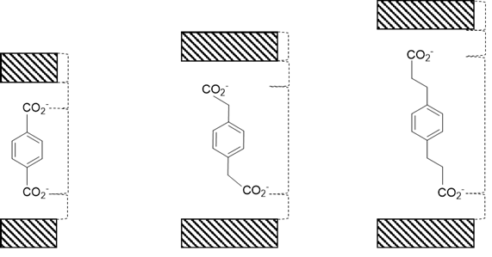
0.15 nm
1.07 nm
0.15 nm
0.50 nm
0.50 nm
0.15 nm
0.77 nm
0.15 nm
0.15 nm
0.58 nm
0.15 nm
0.50 nm
Fig. S3 Theoretical basal spacing calculation for each spacer

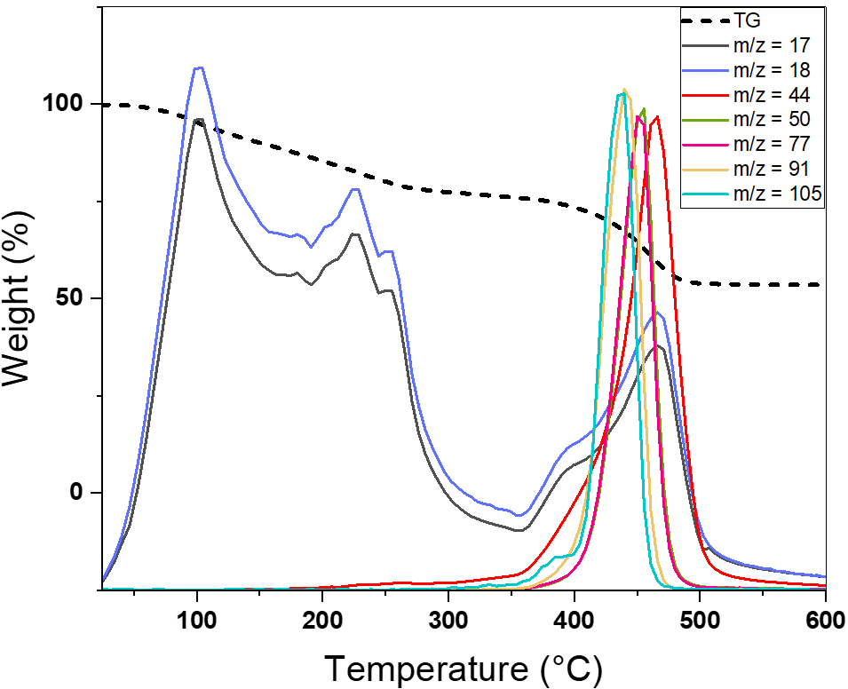
Fig. S4 Thermogravimetric and mass spectrometry of ZNAL-PPA-SRB02

Fig. S5 Structure of Sulforhodamine B (SRB) and main relevant dimensions

Fig. S6 Luminescence decay profiles of a) ZNAL-PPA-SRB005 and b) ZNAL-PPA-SRB02 powders
a)
b)

