(a)

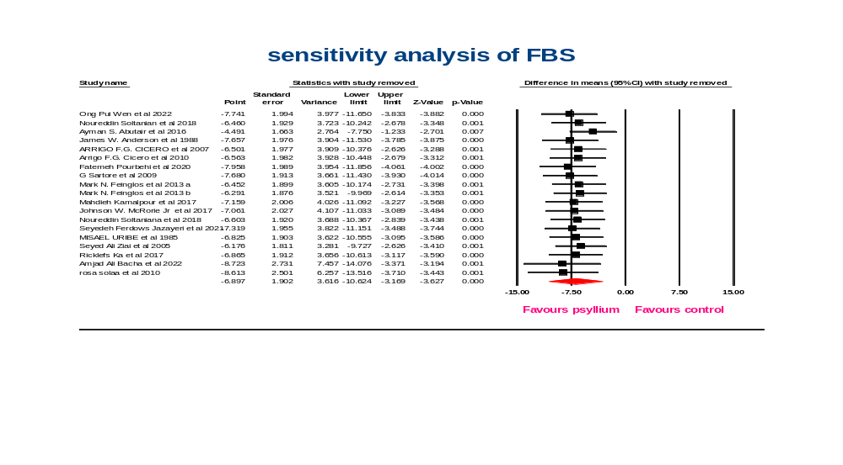(b)
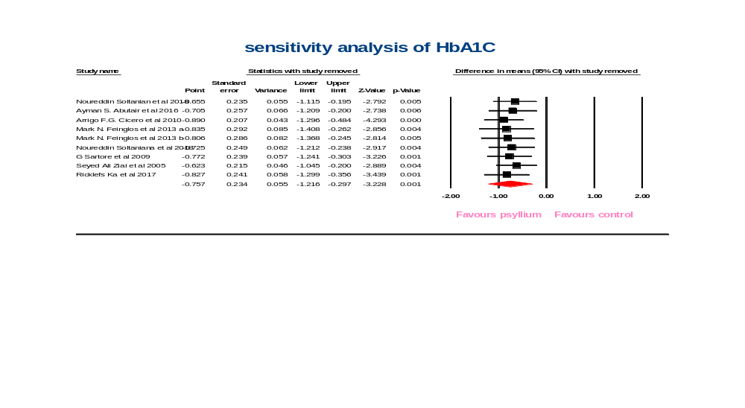

(c)

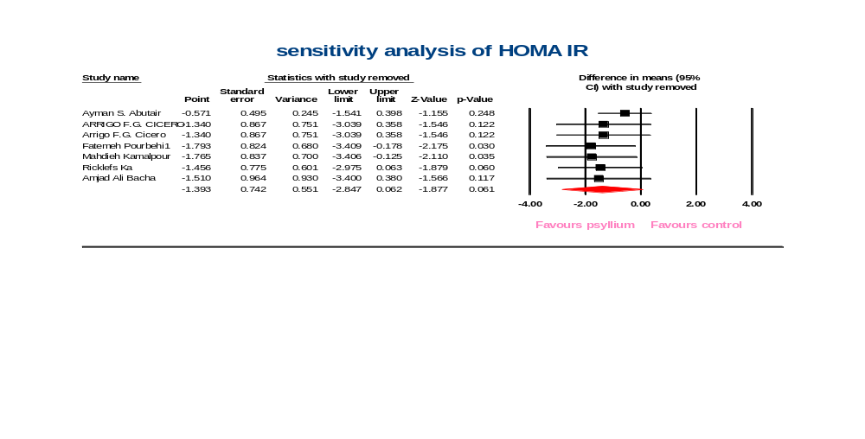

(d)

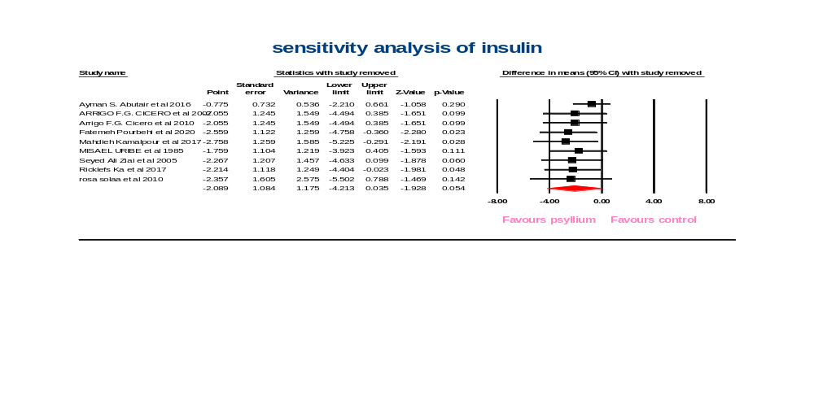
Supplementary figure 1: sensitivity analysis of psyllium on FBS (a), HbA1C (b), HOMA IR (c), and insulin (d)
(a)

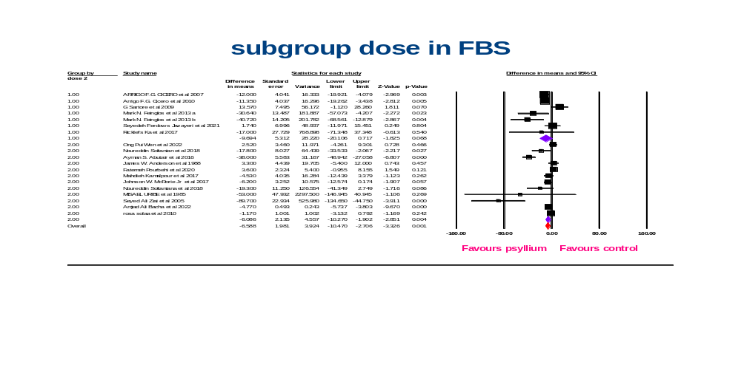(b)

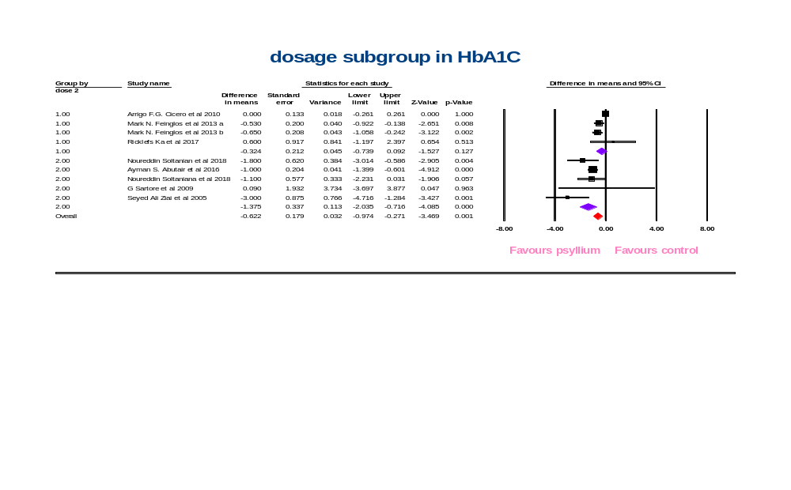

(c)

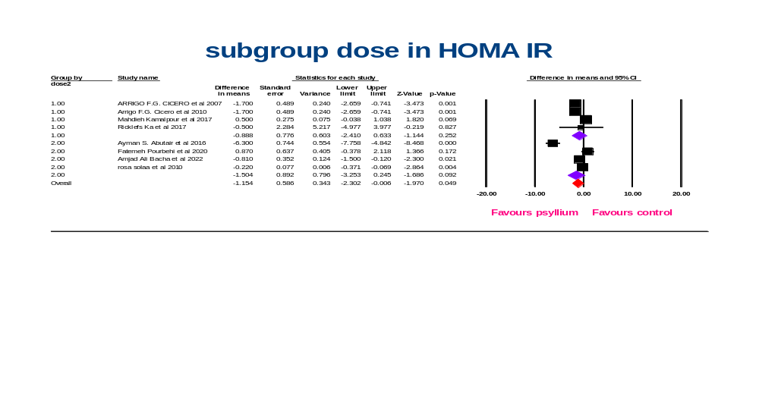(d)

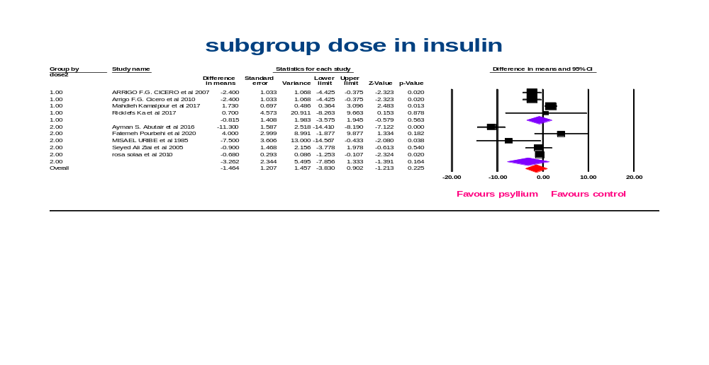

Supplementary figure 2: dosage subgroup analyses for the effects of psyllium on FBS (a), HbA1C (b), HOMA IR (c), and insulin (d)

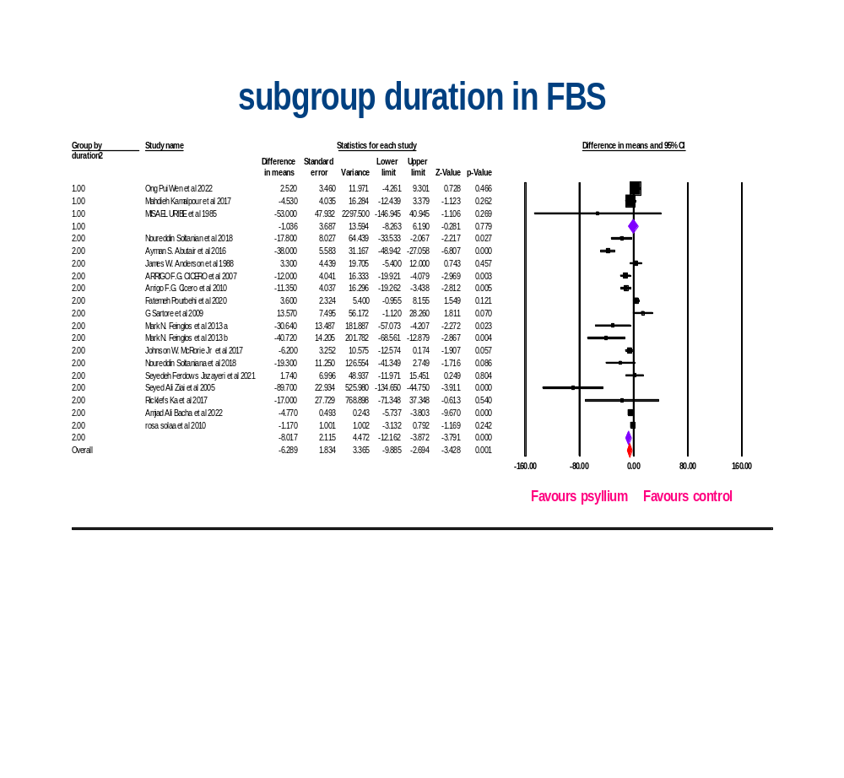Supplementary figure 3: duration subgroup analyses for the effects of psyllium on FBS

(a)

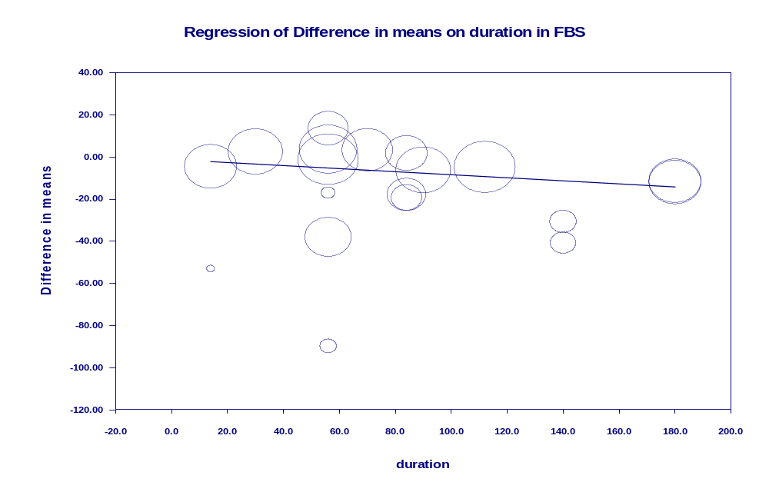
(b)
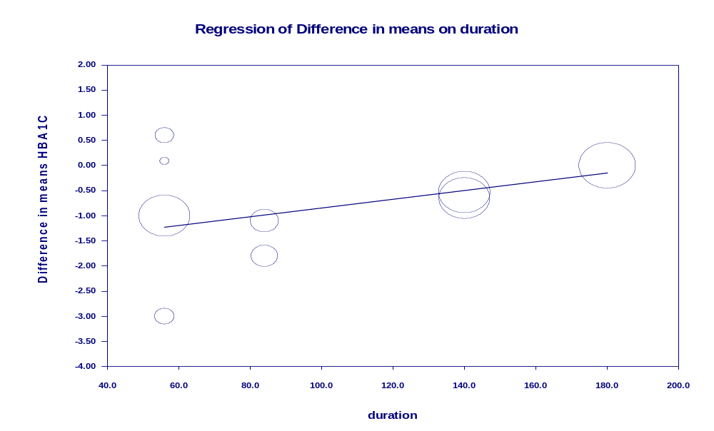
(c)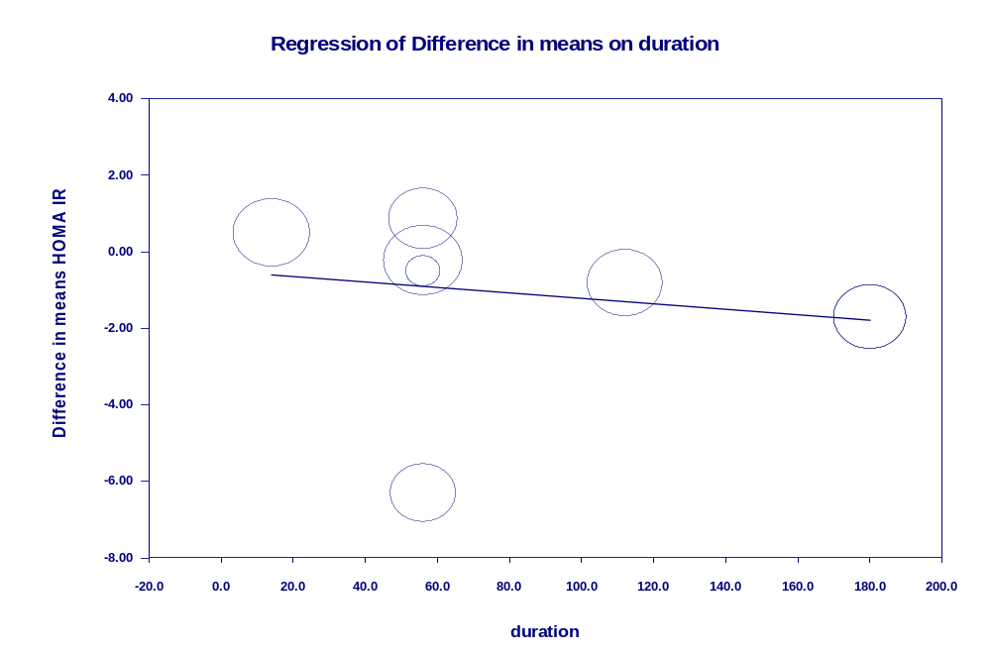
(d)

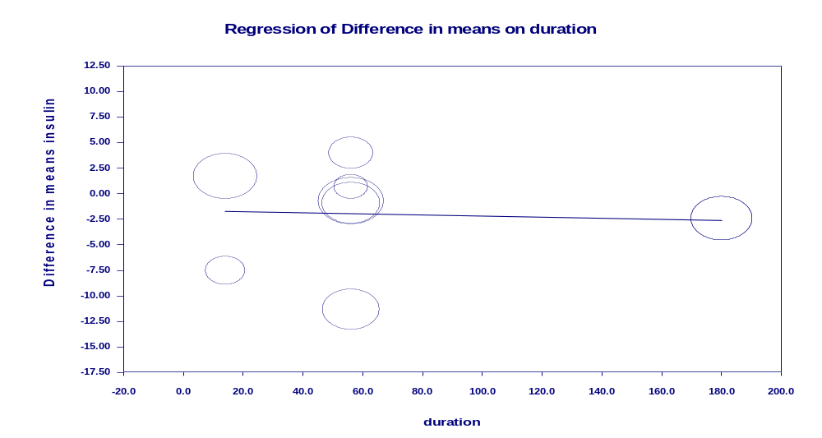

Supplementary figure 4: Random-effects meta-regression plots of the association between mean changes in FBS (a), HbA1C (b), HOMA IR (c), and insulin (d) and intervention duration
(a)

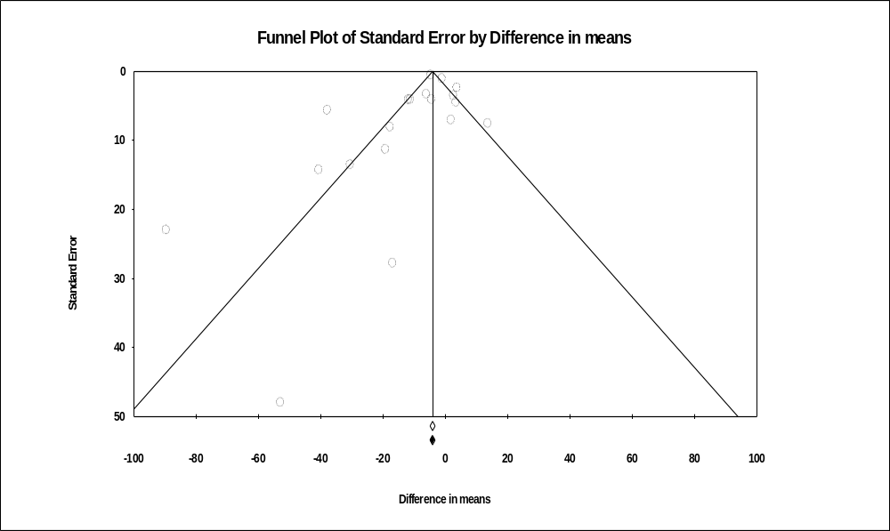
(b)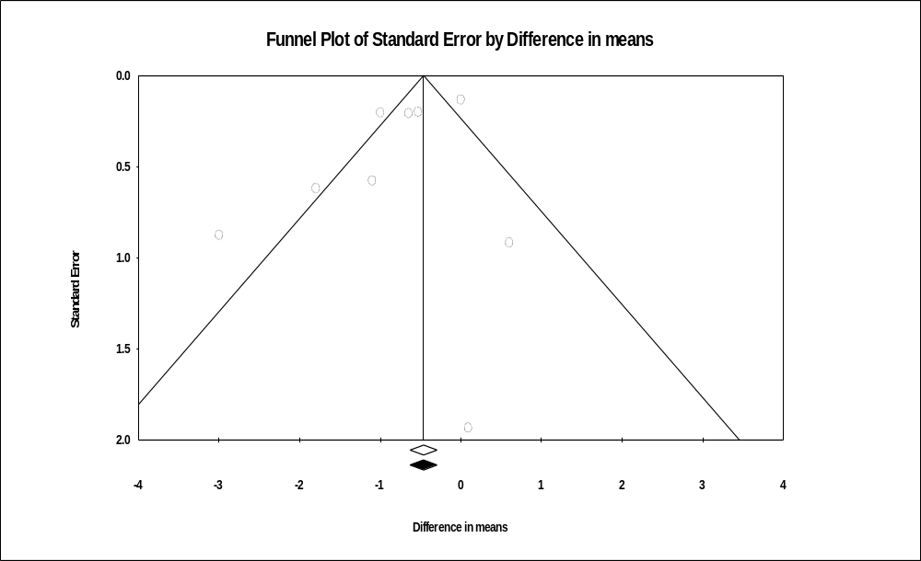

(c)

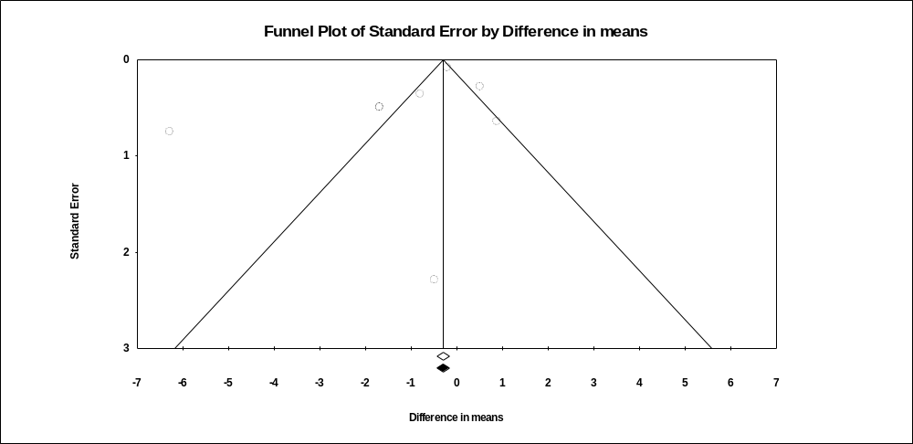

(d)

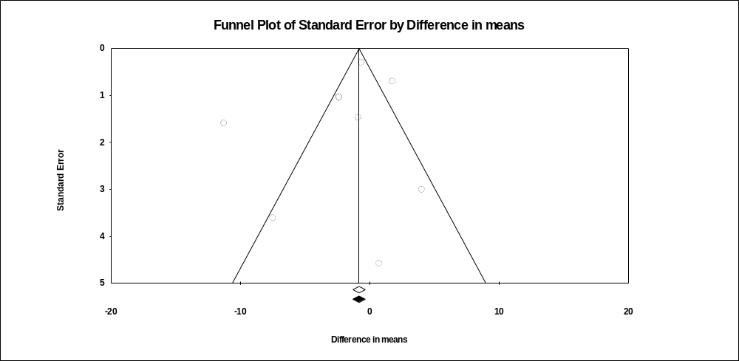
Supplementary figure 5: Publication bias of psyllium on FBS (a), HbA1C (b), HOMA IR (c), and insulin (d)

