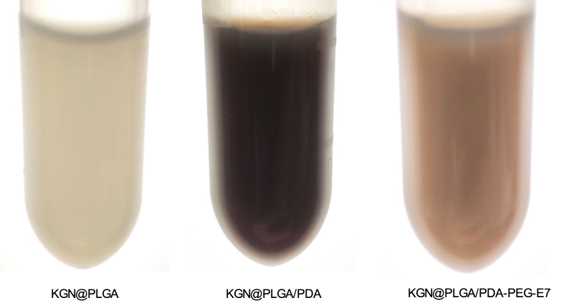
Fig.S1. The general view of the nanoparticles in PBS buffer.
Fig.S2. Cytotoxicity test of BMSCs with different concentrations of H₂O₂ using the CCK8 method.
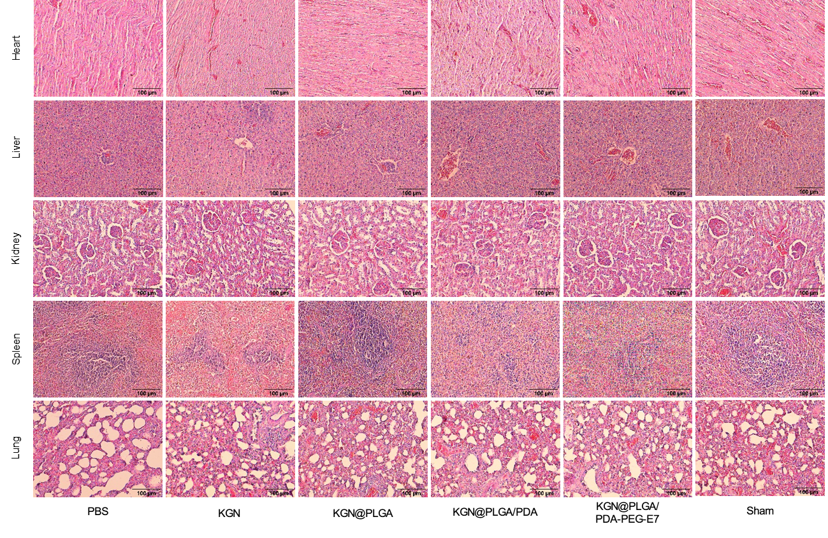
Fig.S3. The H&E staining of heart, liver, kidney, spleen, and lung.

