Table S1 Information of the eight pairs of invasive alien and native plant species used in the experiment.
Pair | Species | Family | Subfamily | Origin | Invasion rank# | Introduction year | Native range | Clonality | Typical habitat
1 | Alternanthera philoxeroides (Mart.) Griseb | Amaranthaceae | Gomphrenoideae | Invasive alien | 1 | 1892 | South America | Clonal | Wetlands, canals,  nearby fields
 | Alternanthera sessilis (Linn.) DC | Amaranthaceae | Gomphrenoideae | Native | – | – | Asia, Africa | Clonal | Wetlands, other moist habitats
2 | Conyza sumatrensis (Retz.) E. Walker | Asteraceae | Carduoideae | Invasive alien | 1 | 1940s | South America | Non-clonal | Roadsides, grasslands, wastelands
 | Kalimeris indica (L.) Sch. Bip. | Asteraceae | Carduoideae | Native | – | – | Asia | Non-clonal | Roadsides, moist grasslands,
3 | Erigeron canadensis (L.) Cronq. | Asteraceae | Carduoideae | Invasive alien | 1 | 1934 | North America | Non-clonal | Roadsides, nearby fields, wastelands
 | Cirsium arvense (L.) Scop. | Asteraceae | Carduoideae | Native | – | – | Asia | Non-clonal | Riversides, crop fields, wastelands
4 | Erigeron annuus (L.) Pers. | Asteraceae | Carduoideae | Invasive alien | 1 | 1886 | North America | Non-clonal | Roadsides, nearby fields, wastelands
 | Eclipta prostrata (L.) L. | Asteraceae | Carduoideae | Native | – | – | Asia | Non-clonal | Roadsides, crop fields, wastelands
5 | Hydrocotyle vulgaris L. | Araliaceae | Hydrocotyloideae | Invasive alien | 2 | 1990s | North America, Europe | Clonal | Wetlands, other moist habitats
 | Hydrocotyle sibthorpioides Lam. | Araliaceae | Hydrocotyloideae | Native | – | – | Asia | Clonal | Wetlands, other moist habitats
6 | Paspalum notatum Flugge | Poaceae | Panicoideae | Invasive alien | 3 | 1920s | North and South America | Clonal | Roadsides and grasslands
 | Paspalum distichum L. | Poaceae | Panicoideae | Native | – | – | Tropics and subtropics of Asia, America | Clonal | Roadsides, nearby fields, grasslands
7 | Sonchus oleraceus L. | Asteraceae | Cichorioideae | Invasive alien | 3 | 1940s | Europe | Non-clonal | Nearby fields, wastelands, other moist habitats
 | Ajania pallasiana (Fisch. ex Bess.) Poljak. | Asteraceae | Carduoideae | Native | – | – | Asia | Non-clonal | Hillside, grasslands, bush wood
8 | Sphagneticola trilobata (L.) Pruski | Asteraceae | Asteroideae | Invasive alien | 2 | 1970s | North and South America | Clonal | Moist grasslands, edges of canals, roadsides
 | Sphagneticola calendulacea (L.) Pruski | Asteraceae | Asteroideae | Native | – | – | Asia | Clonal | Moist grasslands, edges of canals, crop fields, roadsides
Status and habitat information are based on the Flora of China (www.efloras.org), Scientific Database of China Plant Species (DCP) (http://db.kib.ac.cn/) and Wan et al. (2012), Ma (2014) and Ma and Li (2018).
# Invasion rank: 1- highly invasive alien species in China, i.e. those alien species that cause huge economic and ecological losses, and irreversible changes in natural environments in China; 2- serious invasive alien species in China, i.e. those alien species that cause major economic and ecological losses, and changes in natural environments in China; 3- serious invasive alien species in parts of China, i.e. those alien species that cause regional economic and ecological loss, and partly changes in natural environments in part of China. The invasion rank information is from Ma (2014) and Ma and Li (2018).
Supplementary references
Ma, J.S. (2014). The Survey Report on Chinese Alien Invasive Plants, Part I & II. High Education Press.
Ma, J.S., & Li, H.R. (2018). The Checklist of the Alien Invasive Plants in China. High Education Press.
Wan, F.H., Liu, Q.R., & Xie. M. (2012). Biological invasions: Color Illustrations of Invasive Alien Plants in China. Science Press.

Table S2 The SDs of the 16 plant species and 4 soil treatments in the lme models of total biomass, shoot biomass and root biomass per pot.
 |  | SD
 |  | Total biomass | Shoot biomass | Root biomass
 | Hydrocotyle vulgaris | 0.847 | 0.924 | 0.197
 | Hydrocotyle sibthorpioides | 0.501 | 0.513 | 0.124
 | Erigeron annuus | 1.280 | 1.440 | 0.267
 | Eclipta prostrata | 0.893 | 0.998 | 0.171
 | Sonchus oleraceus | 1.173 | 1.337 | 0.060
 | Ajania pallasiana | 0.638 | 0.655 | 0.201
Species | Alternanthera philoxeroides | 0.924 | 1.048 | 0.173
identity | Alternanthera sessilis | 1.893 | 2.089 | 0.288
 | Erigeron canadensis | 1.233 | 1.401 | 0.174
 | Cirsium arvense | 0.682 | 0.742 | 0.129
 | Paspalum notatum | 1.893 | 1.124 | 0.163
 | Paspalum distichum | 1.133 | 1.215 | 0.234
 | Conyza sumatrensis | 1.712 | 1.942 | 0.166
 | Kalimeris indica | 0.521 | 0.538 | 0.217
 | Sphagneticola trilobata | 1.707 | 1.959 | 0.190
 | Sphagneticola calendulacea | 0.999 | 1.098 | 0.214
 | Control | 0.824 | 0.812 | 0.267
Soil | Home | 0.655 | 0.649 | 0.204
treatment | Foreign | 0.680 | 0.686 | 0.180
 | Mixed | 0.745 | 0.746 | 0.187

Table S3 Results of linear mixed models for effects of species origin (invasive vs. native species) and soil treatment (Control vs. Home vs. Foreign) on root biomass of control soil patches.
 |  |  | Root biomass of the control soil patch
Effect | DF |  | χ² | P
Fixed
Origin (O) | 1 | 1 | 0.094 | 0.759
Soil treatment (S) | 2 |  | 2.035 | 0.361
O × S | 2 |  | 0.954 | 0.621
Random |  |  | SD
Taxonomic pair |  |  | 0.036
Species identity |  |  | 0.120
Pot identity |  |  | 0.060
Residual |  |  | 0.055

Root biomass of the control soil patches (square-root transformed) in the three soil treatments was included as the response variable. Species origin (invasive or native) and soil treatment (Control, Home or Foreign) and their interaction were included as fixed terms. Species pair, species identity and pot identity in the test phase were included as random terms. The variance was allowed to vary among the test species by using varIdent function.

Fig. S1 Means and standard errors of concentrations of total nitrogen (N, a), phosphorus (P, b) and potassium (K, c) in the pre-conditioning soil (6 samples), the control soil experiencing conditioning but without growing any plants (6 samples), and the soil conditioned by the invasive species (12 samples) and the soil conditioned by the native species (12 samples).

Fig. S2 Effects of year of first record of invasive alien species on the PSF strength in the three soil treatments.
The response variable is PSF strength (i.e. ln[invasive biomass of conditioned soil treatment / invasive biomass of control soil treatment]). The data points are the means (±SEs) of each species. The dashed blue lines show the fitted non-significant regression lines, and the grey area indicates the 95% confidence intervals for linear model predictions.
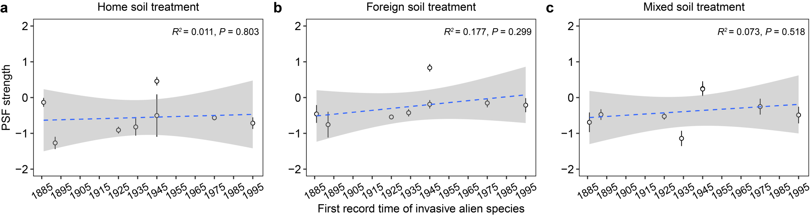

Fig. S3 Means and standard errors of root biomass of invasive alien and native species in control patches of the Control, Home and Foreign soil treatments.
