Supplementary Material

- Treatment regimen
Surgery: Radical hysterectomy (type III) and pelvic lymphadenectomy were performed in all patients. Para-aortic lymph node (PALN) dissection was not a routine procedure as it would increase operative time and complications. It was only performed if intraoperative frozen section examination showed positive common iliac lymph nodes or if intraoperative palpation suggested PALN.
Radiotherapy: (1) External beam radiotherapy (EBRT) was treated with Intensity Modulated Radiotherapy (IMRT) at a total dose of 45.0~50.4 Gy at 1.8~2.0 Gy per session for five weeks, five times per week. The dose of EBRT increases to 60.0~66.0 Gy for patients with lymph node metastasis. EBRT is performed with total pelvic and expanded field radiotherapy only when metastases to the common iliac or retroperitoneal lymph nodes are identified. Only patients with positive parametrial margins are treated with parametrial enhancement. Patients with positive vaginal margins or high-risk factors are treated with intracavitary radiotherapy as appropriate. (2) High-dose-rate intracavitary brachytherapy (192Ir HDR ICBT) was initiated when the EBRT dose reached 40.0 Gy, giving a total dose of 30 Gy with a daily fraction of 6 Gy. No EBRT was given on the day of intracavitary treatment. The total dose at point A was 78~90 Gy, and the external dose at point B was 46~56 Gy.
Chemotherapy: All patients did not receive preoperative chemotherapy and only received postoperative concurrent or adjuvant chemotherapy. The chemotherapy regimens included: ① single-agent regimen: cisplatin/nedaplatin, 30~40 mg/m², once a week. ② EP regimen: etoposide, 60~100 mg/m², D1-3 + cisplatin 50~100 mg/m², D1-3 (once every three weeks). ③ TP regimen: paclitaxel, 135~175 mg/m², D1 + cisplatin, 50~70 mg/m², D2 (once every three weeks). ④ TC regimen: docetaxel, 75mg/m², D1 + carboplatin, area under the concentration-time curve 5, D1 (once every three weeks). Chemotherapy was stopped when the leukocyte counts dropped below 3000 per cubic millimeter or platelet counts dropped below 50,000 per cubic millimeter.

- MRI protocols
All the MR images were obtained on a clinical whole-body 3.0T MRI scanner (GE Signa HDXT 3.0T MRI scanner, GE Healthcare, USA) with a phased-array 8-channel sensitivity-encoding abdominal coil. Patients were placed in a supine position with breathing control. The scan covered the whole pelvis, from the iliac crest's superior edge to the symphysis's inferior edge. Patients were scanned with axial T1, axial T2, axial T2 fat-suppressed (FS), sagittal T2, LAVA-FLEX (axial LAVA-FLEX in arterial phase, venous phase and delayed phase, and sagittal LAVA-FLEX in late delayed phase) and axial IVIM-DWI, which was the axial DWI with 10 b values (0, 10, 20, 50, 100, 200, 400, 800, 1200, 2000 s/mm²). The scan parameters of each sequence are shown in Table S1. Gadolinium diamine (GE Healthcare) was used as a contrast agent at a dose of 0.1 mmol/kg with a flow rate of 2 ml/s.

- Radiomics
Extraction procedure: ① The original images were automatically uploaded to the PACS system and saved when the scan was completed. ② The axial T2WI and sagittal LAVA-FLEX images were imported into ITK-SNAP software (Version 3.6.0, http:// www.itksnap.org) from the PACS system in DICOM format. ③ Region of interest (ROI) of primary lesions was delineated layer by layer and fused into a volume of interest (VOI) to extract three-dimensional radiomics features by a senior radiologist (Dr. Fei Gao with ten years of working experience). Areas of degeneration, hemorrhage, necrosis and exudation were included in ROI. ④ Original images and VOI were imported into PyRadiomics software (http://pyradiomics.readthedocs.io/en/latest/index.html), and 1037 radiomics parameters were generated automatically from each sequence. ⑤ All radiomics parameters were normalized by Z-score before analysis.
Reproducibility: To assess intra- and inter-observer reproducibility of ROI in IVIM-DWI and radiomics, we randomly selected 30 patients for tumor segmentation by the same and one other radiologist four weeks later (Dr. Fei Gao with 10 years working experience and Dr. Chao Wei with 8 years working experience). Subsequently, an intra-group consistency analysis was performed on the 30 images drawn by the same radiologist, and inter-group consistency analysis was performed on the 30 images first drawn by two radiologists. Intraclass correlation coefficient (ICC) > 0.75 indicates good consistency.
Content: In this study, a total of 1037 three-dimensional radiomics features were generated from each sequence: ① Intensity features (n = 18): it is the first-order statistics calculated from the tumor pixel intensities. ② Shape features (n = 14): it shows the size and shape information of tumors. ③ Texture features (n = 75): it measures the relationship between each tumor voxel and its surroundings, quantifying tumor heterogeneity. ④ Wavelet features (n = 744): it decomposes MR images into low and high frequencies and extracts radiomics features from each frequency range to quantify high-dimensional multi-frequency tumor information. ⑤ Laplacian of Gaussian features (n = 186): it describes tumor information from a multi-scale space, combining very detailed and macroscopic tumor texture patterns.
The formula for calculating radiomics score is shown below. Detailed information is shown in Table S2.
Rad-score (RFS) = 6.310×wavelet-LLH-glszm-GrayLevelNonUniformityNormalized + 8.555×wavelet-HHH-glszm-SmallAreaLowGrayLevelEmphasis - 0.019×wavelet-HLH-firstorder-Maximum - 1.446×wavelet-HLH-firstorder-Skewness - 19.425×wavelet-HHL-glcm-Correlation
Rad-score (DFS) = 5.718×original-shape-Flatness + 12.814×exponential-glrlm-ShortRunLowGrayLevelEmphasis - 1.556×wavelet-HLH-firstorder-Skewness + 4.4535E-8×wavelet-HHL-firstorder-Energy + 10.249×wavelet-HLH-ngtdm-Contrast
Rad-score (CSS) = 4.243×original-shape-Flatness + 7.001×wavelet-LLH-glszm-SizeZoneNonUniformityNormalized - 20.172×wavelet-LHH-firstorder-Mean + 186.804×wavelet-HHH-firstorder-Mean + 186.804×exponential-glrlm-ShortRunLowGrayLevelEmphasis - 0.028×wavelet-LHL-gldm-LargeDependenceEmphasis - 1.615×wavelet-HLH-firstorder-Skewness
Rad-score (OS) = 3.614×original-shape-Flatness - 0.363×wavelet-LLH-firstorder-RootMeanSquared + 198.428×wavelet-HHH-firstorder-Mean - 12.592×gradient-glcm-InverseVariance - 1.538×wavelet-HLH-firstorder-Skewness + 15.626×wavelet-LLL-glcm-Imc1

Appendix Table

Table S1 Scan parameters of each sequence in MRI
MR examination | TR /TE (ms) | Slice thickness (mm) | Acquisition matrix | FOV  (mm) | Slice gap (mm) | NEX
Axial T₁WI | 500/7 | 6 | 352 × 192 | 320 × 320 | 2 | 2
Axial T₂WI | 4600/110 | 3 | 320 × 256 | 240 × 240 | 0 | 4
Axial (FS)-T₂WI | 5000/110 | 6 | 320 × 256 | 240 × 240 | 2 | 2
Sagittal T₂WI | 4500/110 | 4 | 320 × 320 | 280 × 280 | 1 | 2
Sagittal LAVA-FLEX | 4.4/2 | 4 | 320 × 224 | 340 × 270 | 0 | 1
Axial IVIM-DWI | 4000/65 | 4 | 96 × 130 | 420 × 420 | 1 | 6
NOTE: TR represents repetition time, TE represents echo time, FOV represents field of view, NEX represents number of excites.

Table S2 Radiomics features in the Rad-score of each study
Sequences | T₂WI | LAVA-FLEX
RFS | original-shape-Flatness  wavelet-LLH-firstorder-Entropy  wavelet-LLH-glrlm-LongRunLowGrayLevelEmphasis  wavelet-LLH-glszm-GrayLevelNonUniformityNormalized  wavelet-HHL-firstorder-Skewness  wavelet-HHH-firstorder-Mean  wavelet-HHH-firstorder-Skewness  wavelet-HHH-glszm-SmallAreaLowGrayLevelEmphasis | original-shape-Sphericity  wavelet-HLL-glszm-GrayLevelVariance  wavelet-HLH-firstorder-Maximum  wavelet-HLH-firstorder-Skewness  wavelet-HHL-glcm-Correlation  wavelet-LLL-glcm-Imc1
DFS | original-shape-Flatness  exponential-glrlm-ShortRunLowGrayLevelEmphasis  gradient-firstorder-Kurtosis  gradient-firstorder-Minimum  wavelet-LLH-glszm-GrayLevelNonUniformity  wavelet-LLH-glszm-GrayLevelNonUniformityNormalized  wavelet-HHH-firstorder-Mean | logarithm-glcm-InverseVariance  wavelet-LHH-glcm-InverseVariance  wavelet-HLH-firstorder-Skewness  wavelet-HLH-ngtdm-Contrast  wavelet-HHL-firstorder-Energy  wavelet-HHL-firstorder-TotalEnergy  wavelet-LLL-glcm-Imc1
CSS | original-shape-Flatness  original-shape-Sphericity  exponential-ngtdm-Busyness  wavelet-LLH-glszm-SizeZoneNonUniformityNormalized  wavelet-LHH-firstorder-Mean  wavelet-HHH-firstorder-Mean  wavelet-HHH-firstorder-Skewness | exponential-glrlm-ShortRunLowGrayLevelEmphasis  lbp-2D-firstorder-10Percentile  lbp-2D-firstorder-90Percentile  lbp-2D-firstorder-Median  wavelet-LHL-gldm-LargeDependenceEmphasis  wavelet-LHL-glrlm-RunVariance  wavelet-HLH-firstorder-Skewness  wavelet-HHH-glcm-Imc1  wavelet-LLL-glcm-Imc1
OS | original-shape-Flatness  original-shape-Sphericity  gradient-firstorder-Minimum  wavelet-LLH-firstorder-RootMeanSquared  wavelet-LHH-firstorder-Mean  wavelet-HHH-firstorder-Mean  wavelet-HHH-firstorder-Skewness | exponential-glrlm-ShortRunLowGrayLevelEmphasis  gradient-glcm-InverseVariance  lbp-2D-firstorder-90Percentile  lbp-2D-firstorder-MeanAbsoluteDeviation  lbp-2D-firstorder-Median  logarithm-glcm-InverseVariance  wavelet-LHL-glcm-Imc1  wavelet-LHL-glrlm-RunVariance  wavelet-LHH-glcm-Correlation  wavelet-HLH-firstorder-Skewness  wavelet-HHH-glcm-Imc1  wavelet-LLL-glcm-Imc1
NOTE: Parameters of each sequence filtered by LASSO algorithm are listed in the table, where the bolded ones are the parameters that finally make up the Rad-socre.

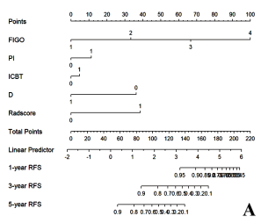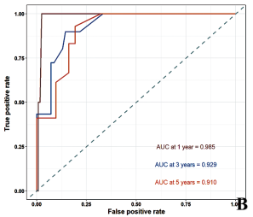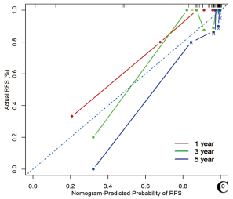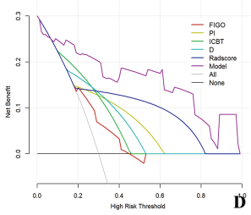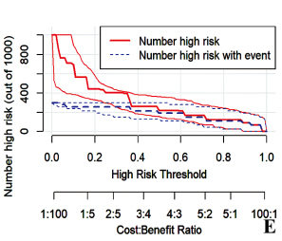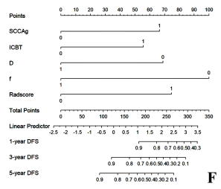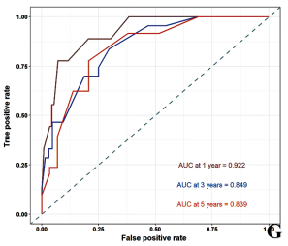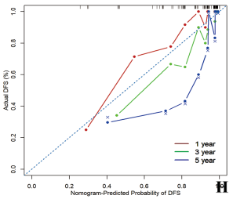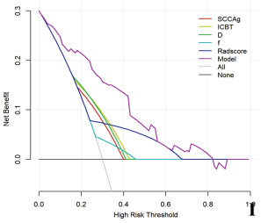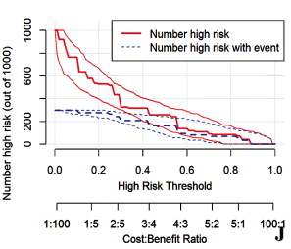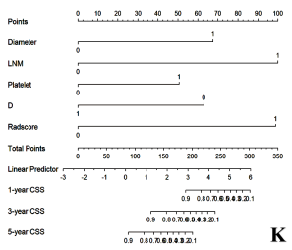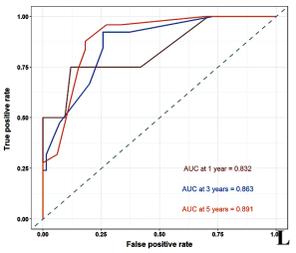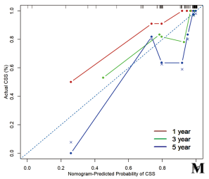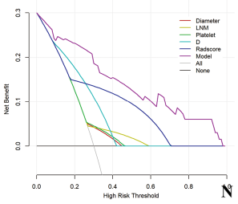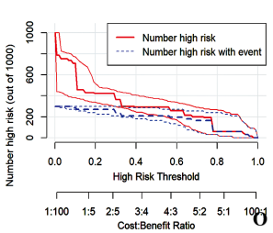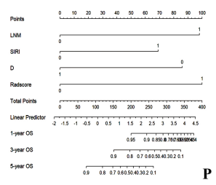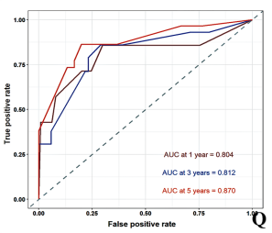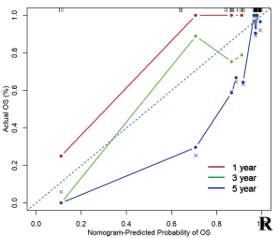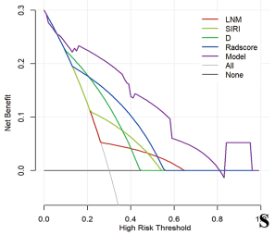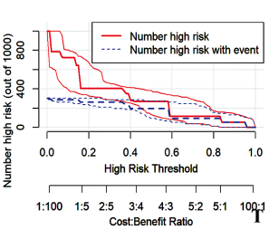
Figure S1 Nomograms and correlation test curves for each model. A-E, F-J, K-O and P-T are the nomograms, ROC curves, calibration curves, decision curves, and clinical impact curves of models for predicting postoperative RFS, PFS, CSS and OS in cervical cancer patients. By calculating the sum of the scores of each factor in nomograms, the probability of 1-year, 3-year, 5-year RFS, PFS, CSS and OS could be calculated. The ROC curve allows an assessment of the predictive performance of models. The fit of the model can be assessed based on the overlap of the calibration curve with ideal curve (diagonal). In decision curve analysis, the net clinical benefit (Y-axis) at each threshold probability (X-axis) of the model can be assessed and compared with complete treatment (dashed line), no treatment (horizontal line) and each parameter. In clinical impact curves, the red curve indicates the number of people classified as positive by the model at each threshold probability, and the blue curve shows the number of genuinely positive people, where the overlap between gives a visual indication of the predictive accuracy of models.

