Figure S1. Standardized levels of Serum Sex Hormones and SHBG by sex and diabetes status
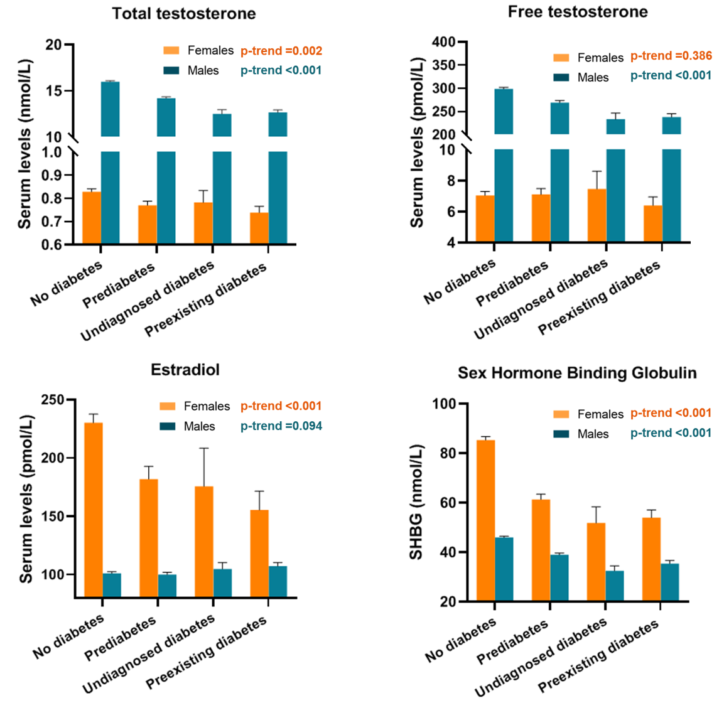
The estimates of sex hormones and SHBG were weighted with the complex sampling design. The difference in biomarkers across diabetic status was assessed by the weighted linear regressi

Table S1. HRs for heart-specific mortality per each unit increase in log2-transformed MMA among adults with diabetes
 |  | Events/  person-yearsª | Mortality rate^{b} | Age-Adjusted |  | Multivariable-Adjusted |  | p-interaction
 |  | Events/  person-yearsª | Mortality rate^{b} | HR (95%CI) | p value | HR (95%CI) | p value
No diabetes |  |  |  |  |  |  |  | 0.540
 | Females | 95/73,992 | 0.87 (0.69-1.12) | 1.58 (1.23-2.02) | <0.001 | 1.32 (1.00-1.75) | 0.052
 | Males | 132/69,463 | 1.10 (0.89-1.38) | 1.33 (1.00-1.76) | 0.047 | 1.34 (0.99-1.81) | 0.06
Prediabetes |  |  |  |  |  |  |  | 0.439
 | Females | 65/18,222 | 2.63 (1.93-3.67) | 1.33 (0.84-2.09) | 0.218 | 1.06 (0.65-1.72) | 0.82
 | Males | 94/20,060 | 2.87 (2.26-3.70) | 1.34 (1.06-1.69) | 0.017 | 1.12 (0.82-1.53) | 0.463
Undiagnosed diabetes |  |  |  |  |  |  |  | 0.220
 | Females | 13/2,518 | 3.97 (2.13-8.25) | 1.71 (1.12-2.62) | 0.014 | 0.80 (0.47-1.38) | 0.418
 | Males | 22/3,148 | 6.32 (3.65-11.91) | 2.49 (1.02-6.04) | 0.044 | 1.58 (0.58-4.31) | 0.370
Preexisting Diabetes |  |  |  |  |  |  |  | 0.045
 | Females | 62/8,720 | 6.99 (5.14-9.75) | 1.38 (1.09-1.75) | 0.009 | 1.23 (0.76-1.97) | 0.391
 | Males | 107/8,484 | 11.14 (8.65-14.58) | 1.95 (1.65-2.30) | <0.001 | 1.86 (1.47-2.36) | <0.001
ª unweighted, ^{b} weighted rate per 1000 person-year. Sex-speciﬁc HR (95%CI) was estimated by weighted Cox regression. The age-adjusted model was adjusted for age. The multivariable-adjusted model was additionally adjusted for race/ethnicity, smoking status, physical activity, BMI, hypertension, cancer, CVD, TC/HDL-C ratio, eGFR, HbA1c, and serum cobalamin.

Table S2. Diabetes-related variables at basline by sex
Variables | Females | Males | p value
Duration of diabetes (year) | 12.0 ± 0.40 | 11.1 ± 0.40 | 0.118
Diabetic complications (%) | 31.29 | 34.08 | 0.262
Retinopathy (%) | 19.26 | 20.55 | 0.507
Foot ulcer/sore (%) | 3.42 | 4.95 | 0.185
Peripheral neuropathy (%) | 17.29 | 16.72 | 0.763
UACR (mg/g) | 113.6 ± 17.66 | 192.1 ± 21.94 | 0.006
Metformin use (%) | 47.75 | 50.83 | 0.267
UACR, urinary albumin-to-creatinine ratio. Categorical and continuous variables were presented as weighted proportions or means (SE) using the chi-square test and Student's t-test, respectively.

Table S3. The HRs for all-cause and heart-specific mortality per each unit increase in log2-transformed MMA after additional adjustment for diabetes-related variables
 | All-cause mortality |  |  | Heart-specific mortality
Sex | HR (95%CI) | p value | p interaction | HR (95%CI) | p value | p interaction
Females (n=1250) | 1.08 (0.93-1.26) | 0.319 | 0.031 | 1.12 (0.66-1.89) | 0.669 | 0.036
Males (n=1285) | 1.41 (1.18-1.69) | <0.001 | 0.031 | 1.72 (1.33-2.22) | <0.001 | 0.036
Sex-speciﬁc HR (95%CI) was estimated by weighted Cox regression analyses after adjustment for age race/ethnicity, smoking, physical activity, BMI, hypertension, cancer, CVD, TC/HDL-C ratio, eGFR, HbA1c, Vitamin B12, metformin use, lipid-lowering agents, duration of diabetes, UACR, ACEI/ARBs, and diabetic complications. P for interaction was assessed by the survey-weighted Wald test

Table S4. Correlations of methylmalonic acid with serum sex hormones and SHBG by sex and diabetes status
 | Females |  |  |  | Males
Sex hormone profiles | No diabetes | Prediabetes | Undiagnosed diabetes | Preexisting diabetes | No diabetes | Prediabetes | Undiagnosed diabetes | Preexisting diabetes
Total testosterone, nmol/L  (n= 11,232) | -0.156 | -0.106 | -0.023 | -0.073 | -0.095 | -0.090 | 0.016 | -0.061
Free testosterone, pmol/L  (n= 5,797) | -0.141 | -0.174 | 0.056 | -0.077 | -0.125 | -0.115 | -0.120 | -0.075
Estradiol, pmol/L  (n= 6,309) | -0.229 | -0.353 | -0.230 | -0.185 | -0.062 | -0.089 | 0.061 | 0.111
SHBG, nmol/L  (n= 5,797) | 0.141 | 0.206 | 0.287 | 0.127 | 0.219 | 0.164 | 0.193 | 0.164
The study population was restricted to those with at least one eligible indicator including total testosterone, free testosterone, estradiol or SHBG.
SHBG, Sex hormone–binding globulin. Correlation coefficients were estimated by the spearman method. After Bonferroni correction, the P value ≤ 0.0016 was considered significant.

Table S5. Spearman's rho between methylmalonic acid and sex hormones in females by menopause status
Sex hormone profiles | No menopause |  | Menopause
Sex hormone profiles | Samples | Spearman's rho | Samples | Spearman's rho
Total testosterone, nmol/L | 2961 | -0.104 | 2197 | -0.056
Free testosterone, pmol/L | 1372 | -0.124 | 1078 | -0.156
Estradiol, pmol/L | 1553 | -0.158 | 1131 | -0.131
SHBG, nmol/L | 1372 | 0.108 | 1078 | 0.139
The study population was restricted to those with at least one eligible indicator including total testosterone, free testosterone, estradiol or SHBG.
SHBG, Sex hormone–binding globulin. Correlation coefficients were estimated by the spearman method. All P values ≤ 0.05.

Table S6. Sex-specific HRs for the relationship between MMA and mortality after adjustment for sex hormones
 | Females (n= 2,319) |  | Males (n= 3,215)
 | HR (95%CI) | p value | HR (95%CI) | p value
Basic Model* | 1.38 (0.86-2.21) | 0.182 | 1.30 (1.11-1.53) | 0.001
Plus Total testosterone | 1.36 (0.85-2.19) | 0.200 | 1.31 (1.11-1.54) | 0.001
Plus Free testosterone | 1.36 (0.85-2.18) | 0.204 | 1.31 (1.12-1.54) | 0.001
Plus Estradiol | 1.38 (0.86-2.21) | 0.182 | 1.30 (1.11-1.53) | 0.001
Plus SHBG | 1.36 (0.85-2.20) | 0.202 | 1.30 (1.11-1.53) | 0.001
Plus Free testosterone and Estradiol | 1.36 (0.84-2.17) | 0.207 | 1.31 (1.12-1.54) | 0.001
The study population was restricted to those who had completed data on total testosterone, free testosterone, estradiol and SHBG. Sex-speciﬁc HR (95%CI) was estimated by weighted Cox regression analyses for the association of a doubling in MMA with mortality risk. The Basic Model was adjusted for diabetes status, age, race/ethnicity, smoking, BMI, physical activity, menopause (for females), hypertension, cancer, CVD, TC/HDL-C ratio, eGFR, HbA1c, and Vitamin B12.

