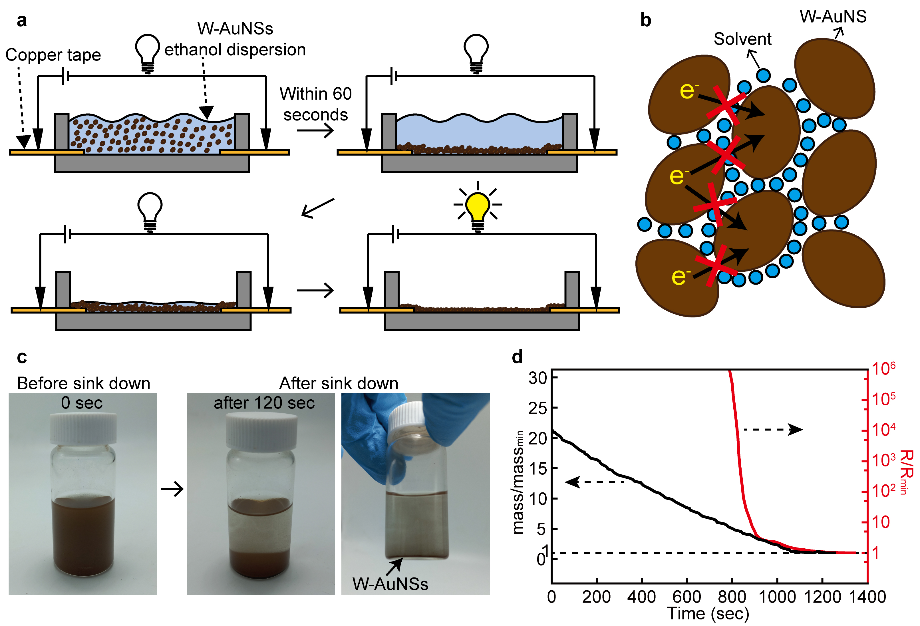

Extended Data Fig. 1. Effect of solvent on contact resistance between W-AuNSs. (a) Schematic illustration of the experimental procedure. (b) Schematic illustration of the solvent molecules disturbing electron transfer between W-AuNSs. (c) Optical images of W-AuNSs dispersed in ethanol before and after the sedimentation of W-AuNSs. (d) Mass change of the W-AuNS solution (mass/mass_{min}: measured mass/minimum mass) and corresponding resistance change of the W-AuNS solution (R/R_{min}: measured resistance/minimum resistance). The measurement was performed in the mold shown in (a).

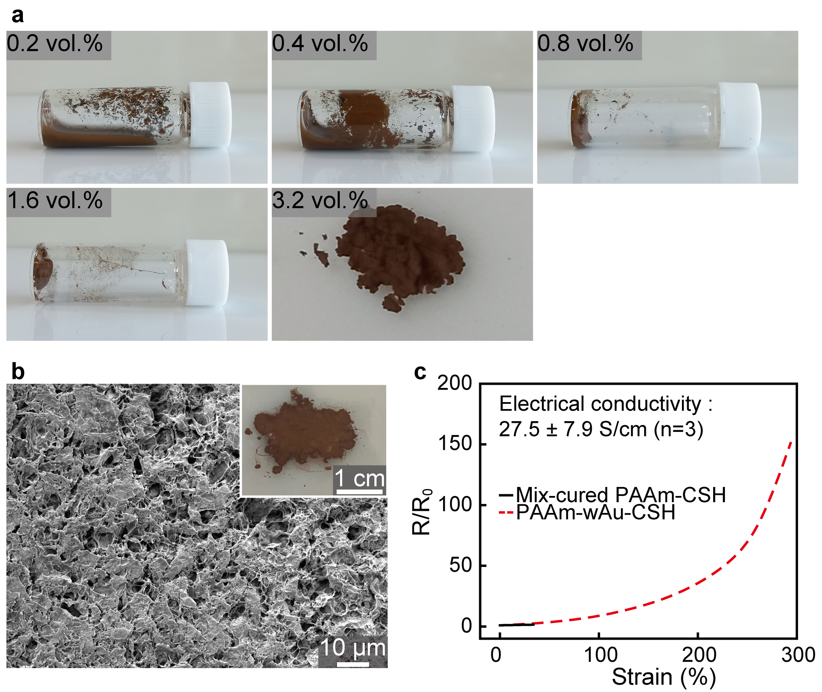
Extended Data Fig. 2. Curing of the hydrogel solution with W-AuNSs. (a) Optical images of the mixture of W-AuNSs and PAAm hydrogel solution. Numbers written in the images indicate the volume percent of W-AuNSs in the mixture. (b) SEM and optical (inset) image of the cured hydrogel composite, which was prepared by simple mixing of W-AuNSs and hydrogel. (c) Resistance change (R/R₀; R₀: initial resistance, R: instantaneous resistance) of the hydrogel composite under tensile strain. The conductivity of PAAm-CSH prepared by simple mixing (~ 27.5 S/cm) is far lower than the conductivity of PAAm-wAu-CSH (~ 520 S/cm).
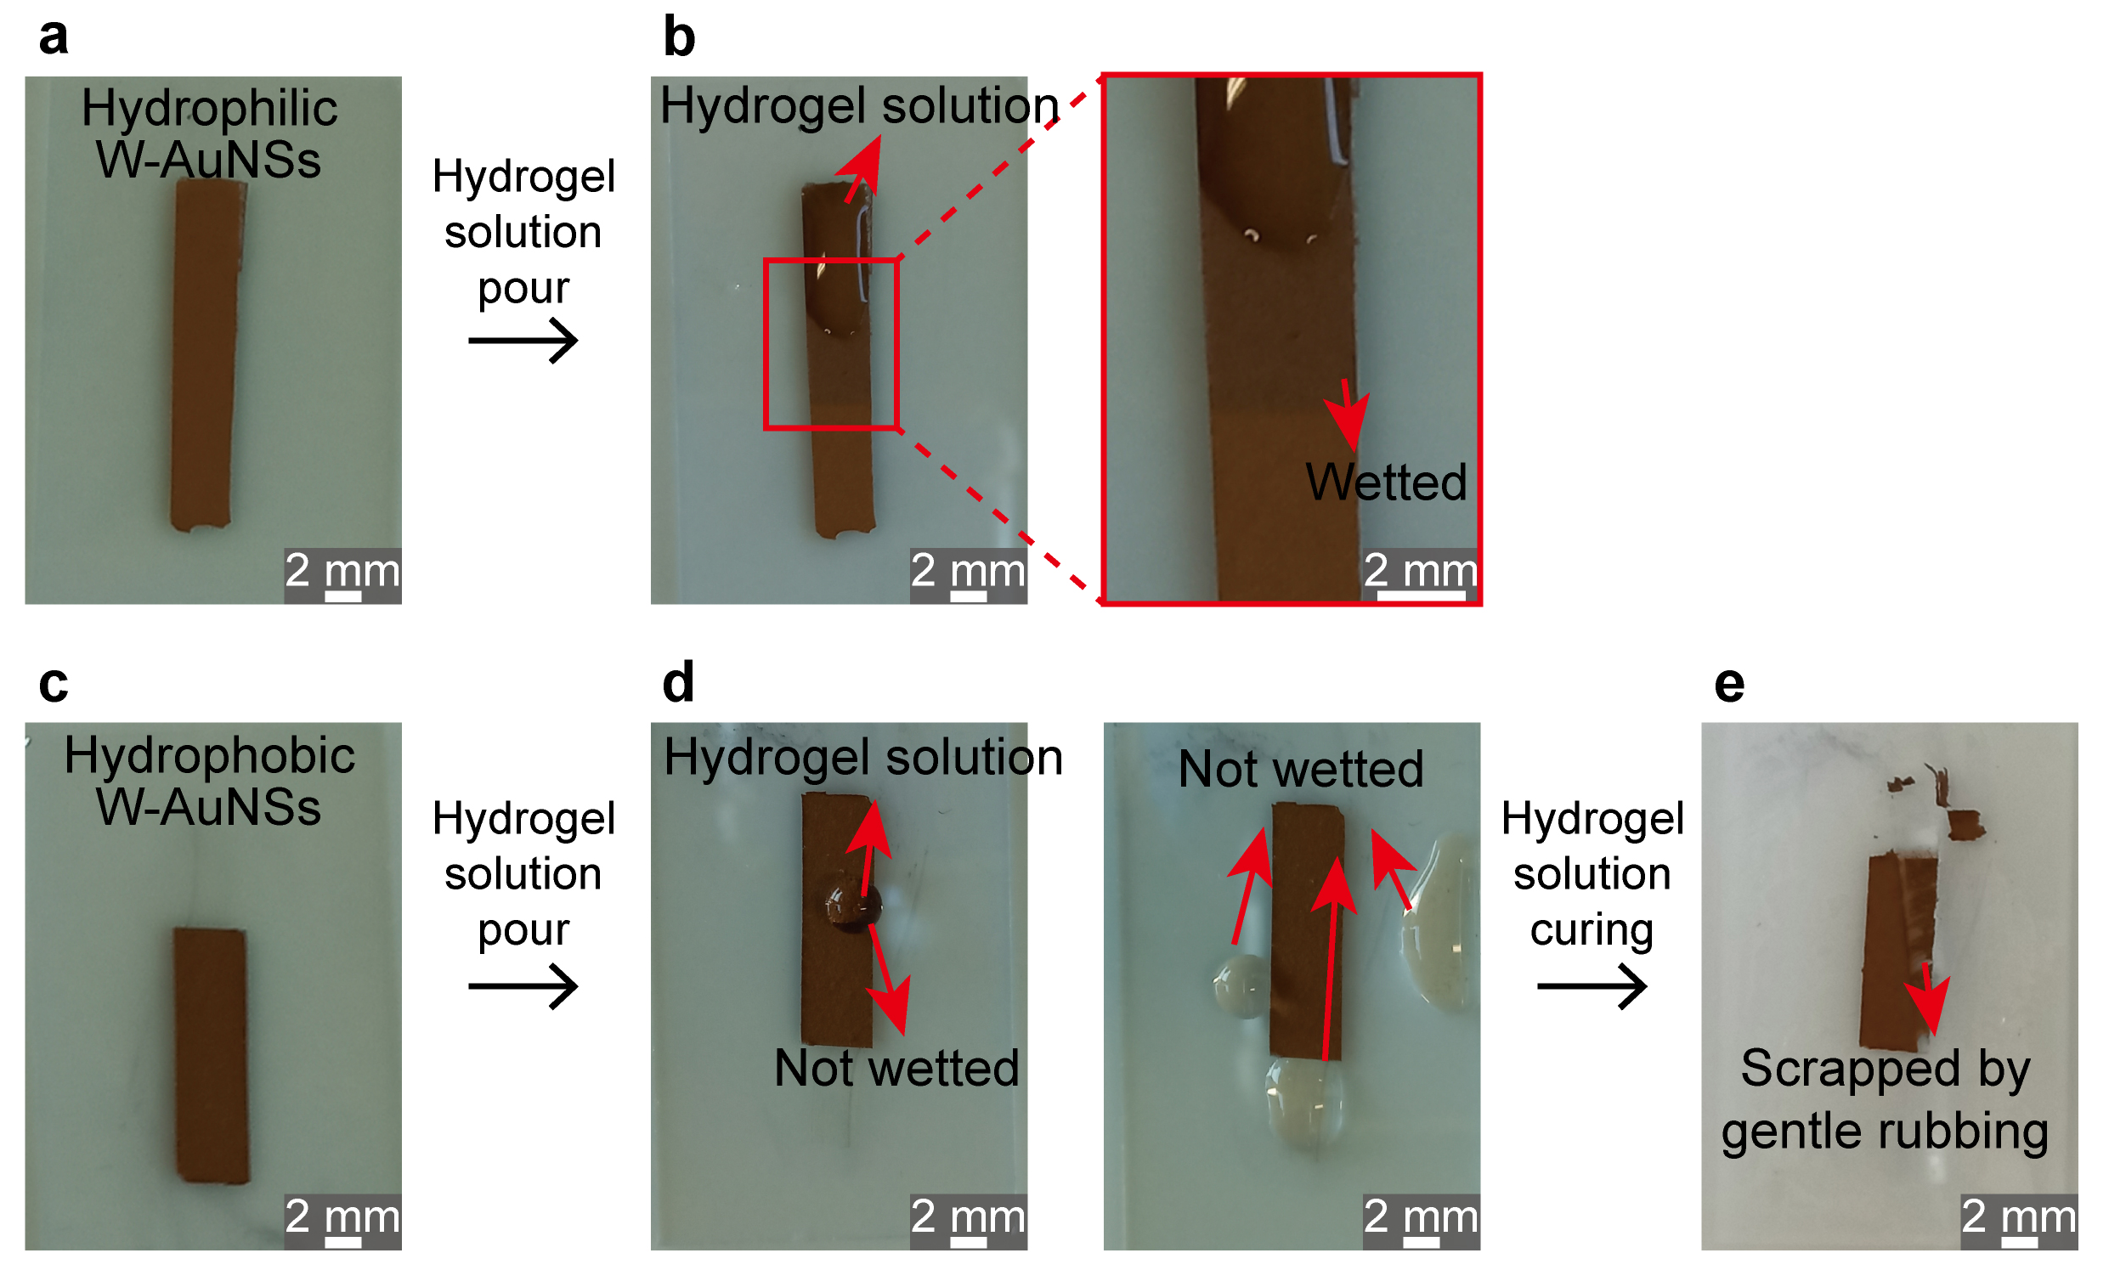
Extended Data Fig. 3. Effect of the surface property of W-AuNSs on wAu-CSHs. (a, b) Optical camera images of the hydrophilic W-AuNS network before pouring a hydrogel solution (a) and after pouring a hydrogel solution (b). (c-e) Optical camera images of the hydrophobic W-AuNS network before pouring a hydrogel solution (c), after pouring a hydrogel solution (d), and after the hydrogel solution is cured (e). Since the hydrogel solution cannot wet the hydrophobic W-AuNS network, the network cannot form a composite with the hydrogel. In fact, the W-AuNS network is fractured by gentle rubbing with a tweezer even after the hydrogel solution is cured, showing that the cured composite is not stretchable.

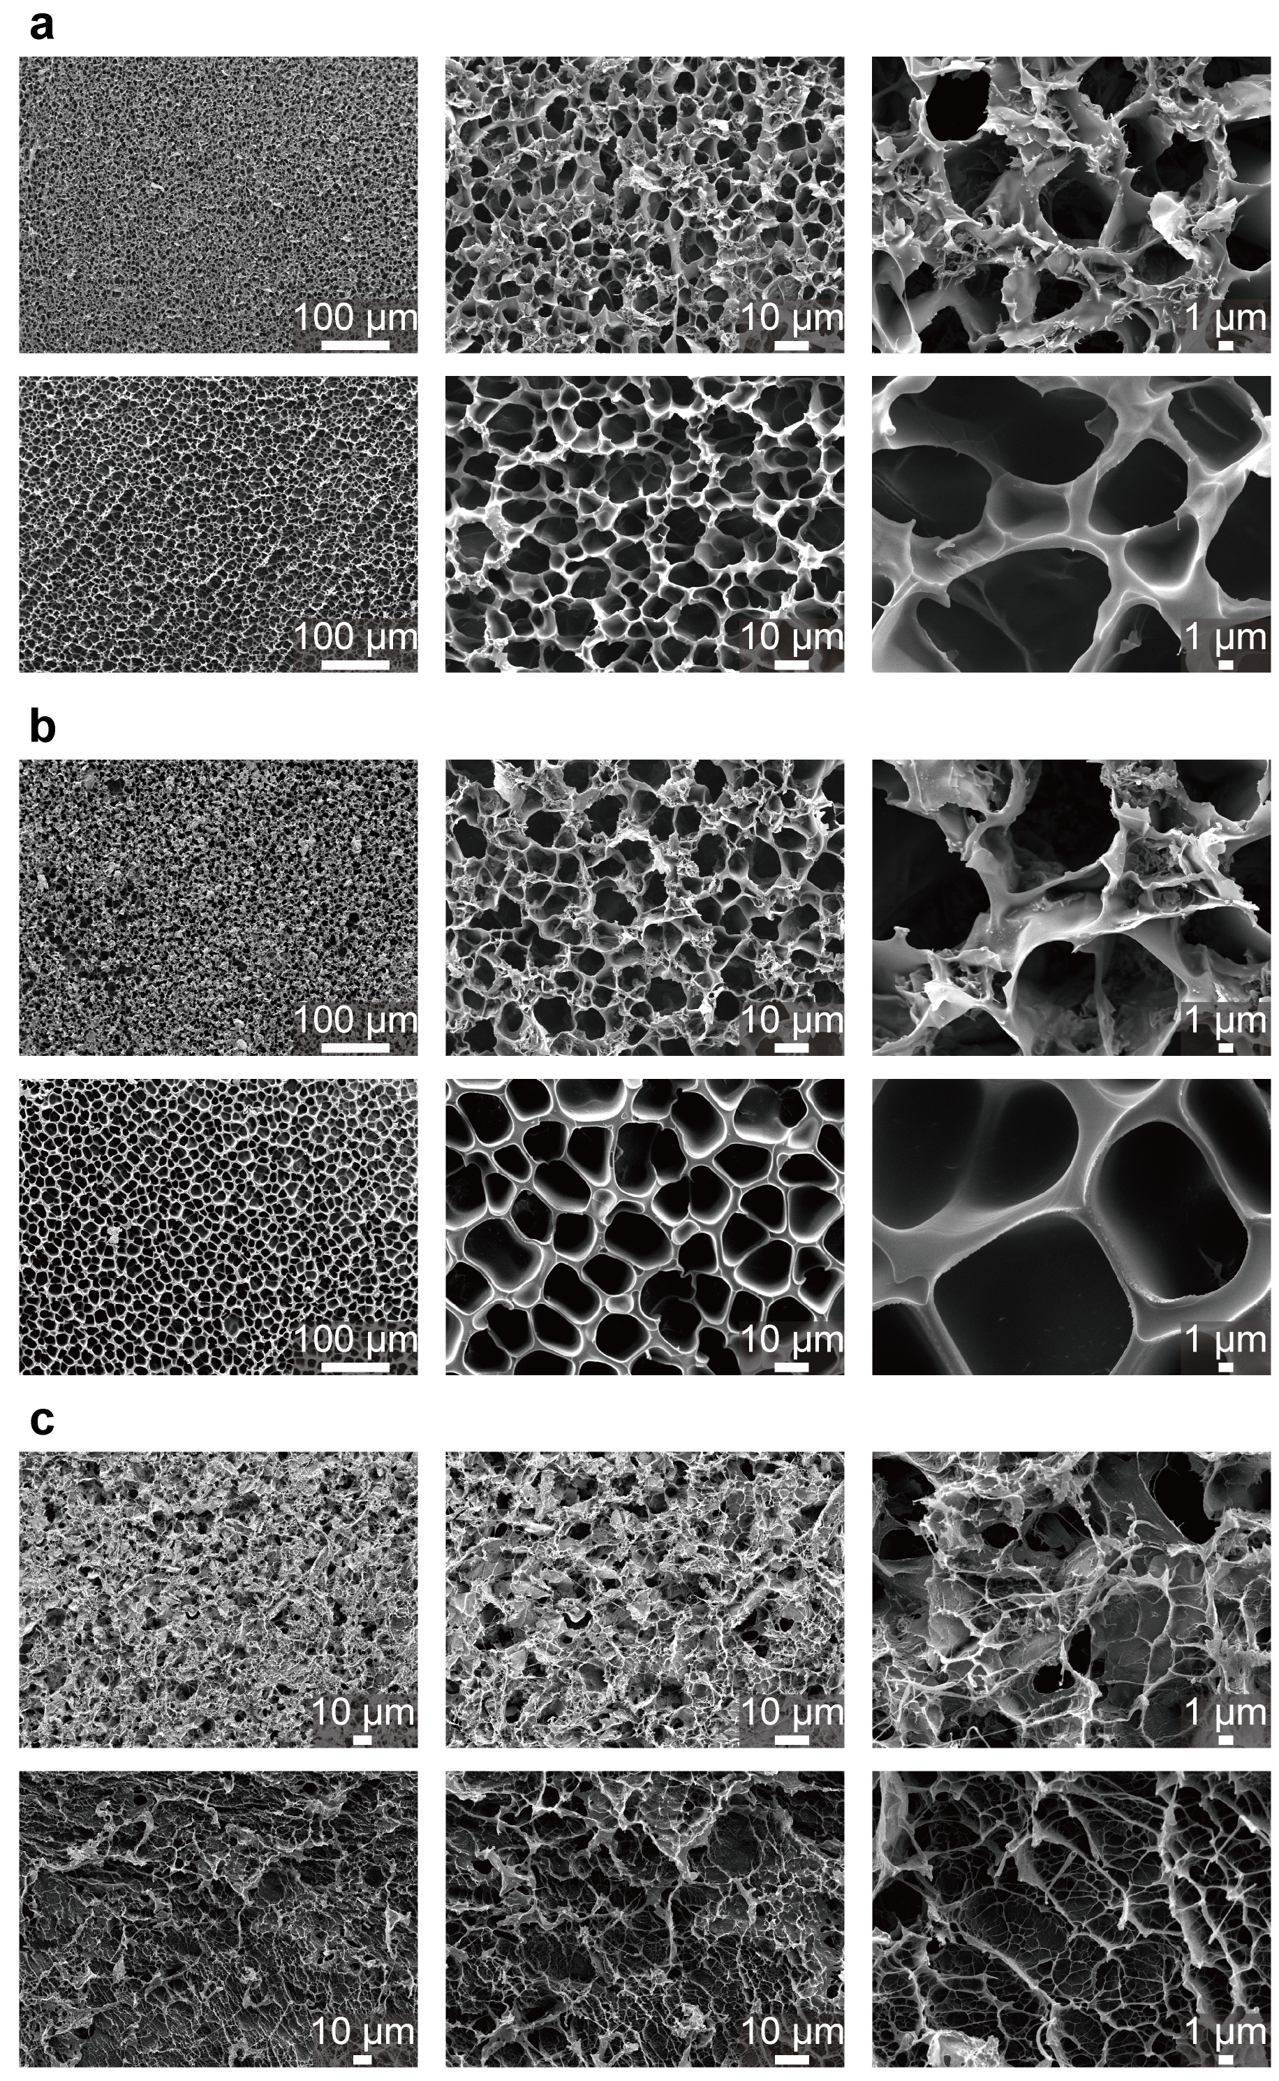
Extended Data Fig. 4. SEM images of wAu-CSHs and bare hydrogels. (a) PAAm-wAu-CSH (top) and PAAm hydrogel (bottom). (b) PAA-wAu-CSH (top) and PAA hydrogel (bottom). (c) PVA-wAu-CSH (top) and PVA hydrogel (bottom).

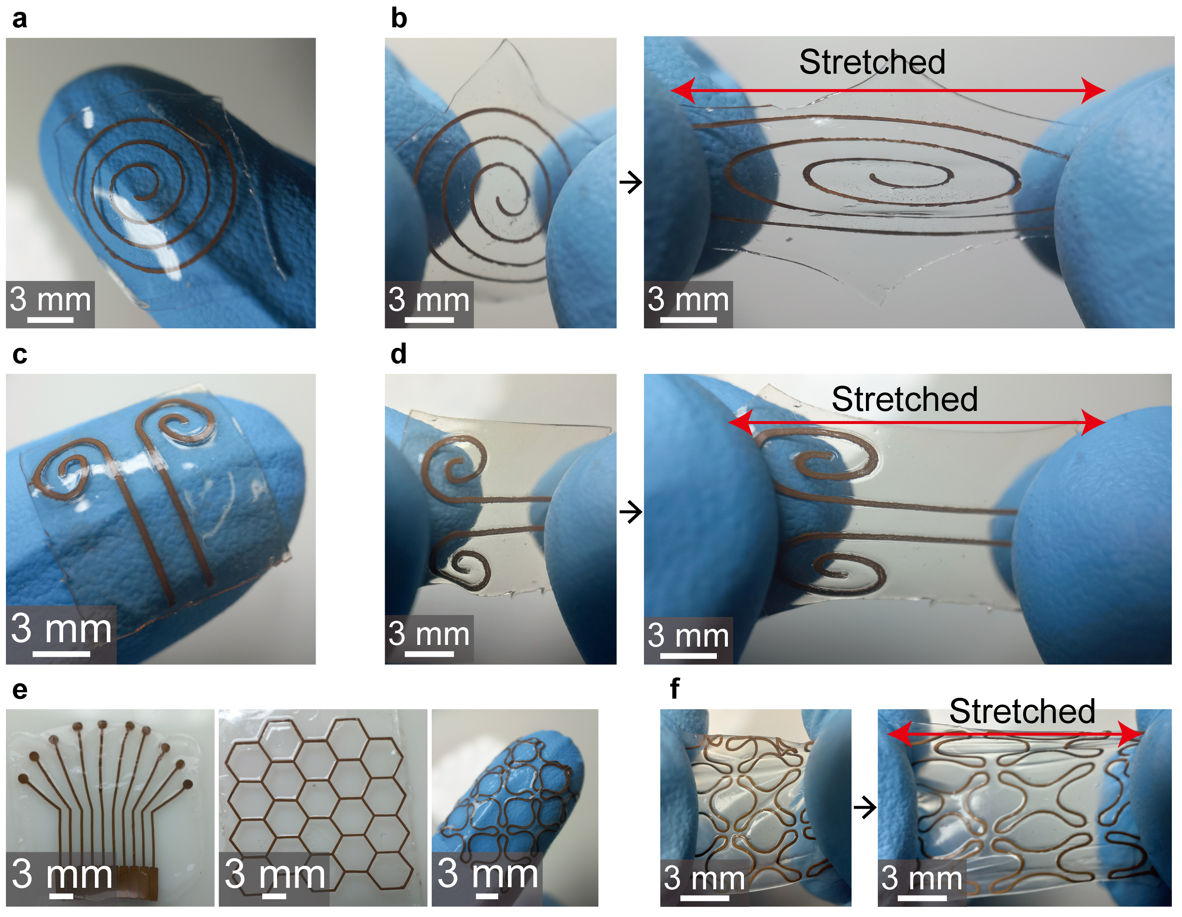
Extended Data Fig. 5. Patterned wAu-CSHs. (a-f) Optical images of patterned PAAm-wAu-CSHs (a, b), patterned PAA-wAu-CSHs (c, d), and patterned PVA-wAu-CSHs (e, f).

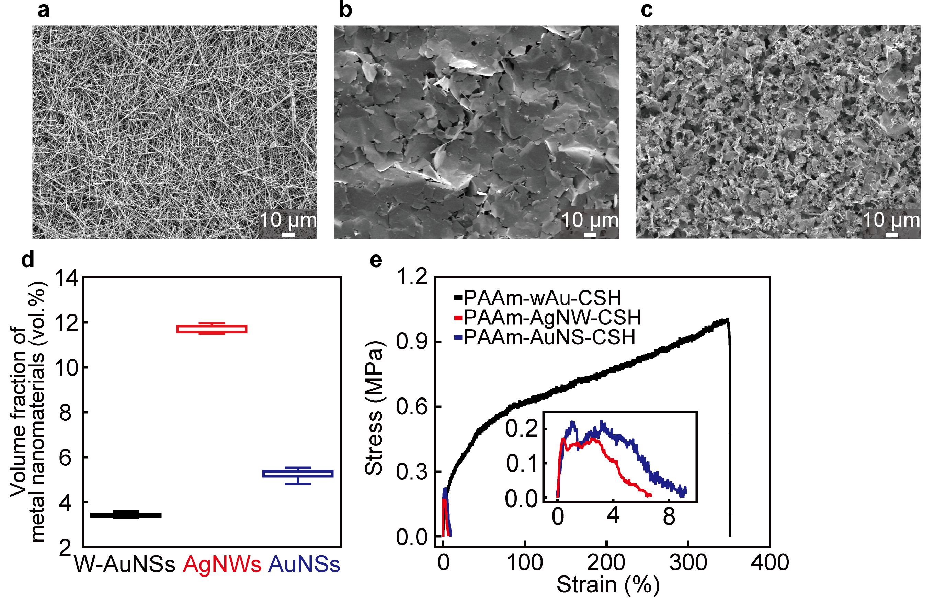
Extended Data Fig. 6. Fabrication of CSHs with conventional metal nanomaterials. (a-c) SEM images of a dried silver nanowire (AgNW) network (a), dried gold nanosheet (AuNS) network (b), dried whiskered gold nanosheet (W-AuNS) network (c). (d) Volume fraction of the dried network of W-AuNSs, AgNWs, and AuNSs. (e) Stress-strain curve of PAAm-CSHs whose metal filler is AgNW (PAAm-AgNW-CSH), AuNS (PAAm-AuNS-CSH), and W-AuNS (PAAm-wAu-CSH).
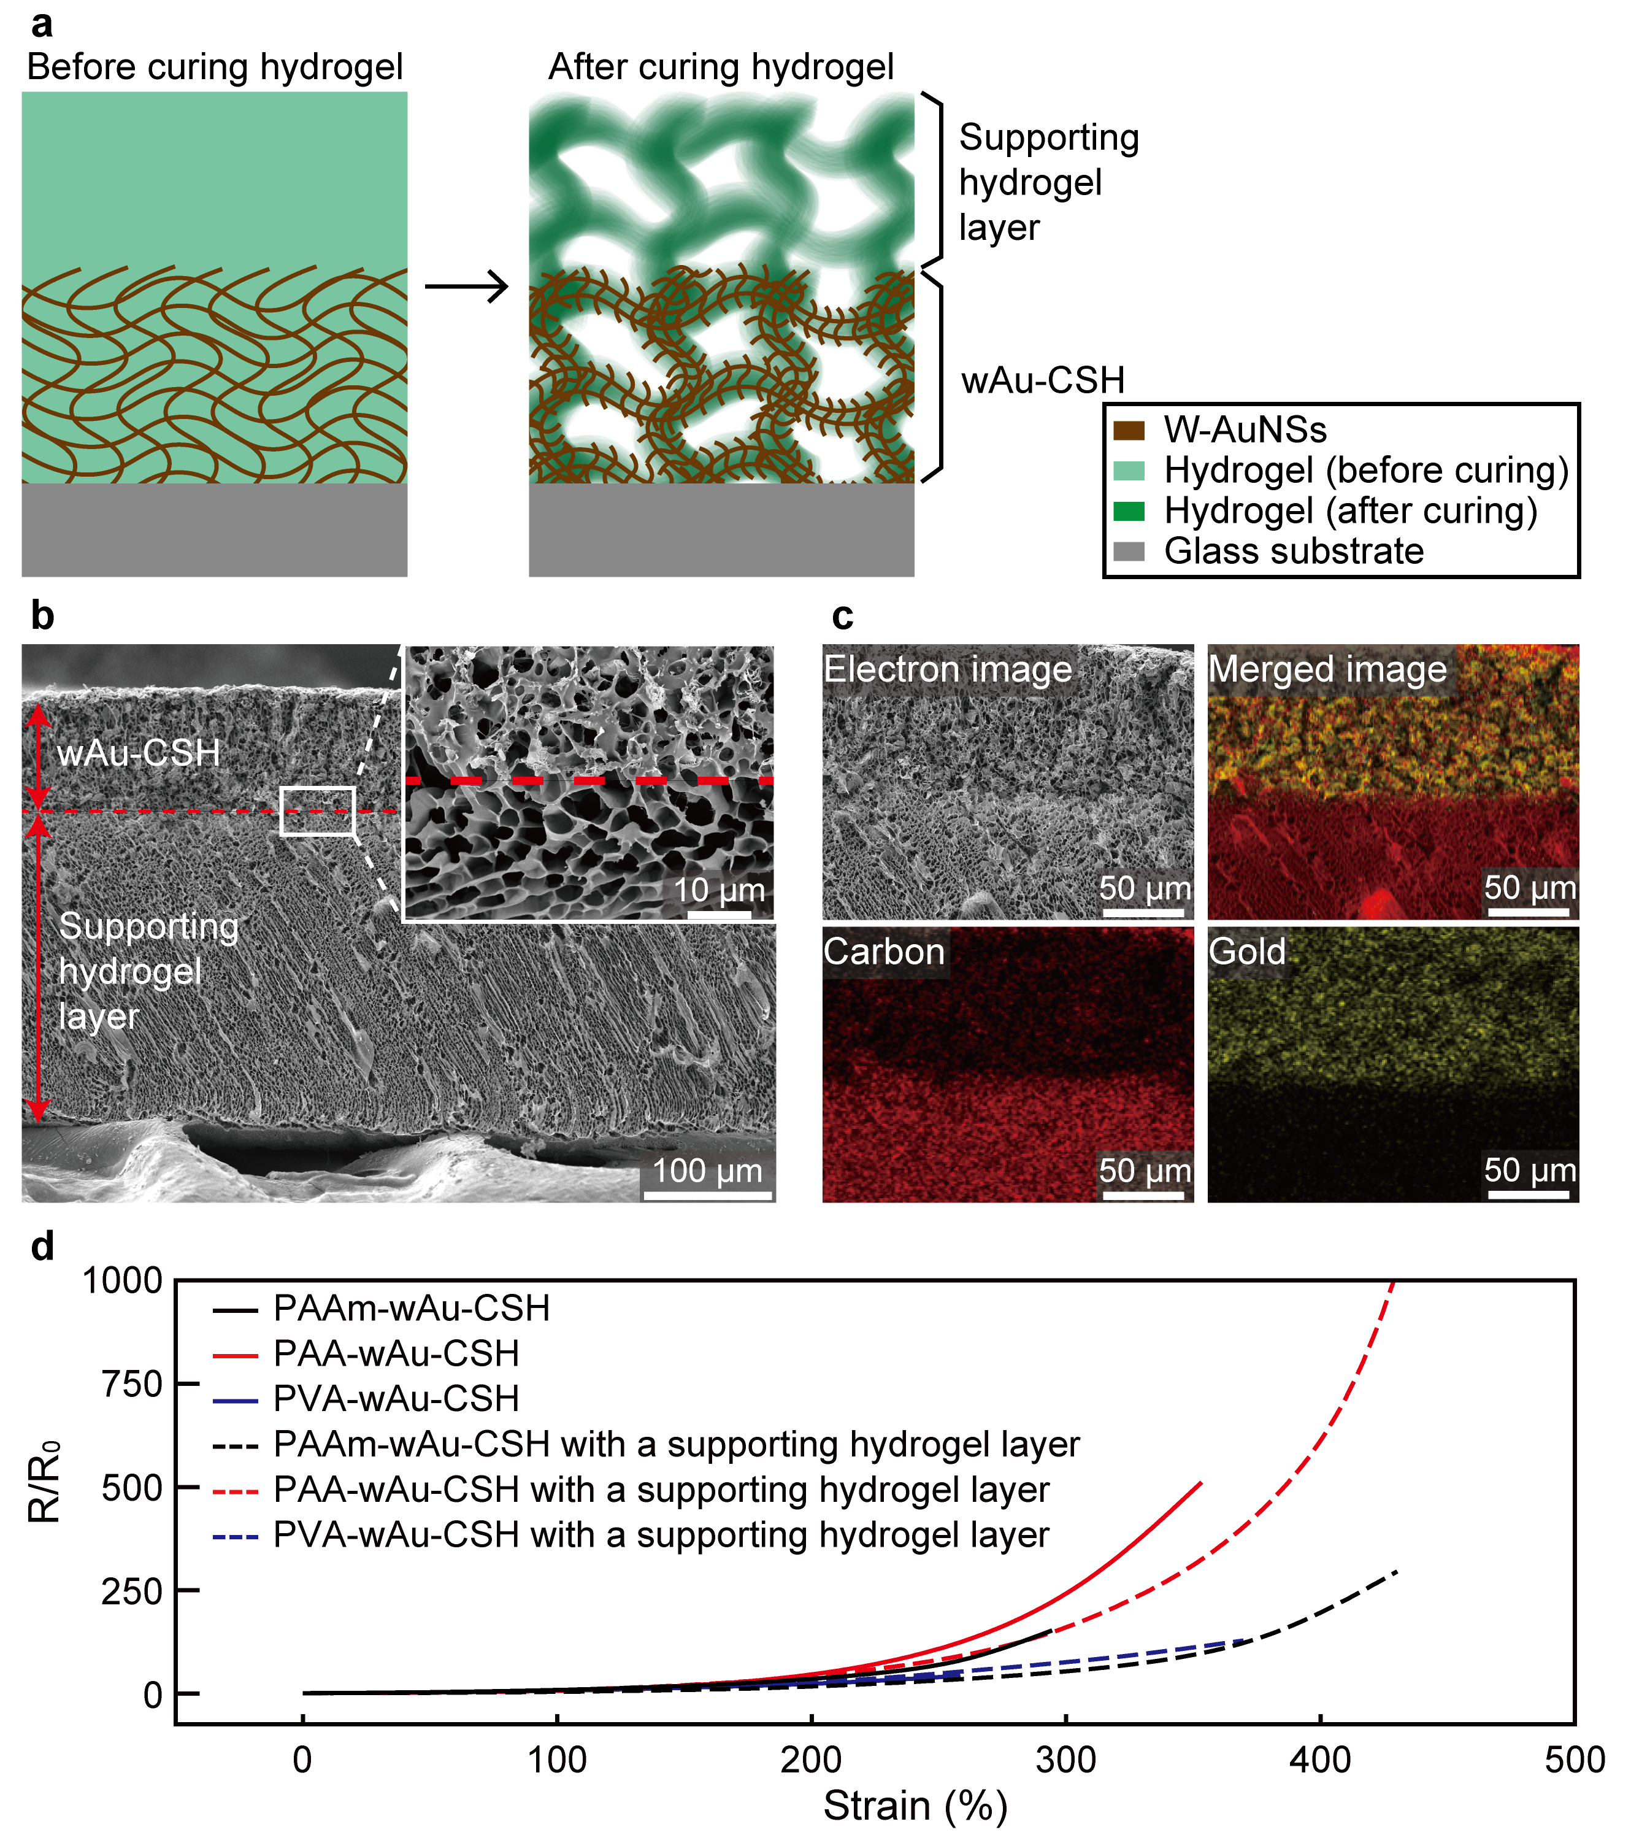
Extended Data Fig. 7. wAu-CSHs with a supporting hydrogel layer. (a) Schematic illustrations of the fabrication process of wAu-CSHs with the supporting hydrogel layer. (b, c) Cross-sectional SEM images (b) and EDS images (c) of PAAm-wAu-CSH with the supporting hydrogel layer. (d) Resistance change (R/R₀; R₀: initial resistance, R: instantaneous resistance) of the wAu-CSHs with or without the supporting hydrogel layer under tensile strain.
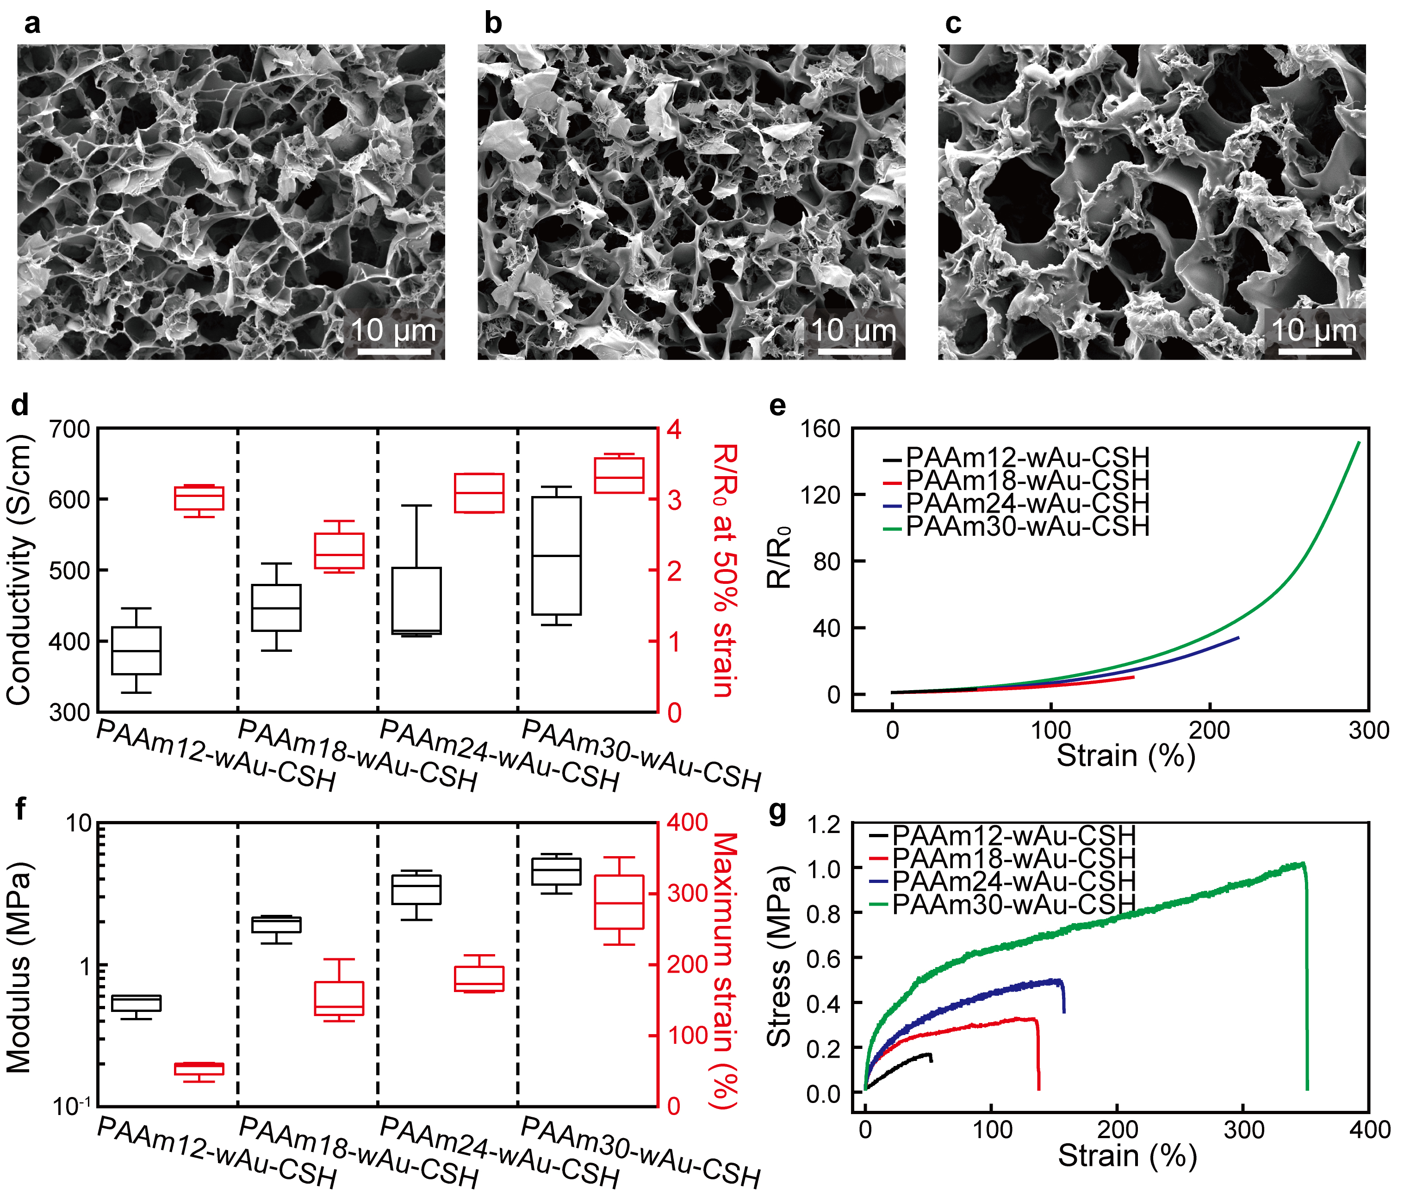
Extended Data Fig. 8. Characterization of PAAm-wAu-CSHs with different hydrogel weight fractions. (a-c) SEM images of PAAm12-wAu-CSHs (a), PAAm18-wAu-CSHs (b), and PAAm24-wAu-CSHs (c). The numbers following PAAm indicate the weight fraction of the hydrogel monomer. (d, e) Electrical properties of PAAm-wAu-CSHs. Conductivity (black) and resistance change (R/R₀; R₀: initial resistance, R: instantaneous resistance) at 50% strain (red) (d), and resistance change under tensile strain (e) of PAAm-wAu-CSHs. (f, g) Mechanical properties of PAAm-wAu-CSHs. Modulus (black) and maximum strain (red) (f), and stress-strain curves (g) of PAAm-wAu-CSHs.

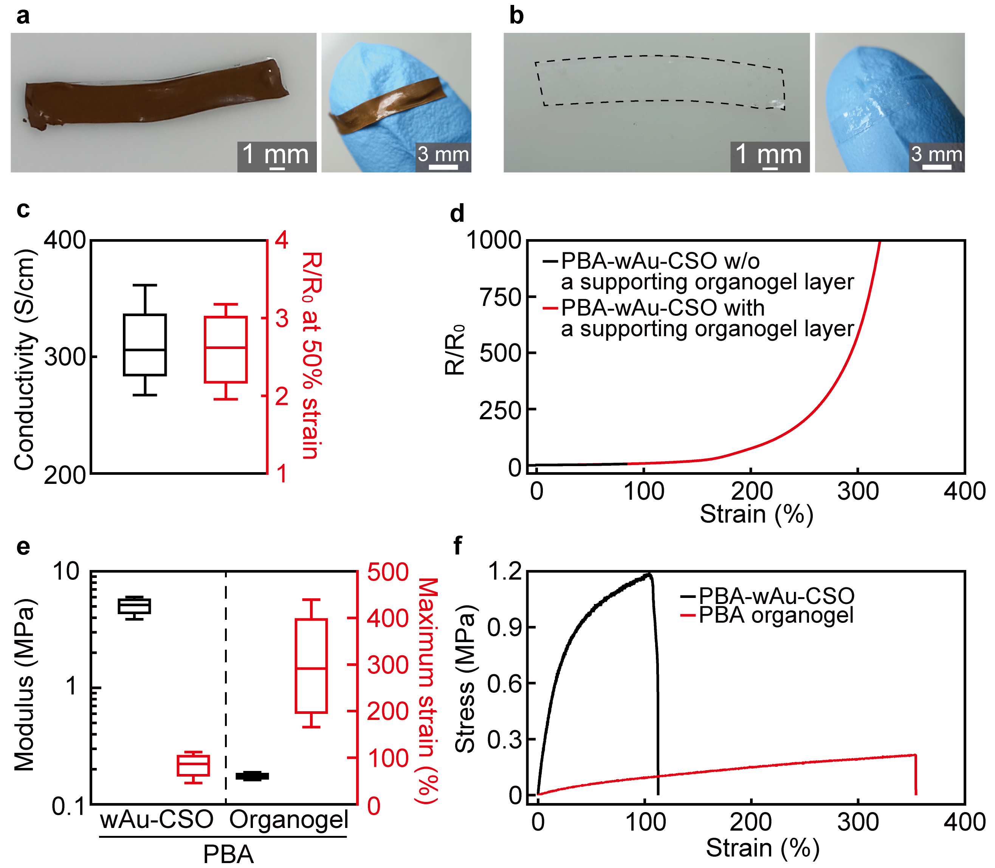
Extended Data Fig. 9. Electrical and mechanical properties of PBA-wAu-CSOs. (a, b) Optical camera images of PBA-wAu-CSOs (a) and PBA organogels (b). (c) Conductivity (black) and resistance change (R/R₀; R₀: initial resistance, R: instantaneous resistance) at 50% strain (red). (d) R/R₀ of PBA-wAu-CSOs with or without a supporting organogel layer under tensile strain. (e, f) Modulus (black) and maximum strain (red) (e) and stress-strain curves (f) of PBA-wAu-CSOs and PBA organogels.
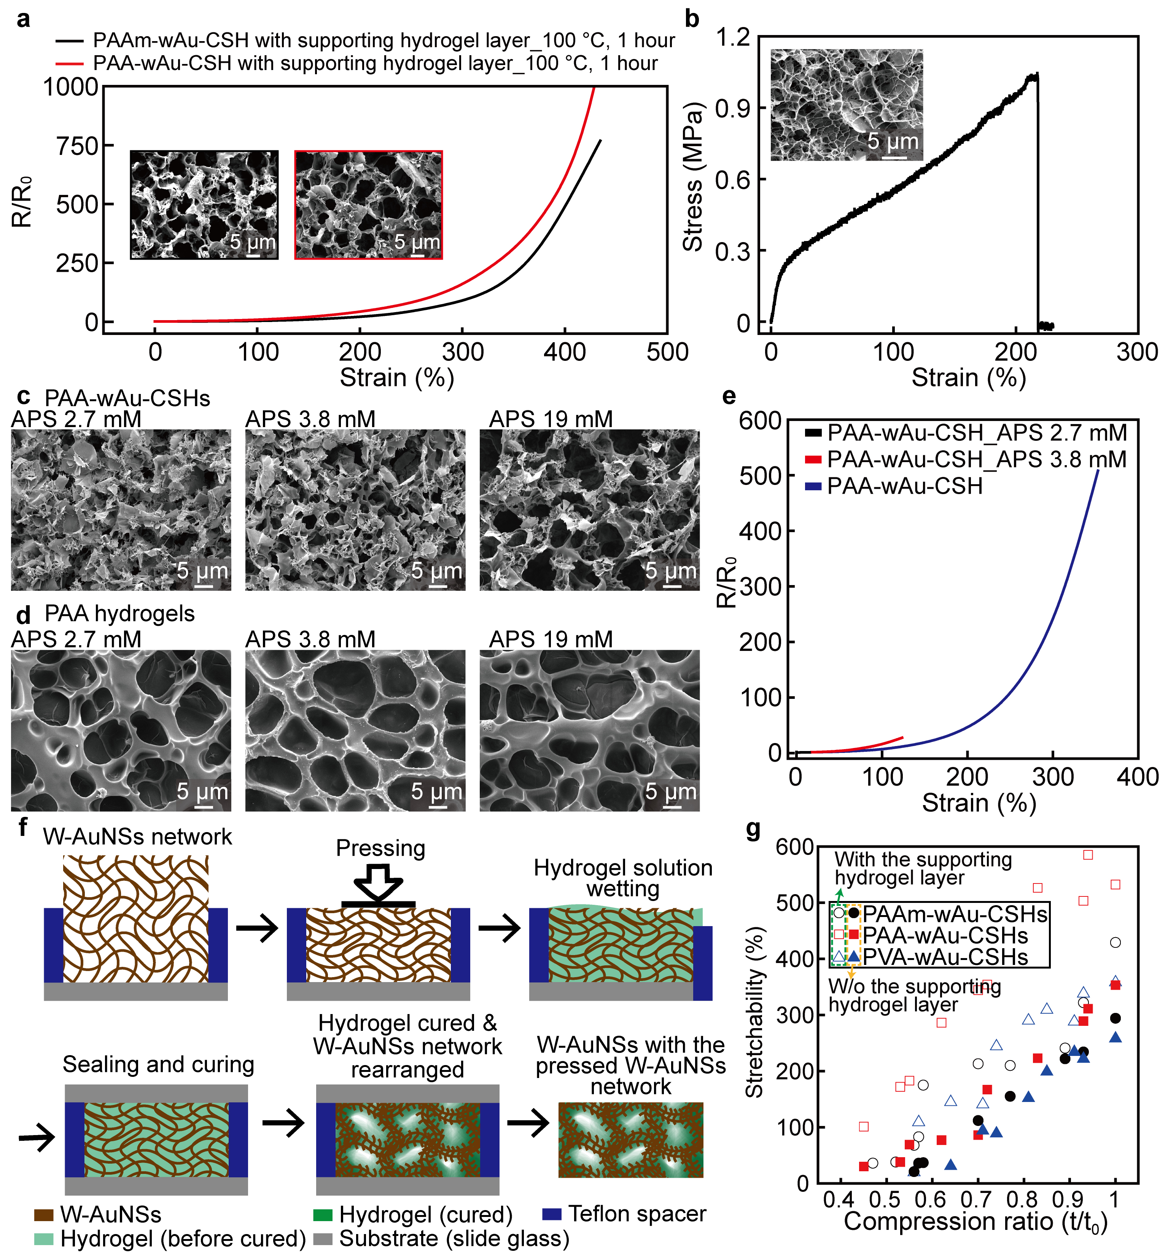
Extended Data Fig. 10. Electrical and mechanical properties of various wAu-CSHs, and fabrication process of wAu-CSHs with the pressed W-AuNS network. (a) Resistance change (R/R₀; R₀: initial resistance, R: instantaneous resistance) under tensile strain of PAAm-wAu-CSHs and PAA-wAu-CSHs with a supporting hydrogel layer fabricated by using the W-AuNS network thermally treated at 100 ℃ for 1 hour. Insets show SEM images of PAAm-wAu-CSH (black box) and PAA-wAu-CSH (red box). (b) Stress-strain curve of PVA-wAu-CSH fabricated with 15 wt% PVA monomer. The inset shows a SEM image of PVA-wAu-CSH. (c, d) SEM images of PAA-wAu-CSHs (c) and PAA hydrogels (d) fabricated with different initiator concentrations. (e) R/R₀ of PAA-wAu-CSHs fabricated with different initiator concentrations under tensile strain. (f) Schematic illustrations of wAu-CSHs with the pressed W-AuNS network. (g) Stretchability of wAu-CSHs with the pressed W-AuNS network for various C.R. with (empty points) or without (filled points) the supporting hydrogel layer.

