Table 1 Deformation and failure characteristics of the surrounding rock of the 7312 head entry
Failure  type | Asymmetric deformation of roof | Deformation of the coal pillar side |  | Deformation of the solid coal side
On-site  failure | 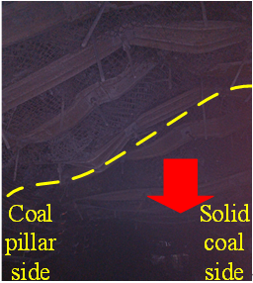 | 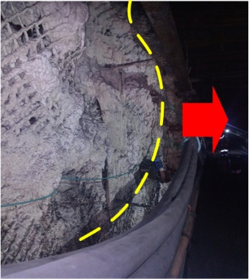 |  | 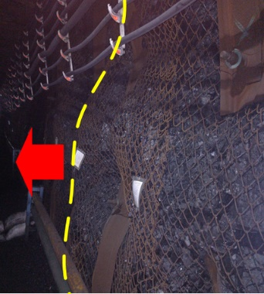
Sketch
Failure  type | Floor heave |  | Failure of support components
On-site  failure | 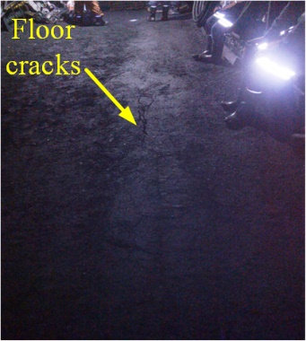 |  | 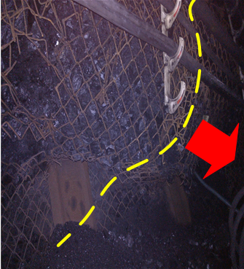
Sketch

