Appendix. Additional tables and figures
Table A1. Table of integrated distribution accounts nomenclature
Table of integrated distributional accounts |  |  |  | Table of integrated economic accounts
DNA | First level |  | Second level
A | Net national income before transfers (1+2+3+4) |  |  | S1 | B5n
1 | Gross labor income |  | 1.1 Net Wages  1.2 Social Contributions | S14 | D1
2 | Net mixed income and property income |  | 2.1 Net mixed income  2.2 Net property income  2.3 Actual and fictitious rents, net of charges | S14  S14 net  S14 | B3n  D4  B2n
3 | Retained earnings and other corporate |  | 3.1 Retained earnings net of corporate income tax  3.2 Corporate income tax  3.3 Other corporate transfers (fraud) | S11+S12+S15  S11+S12  S11+S12 net | B5n-D5-S7  D5  D6+D7
A.fac | Factor income (= 1+2+3)
4 |  | Primary income of the public authorities | 4.1 Levies on production and consumption  4.2 Property inc. and net EBITDA (inc. interest paid) | S13  S13+S12 net | D2+D3, res.  D4
 |  | Monetary transfers (5.1+5.2+6+7+8+9)
5.1 |  | Taxes on products | 5.1.1 VAT  5.1.2 Oil and energy taxes  5.1.3 Alcohol, tobacco and insurance  5.1.4 Registration and construction  5.1.5 Other net subventions on products | S13  S13  S13  S13  S13 | D21N  D21N  D21N  D21N  D21N
5.2 |  | Taxes on production | 5.2.1 Corporate production taxes on wages  5.2.2 Corporate production tax on building  5.2.3 Household production tax (TFPB...)  5.2.4 Corporate subventions on wages (CICE) | S13+S2  S13+S2  S13+S2  S13+S2 | D2-D3  D2-D3  D2-D3  D2-D3
6 |  | Taxes on income and wealth | 6.1 Generalized Social Contribution  6.2 Households income tax  6.3 Corporate income tax  6.4 Housing tax  6.5 Solidarity tax on wealth  6.6 Social debt repay. (CRDS), wealth inc. social tax | S14  S14  S11+S12  S14  S15  S14 | D5  D5  D5  D5  D5  D5
7 |  | Social contributions | 7.1 Pensions  7.2 Health  7.3 Family  7.4 Unemployment  7.5 Specific welfare schemes | S14  S14  S14  S14  S14 | D61  D61  D61  D61  D61
8 |  | Benefits in cash | 8.1 Pensions  8.2 Unemployment  8.3 Family  8.4 Disability  8.5 Mutual  8.6 Compensation for daily sickness or accident at work | S14  S14  S14  S14  S14  S14 | D62  D62  D62  D62  D62  D62
9 |  | Other secondary transfers | 9.1 Other current transfers  9.2 Property income and net EBITDA | S14  S13 net | D7  D4+EBEn
B |  | Disposable income (1+2+3+4+5.1+5.2+6+7+8+9) |  | S14 | B6n
B.micro |  | Disposable income (usual micro definition: 1.1+2.1+2.2+6 -6.5+8)
 |  | Non-monetary transfers (10+11+12+13)
10 |  | Benefits in kind (individualizable social security transfers in kind) | 10.1 Health  10.2 Education  10.3 Social welfare  10.4 Cultural and associative activities  10.5 Housing allowances | S13  S13  S13  S13  S13 | D63  D63  D63  D63  D63
11 |  | Benefits from collective public services (collective expenditure) | 11.1 General administration  11.2 Police, justice, defense  11.3 Other (of which dissemination of research) | S13  S13  S13 | P32 net  P32 net  P32 net
12 |  | Other (net adj. disp. inc. of pub. auth. and rest of the world) | 12.1 Net adjusted disposable income of NPISH  12.2 Rest of the World Use-Resource balance (EU..) | S15  S2 | B7n-B5n  B6n-B5n
13 |  | Net sav. of pub. auth. net of FCC | 13.1 Net saving of public authorities net of FCC | S13 | B8n
D |  | Income after transfers (B+10+11+12+13) –> Extended standard of Living |  | S1 | B5n
Notes: A “DNA” (distributed national accounts) nomenclature has been established to facilitate comparisons, with a tow level distinction to be able to issue either simplified or detailed TIDA. The following tables collate the accounting rules that allow this initial contraction of the TIEA to be performed. The capital letters indicate the different income concepts: DNA.A is Net national income before transfers (NNIBT). DNA.A.fac is the labor and capital factor income, DNA.B is disposable income, DNA.C is adjusted disposable income and DNA.D is income after transfers (NNIAT), which has also been referred to as expanded income above.

Table A2. From the Table of Integrated Economic Accounts to a Table of Integrated Distributional Accounts
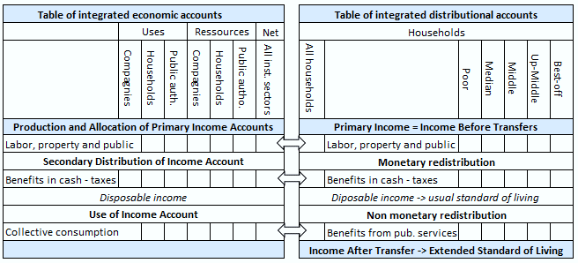
Note: TIDA is here written by standard of living groups, other categories of households are possible.Source: authors

Table A3. Education expenditure per tenth of usual standard of living by training
Note: the figure gives the education expenditure per tenth of usual standard of living by training in 2019. The first ten column give the percentage of education expenditure of each tenth of usual standard of living (the sum equal to 100%). For instance, 14,6% of the education expenditure for kindergarden and elementary school goes to the bottom 10% of the population. The last column gives the total in billions of euros. Source: INSEE, Distributional National Accounts, 2018. Authors’ Calculations.

Table A4. Factor income by age and level of education (excluding pensions)
(Unit : k€/ceq) | 18-29 yrs | 30-39 yrs | 40-49 yrs | 50-64 yrs | 65 yrs&+ | All
No diploma | 15 000 | 20 000 | 25 500 | 30 000 | 9 500 | 24 900
Vocational diploma | 23 000 | 27 000 | 34 000 | 38 500 | 11 000 | 18 450
Baccalaureate | 28 000 | 38 000 | 38 000 | 46 000 | 17 000 | 28 750
Bac. +2 degree | 35 500 | 49 000 | 50 500 | 64 000 | 14 500 | 34 900
Bachelor and more | 41 000 | 65 500 | 75 500 | 100 500 | 37 000 | 47 550
All | 29 550 | 41 850 | 45 450 | 50 000 | 14 200 | 36 850
Source: INSEE, National Distributional Accounts, 2019. Authors’ Calculations.
INSEE

Table A5. Total taxes paid by age and diploma
(Unit : euros) | 18-29 yr | 30-39 yr | 40-49 yr | 50-64 yr | 65 yr&+ | All
No diploma | -10 500 | -13 500 | -16 000 | -19 500 | -11 000 | -14 000
Vocational dipl. | -14 000 | -16 500 | -20 500 | -24 500 | -12 500 | -19 000
Baccalaureate | -17 500 | -22 000 | -23 000 | -29 000 | -18 500 | -22 500
Bac. +2 degree | -20 500 | -29 000 | -30 000 | -38 500 | -17 500 | -29 500
Bachelor & more | -25 000 | -39 500 | -45 500 | -61 000 | -33 000 | -43 500
All | -18 000 | -25 000 | -27 500 | -31 000 | -15 000 | -24 000
Source: INSEE, National Distributional Accounts, 2019. Authors’ Calculations.

Table A6. Taxation by age and diploma (weighted sum over ages)
(Unit : euros) | Taxes on products &prod. | Taxes on inc.&wealth | Social Sec. Contribution | Total taxes | % inc. bef. transfers | % total inc. bef. taxes
No diploma | 375 000 | 210 000 | 335 000 | 920 000 | 57% | 39%
Vocational dipl. | 435 000 | 280 000 | 445 000 | 1 160 000 | 55% | 40%
Baccalaureate | 495 000 | 440 000 | 555 000 | 1 490 000 | 57% | 42%
Bac.+2 degree | 545 000 | 530 000 | 715 000 | 1 790 000 | 56% | 43%
Bachelor & more | 675 000 | 1 040 000 | 1 090 000 | 2 805 000 | 58% | 47%
Source: INSEE, National Distributional Accounts, 2019. Authors’ Calculations.

Table A7: transfers by age and diploma (weighted sum over ages, pensions as transfers)
 | 18–29 yrs | 30–39 yrs | 40–49 yrs | 50–64 yrs | 65 yrs&+ | Mean | Weighed Sum*
No diploma
Pens = trans (in € eq.) | 9 400 | 11 350 | 8 150 | 3 000 | 26 750 | 15 800 | 858 450
Pens = trans (in bill €) | 5 | 13 | 13 | 10 | 155 | 196
Population (thousands) | 741 | 1 991 | 2 614 | 4 639 | 6 967 | 741
Vocational diploma
Pens = trans (in € eq.) | 2 600 | 5 250 | 600 | -4 950 | 24 700 | 4 900 | 518 200
Pens = trans (in bill €) | 2 | 9 | 2 | -21 | 67 | 58
Population (thousands) | 1 063 | 2 910 | 4 136 | 5 859 | 3 378
Baccalaureate
Pens = trans (in € eq.) | -3 100 | -2 800 | -3 350 | -10 800 | 22 400 | -400 | 219 400
Pens = trans (in bill €) | -3 | -5 | -6 | -17 | 28 | -3
Population (thousands) | 1 215 | 2 773 | 2 967 | 2 247 | 1 510
Bac. +2 degree
Pens = trans (in € eq.) | -7 800 | -10 900 | -11 750 | -20 800 | 22 550 | -9 050 | -160 950
Pens = trans (in bill €) | -4 | -12 | -19 | -29 | 16 | -48
Population (thousands) | 616 | 1 875 | 2 678 | 1 998 | 867
Bachelor’s and higher
Pens = trans (in € eq.) | -14 150 | -24 400 | -27 450 | -44 850 | 15 500 | -22 800 | -1 014 200
Pens = trans (in bill €) | -14 | -50 | -65 | -94 | 21 | -202
Population (thousands) | 1 256 | 3 233 | 3 974 | 3 048 | 1 681
All
Pens = trans (in € eq.) | -4 050 | -5 850 | -7 500 | -11 800 | 24 250 | 0
Pens = trans (in bill €) | -15 | -45 | -75 | -152 | 288 | 0
Population (thousands) | 4 891 | 12 782 | 16 368 | 17 790 | 14 403

Table A8: transfers received by nature and age - diploma (weighted sum over ages)
(Unit : euros) | Pensions | Other in cash | Health | Education | Other in kind | Total | Total exc. pensions
No diploma | 440 000 | 315 000 | 355 000 | 120 000 | 535 000 | 1 765 000 | 1 325 000
Vocational dipl. | 530 000 | 265 000 | 270 000 | 125 000 | 490 000 | 1 680 000 | 1 150 000
Baccalaureate | 695 000 | 220 000 | 230 000 | 140 000 | 440 000 | 1 725 000 | 1 030 000
Bac.+2 degree | 710 000 | 205 000 | 180 000 | 135 000 | 420 000 | 1 650 000 | 940 000
Bachelor&more | 910 000 | 200 000 | 190 000 | 145 000 | 405 000 | 1 850 000 | 940 000
Source: INSEE, National Distributional

Table A9. Greater Paris / Mid Sized Cities by age of household reference person
 | Factor income and pensions | Disposable income | Extended disposable income
18-29 yrs | 136% | 121% | 113%
30-39 yrs | 155% | 130% | 117%
40-49 yrs | 154% | 139% | 125%
50-64 yrs | 161% | 128% | 131%
65 yrs+ | 147% | 124% | 120%
All | 154% | 129% | 123%
Source: INSEE, National Distributional Accounts, 2019. Authors’ Calculations.

Fig A1. Extended Redistribution at market price with different assumption for VAT distribution

Note: This figure displays income before and after transfers at market price with two different assumptions for VAT distribution in primary income. In the first assumption (presented also in Table 1), VAT is distributed in the primary income as a function of consumption, which we called in the figure “VAT refund as paid” for income before transfers and “VAT as paid prim. income” for income after transfers (to indicate that this assumption concerns the distribution of VAT in primary income). In the second assumption, VAT is distributed as primary income in the primary income (but as paid depending consumption in the redistribution), which we called in the figure “VAT refund neutrally” for income before transfers and “VAT neutral prim. Inc.” for income after transfers. Source: INSEE, Distributional National Accounts, 2019. Authors’ Calculations.

Fig A2.a Overall tax rate by twentieth of standard of living (% of total income and benefits before taxes)
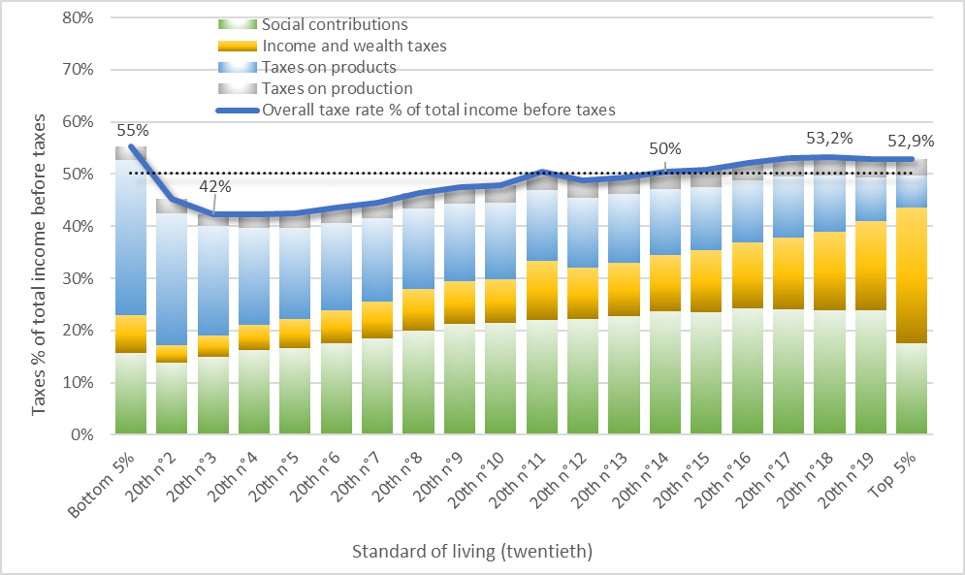
Note: overall tax rate and its decomposition in percentage of income before transfers. The corresponding figure is in the article (Figure 5) in percentage of income before transfers. Source: INSEE, Distributional National Accounts, 2019. Authors’ Calculations.

Fig A3 Comparing tax rate with VAT produced or paid for computing primary income of public administration (% of total income before transfers)

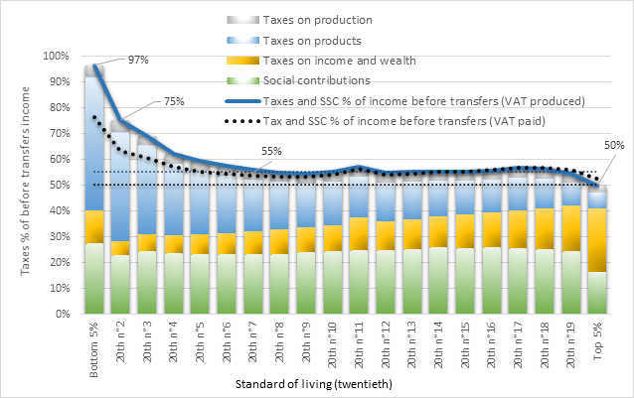
Source: INSEE, Distributional National Accounts, 2019. Authors’ Calculations.

Fig A4. Public transfers by twentieth of standard of living
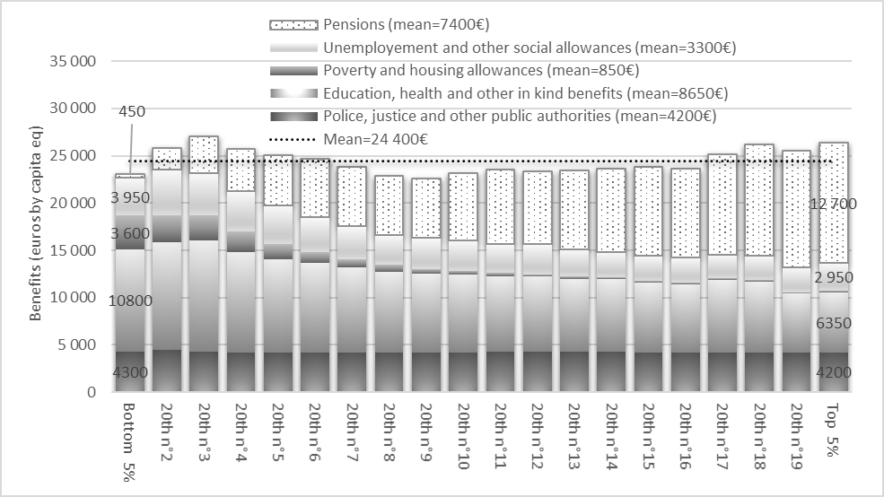
Note: total public transfers and its decomposition by twentieth of standard of living (m=mean over the whole distribution). Source: INSEE, Distributional National Accounts, 2019. Authors’ Calculations.

Fig A5. Before and after transfers income by age of household reference person
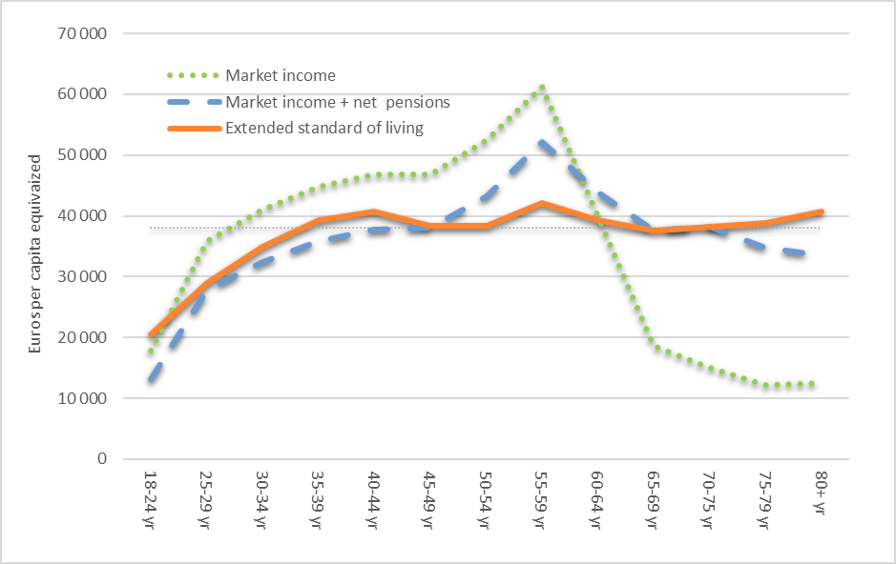
Source: INSEE, National Distributional Accounts, 2019. Authors’ Calculations.

Fig A6. Property and mixed income by age and level of education
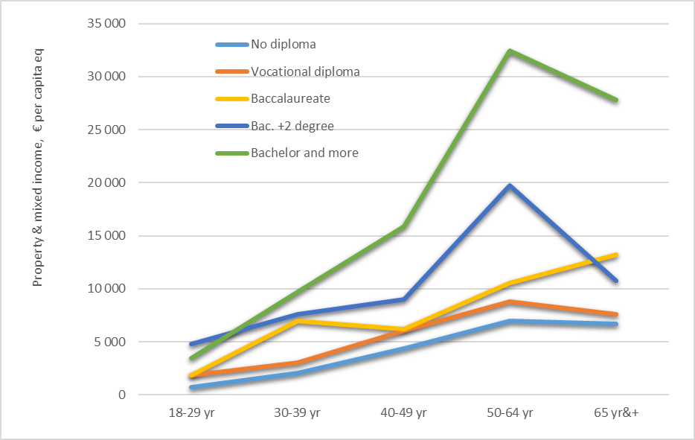
Source: INSEE, National Distributional Accounts, 2019. Authors’ Calculations.

Fig A7. Primary income for single male and female, without (left) or with child (right)
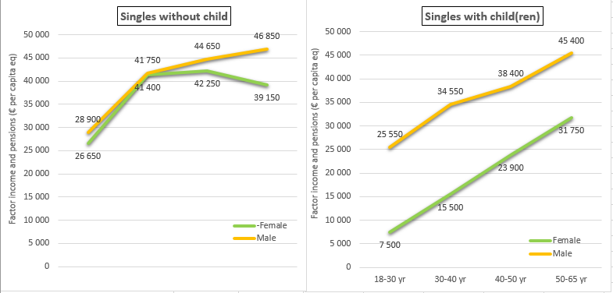
Source: INSEE, National Distributional Accounts, 2019. Authors’ Calculations.

Fig A8. Disposable income for male and female, with (left) or without child
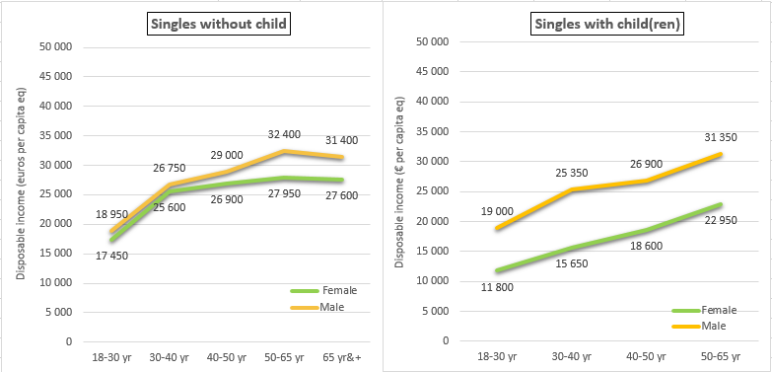
Source: INSEE, National Distributional Accounts, 2019. Authors’ Calculations.

Fig A9. Greater Paris / Mid-Sized Cities by age of household reference person
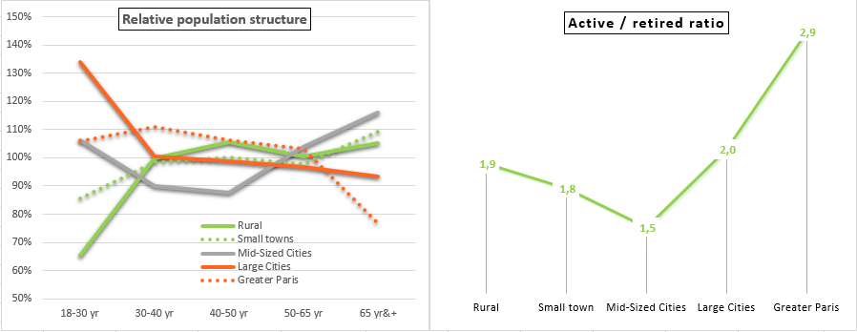
Source: INSEE, National Distributional Accounts, 2019. Authors’ Calculations.

