Table of Contents
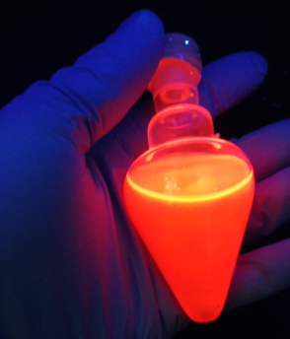
Red emissive silver-telluride 2D organometallic nanofibers prepared using diphenyl ditelluride as a precursor and activated by oleylamine under ultrasound treatment: Optical and Nanothermometer materials.
Institute and/or researcher Twitter usernames: @CLodeiro4Nano; @ProteomassS; @laqv_requimte

