Diphenyl ditelluride assisted synthesis of noble metal-based Silver-Telluride 2D organometallic Nanofibers with enhanced aggregation-induced emission (AIE) using oleylamine.

Jamila Djafari,¹ Frederico Duarte,^{1,2} Javier Fernández-Lodeiro, ^{*1,2} Adrián Fernández-Lodeiro,^{1,2} Hugo Santos,^{1,2} Eva Bladt,^{3,4} Sara Bals,^{3,4} Aikaterini Flessa Savvidou,^{5,6} Luis Balicas,^{5,6} Benito Rodríguez-González,^{7,8} Alcindo Aparecido Dos Santos,⁹ José Luis Capelo-Martínez,^{1,2}Carlos Lodeiro^{*1,2}

¹ BIOSCOPE Research Group, LAQV-REQUIMTE, Chemistry Department, NOVA School of Science and Technology, Universidade NOVA de Lisboa, 2829-516 Caparica, Portugal.
² PROTEOMASS Scientific Society, Rua dos Inventores, Madam Parque, Caparica Campus, 2829-516 Caparica, Portugal
³ Electron Microscopy for Materials Science (EMAT), University of Antwerp, Groenenborgerlaan 171, Antwerp, 2020, Belgium
⁴ NANOlab Center of Excellence, University of Antwerp, Groenenborgerlaan 171, Antwerp, 2020, Belgium
⁵National High Magnetic Field Laboratory, Tallahassee, FL 32310, USA.
⁶ Department of Physics, Florida State University, Tallahassee, FL 32306, USA.
⁷ CINBIO, Universidade de Vigo, Departamento de Química Física, Campus Universitario Lagoas Marcosende, 36310 Vigo, Spain
⁸ Galicia Sur Health Research Institute (IIS Galicia Sur), SERGAS-UVIGO, 36310 Vigo, Spain
⁹ Departamento de Química Fundamental, Instituto de Química, Universidade de São Paulo, SP, São Paulo, Brazil

Corresponding authors: Javier Fernández-Lodeiro (j.lodeiro@fct.unl.pt) | Carlos Lodeiro (cle@fct.unl.pt)

Index

Figure S1. HRTEM at higher magnification of nanofibers showing the nanostructure. Internal granular electron-dense nanostructures of 1.5 -2 nm, packed in the form of a double line, and having 6-7 nm in thickness.

Figure S2. Different HAADF-STEM images obtained from the same region showing the degradation of the nanofibers after electron beam irradiation. Image (b), (c) and (d) were acquired after 8s, 16s and 36s after the initial acquisition (a), respectively.

Figure S3. Energy dispersive X-ray spectroscopy obtained from the Nanofibers.

Figure S4. Absorption spectra of Ph₂Te₂ in acetonitrile (left), and spectroscopy evolution of Ph₂Te₂ in acetonitrile after interaction with AgNO₃ (right).

Figure S5. Mass spectrometry analysis obtained after ca. 1 min. (left) and 5 min (right) of the reaction.

Figure S6. Magnifications of the signals observed at 518.791, 928.678 and 1847.245 m/z with molecular assignment and calculated value.

Figure S7. FTIR spectra of the organometallic nanofibers in KBr disk and the assignment of the signals

Figure S8. Time series of HRTEM images (A-F) of an oleylamine treated nanofiber, showing consecutive (15 s) images captured along the change in the structure promoted by irradiation with larger dose under the electron beam. From A to F, a clear increase in the order of the crystalline structure is observed, until finally a faceted nanocrystal is clearly observed (F). In F an interplanar distance of 0.24 nm was observed, which can be matched with Ag (111) crystalline planes.

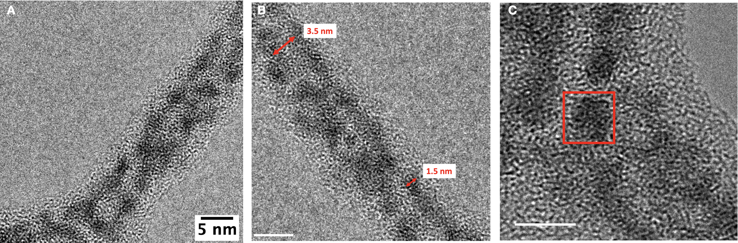

Figure S1. HRTEM at higher magnification of nanofibers showing the nanostructure. Internal granular electron-dense nanostructures of 1.5 -2 nm, packed in the form of a double line, and having 6-7 nm in thickness.

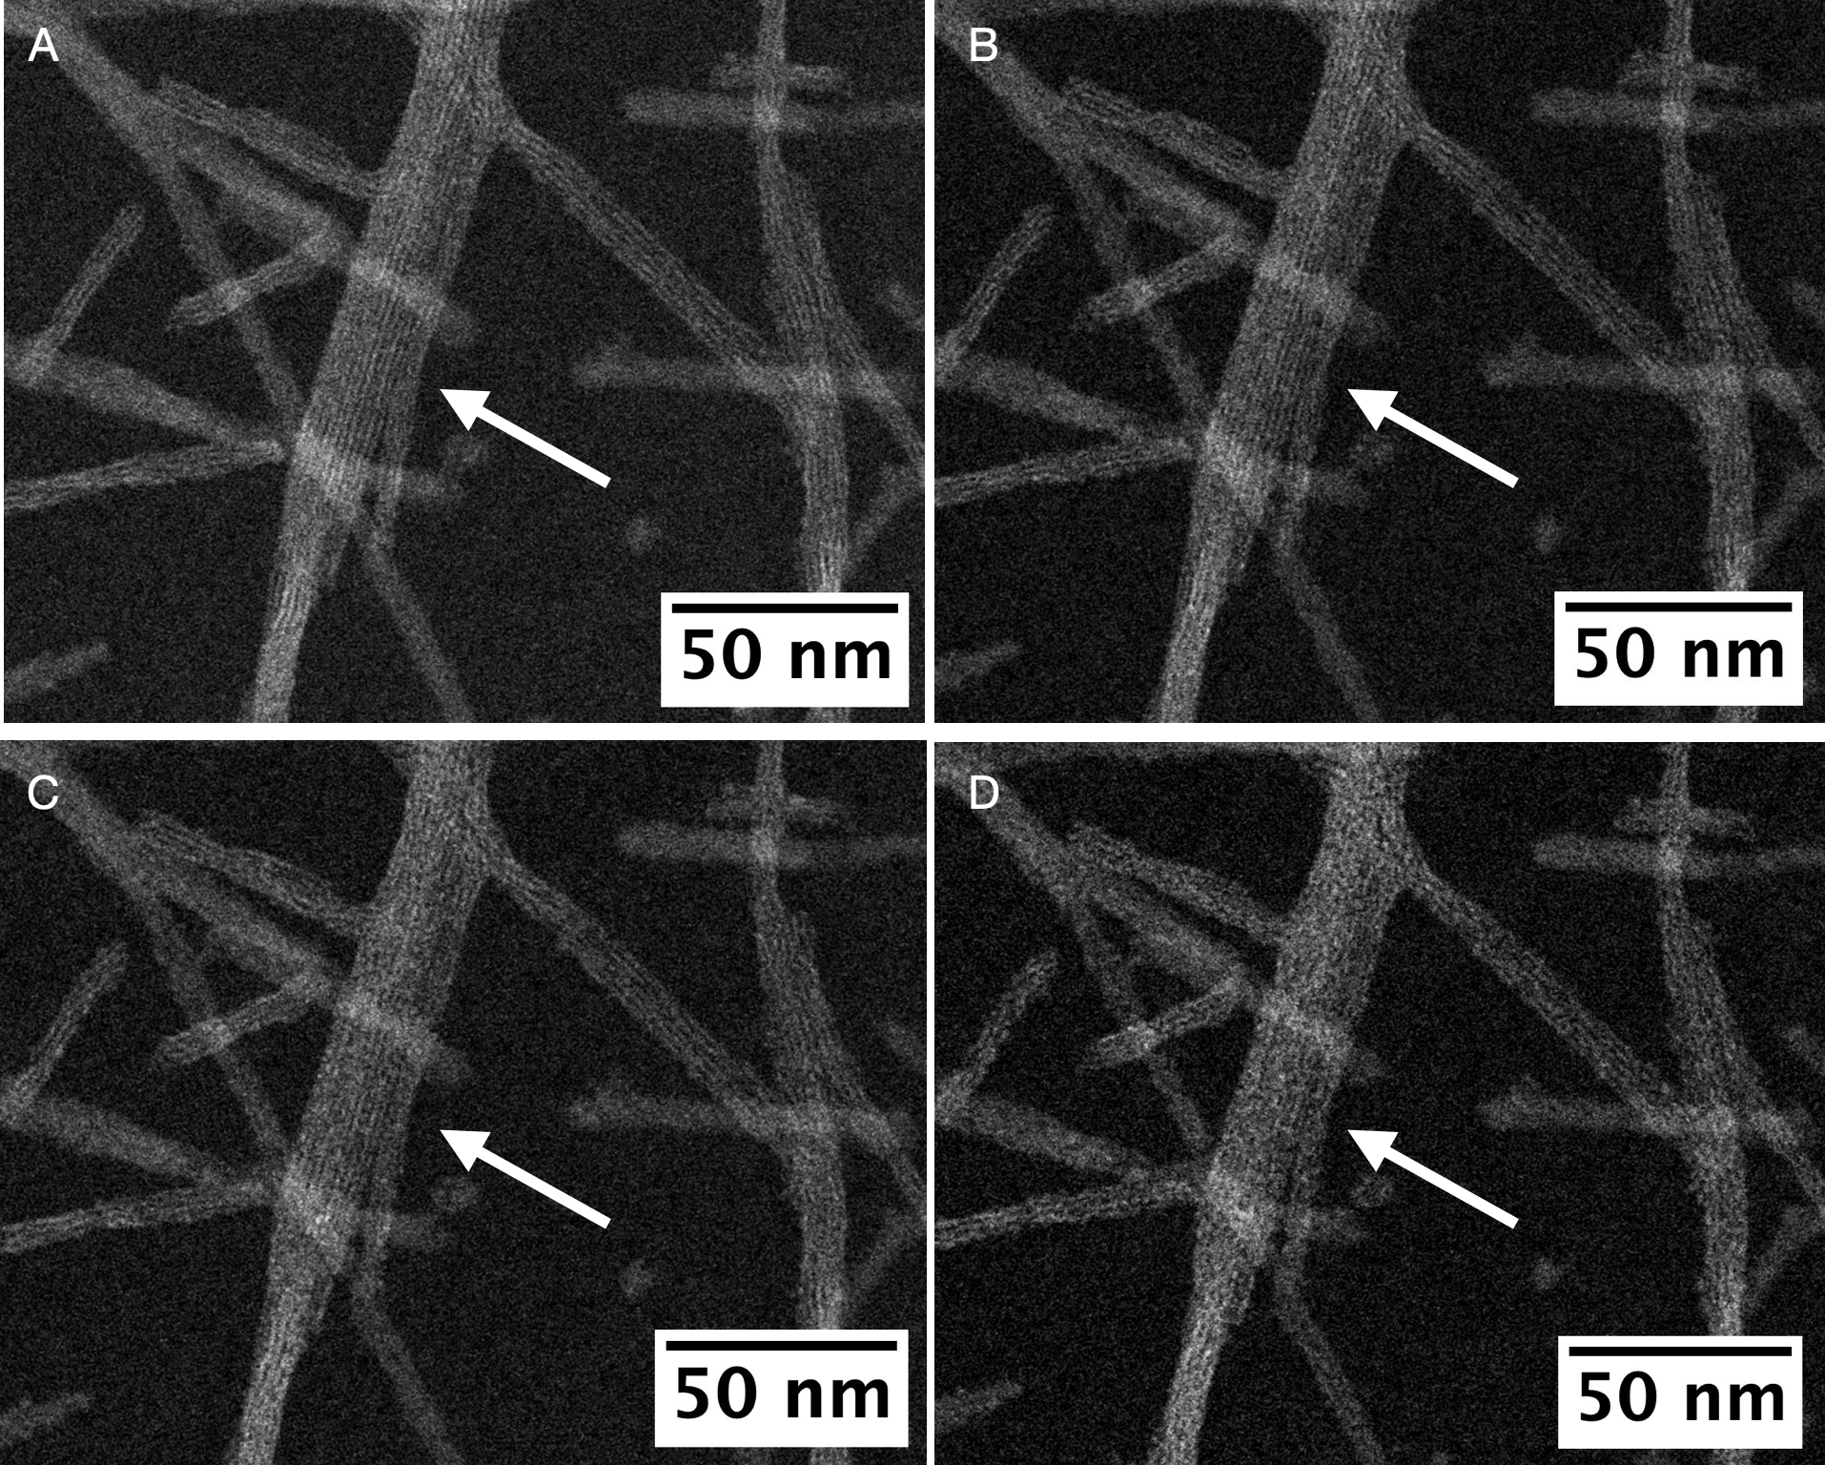

Figure S2. Different HAADF-STEM images obtained from the same region showing the degradation of the nanofibers after electron beam irradiation. Image (B), (C) and (D) were acquired after 8s, 16s and 36s after the initial acquisition (A), respectively.

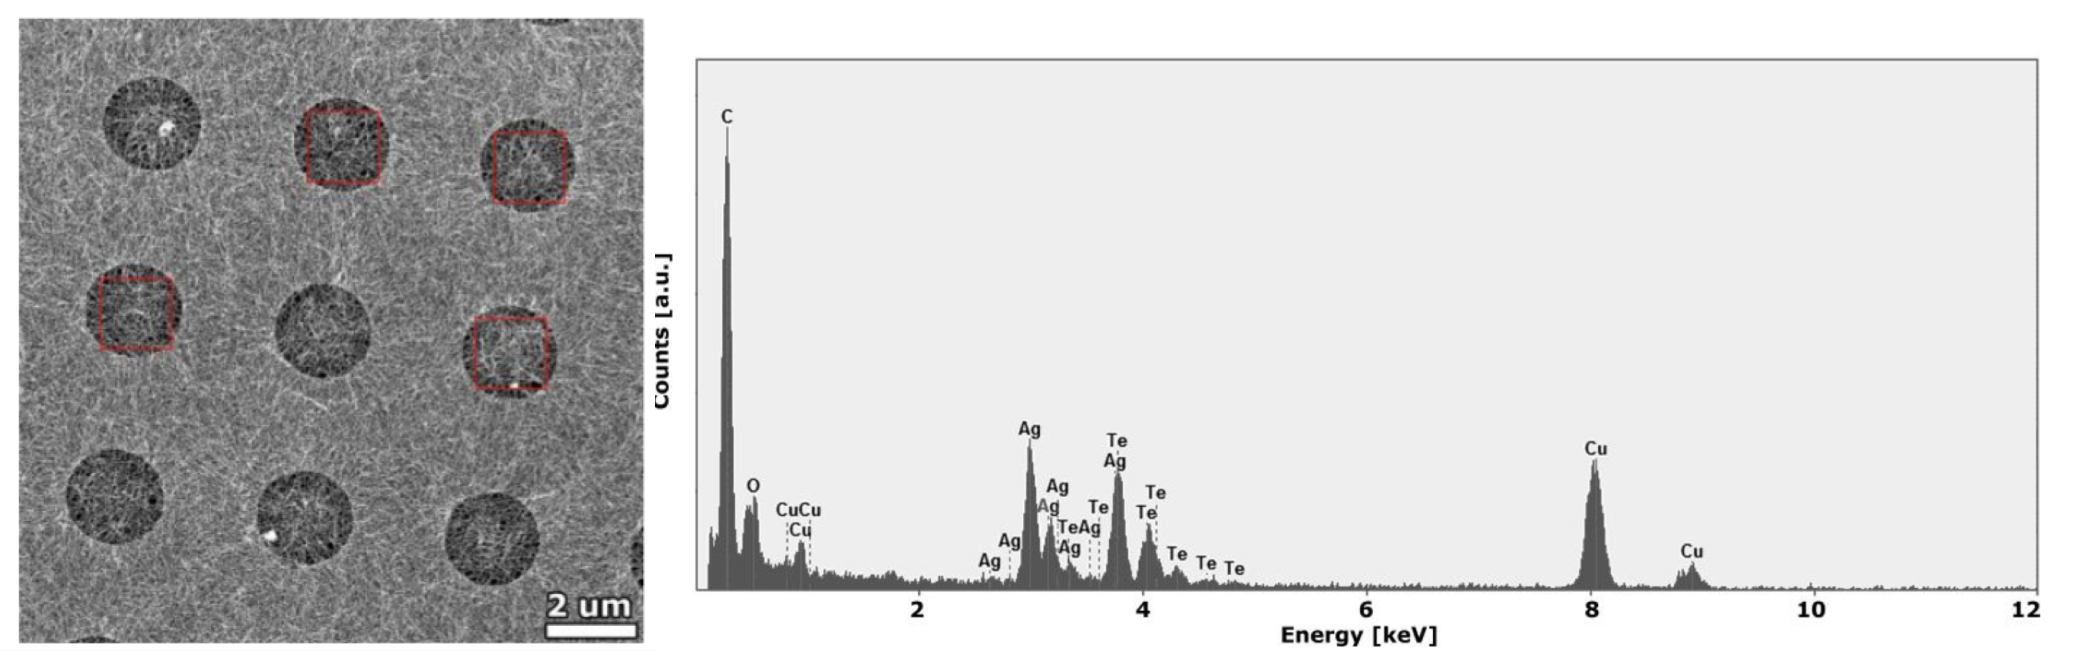

Figure S3. Energy dispersive X-ray spectroscopy obtained from the Nanofibers.

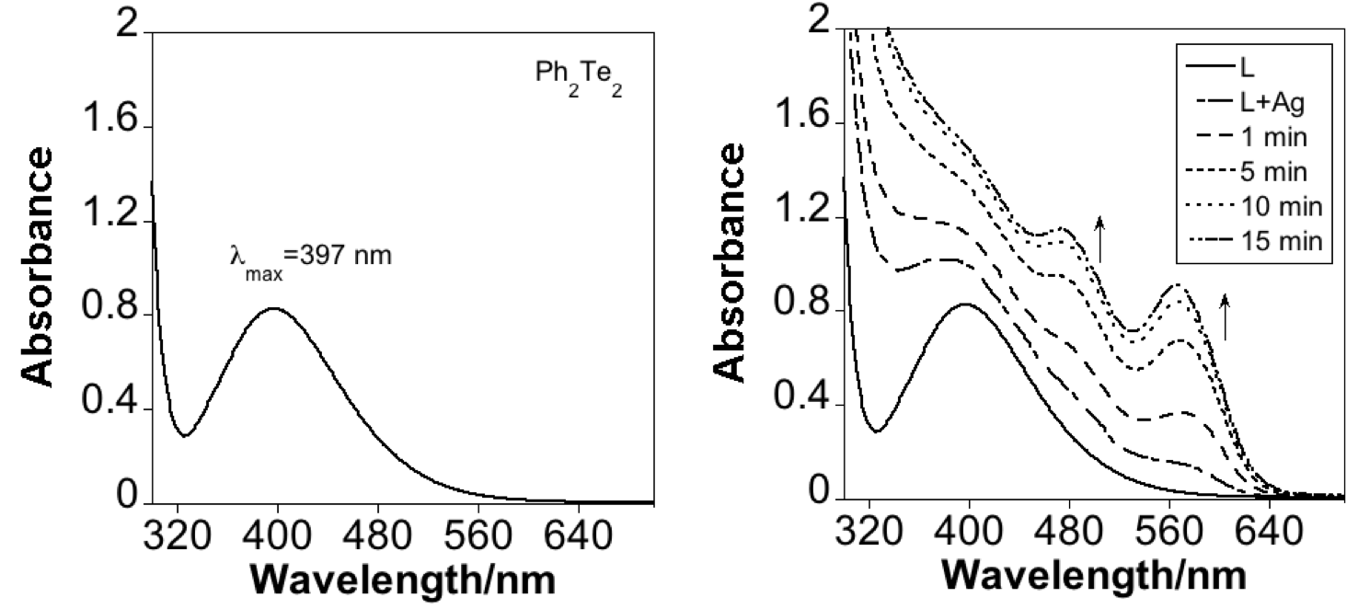

Figure S4. Absorption spectra of Ph₂Te₂ in acetonitrile (left), and spectroscopy evolution of Ph₂Te₂ in acetonitrile after interaction with AgNO₃ (right).

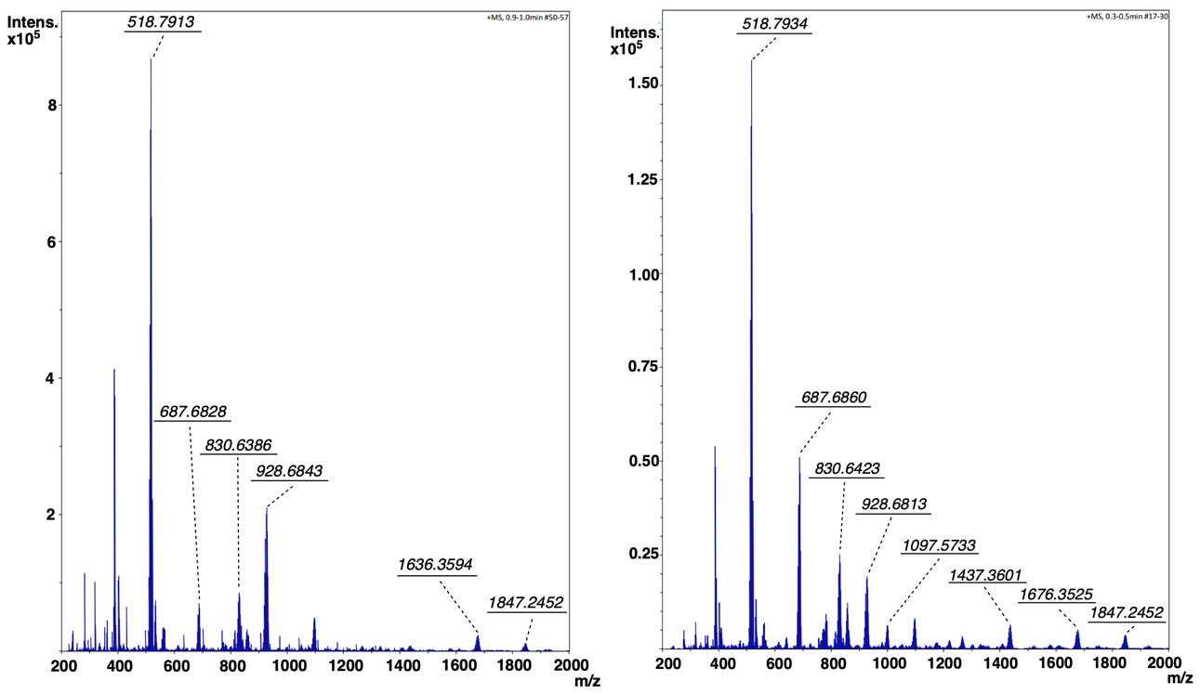

Figure S5. Mass spectrometry analysis obtained after ca. 1 min. (left) and 5 min (right) of the reaction.

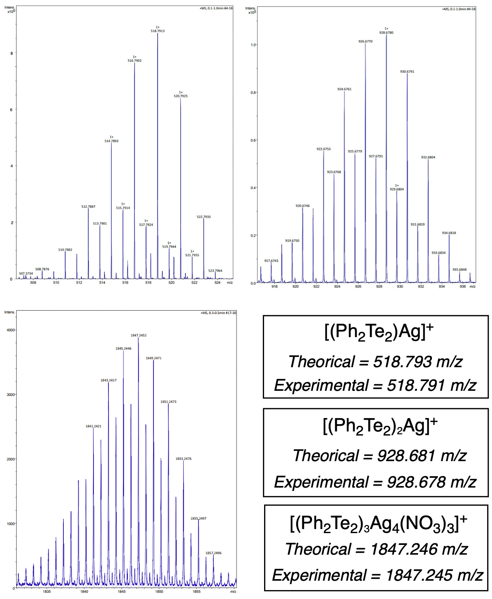

Figure S6. Magnifications of the signals observed at 518.791, 928.678 and 1847.245 m/z with molecular assignment and calculated value.

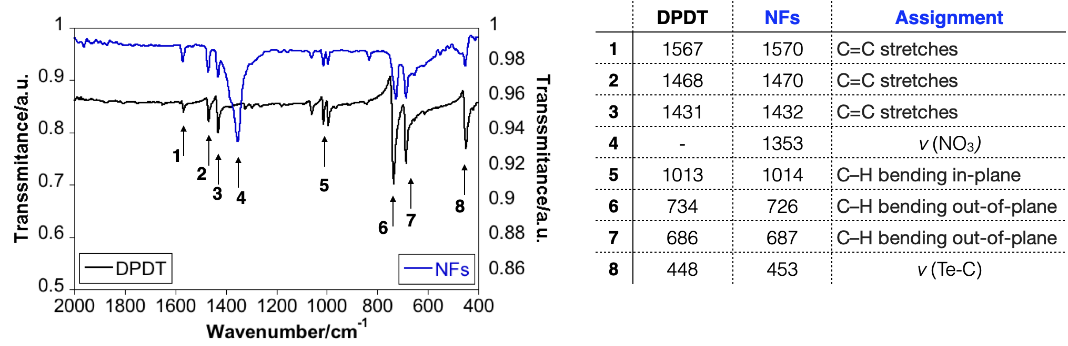
Figure S7. FTIR spectra of the organometallic nanofibers in KBr disk and the assignment of the signals

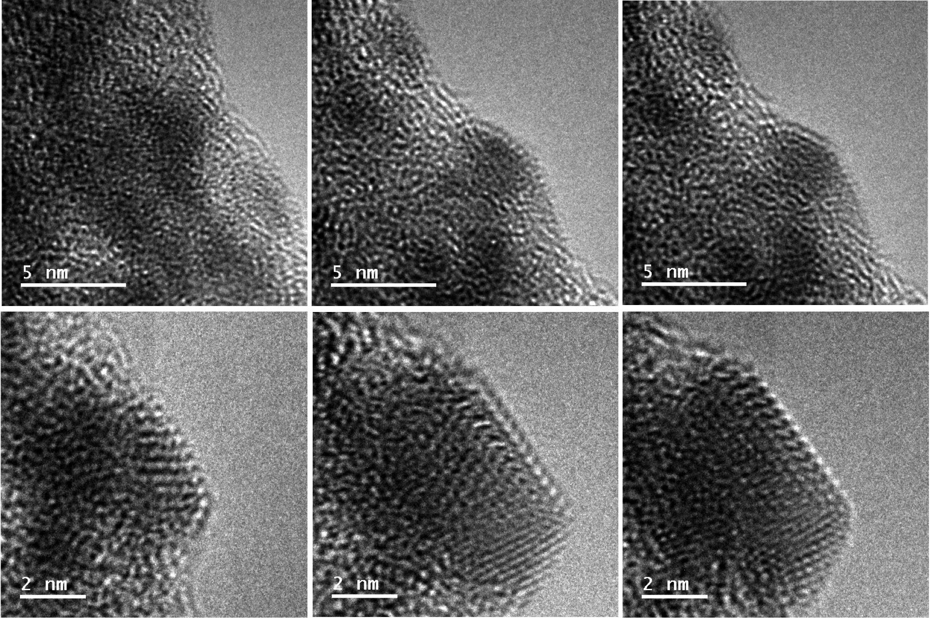

Figure S8. Time series of HRTEM images (A-F) of an oleylamine treated nanofiber, showing consecutive (15 s) images captured along the change in the structure promoted by irradiation with larger dose under the electron beam. From A to F, a clear increase in the order of the crystalline structure is observed, until finally a faceted nanocrystal is clearly observed (F). In F an interplanar distance of 0.24 nm was observed, which can be matched with Ag (111) crystalline planes.

