Supplementary Information for
Goldene: Free-standing Single-atom-thick Sheets of Gold
Shun Kashiwaya¹, Yuchen Shi¹, Jun Lu², Davide G. Sangiovanni³, Mike Andersson⁴, Johanna Rosen¹, Lars Hultman²

¹ Materials Design Division, Department of Physics, Chemistry and Biology (IFM), Linköping University, SE-581 83 Linköping, Sweden
² Thin Film Physics Division, Department of Physics, Chemistry and Biology (IFM), Linköping University, SE-581 83 Linköping, Sweden
³ Theoretical Physics Division, Department of Physics, Chemistry and Biology (IFM), Linköping University, SE-581 83 Linköping, Sweden
⁴ Division of Sensor and Actuator Systems, Department of Physics, Chemistry and Biology (IFM), Linköping University, SE-581 83 Linköping, Sweden

Section S1: Formation of free-standing 2D single-atom-thick Au
Figure S1 shows the unetched part of Ti₃AuC₂ remaining in Fig.1, showing the high-resolution scanning transmission electron microscopy (HR-STEM) images of goldene prepared by etching Ti₃AuC₂ using alkaline potassium ferricyanide solution (Murakami’s reagent) with cetyltrimethyl ammonium bromide (CTAB) and cysteine as surfactants. The c lattice parameter of Ti₃AuC₂ was previously experimentally determined to 18.56 Å, close to theoretically predicted 18.633 Å¹. We use this lattice spacing as our reference value to calibrate scale bars and experimental Au-Au spacing determined by line profiles in the STEM images. The measured and calibrated Au-Au spacing within Ti₃AuC₂ are 2.74 and 2.66 Å, respectively.

Figure S2 shows the STEM images of slightly rippled goldene produced by etching Ti₃Au_{n}C₂ using the Murakami’s reagent with CTAB and cysteine as surfactants. The measured and calibrated Au-Au spacing within Ti₃AuC₂ are 2.71 and 2.62 Å, respectively, smaller than the spacing in Ti₃Au_{n}C₂ before the etching. Thus, the initial strain within Au-Au bonding would cause rippling to the resulting goldene after etching.
Figure S1 | Calibration using c lattice parameter of Ti₃AuC₂ and in-plane Au-Au spacing of Ti₃AuC₂. a, HR-STEM image of Ti₃AuC₂ along with [$\text{11}\overline{\text{2}}\text{0}$] orientation. The measured c lattice parameter is 19.12 Å. The scale bar of Figure 1 and Au-Au distances were calibrated using the reference c parameter value of 18.56 Å. b,c, Line profiles extracted from the dash lines highlighted in a. Values in parentheses are calibrated distances.

Figure S2 | Formation of free-standing goldene. a,c,e HR-STEM image of goldene produced by etchig Ti₃AuC₂ by the Murakami’s reagent with CTAB (a,c) and cysteine (e), along with [$\text{11}\overline{\text{2}}\text{0}$] orientation. b,d,f Zoomed-in HR-STEM image of the area marked in a,c,e. g,h line profiles extracted from the dash lines highlighted in e. Values in parentheses are calibrated distances.

Section S2: Formation of free-standing 2D single and multiple-atom-thick Au
The Au-Au spacing in 2D Au crystals is typically shorter than those for closely packed fcc and hcp Au crystal structures, 2.88 and 2.80 Å. Au-Au spacing of previously reported ultra-thin Au membranes with various morphologies is summarized in Table S1.
Table S1 | Literature values of in-plane Au-Au spacing of ultra-thin Au membranes.

Thickness | In-plane Au-Au spacing [Å] |  | Growth morphology/structure | reference
2-6 nm | 2.93 | Free-standing 4H hcp nanoribbons synthesized via a chemical route |  | [2]
~ 2.4 nm  (~ 16 atom-thick) | 2.92 | Free-standing 2H hcp square nanosheets synthesized via a chemical route |  | [3]
0.2-0.4 nm  (1-2 atom-thick) | 2.80 ± 0.01 | Layers diffused into layered double hydroxides template |  | [4]
Single-atom-thick | 2.67 ± 0.04  2.68 ± 0.05 | Monolayer framed in bulk Au-Ag alloy, fabricated by electron beam irradiation |  | [5]
Single-atom-thick | 2.56  (2.71)* | Monolayer nanoribbons suspended in graphene pores |  | [6]
Single-atom-thick | 2.66  (2.69-2.72)# | Monolayer quantum dots stabilized on hexagonal boron nitride surfaces |  | [7]
1-2 atom-thick | 3.08 (monolayer)  2.93 (bilayer) | Monolayer diffused in between bulk SiC and monolayer graphene |  | [8]
Two-atom-thick | 2.89 | Free-standing seaweed-like membrane synthesized via a chemical route |  | [9]
Single-atom-thick | 2.8 | Monolayer flowers grown on sapphire substrates |  | [10]

*2.56 Å is the measured value experimentally derived from STEM images. The value of 2.77 Å in the parenthesis is the calibrated value using lattice spacings of nearby graphenes as a reference.
#2.66 Å is the measured value experimentally derived from STEM images. The value of 2.69-2.72 Å in the parenthesis is the theoretical value calculated for the hexagonal boron nitride supported 2D Au_{n} clusters (n = 6-16).

Section S3: Ab initio molecular dynamics computations
S3.1 Ab initio methods and computations
Ab initio molecular dynamics (AIMD) investigations offer insights on several possible factors that may assist or hinder the experimental realization of free-standing goldene monolayers via Au-intercalation and etching of MAX-phases. More specifically, the simulations are here used to shed light on the structural and dynamic stability of free-standing and closely-interacting gold monolayers, as well as on the effects induced by lattice vacancies and impurities on goldene’s stability. AIMD simulations are carried out using the VASP code implemented with the projector augmented wave method^{11,12} and the generalized-gradient electronic exchange and correlation approximation of Ref.¹³. An average temperature of 300 K is controlled via the Nosé-Hoover thermostat (NVT ensemble). The classical equations of motion are integrated on timesteps of 1 fs. Spin-orbit coupling and relativistic effects are neglected. Van der Waals interactions are modeled using Grimme’s approximation¹⁴. At each ionic step, the energy is calculated with accuracy of 10^{–5} eV/supercell, using 300 eV cutoff for the planewave basis set and Γ-point sampling of the reciprocal space.

Our free-standing defect-free goldene model (Fig. 2) is a monolayer of fcc Au(111). Simulation snapshots are created using VMD¹⁵. It contains 360 Au atoms: 18 × 10 2D-unit-cells. The sheet is periodic in x//$\text{[}\text{1}\overline{\text{1}}\text{0]}$ and y//$\text{[11}\overline{\text{2}}\text{]}$ directions. Goldene is vertically separated by 1.4 nm vacuum regions from its replicas (note that VASP employs 3D periodic boundary conditions). The monolayer is first equilibrated at 300 K for a few ps. During NVT sampling, the supercell vector lengths are manually adjusted to ensure that time-averaged in-plane stresses σ_{xx} and σ_{yy} are negligibly small (< 0.1 GPa). This is achieved for an average in-plane Au-Au nearest-neighbor distance d_{NN}=2.735 Å, which is ≈5% smaller than the equilibrium interatomic distance in fcc gold (2.884 Å) and close to the value of 2.755 Å predicted in a previous report¹⁶.

S3.2 Free-standing defect-free 2D Au monolayers
The dynamics of 2D defect-free goldene is followed for 5 ps. AIMD simulations confirm the dynamic stability of the 2D material in the hexagonal structure, as predicted by previous ab initio calculations and simulations¹⁶. At room temperature, goldene’s out-of-plane vibrations have a mean squared displacement of 0.14±0.01 Å².

Using AIMD, we investigate Au adatom (Au_{ad}) self-diffusion on free-standing goldene. The simulations allow us to estimate Au_{ad} migration rates and observe whether the diffusion modes are normal or superdiffusive (as reported for the migration of some noble metals on graphene¹⁷). A gold adatom is placed on the free-standing sheet shown in Fig. 2. Equilibration at room temperature indicates that the adatom favors adsorption in surface hollow sites coordinated by three goldene atoms. Thus, Au_{ad}/goldene dynamics is monitored for 32 ps. During this timeframe, we record four Au_{ad} jumps among adjacent hollow sites. From visualization of the simulation, we also infer that Au_{ad}/goldene self-diffusion at 300 K can be fairly well described as a random-walk process, which assumes uncorrelated Au_{ad} jumps. The migration rate Γ_{Auad}(300 K) ≈ 0.125 THz yields an estimate of the Au_{ad}/goldene self-diffusion coefficient D(300 K) ≈ 7.8·10^{–10} m² s^{–1}. The value D is calculated using D = Γ_{Au} · L²/4, where L = d_{NN}·3^{–½} is the effective Au_{ad} jump length. The self-diffusivity of Au adatoms attached to the gold layers during etching would contribute to blob formation on and thickening of 2D Au layers observed in our STEM analysis.

S3.3 Goldene nanoribbons
Etching of Au-intercalated MAX phases removes material around goldene monolayers, thus exposing goldene’s edges. Our experimental results revealed the tendency of goldene edges to curl, which facilitates the attachment of adjacent Au monolayers. Thus, we carry out AIMD simulations to gain insights into the dynamic stability of goldene structures with $\text{[1}\overline{\text{1}}\text{0]}$ and $\text{[11}\overline{\text{2}}\text{]}$ edges free to curl. To allow the monolayer to curl during AIMD simulations (which employ periodic boundary conditions in 3D), we: (i) create $\text{[1}\overline{\text{1}}\text{0]-}$ and $\text{[11}\overline{\text{2}}\text{]-}$oriented Au nanoribbons; (ii) remove Au atoms to form tooth-shaped models with 1D-periodicity, as visualized in Fig. S3a,b.

Initial simulation tests reveal that the traction-free edges of tooth-shaped goldene nanoribbons do not curl during ps-timeframes. Their out-of-plane vibrational amplitudes are similar to that of an infinite defect-free Au(111) monolayer (see the bottom part of Fig. 2). To consider the effects of lattice mismatch between a Au(111) monolayer and the host MAX phase structure, we perform additional AIMD simulations of tooth-shaped Au-nanoribbons initially subject to 5% in-plane compression and tension. Despite the initial strain, goldene’s edges remain flat during a simulated time of ≲5 ps. The result suggests that the curling of goldene monolayers observed upon chemical etching is induced by external factors; not manifestation of intrinsic structural instabilities of free-standing goldene monolayers nor nanoribbons.

Figure S3 | Plan view of goldene nanoribbons. a,b, Goldene nanoribbons with traction-free ⟨110⟩ (a) and ⟨112⟩ (b) tooth-shaped edges carved out of the supercell model shown in Fig. 2. The dashed squares delimit the supercell boundaries (note supercell replicas partially visible outside the dashed squares).

S3.4 Defective goldene nanoribbons
Besides chemical agents, factors that may plausibly cause destabilization and subsequent attachment of two or more goldene monolayers during MAX-phase etching are crystallographic point defects and goldene/goldene mutual attraction. Hence, AIMD simulations are carried out to probe effects induced by the presence of Au vacancies and Si impurities. Si species are often present in experiments, as Au intercalation has been successfully achieved by replacing Si in Si-containing MAX phases. The simulations are done for both (i) free-standing Au monolayers and (ii) goldene bilayers as a function of goldene/goldene vertical separation. Indeed, the degree of interaction between Au monolayers etched out of different MAX-phase structures (e.g., Ti₃AuC₂, Nb₂AuC, or Mo₂AuC) is expected to decrease with increasing c lattice parameter (vertical crystal axis vector) of the host lattice. To this purpose, we construct supercells containing a goldene bilayer with different goldene/goldene initial distances.

S3.4A Isolated Au-vacancies and Si impurities. AIMD simulations show that lattice vacancies do not affect – over ps timescales at room temperature – the stability and flatness of goldene monolayers. This is also the case for Au vacancies located near ⟨110⟩ and ⟨112⟩ edges of Au nanoribbons. Conversely, our simulations demonstrate that a goldene monolayer is relatively strongly destabilized by the presence of Si impurities. Figure S4 illustrates an example of destabilization effects induced by an isolated Si impurity. In Fig. S4a, a Si adatom (Si_{ad}, red sphere) is initialized with 0 velocity on an atop-Au position proximate to a ⟨110⟩–⟨112⟩ surface corner. The surface had been previously equilibrated at a temperature of 300 K. During the first ps, the Si_{ad} reaches a hollow-site position, coordinated underneath by three Au atoms (Fig. S4b). After approximately 2 ps, the adatom moves downward (replaces Au in a goldene lattice site), thus laterally displacing an Au atom (Fig. S4c). Due to different Au–Au and Au–Si equilibrium distances, the presence of the Si impurity distorts the bond network and hence generates ripples in the edge. The final part of the simulation shows that the Si impurity can move back and forth between substitutional and adatom positions in agreement with the eutectic Au-Si phase diagram, yet constantly inducing alterations in goldene’s structure (Fig. S4d). Local changes in bond angles and bond lengths are the cause of surface corrugation.

S3.4B Stabilization/destabilization due to Au vacancies and Si impurities. A more detailed understanding of the role played by point defects on goldene’s stability is provided by AIMD simulations, where we introduce several Si impurities and lattice vacancies. Figure S5 and S6 present results obtained for tooth-shaped ⟨110⟩ and ⟨112⟩ goldene nanoribbons, respectively. Our results indicate that Au vacancies do not alter goldene’s stability even if the vacancy is located along an edge. This can be seen in Fig. S6a,b, noting that vacancies placed along ⟨110⟩ and ⟨112⟩ edges (two blue dots on the upper part of Fig. S6a) do not cause bond distortion nor lattice corrugation. On the contrary, our simulations suggest that vacancies have indirect stabilization effects by acting as traps to Si impurities. Examples are provided in Figs. S5b and S6b, where blue arrows indicate a lattice vacancy filled by a former Si adatom. While occupying vacancy positions, Si does not have a significant influence on the structure of goldene. On the other hand, both ⟨112⟩ and ⟨110⟩ goldene edges are particularly susceptible to the presence of Si impurities. Si adatoms at goldene’s edges (Fig. S5a) may vertically descent in the goldene layer, thus displacing goldene Au atoms to adatom positions on the other side of the surface (see red arrows in Fig. S5b and magnification in Fig. S5c).

Figure S4 | Effects induced by a Si impurity (red sphere) on goldene monolayer stability. a-d, The figure presents a case of a tooth-shaped ⟨110⟩ goldene nanoribbon. Each panel illustrates an AIMD snapshot taken at a different simulation time (t = 0, 0.5, 2, and 4 ps). The length of visible Au–Au and Au–Si bonds is ≤3.6 Å.

Figure S5 | Effects induced by Si impurities (red spheres) on the stability of defective goldene. The figure presents a case of a tooth-shaped ⟨110⟩ goldene nanoribbon. a,b, Initial (a) and final (b) AIMD simulation snapshots. In a, the adatoms are initialized with 0 velocity on a goldene ribbon that had been separately equilibrated to 300 K. The vacancy sites are indicated by blue dots in a. c, Side-view magnification of the final AIMD configuration [seen from the direction of red arrows in (b)] that evidences the substitution of Au edge-atoms by Si. As Si impurities occupy goldene’s lattice sites, the displaced goldene atoms become Au adatoms on the opposite face of the surface.

In other instances, Si adatoms descent in edge positions by laterally pushing Au atoms. The effect – anticipated by Fig. S4 – can also be seen in Fig. S6. There, Si impurities distort goldene’s network by forming fivefold coordinated Si-Au₅ defects at both ⟨110⟩- and ⟨112⟩-edges, as indicated by red arrows in Fig. S6b. However, there are also cases in which Si impurities near edges seem not to alter goldene’s structure. This happens, for example, when former Si adatoms laterally attach to the side of the edge (see black arrows in Fig. S6b). To complete the discussion of the effect of Si impurities, we note that Si adatoms migrating on inner regions of goldene’s surface generally occupy bridge positions – above Au-Au bond centers – without affecting the underlying lattice. Nevertheless, AIMD reveals that Si adatoms reaching an atop-Au position may enter the surface by pushing a gold atom on the opposite side (green arrows in Fig. S6b,c,d), which is similar to what is seen for Si near goldene edges.

To summarize, AIMD simulations suggest that isolated Au-vacancies have an overall beneficial effect on goldene’s stability. Conversely, Si impurities may substantially alter the structure of goldene, especially if located near goldene’s edges.

Figure S6 | Effects induced by Si impurities (red spheres) on the stability of defective goldene. The figure presents the case of a tooth-shaped ⟨112⟩ goldene nanoribbon. a,b, Initial (a) and final (b) simulation snapshots. Vacancies are indicated by blue dots. In a, the adatoms are initialized with 0 velocity on a goldene ribbon that had been separately equilibrated to 300 K. The length of visible Au–Au and Au–Si bonds is ≤3.6 Å. c,d, Side-orthographic and panoramic-perspective views of the final AIMD configuration showing that Si impurities can displace Au atoms also at inner goldene regions [note green arrows in b,c,d].

S3.5 Bilayers of defect-free goldene nanoribbons
This subsection describes how the separation distance among vertically-stacked goldene layers affects their out-of-plane vibrational amplitude and hence their tendency to attach. This information is important to identify MAX-phase host lattices that maximize the chances of isolating free-standing Au monolayers. The investigations are done by AIMD simulations at room temperature. A supercell model contains two vertically-stacked tooth-shaped ⟨110⟩ nanoribbons (592 Au atoms in total) with different initial interlayer distances. We have considered initial distances of 1.0, 1.2, and 1.4 nm. The case of 1-nm interlayer distance is illustrated in Fig. S7. The initial positions and velocities of each layer are extracted from different simulation times of a previously equilibrated nanoribbon. This ensures the uncorrelated behavior of the two layers. Note that tooth-shaped edges are traction-free. This gives them freedom to curl and attach to adjacent gold layers.

Figure S7 | AIMD supercell model used to investigate interactions between vertically-stacked defect-free goldene nanoribbons. a,b, Independently-equilibrated nanoribbons placed at an initial separation distance of 1 nm (plan (a) and lateral views (b)). Semi-transparent layers in b are part of supercell replicas along [111]. Other two simulations are carried out for goldene/goldene initial distances of 1.2 and 1.4 nm.

The dynamics of bilayer goldene nanoribbons is followed for ≈ 5 ps. Fig. S8 visually demonstrates that the undulation of goldene nanoribbons becomes quickly large for interlayer distances of 1 nm. The effect can be appreciated by noting that the surface rippling of the final (Fig. S8a) configuration is much greater than the initial one (Fig. S7b). The observation suggests a high risk of goldene/goldene attachment over actual experimental times. In contrast, after 5 ps, bilayers with initial distances of 1.2 and 1.4 nm exhibit relatively small corrugation. Their out-of-plane vibrational amplitude is slightly larger than that observed in 2D isolated goldene monolayers (see the lower part of Fig. 2). While bearing in mind that our model systems may evolve in an unexpected manner during timescales of practical relevance, the information offered by AIMD simulations indicate us to prioritize Au-intercalation and etching experiments based on MAX-phases with c lattice parameter as large as possible.

Figure S8 | Lateral views of bilayer goldene nanoribbons with various interlayer distances. a-c, Bilayer goldene nanoribbons with interlayer distances of 1 nm (a), 1.2 nm (b), and 1.4 nm (c), after ≈5 ps AIMD equilibration at room temperature (an example of initial supercell model is shown in Fig. S7). AIMD results suggest that the goldene/goldene attraction is drastically reduced for average interlayer distances greater than 1 nm.

S3.6. Bilayers of defective goldene nanoribbons
A last simulation test serves us to confirm the role played by Si impurities and “small” (<1 nm) interlayer distances on destabilizing goldene’s structure and accelerating attachment of vertically-adjacent Au layers. Hence, we create a defective goldene bilayer, where each layer the nanoribbon with vacancies and Si impurities shown in Fig. S6b,c,d. Thus, the final configuration (atomic positions and velocities) of that simulation serves as starting point for the new AIMD investigation. The model is initialized as shown in Fig. S9a,b. In this test, the nanoribbons have initial separation distance of only 0.7 nm. As expected, the presence of Si impurities, combined with a relatively strong goldene/goldene attraction, facilitates the attachment of the two nanoribbons. After less than 6 ps, these have completely merged into one structure. Moreover, the simulation reveals that – besides rippling the goldene layer – Si impurities facilitate the formation of Au-Si-Au bonds between the layers.

Figure S9 | Defective bilayer goldene nanoribbons with a “small” interlayer distance of 0.7 nm. a,b, Plan (a) and lateral (b) views of defective bilayer goldene nanoribbons. Semi-transparent layers in b are part of supercell replicas along [111]. c , A snapshot of the nanoribbons, acquired after 5.7 ps. A simulation time of ≈6 ps is sufficient to observe the merging of the two layers. AIMD simulations also suggest that the presence of Si impurities accelerates the attachment process by creating Au-Si-Au bridges between the layers. The length of visible Au–Au and Au–Si bonds is ≤3.6 Å.

Section S4: Free-standing multiple-atom-thick 2D Au
Free-standing two- and three-atom-thick 2D Au layers were produced by etching Ti₃Au_{n}C₂ (n = 2 and 3, Fig. S10-13) with 1-3 % Murakami’s reagent with CTAB and cysteamine as surfactants. The bob formation at the edges was observed (Fig. S12).
Figure S10 | Formation of rippled free-standing two- and three-atom-thick gold sheets. a-d, HR-STEM images of free-standing two- and three-atom-thick 2D Au produced by etching Ti₃Au_{n}C₂ by the Murakami’s reagent with CTAB (a) and cysteamine (b-d). The image d is the zoomed-in area marked in b.

Figure S11 | In-plane Au-Au spacing within bi- and tri-layers of Ti₃Au_{n}C₂. a, HR-STEM image of Ti₃Au_{n}C₂ along with [$\text{11}\overline{\text{2}}\text{0}$] orientation. The measured c lattice parameter of Ti₃Au_{n}C₂ is 23.72 Å. The scale bar and Au-Au distances were calibrated using the reference c parameter value of 23.14 Å. b-h, Line profiles extracted from the dash lines highlighted in a. Values in parentheses are calibrated distances.

Figure S12 | Blob formation at the edges of free-standing two- and three-atom-thick 2D Au. a, HR-STEM image of free-standing two- and three-atom-thick 2D Au produced by etching Ti₃Au_{n}C₂ by the Murakami’s reagent with CTAB. b, c, Zoomed-in areas marked in a. d, e, Zoomed-in areas marked in b, c.

Figure S13 | Formation of large-scale free-standing multilayer gold sheets. HR-STEM image of free-standing two- and three-atom-thick 2D Au produced by etching Ti₃Au_{n}C₂ by the Murakami’s reagent with CTAB.

Section S5: Chemical and mechanistic considerations for the etching
The etching effect produced by the Murakami’s reagent originates from radical nascent oxygen [O] generated in the reaction occurring between potassium ferricyanide and alkali in close conjunction with metal carbides surface that has an attraction for oxygen¹⁸. When the surface is attacked by potassium ferricyanide K₃[Fe(CN)₆] and KOH, the Ti₃C₂ slabs withdraw the nascent oxygen from KOH on the slab surface, and the left potassium combines with potassium ferricyanide K₃[Fe(CN)₆] to form potassium ferrocyanide K₄[Fe(CN)₆]¹⁸, according to the following reaction:
$$4{\text{K}}_{\text{3}}\text{[Fe}{\text{(CN)}}_{\text{6}}\text{] + 4KOH →}{\text{ 4K}}_{\text{4}}\text{[Fe(}{\text{CN)}}_{\text{6}}\text{] + 2}H_{\text{2}}\text{O + 2[O] }$$
Subsequently, the Ti₃C₂ slabs get attacked by the oxidative nascent oxygen as follows:
$$\text{2}{\text{Ti}}_{\text{3}}{\text{C}}_{\text{2}}\text{ + 11[O] →}{\text{ 3Ti}}_{\text{2}}\text{O + 4}{\text{CO}}_{\text{2}}$$
$$\text{2}{\text{Ti}}_{\text{3}}{\text{C}}_{\text{2}} \text{+ 7[O] →}{\text{ 3Ti}}_{\text{2}}\text{O + 4CO}$$
$$\text{2}{\text{Ti}}_{\text{3}}{\text{C}}_{\text{2}}\text{ + 3[O] →}{\text{ 3Ti}}_{\text{2}}\text{O + 4C}$$
Here, ionization tendency and susceptibility to oxidation of Ti and C are significantly higher than those of Au. Thus, Ti and C are selectively oxidized by the nascent oxygen.

Au is inert to both potassium ferricyanide and its by-product of potassium ferrocyanide under the darkness; on the other hand, the light-triggered dissolution of Au by potassium ferrocyanide was observed¹⁹. Even ambient light could dissolve Au in the presence of potassium ferrocyanide. Fritz Haber first reported that light irradiation can release free cyanide from potassium ferrocyanide²⁰, and later, the evolution of cyanide upon light exposure was also demonstrated for potassium ferricyanide²¹. The cyanide solution can dissolve gold, known as the Elsner equation, and was conventionally used in gold mining industries. In this work, preparation of the Murakami’s reagent was conducted under minimum ambient light, and the etching was performed under complete darkness in order to avoid the evolution of cyanide that attacks Au. In summary, the susceptibility of Ti₃C₂ slabs to oxidation is greater than that of Au, which is negligible under darkness under the etching conditions in this work.

To hamper the coalescence of goldene layers and stabilize them, the Murakami’s reagent was mixed with various surfactants: CTAB, cysteine, and cysteamine. CTAB comprises 16-carbon tails and an ammonium head group with three methyl groups and a common surfactant to tailor morphologies of Au nanoparticles. CTAB covers the Au surface as a bilayer that hinders the agglomeration of the Au nanoparticles. Cysteine and cysteamine are unique biosynthetic small molecules, containing both an amine and a thiol functional groups. The thiols are used in a wide range of applications to stabilize and functionalize the planar gold surfaces²². Meanwhile, methyl and amine groups also have a strong affinity toward the Au surfaces²³.

Cysteine, of which the thiol group is attached to the Au surface, is more inert to oxidation than cysteine that is far from the Au. This is because the oxidation of cysteine takes place preferentially by taking away the hydrogen from the thiol group to form the disulfide cysteine. Thus, the nascent oxygen on the surface of carbides slabs would oxidize excess cysteine, which does not reach the Au surface, to form cystine. Similarly, excess cysteamine would also readily oxidize to form the disulfide cystamine by the nascent oxygen. These disulfide by-products are twice as large as cysteine and cysteamine and have less possibility to diffuse into between the goldene layers during the etching, although their affinity toward the Au surfaces would endure as the amine functional groups remain. Therefore, goldene layers were observed near the edges where large surfactants can reach in between the Au layers.

Section S6: Prospects for preparing goldene from a series of non-van der Waals Au-intercalated MAX phases
Our developed processing scheme has potential for expansion of the goldene sheet area by further optimization of etchant concentrations, etching duration, and selection of surfactants. In addition, our AIMD simulations raised important theoretical insights on a role of Au interlayer distance within the Au-intercalated MAX phases that may well have a bearing on the yield of goldene and its size in our scheme. The larger the interlayer distance between goldene sheets is, the weaker the attraction and interaction between goldene sheets are, resulting in a higher chance for surfactants to infiltrate between goldene sheets during etching to stabilize them. Thus, it is beneficial to prepare Au-intercalated MAX phases with larger c lattice parameters as parent materials to be etched.

Very recently, we achieved to produce Ti₄AuC₃, Ti₄Au₃C_{3,} and Ti₇Au₂C₃ (alternating patterns of Ti₃AuC₂ and Ti₄AuC₃) by intercalating Ti₄SiC₃ with Au, varying annealing temperature (unpublished, Fig. S14). The Au interlayer distance within Ti₄AuC₃ is about 12 Å. The separation distance of 12 Å would cause substantially smaller corrugation of goldene sheets than that of 10 Å (Fig. S8). An initial attempt to etch Ti₄AuC₃ by 1 % Murakami’s reagent with cysteine resulted in production of goldene with length of about 5 nm (Fig. S14). Thus, the realization of the first 413 Au-intercalated MAX phase, Ti₄AuC₃, lays the groundwork for future research into the optimization of our unique scheme to produce goldene.
Figure S14 | Formation of Ti₇Au₂C₅ and Ti₄AuC₃. a, HR-STEM image of Ti₇Au₂C₅, alternating Ti₃AuC₂ and Ti₄AuC₃. b, HR-STEM image of Ti₄AuC₃. c, Line profile marked in b. d, HR-STEM image of goldene produced by etching Ti₄AuC₃.

Section S7: General methods
S7.1 Ti₃Au_{n}C₂ film preparation
Ti₃SiC₂ films with a thickness of 60 nm were initially grown on 4H-SiC substrate via a single-step synthesis process²⁴. The prepared Ti₃SiC₂ films were transferred into other deposition chamber after being etched in buffered HF (NH₃F (25 g) + H₂O (50 mL) + 48 % HF (10 mL)) for 5 s to remove residual oxides on the surface that may hinder the next step of Au interdiffusion. The films were covered with Au to a thickness of 200 nm using magnetron sputter deposition at room temperature. The Au-covered films were transferred into a quartz tube inserted in a tube furnace for annealing at 943 K for 12 h. The furnace was heated up at a ramping rate of 18 K/min. To avoid oxidation of the samples, nitrogen gas was flowed through the quartz tube during annealing. At the elevated temperature, an exchange reaction of Au on top with Si within the Ti₃SiC₂ films takes place, forming Ti₃AuC₂, without destroying the original layered structure. The details of the film preparation can be found somewhere else¹.

S7.2 Preparation of goldene, free-standing single-atom-thick Au
Prior to etching away Ti₃C₂ slabs, the residual bulk Au with a thickness of up to 200 nm on the top of Ti₃Au_{n}C₂ was removed by chemical-mechanical polishing (CMP). CMP slurry was prepared by mixing fumed silica (2 g, Sigma-Aldrich), I₂ (1.2 g, Sigma-Aldrich), KI (12 g, Sigma-Aldrich), citric acid (16 g, Sigma-Aldrich), and trisodium citrate (3.7 g, Sigma-Aldrich) in 200 mL of deionized water; here, the concentration of chemicals is optimized, significantly increased compared to the original recipe in order to effectively etch the thick Au reservoir²⁵. The mixture was subsequently sonicated for 1 h. The CMP polishing was performed with a polishing system Struers Tegramin-30 while the resulting CPM slurry was dripped onto a polishing cloth (Struers MD Chem). Figure S15 shows XRD patterns of Ti₃Au_{n}C₂, on which the bulk gold remains after the Au intercalation into Ti₃SiC₂, before and after stepwise CMP polishing. The intensity of the Au (002) peak attenuates with stepwise CMP to remove the reservoir Au on the top of Ti₃Au_{n}C₂ films. In contrast, the intensity of peaks corresponding to Ti₃Au_{n}C₂ (000l) (l = 4, 6, 8, and 10) remains the same, indicating that only the topmost Au was removed. Figure S16 shows the SEM/EDX analysis of the films before and after CMP. The surface before CMP is fully covered by the residual Au with Si diffused out from Ti₃SiC₂, whereas after CMP, the topmost Au disappears, and the unique surface patterns of nano-laminated Ti₃Au_{n}C₂ similar to that observed for Ti₃SiC₂ appear²⁴.
The Ti₃Au_{n}C₂ films exposed to the surface were immersed into the Murakami’s reagent with different concentrations with and without various surfactants for different duration under darkness. An alkaline solution of potassium ferricyanide consisting of 1 g of KOH, 1 g of K₃[Fe(CN)₆], and 10 mL H₂O is called the Murakami’s reagent, and this concentration is referred to as 100 %²⁶. The etching conditions used for Ti₃Au_{n}C₂ to produce 2D Au layers with various thicknesses in this work are summarized in Table S2.

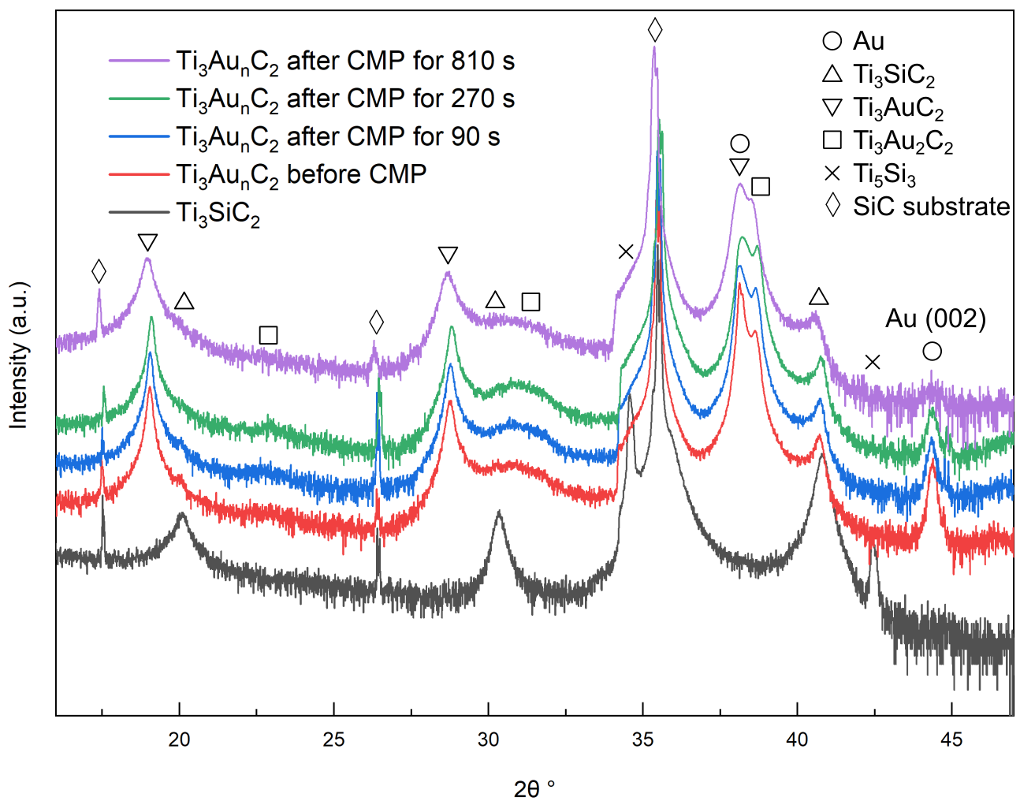
Figure S15 | XRD patters of Ti₃Au_{n}C₂ after stepwise chemical-mechanical polishing (CMP).
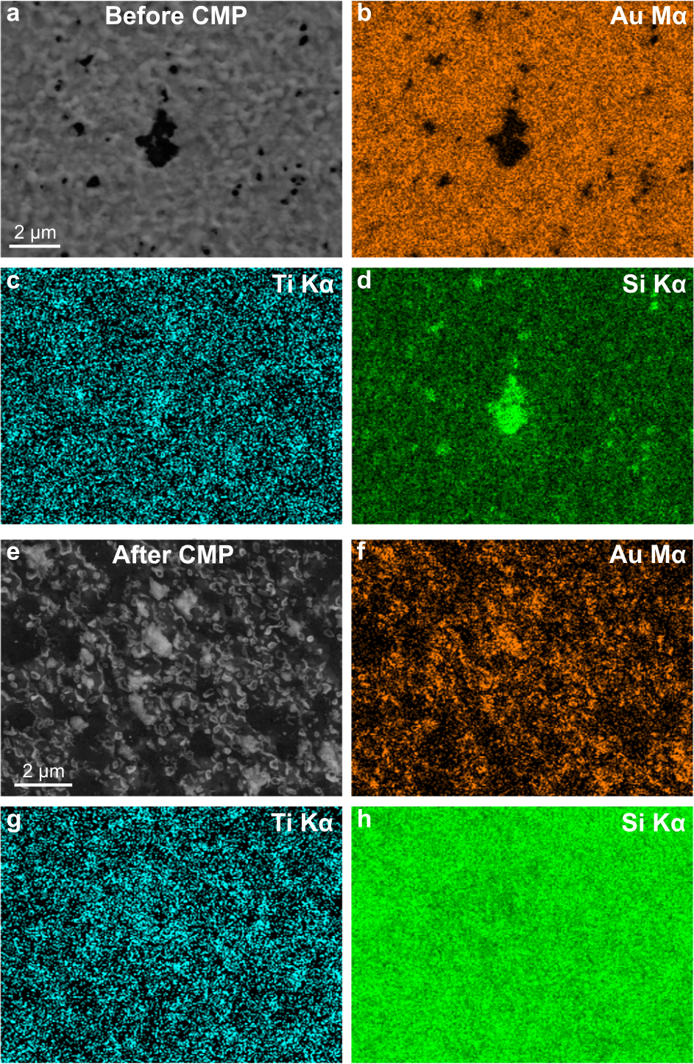
Figure S16 | SEM image with EDX mapping before and after CMP. a-d, Planview SEM image and EDX mappings of Ti₃AuC₂ before CMP. e-h, Plan-view SEM image and EDX mappings of Ti₃AuC₂ after CMP.

Table S2 | Etching conditions
Sample | Resultant structure | Murakami’s reagent concentration | Surfactant  (10m M) | Duration
Figure 1 | One-atom-thick | 0.2 % (2 µg KOH, 2 µg K₃[Fe(CN)₆], 10 mL) | CTAB | 2 months
Figure S2 a,b | One-atom-thick | 0.2 % (2 µg KOH, 2 µg K₃[Fe(CN)₆], 10 mL) | CTAB | 2 months
Figure S2 c,d | One-atom-thick | 0.5 % (5 µg KOH, 5 µg K₃[Fe(CN)₆], 10 mL) | CTAB | 1 month
Figure S2 e,f | One-atom-thick | 1 % (10 µg KOH, 10 µg K₃[Fe(CN)₆], 10 mL) | cysteine | 3 days
Figure S10 a | Two- and three-atom thick | 3 % (30 µg KOH, 30 µg K₃[Fe(CN)₆], 10 mL) | CTAB | 17 days
Figure S10 b-d | Two- and three-atom thick | 1 % (10 µg KOH, 10 µg K₃[Fe(CN)₆], 10 mL) | cysteamine | 3 days
Figure S12 | Two- and three-atom thick | 0.5 % (5 µg KOH, 5 µg K₃[Fe(CN)₆], 10 mL) | CTAB | 1 month
Figure S13 | Two- and three-atom thick | 0.5 % (5 µg KOH, 5 µg K₃[Fe(CN)₆], 10 mL) | CTAB | 1 month
Figure S14 | one-atom-thick | 1 % (10 µg KOH, 10 µg K₃[Fe(CN)₆], 10 mL) | cysteine | 7 days

S7.3 Characterization methods
The phase composition of the samples was identified from X-ray diffraction (XRD) patterns, acquired by a Philips PW 1820 diffractometer using Cu Kα radiation. Scanning electron microscopy (SEM) was performed in a Sigma 300 for imaging and energy-dispersive X-ray analysis (EDX) of the surface. Structural analysis was carried out by high-resolution scanning transmission electron microscopy high angle annular dark field (HRSTEM-HAADF) imaging within Linköping’s double C_{S} corrected FEI Titan³ 60−300 microscope operated at 300 kV. HRSTEM-HAADF imaging was performed using 21.5 mrad probe convergence angle. The corresponding cross-sectional samples were mechanically polished to a thickness of about 50 μm, followed by ion-beam milling with Ar⁺ in a Gatan precision ion polishing system at 5 keV with a final polishing step at 0.8 keV of ion energy. To reduce excessive sample heating, temperature of the sample holder was kept at about 100 K by liquid nitrogen during the ion-milling.

References
1 Fashandi, H. et al. Synthesis of Ti₃AuC₂, Ti₃Au₂C₂ and Ti₃IrC₂ by noble metal substitution reaction in Ti₃SiC₂ for high-temperature-stable Ohmic contacts to SiC. Nature materials 16, 814 (2017).
2 Fan, Z. et al. Stabilization of 4H hexagonal phase in gold nanoribbons. Nature communications 6, 1-8 (2015).
3 Huang, X. et al. Synthesis of hexagonal close-packed gold nanostructures. Nature communications 2, 1-6 (2011).
4 Wang, L. et al. Two-dimensional gold nanostructures with high activity for selective oxidation of carbon–hydrogen bonds. Nature communications 6, 6957 (2015).
5 Wang, X., Wang, C., Chen, C., Duan, H. & Du, K. Free-standing monatomic thick two-dimensional gold. Nano Letters 19, 4560-4566 (2019).
6 Zhao, L., Ta, H. Q., Mendes, R. G., Bachmatiuk, A. & Rummeli, M. H. In situ observations of free-standing single‐atom‐thick gold nanoribbons suspended in graphene. Advanced Materials Interfaces 7, 2000436 (2020).
7 Bhandari, S. et al. Two-dimensional gold quantum dots with tunable bandgaps. ACS nano 13, 4347-4353 (2019).
8 Forti, S. et al. Semiconductor to metal transition in two-dimensional gold and its van der Waals heterostack with graphene. Nature communications 11, 1-7 (2020).
9 Ye, S. et al. Sub‐nanometer thick gold nanosheets as highly efficient catalysts. Advanced Science 6, 1900911 (2019).
10 Sharma, S. K., Pasricha, R., Weston, J., Blanton, T. & Jagannathan, R. Synthesis of Self-Assembled Single Atomic Layer Gold Crystals-Goldene. ACS Applied Materials & Interfaces 14, 54992-55003 (2022).
11 Kresse, G. & Furthmuller, J. Efficient iterative schemes for ab initio total-energy calculations using a plane-wave basis set. Physical Review B 54, 11169-11186 (1996).
12 Kresse, G. & Joubert, D. From ultrasoft pseudopotentials to the projector augmented-wave method. Physical Review B 59, 1758-1775 (1999).
13 Perdew, J. P., Burke, K. & Ernzerhof, M. Generalized gradient approximation made simple. Physical Review Letters 77, 3865-3868 (1996).
14 Grimme, S. Semiempirical GGA-type density functional constructed with a long-range dispersion correction. Journal of Computational Chemistry 27, 1787-1799 (2006).
15 Humphrey, W., Dalke, A. & Schulten, K. VMD: visual molecular dynamics. Journal of molecular graphics 14, 33-38 (1996).
16 Yang, L.-M., Dornfeld, M., Frauenheim, T. & Ganz, E. Glitter in a 2D monolayer. Physical Chemistry Chemical Physics 17, 26036-26042 (2015).
17 Gervilla, V., Zarshenas, M., Sangiovanni, D. G. & Sarakinos, K. Anomalous versus normal room-temperature diffusion of metal adatoms on graphene. The Journal of Physical Chemistry Letters 11, 8930-8936 (2020).
18 Groesbeck, E. C. & United, S. Metallographic etching reagents. [Part] III., For alloy steels. (U.S. Dept. of Commerce, Bureau of Standards : U.S. Govt. Print. Off., 1925).
19 Chen, W. D., Kang, S.-K., Stark, W. J., Rogers, J. A. & Grass, R. N. The light triggered dissolution of gold wires using potassium ferrocyanide solutions enables cumulative illumination sensing. Sensors and Actuators B: Chemical 282, 52-59 (2019).
20 Haber, F. Nachweis und Fällung der Ferroionen in der Wässerigen Lösung des Ferrocyankaliums. Zeitschrift für Elektrochemie und angewandte physikalische Chemie 11, 846-850 (1905).
21 Yu, X., Peng, X. & Wang, G. Photo induced dissociation of ferri and ferro cyanide in hydroponic solutions. International Journal of Environmental Science & Technology 8, 853-862 (2011).
22 Häkkinen, H. The gold–sulfur interface at the nanoscale. Nature chemistry 4, 443-455 (2012).
23 Abild-Pedersen, F. et al. Scaling properties of adsorption energies for hydrogen-containing molecules on transition-metal surfaces. Physical review letters 99, 016105 (2007).
24 Fashandi, H. et al. Single-step synthesis process of Ti3SiC2 ohmic contacts on 4H-SiC by sputter-deposition of Ti. Scripta Materialia 99, 53-56 (2015).
25 Miller, M. S., Ferrato, M.-A., Niec, A., Biesinger, M. C. & Carmichael, T. B. Ultrasmooth gold surfaces prepared by chemical mechanical polishing for applications in nanoscience. Langmuir 30, 14171-14178 (2014).
26 Walker, P. & Tarn, W. H. CRC handbook of metal etchants. (CRC press, 1990).

