Table.2 Predicting on Random Images
S. No | Image Prediction | Original Asana | Predicted Asana | Probability (%)
1. | 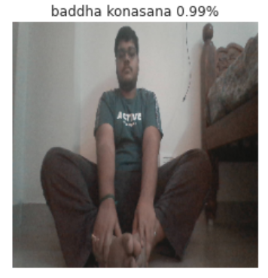 | Baddha konasana | Baddha konasana | 99%
2. | 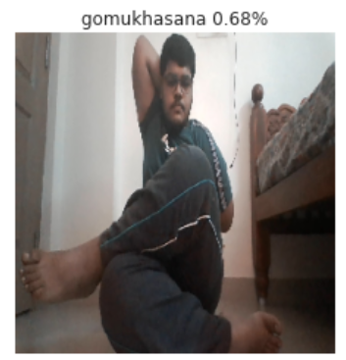 | Gomukhasana | Gomukhasana | 68%
3. | 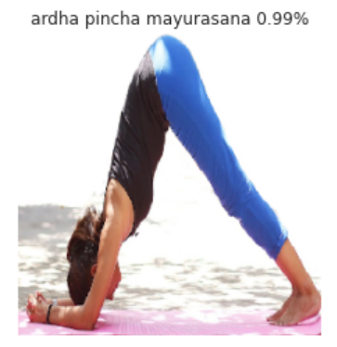 | Ardha pincha mayurasana | Ardha pincha mayurasana | 99%
4. | 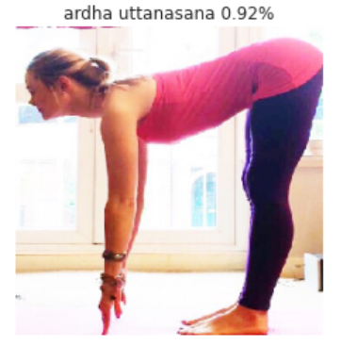 | Ardha uttanasana | Ardha uttanasana | 92%

