Enhanced toxic gas sensing properties with hexagonal - polyhedral 3D like ZSO chemiresistive sensor
Rakesh K. Sonker^{1,2}
¹Department of Physics and Astrophysics, University of Delhi, Delhi-110007, India
²Department of Physics, Acharya Narendra Dev College, University of Delhi, Delhi-110019, India
Email: rakesh.sonker81@gmail.com

Supporting Information:

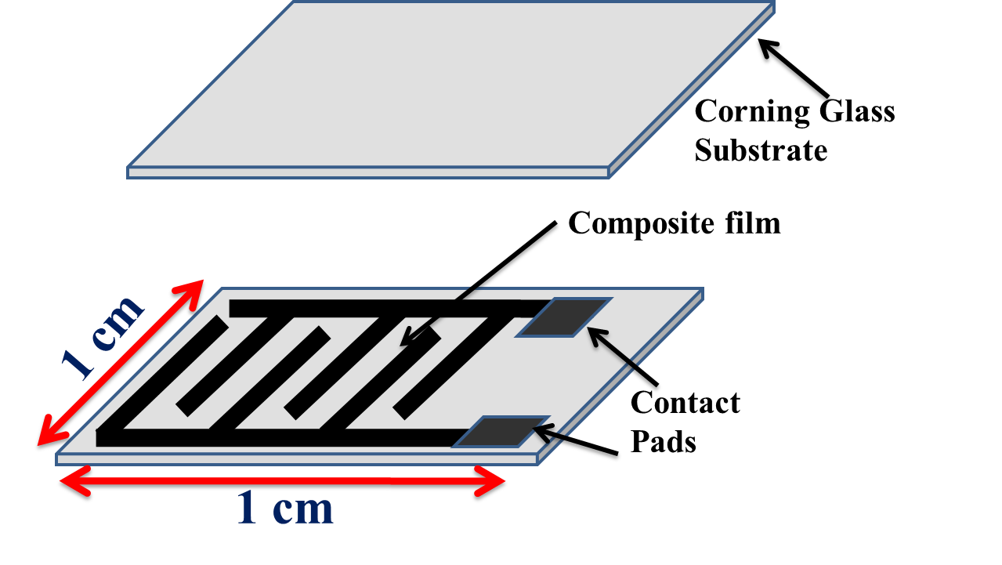
Fig. 1: IDE structure
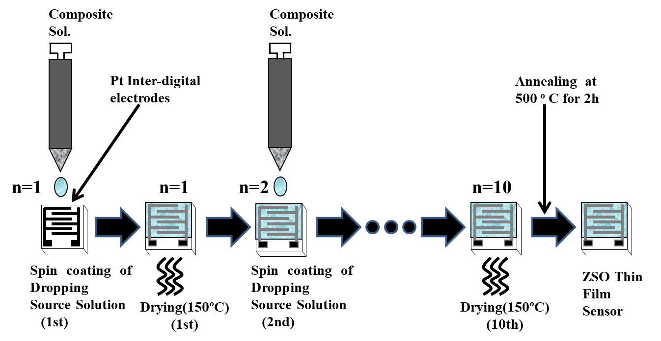
Fig. 2: ZSO sensor preparation

Different gas response:

Fig. 3: (a) Response for Acetone

Fig. 3: (b) Response for CH₄

Fig. 3: (c) Response for CO

Fig. 3: (d) Response for CO₂

Fig. 3: (e) Response for IPA

Fig. 3: (f) Response for NH₃

