Supplementary information for the manuscript entitled “External cycling of NO_{x} promotes the oxidative capacity of the atmosphere”

This file includes methods section and SI figures and tables

Methods
Aircraft observation
A total of 19 research flights were conducted, mostly from 8:00 to 18:00 local time, in various low-NO_{x} troposphere environments. The raw data from the first 15 min after taking off and the last 15 min before landing were excluded from the analysis to avoid interferences from pollution at the airport and were then averaged for 3 min for further analysis.
O₃ and NO_{x} were measured using chemiluminescence methods^{1,2}. HONO, HNO₃, and pNO₃ were measured using a wet-chemistry method similar to LOPAP³. Aerosol number-size distributions were measured using a scanning mobility particle sizer (SMPS) and an ultrahigh sensitivity aerosol spectrometer (UHSAS) ⁴. Alkyl nitrates, PANs and VOCs were measured by a trace organic gas analyzer (TOGA) ⁵. Free radicals were measured using a selected-ion chemical-ionization mass spectrometer (SICIMS) ⁶. Photolysis frequencies were calculated from measurements of a scanning actinic flux spectroradiometer (SAFS) ⁷.
Budget analysis of HONO
The aircraft measurements were taken ≥ 300 m above the ground in the boundary layer and up to 8000 m in the free troposphere. The air masses encountered were therefore decoupled from ground surface HONO sources such as soil emissions and heterogeneous reactions of NO₂ at ground surfaces ⁸. The high HONO/NO₂ ratio observed here also excluded influences from primary HONO emissions except for occasional influences from power plant plumes or city plumes. Therefore, only in situ chemical reactions are considered in the budget analysis of HONO. The internal source of HONO ($P_{internal}$) included reactions R1 and R2’. The external source of HONO ($P_{external}$) is the unidentified mechanism under discussion in this context. The major sink for HONO included reactions R2 and R3.
$${NO}_{2}+surface→HONO+other products (R1)$$
$$HONO+hv (λ<400 nm)↔OH+NO (R2,R2')$$
$$HONO + OH → H_{2}O + {NO}_{2} (R3)$$
With a photolytic lifetime of approximately 10 min, the photosteady-state assumption is applicable for the HONO budget.
$$P_{internal} + P_{external}={(k}_{R2 }+ k_{R3}\left[OH\right])×\left[HONO\right] (1)$$
where [X] represents the concentration of species X in molecule cm⁻³ and k_{Ri} represents the rate constants of Ri. The heterogeneous uptake rate constant of NO₂ on the aerosol surface is defined in Eq (2).
$$k_{R1}=\frac{1}{4}×s/v×c×γ (2)$$
where s/v represents the aerosol surface density, which is calculated from the particle number-size distribution by the SMPS. c represents the average molecular speed of NO₂. $γ$ represents the uptake coefficient of NO₂ on an aerosol particle surface. An upper limit of 10⁻⁴ was adopted to avoid overestimation of unidentified external sources of HONO ⁹. The relative contribution of the internal source and external source to the total HONO source, C_{internal} and C_{external}, can be defined as:
$C_{internal}= \frac{P_{internal}}{P_{internal}+P_{external}}=\frac{k_{R1}[{NO}_{2}]+ k_{R2'}\left[OH\right]\left[NO\right]}{{(k}_{R2 }+ k_{R3}\left[OH\right])×\left[HONO\right]} (3)$
$$C_{external}= \frac{P_{external}}{P_{internal}+P_{external}} (4)$$
HONO production from the external cycling proxy mechanism, $P_{{pNO}_{3}→HONO}$, was expressed as follows:
$$P_{{pNO}_{3}→HONO}= {[{pNO}_{3}]×j}_{HNO3}×EF (5)$$
where$j_{HNO3}$ is the photolysis frequency of HNO₃ in its gaseous form, and the enhancement factor, EF, is the ratio of the photolysis rate constant of particulate nitrate relative to$j_{HNO3}$. If the particulate nitrate photolysis rate fully accounts for $P_{external}$, the apparent EF value for the air masses encountered in our research flight can be obtained and plotted in Fig. S4. As shown, the apparent EF value is comparable to the EF value (median = 150) obtained from laboratory experiments using aerosol samples collected from various environments ¹⁰ (Fig. S4).
Nearly explicit chemical model simulation
The master chemical mechanism (MCM v3.3.1) is adapted here to simulate nitrogen cycling photochemistry and its impacts on the oxidative capacity of the atmosphere. The specific objective of the model run was to test whether the external cycling proxy mechanism, i.e., particulate nitrate photolysis, is able to reproduce the unique distribution patterns of OH, HONO and NO₂ in the low-NO_{x} troposphere.
The initial mechanism revisions of the MCM model include the addition of the heterogeneous production of HONO from NO₂ reactions, dry deposition-driven removal of model-calculated OVOC intermediates and reactive nitrogen species, and a transport source for HNO₃ and PAN to compensate for dry deposition losses of NO_{y} species. These revisions are described in detail in previous modeling work¹¹. This model mechanism setup is referred to as the baseline model, S0, which excludes the external cycling proxy mechanism. In further revised models, we added the proxy mechanism with a HONO yield of 0% (S1, 100% yield for NO₂) or 100% (S2, 0% yield for NO₂). A median EF of 150 and a pNO₃/HNO₃ partitioning ratio of 0.5 were employed in the model to represent the average condition for the background troposphere (Fig. S6).
The model was initialized with a NO_{x} mixing ratio of 10 ppbv, as observed in the Fort Martin station power plant plume, and with concentrations of O₃ and OH of 30 ppbv and 1.7×10⁶ cm⁻³, respectively, which were typically observed in our daytime measurements. The photosteady state was established quickly in the model under these initial conditions. The simulation thus mimicked the photochemical evolutions of reactive nitrogen species in the typical troposphere background. Because our focus was on the photochemical cycling of HONO and NO₂, the models were run without day-night shifts and had constant photolysis frequencies under zero solar zenith angle conditions to mimic the continuous 400 hrs photochemical aging of the power plant plume in the background troposphere. After approximately 100 hrs, the model simulation reached a stable stage. Thus, only results for the first 200 hrs are shown. To best represent the radical chemistry for the background troposphere, an OH reactivity of approximately 5 s⁻¹ was used for the model based on our aircraft measurements of VOCs and other species that consume OH, such as O₃, NO_{x}, CO. CO, CH₄ and HCHO are found to be the top three contributors to OH reactivity in the background troposphere. To simplify the model, all measured VOCs, except HCHO, are grouped with CO to obtain an equivalent OH reactivity. The oxidative mechanism of these grouped VOCs is thus not included in our model. The model settings and initialization conditions are summarized in Tables S3-S4.
GEOS-Chem simulation
The GEOS-Chem model (version 9-02; www.geos-chem.org) regional simulations were conducted in a one-way nested grid formulation with the native GEOS-5 Forward Processing horizontal resolution of 0.25° × 0.3125° over the North America domain (130–60° W, 10–60° N). The initial and boundary conditions were obtained through a global GEOS-Chem model simulation with a coarser resolution of 2° × 2.5° (reduced from the native GEOS-5 forward processing grid). The GEOS-Chem meteorological fields were obtained from the assimilated products of the NASA Global Modeling and Assimilation Office Goddard Earth Observing System (http://gmao.gsfc.nasa.gov/products/). The model simulations had 47 vertical layers in the atmosphere. We used a nonlocal planetary boundary layer mixing scheme developed by Holtslag and Boville (1993) and implemented in GEOS-Chem by Lin and McElroy (2010) ^{12,13}. The tropospheric chemistry mechanism was described in Parrella et al. (2012) ¹⁴. No further updates, including external cycling, were made. Emissions of atmospheric components included anthropogenic emissions from the Emissions Database for Global Atmospheric Research (https://edgar.jrc.ec.europa.eu), biogenic emissions of volatile organic carbons from the Model of Emissions of Gases and Aerosols from Nature inventory¹⁵, fire emissions from the Global Fire Emissions Database¹⁶ , soil NO_{x} emissions¹⁷, and lightning NO_{x} sources¹⁸. The dry deposition scheme used a resistance in-series model based on Wesely (1989)¹⁹. The wet deposition scheme included the scavenging of soluble tracers in convective updrafts as well as rainout and washout of soluble tracers²⁰. Simulation results corresponding to the research flight track during the same period were extracted for measurement comparison.

SI figures
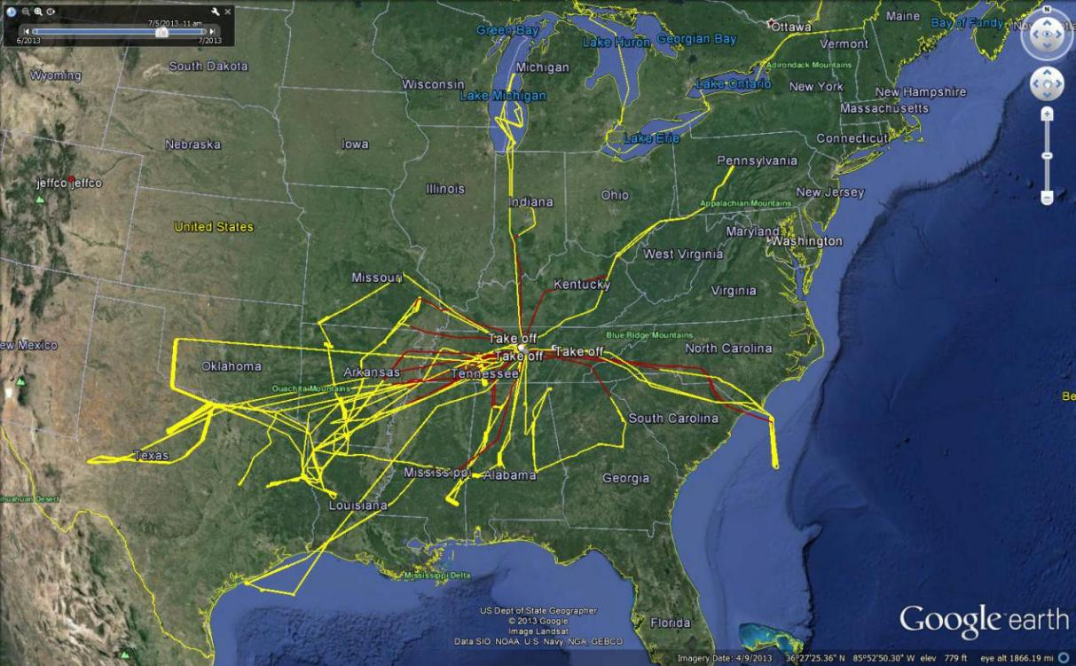
Fig. S1 | Flight track map of the NSF/NCAR C130 research aircraft from June 1 to July 15, 2013.

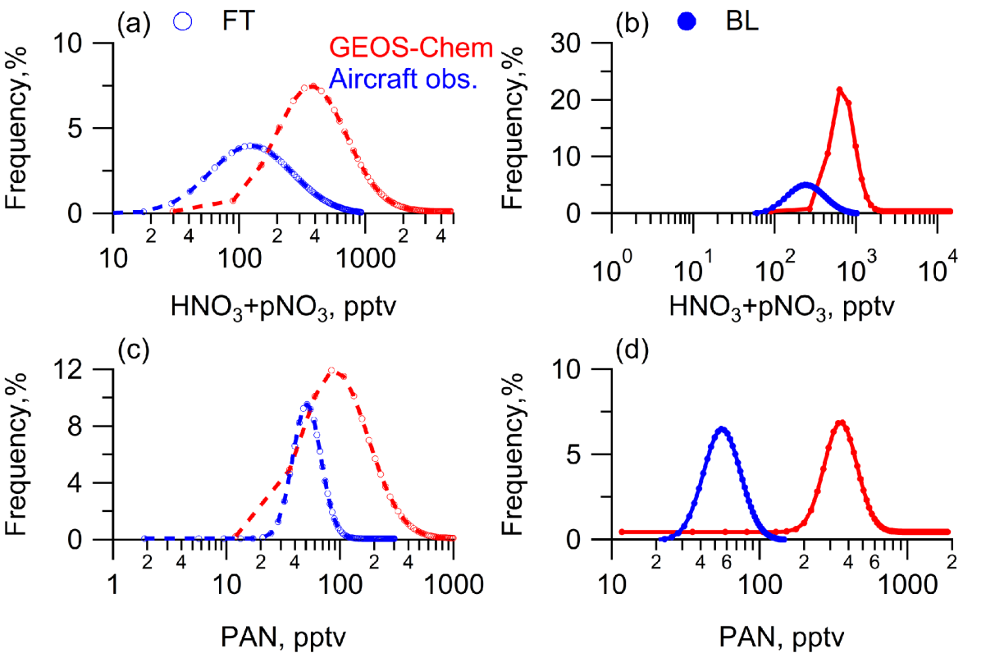
Fig. S2 | Frequency distribution of HNO₃+pNO₃ ((a) & (b)) and PAN ((c) & (d)) in the FT and BL as measured on board the C-130 research aircraft and simulated by GEOS-Chem. The red circles represent GEOS-Chem model predictions. The blue circles represent our aircraft observations. Open circles and solid circles represent data points from the FT and the BL, respectively. Dashed lines and solid lines connect adjacent data points.

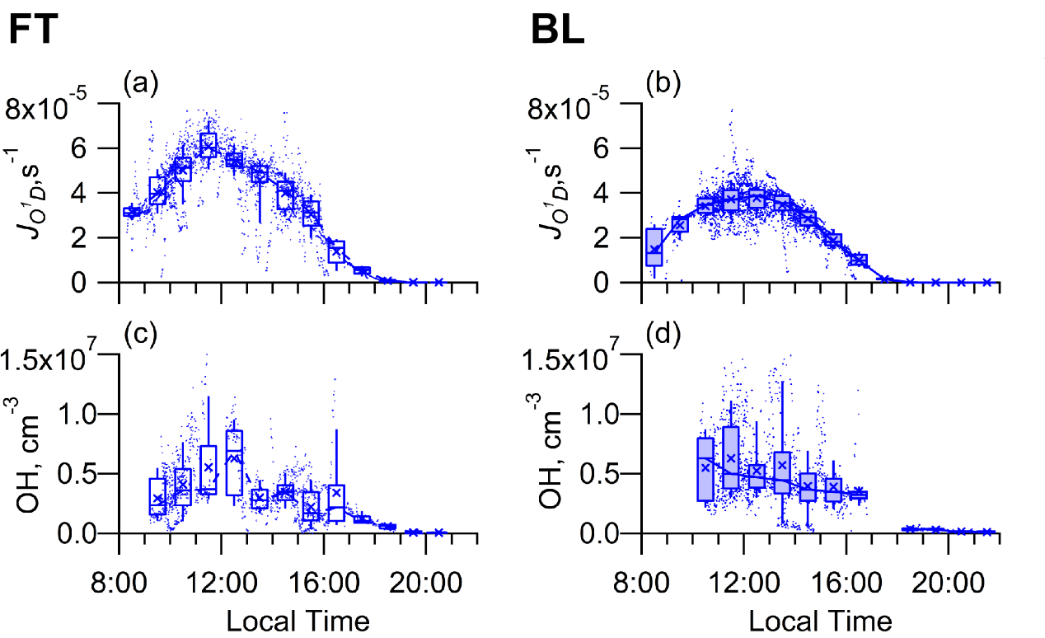
Fig. S3 | Diurnal profiles of the mixing ratio of the O₃ photolysis frequency, JO¹D ( (a) & (b) ) and OH ( (c) & (d) ) in the FT and the BL as measured on board the C-130 research aircraft. Open boxes and solid boxes represent data points from the FT and the BL. The boxes represent, from top to bottom, the 75th, 50th, and 25th percentiles; the whiskers above and below the boxes represent the 90th and 10th percentiles; and the cross represents the mean value. The dashed lines and solid lines connect adjacent medians.

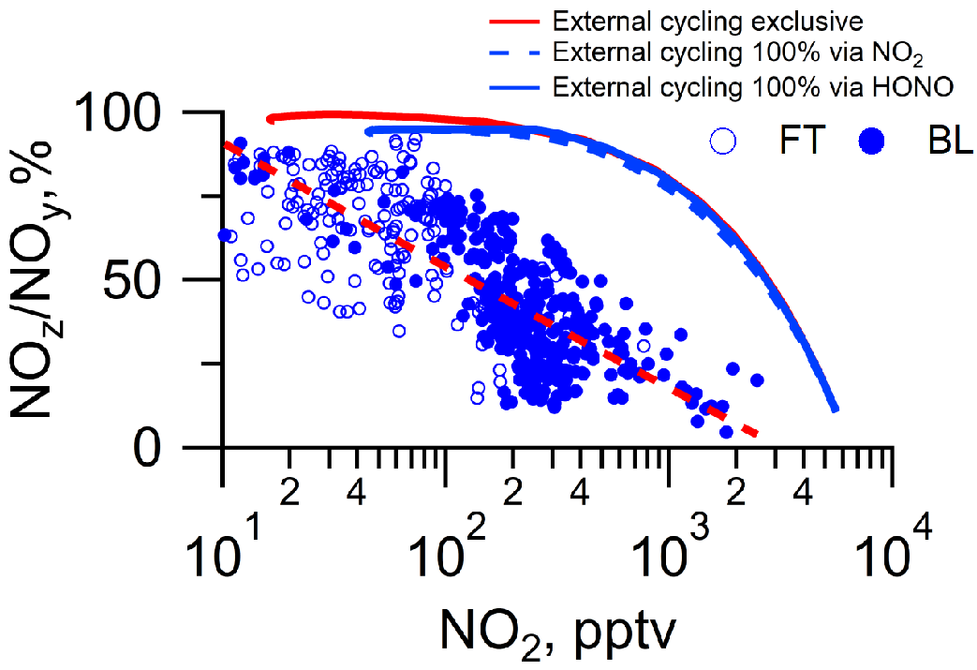
Fig. S4 | Scatter plots of the NO_{z}/NO_{y} ratio against NO₂ as measured on board the C-130 research aircraft and simulated by the MCM model. Open circles and solid circles represent measured data points from the FT and the BL. The red line represents the model S0, which excludes external cycling. The blue line and blue dashed line present the S1 and S2 models, which include the proxy mechanism for external cycling with HONO yields of 100% (0% yield for NO₂) and 0% (100% yield for NO₂), respectively.
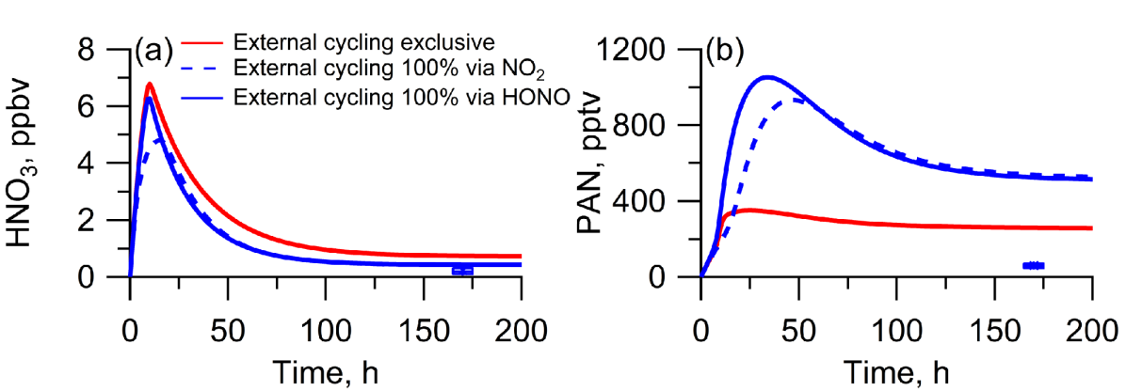
Fig. S5 | Distribution of HNO₃ (a) and PAN (b) during plume aging under the full sun scenario of NO_{x} emission in a fresh power plant plume as simulated by the MCM model. The red line represents the baseline model, which excludes the external cycling proxy mechanism. The blue line and blue dashed line present the control models, which include the external cycling proxy mechanism with a HONO yield of 100% (0% yield for NO₂) and a HONO yield of 0% (100% yield for NO₂), respectively. The boxes represent, from top to bottom, the 75th, 50th, and 25th percentiles; the whiskers above and below the boxes represent the 90th and 10th percentiles; and the cross represents the mean value of our aircraft observations. NO_{x} regeneration from PAN, even when it was model-optimized, could not reconcile the model–observation discrepancy in the NO₂/NO_{y} ratio.
SI Tables
Table S1: Summary of flight missions and flight tracks.
Mission | Start Time | End Time | mission summaries
rf01 | 2013/6/3 14:00 | 2013/6/3 18:34 | Smyrna to ROSE site in Central AL and then return to Smyrna.
rf02 | 2013/6/5 14:44 | 2013/6/5 21:30 | Flight to Texas/Louisiana border for multiple (4) stacked racetracks in the BL.
rf03 | 2013/6/8 14:06 | 2013/6/8 21:05 | Flight to Missouri/Arkansas for multiple (2 to 4) stacked racetracks in the BL at four forested sites.
rf04 | 2013/6/12 15:14 | 2013/6/12 22:28 | Flight to racetrack sites in Alabama and Mississippi.
rf05 | 2013/6/14 15:05 | 2013/6/14 21:31 | Flight #2 to Alabama/Mississippi for multiple (2 to 4) stacked racetracks in the BL at four forested sites.
rf06 | 2013/6/19 14:59 | 2013/6/19 22:08 | Sampling of high altitude/dry air over Texas and East Texas power plant plumes.
rf07 | 2013/6/20 16:29 | 2013/6/20 23:38 | Sample power plant and other plumes in a heavily impacted region of the Ohio River Valley.
rf08 | 2013/6/22 15:16 | 2013/6/22 22:15 | Sample Birmingham and NE Texas power plant plumes.
rf09 | 2013/6/24 15:09 | 2013/6/24 22:21 | Vertical profile in very dry air over Texas. Sampled possible biomass burning plume at 15 kft.
rf10 | 2013/6/27 15:03 | 2013/6/27 21:53 | Sampled high elevation air over TX/OK with likely BB influence. Sampling at low elevations near Texarkana and Martin Lake power plants.
rf11 | 2013/6/29 15:20 | 2013/6/29 21:02 | Sample Birmingham, Gaston power plant and Atlanta power plant plumes.
rf12 | 2013/7/1 14:14 | 2013/7/1 21:22 | Flight to Texas Gulf Coast.
rf13 | 2013/7/4 15:19 | 2013/7/4 22:09 | Sampled Hg plume at high levels between Smyrna and El Dorado, Texas.
^{To be continued}

rf14 | 2013/7/5 15:08 | 2013/7/5 21:44 | Sampled clean marine air over the Atlantic Ocean.
rf15 | 2013/7/7 15:11 | 2013/7/7 22:01 | To study Chicago outflow over Lake Michigan in and above BL; (2) To sample Indianapolis plume in the BL; (3) To measure biogenic VOC flux over forested regions in South Indiana.
rf16 | 2013/7/8 15:04 | 2013/7/8 21:48 | To sample clean marine air over Atlantic Ocean; (2) to sample boundary layer air masses over the forest and over the land‒sea transition zone.
rf17 | 2013/7/11 15:08 | 2013/7/11 21:57 | Sampled aged Canadian biomass burning plume over the eastern border of the Ozarks.
rf18 | 2013/7/12 20:32 | 2013/7/13 3:37 | Sampled air in multiple stacked racetracks over a forested region to establish vertical profiles during the day; (2) to study nighttime evolution of HONO in the daytime BL remnant and in the free troposphere.
rf19 | 2013/7/14 14:05 | 2013/7/14 21:08 | Flight to Eastern Arkansas.

Table S2: Medians and means (±SD) of the mixing ratios of HONO, NO₂, PAN and HNO₃+pNO₃ in our aircraft observations and simulated by GEOS-Chem.
parameters | HONO, pptv  Median  Mean(±SD) | NO₂, pptv  Median  Mean(±SD) | PAN, pptv  Median  Mean(±SD) | HNO₃+pNO₃, pptv  Median  Mean(±SD)
Free troposphere  Aircraft obs. | 7.0  9.2(±8.0) | 30  41 (±87) | 55  59 (±23) | 189.1  221 (±127)
Boundary layer  Aircraft obs. | 12.1  14.1(±8.5) | 219  340(±764) | 60  60 (±17) | 319  308 (±136)
Free troposphere  GEOS-Chem | 1.0  1.8(±2.4) | 80  93 (±76) | 146  194 (±169) | 566  739(±558)
Boundary layer  GEOS-Chem | 1.0  2.67(±8.0) | 218  291(±401) | 379  410(±212) | 757  1132 (±1179)

Table S3: MCM model mechanisms in specific model run scenarios.
MCM v3.3.1 | Mechanism revisions
S0, external cycling exclusive model | MCM v3.3.1 + heterogeneous NO₂ → HONO conversion (γ = 1×10⁻⁴) + dry deposition removal + transport of HNO₃ and PAN¹¹
S1, external cycling 100% via HONO | S0 + pNO₃ photolysis → HONO with 0% yield (100% NO₂ yield) and EF = 150¹⁰
S2, external cycling 100% via NO₂ | S0 + pNO₃ photolysis → HONO with 100% yield (0% NO₂ yield) and EF = 150¹⁰

Table S4: Initialization conditions of all MCM model runs.
Parameters/variables | Settings
NO₂ (variable) | Initialized at 10 ppb
OH (variable) | Initialized at 1.7×10⁶ cm⁻³
O₃ (variable) | Initialized at 30 ppb
OH reactivity (parameter) | Fixed as 5 s⁻¹ by constraining the CH₄, CO, and HCHO mixing ratio while neglecting other VOCs.
Photolysis frequencies (parameters) | Set to cloud free and zero solar zenith angle conditions, e.g., j_{HONO} =1.6×10⁻³ s⁻¹

References
1 Ridley, B. Florida thunderstorms: A faucet of reactive nitrogen to the upper troposphere. Journal of Geophysical Research 109, doi:10.1029/2004jd004769 (2004).
2 Griffin, R. J., Beckman, P. J., Talbot, R. W., Sive, B. C. & Varner, R. K. Deviations from ozone photostationary state during the International Consortium for Atmospheric Research on Transport and Transformation 2004 campaign: Use of measurements and photochemical modeling to assess potential causes. Journal of Geophysical Research: Atmospheres 112, doi:10.1029/2006jd007604 (2007).
3 Huang, G., Zhou, X. L., Deng, G. H., Qiao, H. C. & Civerolo, K. Measurements of atmospheric nitrous acid and nitric acid. Atmos. Environ. 36, 2225-2235, doi:10.1016/s1352-2310(02)00170-x (2002).
4 Flagan, R. C. Electrical Mobility Methods for Submicrometer Particle Characterization. Aerosol Measurement 339-364 (2011).
5 de Gouw, J. & Warneke, C. Measurements of volatile organic compounds in the earths atmosphere using proton-transfer-reaction mass spectrometry. Mass Spectrom. Rev. 26, 223-257, doi:10.1002/mas.20119 (2007).
6 Hornbrook, R. S. et al. Measurements of tropospheric HO2 and RO2 by oxygen dilution modulation and chemical ionization mass spectrometry. Atmospheric Measurement Techniques 4, 735-756, doi:10.5194/amt-4-735-2011 (2011).
7 Shetter, R. E., Cinquini, L., Lefer, B. L., Hall, S. R. & Madronich, S. Comparison of airborne measured and calculated spectral actinic flux and derived photolysis frequencies during the PEM Tropics B mission. Journal of Geophysical Research-Atmospheres 108, doi:10.1029/2001jd001320 (2002).
8 Carlton, A. G. et al. SYNTHESIS OF THE SOUTHEAST ATMOSPHERE STUDIES: Investigating Fundamental Atmospheric Chemistry Questions. Bulletin of the American Meteorological Society 99, 547-567, doi:10.1175/bams-d-16-0048.1 (2018).
9 Stemmler, K. et al. Light induced conversion of nitrogen dioxide into nitrous acid on submicron humic acid aerosol. Atmospheric Chemistry and Physics 7, 4237-4248, doi:10.5194/acp-7-4237-2007 (2007).
10 Ye, C. X., Zhang, N., Gao, H. L. & Zhou, X. L. Photolysis of Particulate Nitrate as a Source of HONO and NOx. Environmental Science & Technology 51, 6849-6856, doi:10.1021/acs.est.7b00387 (2017).
11 Ye, C. X., Heard, D. E. & Whalley, L. K. Evaluation of Novel Routes for NOx Formation in Remote Regions. Environmental Science & Technology 51, 7442-7449, doi:10.1021/acs.est.6b06441 (2017).
12 Holtslag, A. A. M. & Boville, B. A. LOCAL VERSUS NONLOCAL BOUNDARY-LAYER DIFFUSION IN A GLOBAL CLIMATE MODEL. Journal of Climate 6, 1825-1842, doi:10.1175/1520-0442(1993)006<1825:Lvnbld>2.0.Co;2 (1993).
13 Lin, J. T. & McElroy, M. B. Impacts of boundary layer mixing on pollutant vertical profiles in the lower troposphere: Implications to satellite remote sensing. Atmos. Environ. 44, 1726-1739, doi:10.1016/j.atmosenv.2010.02.009 (2010).
14 Parrella, J. P. et al. Tropospheric bromine chemistry: implications for present and pre-industrial ozone and mercury. Atmospheric Chemistry and Physics 12, 6723-6740, doi:10.5194/acp-12-6723-2012 (2012).
15 Guenther, A. B. et al. The Model of Emissions of Gases and Aerosols from Nature version 2.1 (MEGAN2.1): an extended and updated framework for modeling biogenic emissions. Geoscientific Model Development 5, 1471-1492, doi:10.5194/gmd-5-1471-2012 (2012).
16 van der Werf, G. R. et al. Global fire emissions and the contribution of deforestation, savanna, forest, agricultural, and peat fires (1997-2009). Atmospheric Chemistry and Physics 10, 11707-11735, doi:10.5194/acp-10-11707-2010 (2010).
17 Hudman, R. C. et al. Surface and lightning sources of nitrogen oxides over the United States: Magnitudes, chemical evolution, and outflow. Journal of Geophysical Research-Atmospheres 112, doi:10.1029/2006jd007912 (2007).
18 Murray, L. T., Jacob, D. J., Logan, J. A., Hudman, R. C. & Koshak, W. J. Optimized regional and interannual variability of lightning in a global chemical transport model constrained by LIS/OTD satellite data. Journal of Geophysical Research-Atmospheres 117, doi:10.1029/2012jd017934 (2012).
19 Wesely, M. L. PARAMETERIZATION OF SURFACE RESISTANCES TO GASEOUS DRY DEPOSITION IN REGIONAL-SCALE NUMERICAL-MODELS. Atmos. Environ. 23, 1293-1304, doi:10.1016/0004-6981(89)90153-4 (1989).
20 Liu, H. Y., Jacob, D. J., Bey, I. & Yantosca, R. M. Constraints from Pb-210 and Be-7 on wet deposition and transport in a global three-dimensional chemical tracer model driven by assimilated meteorological fields. Journal of Geophysical Research-Atmospheres 106, 12109-12128, doi:10.1029/2000jd900839 (2001).

