Supplementary Information

Physical origins of canonical and tautomeric mutagenesis
Mariusz Pietruszka and Marcin Lipowczan

University of Silesia, Faculty of Natural Sciences, Institute of Biology, Biotechnology and Environmental Protection, 28 Jagiellońska St., PL-40032 Katowice, Poland

Corresponding author: mariusz.pietruszka@us.edu.pl
Table S1 Data analysis for Fig. S2. The legend represents the sign for (U, I) pairs.
  B=0
   | nr | T
  1 | 5 | 36,3
  2 | 7 | 36,5
  3 | 8 | 36,6
  4 | 9 | 36,7
  5 | 11 | 36,8
  6 | 13 | 36,55
  7 | 15 | 36,4
  8 | 18 | 36,8
  9 | 19 | 36,7
  10 | 20 | 36,9
  11 | 21 | 36,1
  12 | 32 | 36,8
  13 | 33 | 37
  B=0
   | nr | T
  1 | 23 | 36,9
  2 | 24 | 36,8
  3 | 26 | 36,5
  4 | 27 | 36,3
  5 | 72 | 36,1
  6 | 73 | 36,2
  7 | 74 | 36,4
  8 | 75 | 36,6
  9 | 76 | 36,7
  10 | 77 | 37
  11 | 78 | 36,6
  B=1
   | nr | T
  1 | 36 | 36
  2 | 37 | 36,4
  3 | 38 | 36,9
  4 | 39 | 37
  5 | 40 | 36,8
  6 | 41 | 36,2
  7 | 42 | 36,1
  8 | 43 | 36,3
  9 | 44 | 36,7
  10 | 45 | 36,6
  11 | 46 | 36,5
  B=1
   | nr | T
  1 | 66 | 36,8
  2 | 67 | 36,9
  3 | 68 | 37
  4 | 69 | 36,6
  5 | 70 | 36,5
  6 | 71 | 36,7
  7 | 79 | 36,4
  8 | 80 | 36,6
  9 | 81 | 36,3
  10 | 82 | 36,1
  11 | 83 | 36,2
  B=2
   | nr | T
  1 | 49 | 36
  2 | 50 | 36,2
  3 | 51 | 36,1
  4 | 53 | 36,4
  5 | 56 | 36,3
  6 | 57 | 36,8
  7 | 59 | 36,6
  8 | 60 | 36,5
  9 | 62 | 36,9
  10 | 63 | 37
  11 | 64 | 36,7
  B=2
   | nr | T
  1 | 85 | 36,6
  2 | 86 | 36,9
  3 | 91 | 36,1
  4 | 92 | 36,2
  5 | 93 | 36,4
  6 | 94 | 36,3
  7 | 96 | 36,7
  8 | 97 | 36,8
  9 | 98 | 37
  10 | 99 | 36,5
legend
  IU ++--
  IU +--- | IU +-+-
  IU +++-
  IU ++++
male | female

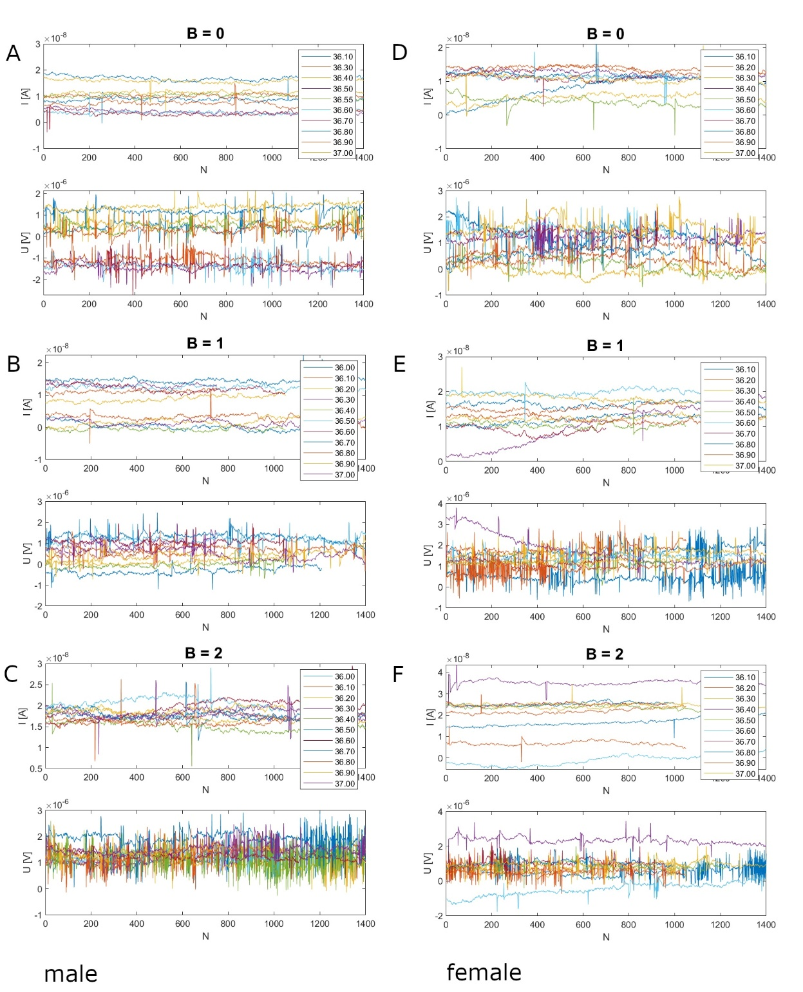

Fig. S1 Sample time series of voltages and currents obtained in the experiment (raw data) at magnetic field B = 0, 1, 2 and different temperatures.
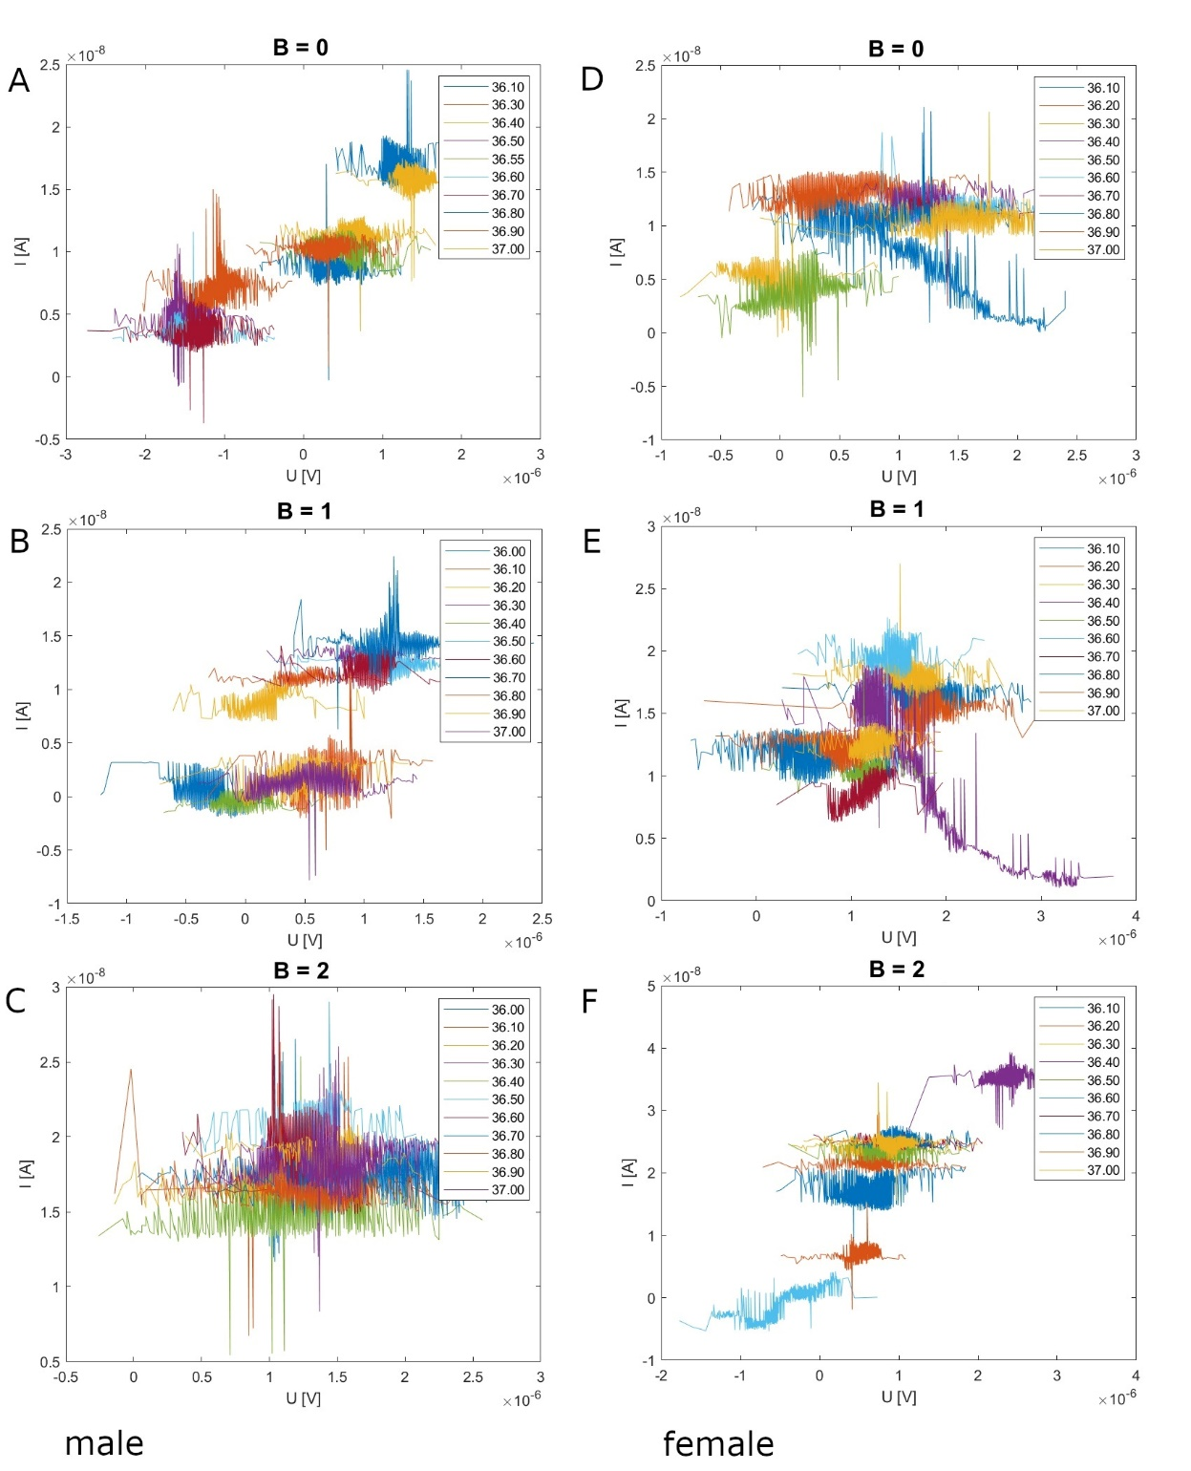

Fig. S2 The ion charge separation effect in human blood. The bifurcation occurs at magnetic field B = B_{c} ~ 0.35 T for male (left column) and ~ 0.5 T for female (right column) blood samples at T = T_{c} (~ 36.6 ºC).

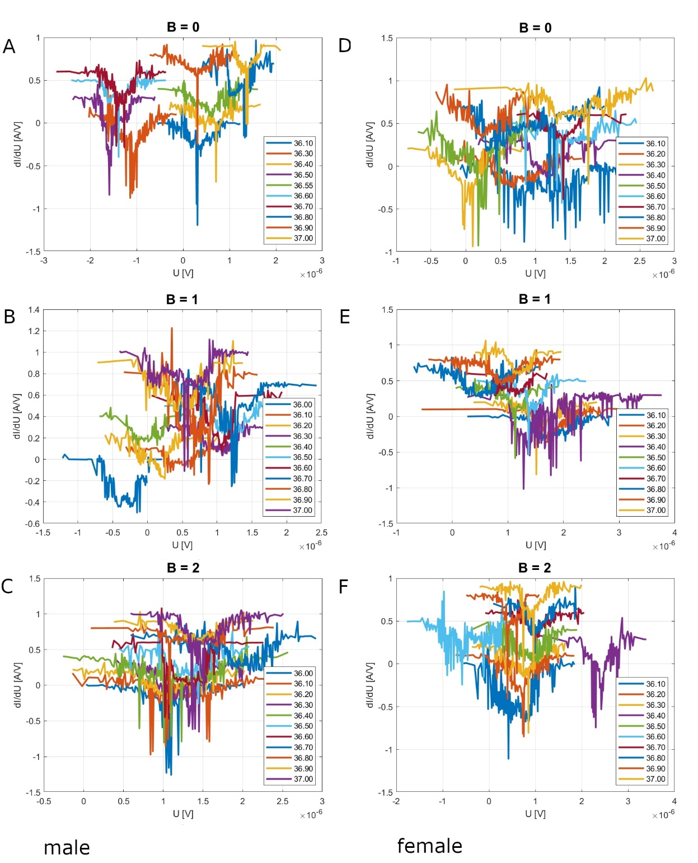

Fig. S3 Derivative of current versus voltage at different external magnetic fields. Note the extreme value at the central part of each curve for B = 0 at a critical temperature of 36.6 degrees Celsius (male) and 36.7 (female).

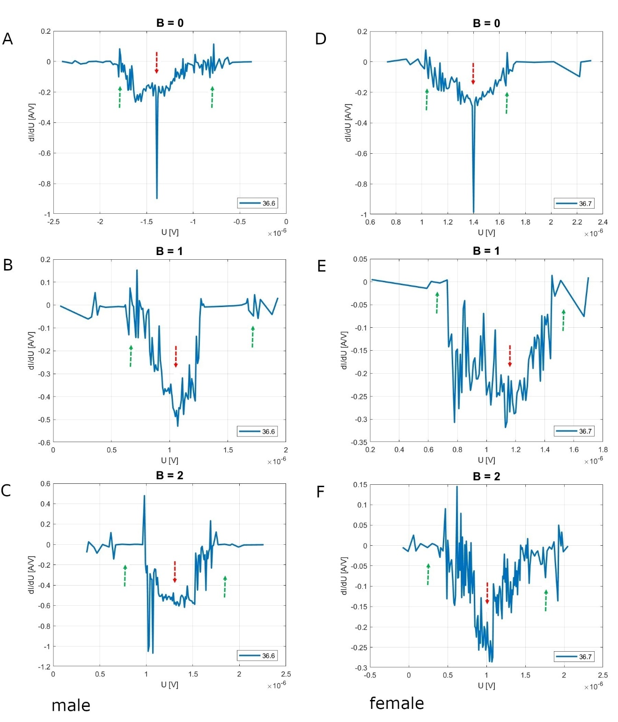
Fig. S3a Derivative of current versus voltage at different external magnetic fields. Note the extreme value at the central part of each curve for B = 0 at a critical temperature of 36.6 degrees Celsius (male) and 36.7 (female).
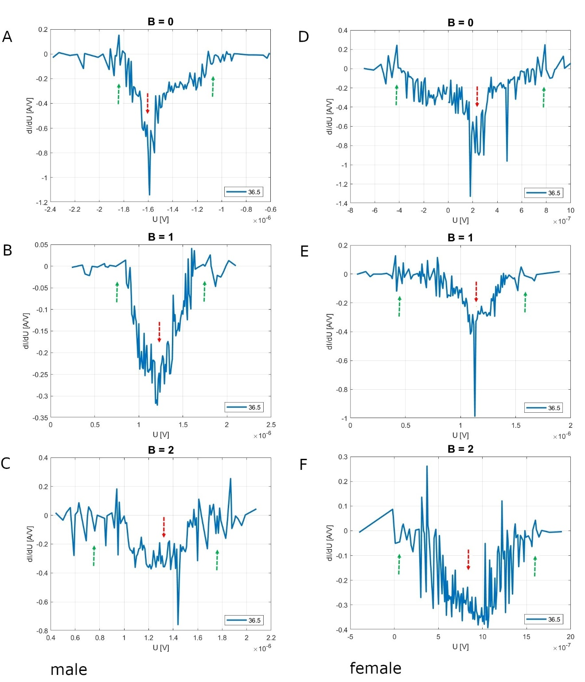
Fig. S3b Derivative of current versus voltage at different external magnetic fields. Note the extreme value at the central part of each curve for B = 0 at a critical temperature of 36.5 degrees Celsius (male) and 36.5 (female).

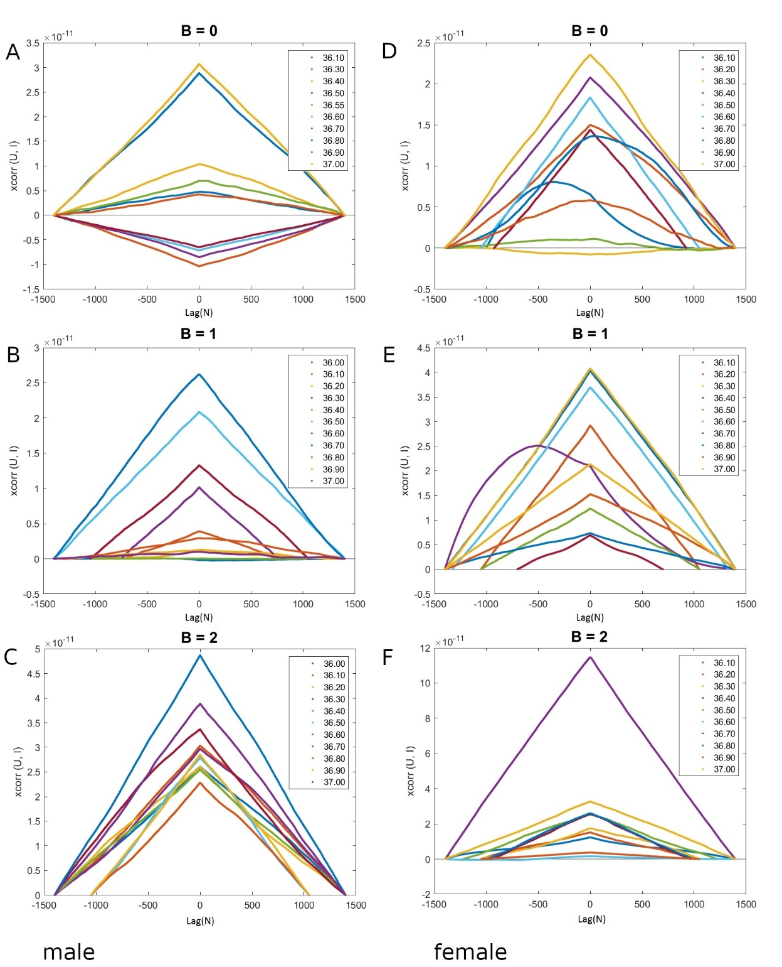

Fig. S4 Cross-correlation of a voltage versus current time-series; here, N expresses time delay.

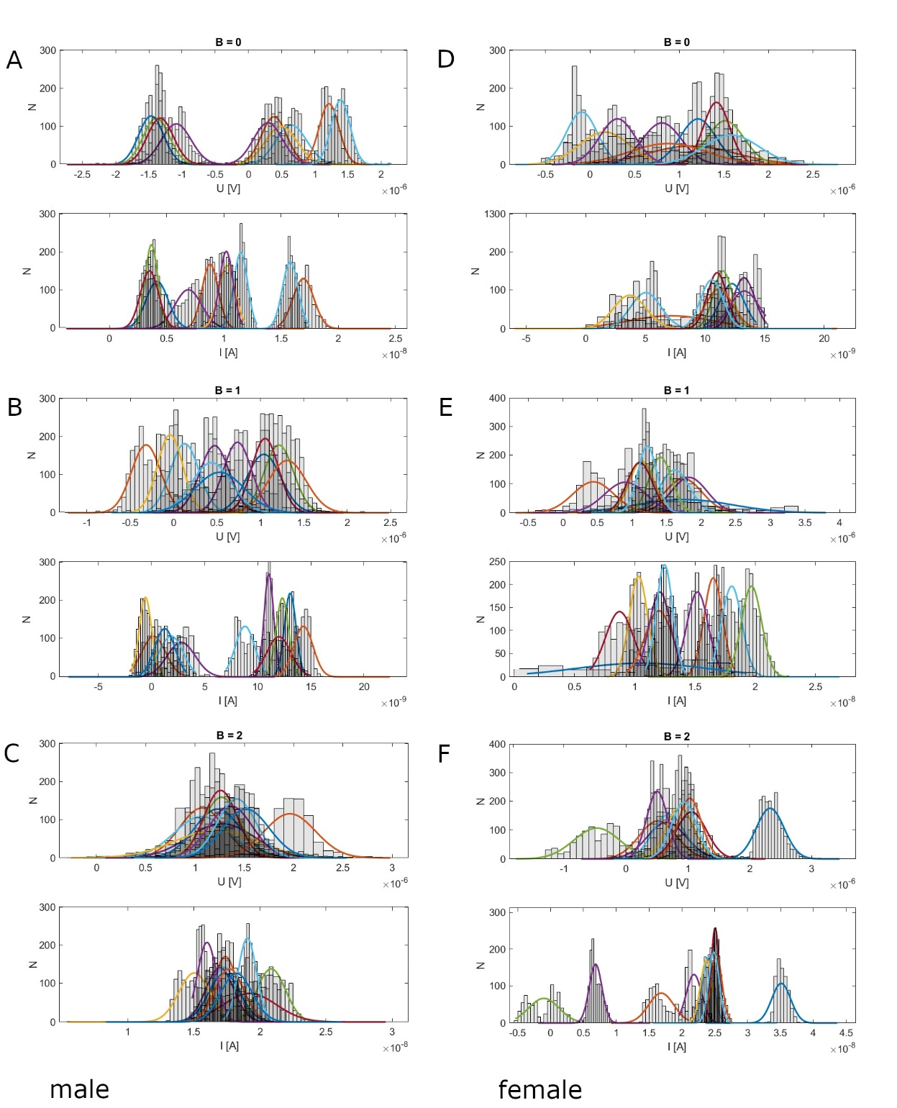

Fig. S5 Normalized Gauss distributions for the voltage and current (here: N - number of counts). In the right column you can see the removal of the spin/charge degeneracy in the external magnetic field.
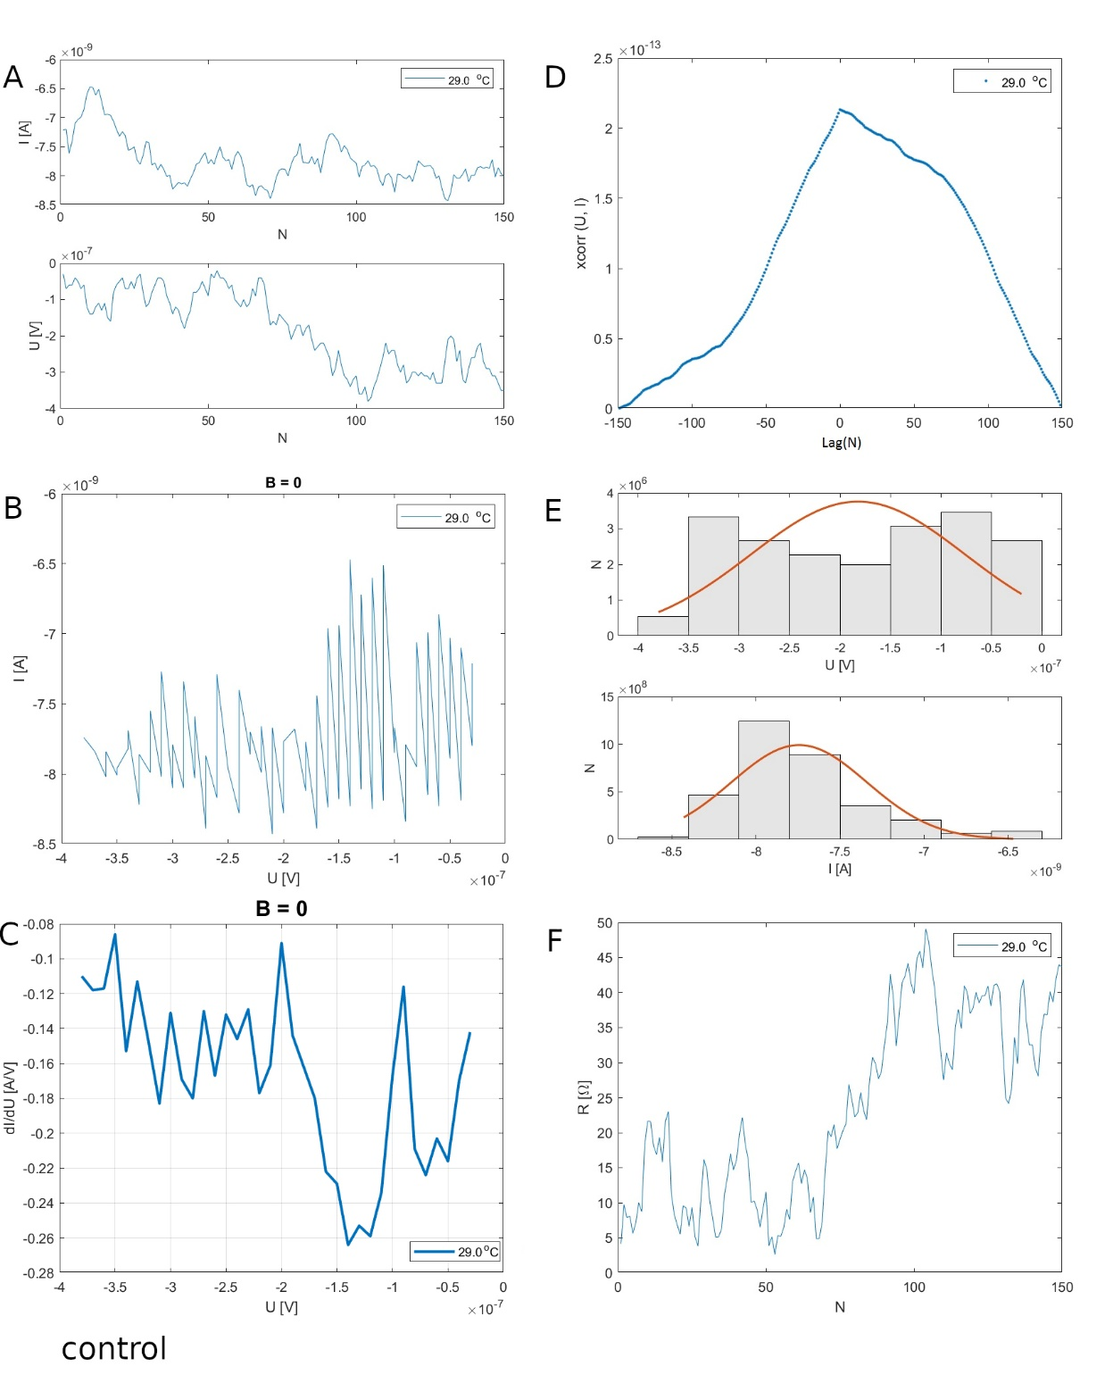
Fig. S6 Control measurement (empty silicon wafer) at room temperature—panels description as in the main text. The signal is approximately two orders of magnitude lower than with a blood sample.

MATLAB code:
T_m=[];
ii=zeros(1400,1);

for m=[93:94]%
d=readtable(['../pomiary/pub_b2_al/meas00',num2str(m),'p.csv']);% raw data from measurement
d_l=importdata(['../pomiary/pub_b2_al/data',num2str(m),'_legend.txt']);% input file with conditions data

T=num2str(d_l(3),'%.2f');
no=num2str(d_l(1));
B=num2str(d_l(2));%legend [B]
T_m=[T_m; T];% legend [T]
IU1=d.Var2;
IU2=d.Var4;
r=size(IU1);
IU=[IU1(1) IU2(2)];
for i=1:r(1)/2-1 % ordering in matrix data
IU=[IU; IU1(2*i+1) IU2(2*i+2)];
end;

%% detrending
UI=[IU(:,2) IU(:,1)];
rr=size(IU);
xx = linspace(1,rr(1),rr(1));
pp1 = polyfit(xx',UI(1:rr(1),1),1);
yy1 = polyval(pp1,xx);
pp2 = polyfit(xx',UI(1:rr(1),2),1);
yy2 = polyval(pp2,xx);
UI(1:rr(1),1)=UI(1:rr(1),1)-yy1';
UI(1:rr(1),2)=UI(1:rr(1),2)-yy2';

P=[IU(:,2).*IU(:,1)];% Power calculation
R=[UI(:,1)./UI(:,2)];% Resistance calculation
UI_s=sortrows(UI);

rr=size(IU);
in(1)=1;
for i=1:rr(1)-1 % derivative calculation [dI/dU]
in(i+1)=i+1;
di_dv(i)=(UI_s(i+1,1)-UI_s(i,1))/(UI_s(i+1,2)-UI_s(i,2));%[A/V]
end;

figure(1)% [I] vs. [U] plot
plot(UI_s(1:rr(1)-1,1),UI_s(1:rr(1)-1,2)), hold on;
xlabel('U [V]');
ylabel('I [A]');
title(['B = ',B]);
legend(T_m);
saveas(gcf,['UI_',no,'.fig'])
print(strcat(['UI_',no,'.png']), '-dpng')

figure(2)% derivative [dI/dU(U,T)] plot3D
xlabel('V');
title(['B = ',B]);
for l=1:r/2
ii(l)=d_l(3);
end;
view([0 70])
grid on;
box on;
plot3(UI_s(1:rr(1)-1,1),di_dv(1:rr(1)-1),ii(1:rr(1)-1),'LineWidth',2), hold on;
xlabel('U [V]');
ylabel('dI/dU [A/V]');
legend(T_m);
grid on;
saveas(gcf,['di_dv_3d',no,'.fig'])
print(strcat(['di_dv_3d',no,'.png']), '-dpng'), hold on;

figure(6) % derivative [dI/dU(U)] plot2D
xlabel('V');
title(['B = ',B]);
plot(UI_s(1:rr(1)-1,1),di_dv(1:rr(1)-1),'LineWidth',2), hold on;
xlabel('U [V]');
ylabel('dI/dU [A/V]');
legend(T_m);
grid on;
saveas(gcf,['di_dv_',no,'.fig'])
print(strcat(['di_dv_',no,'.png']), '-dpng'), hold on;

figure(3)% histogram with gaussian fit
subplot(2,1,1) % voltage [U]
title(['B = ',B]);
histogram(UI(:,1),'Normalization','pdf','FaceColor','k','FaceAlpha',0.1); hold on;
mu = mean(UI(:,1));
su = std(UI(:,1));
minu=min(UI(:,1));
maxu=max(UI(:,1));
dd=1000;
du=(maxu-minu)/dd;
yu = minu:du:maxu;
fu = exp(-(yu-mu).^2./(2*su^2))./(su*sqrt(2*pi)); % gaussian function - probability density
xlabel('U [V]');
ylabel('N');
plot(yu,fu,'LineWidth',1.5), hold on;

subplot(2,1,2)% current [I]
histogram(UI(:,2),'Normalization','pdf','FaceColor','k','FaceAlpha',0.1), hold on;
mi = mean(UI(:,2));
si = std(UI(:,2));
mini=min(UI(:,2));
maxi=max(UI(:,2));
di=(maxi-mini)/dd;
yi = mini:di:maxi;
fi = exp(-(yi-mi).^2./(2*si^2))./(si*sqrt(2*pi)); % gaussian function - probability density
xlabel('I [A]');
ylabel('N');
plot(yi,fi,'LineWidth',1.5), hold on;
saveas(gcf,['UI_hist_',no,'.fig'])
print(strcat(['UI_hist_',no,'.png']), '-dpng')

figure(4) % raw data plot,
title(['B = ',B]);
subplot(2,1,2)% [U(N)]
plot(in(1:rr(1)),UI(1:rr(1),1)); hold on;
ylabel('U [V]');
xlabel('N');
subplot(2,1,1)% [I(N)]
plot(in(1:rr(1)),UI(1:rr(1),2)); hold on;
ylabel('I [A]');
xlabel('N');
legend(T_m);
saveas(gcf,['IU_N_',no,'.fig'])
print(strcat(['IU_N_',no,'.png']), '-dpng')
dlmwrite(['U_',no,'.txt'],UI(:,1));
dlmwrite(['I_',no,'.txt'],UI(:,2));

figure(5)% xcorr (U, I)
title(['B = ',B]);
n = r;
x = UI(:,1);
y = UI(:,2);
[c,lags] = xcorr(x,y);
stem(lags,c,'LineStyle','none',...
'Marker','.'), hold on;
ylabel('xcorr (U, I)');
xlabel('N');
legend(T_m);
saveas(gcf,['x_corr',no,'.fig'])
print(strcat(['xcorr',no,'.png']), '-dpng')

figure(7)
title(['B = ',B]);
plot(in(1:rr(1)),P(1:rr(1))); hold on;
ylabel('P [W]');
xlabel('N');
legend(T_m);
saveas(gcf,['P',no,'.fig'])
print(strcat(['P',no,'.png']), '-dpng')

figure(8) % resistance [R]
title(['B = ',B]);
plot(in(1:rr(1)),R(1:rr(1))); hold on;
ylabel('R [\Omega]');
xlabel('N');
legend(T_m);
saveas(gcf,['R',no,'.fig'])
print(strcat(['R',no,'.png']), '-dpng')

end;

Fig. S7 The Matlab code for data acquisition, sorting, and printing is delivered.

