Supplementary Material for Drever et al. (2023) ‘Shorebird abundance is associated with nutritional quality of intertidal biofilm on the Fraser River tidal flats’

Supplementary Figure 1. Correlations between macronutrient content (ug/g dry sediment) and macronutrient concentration (ug/m2).
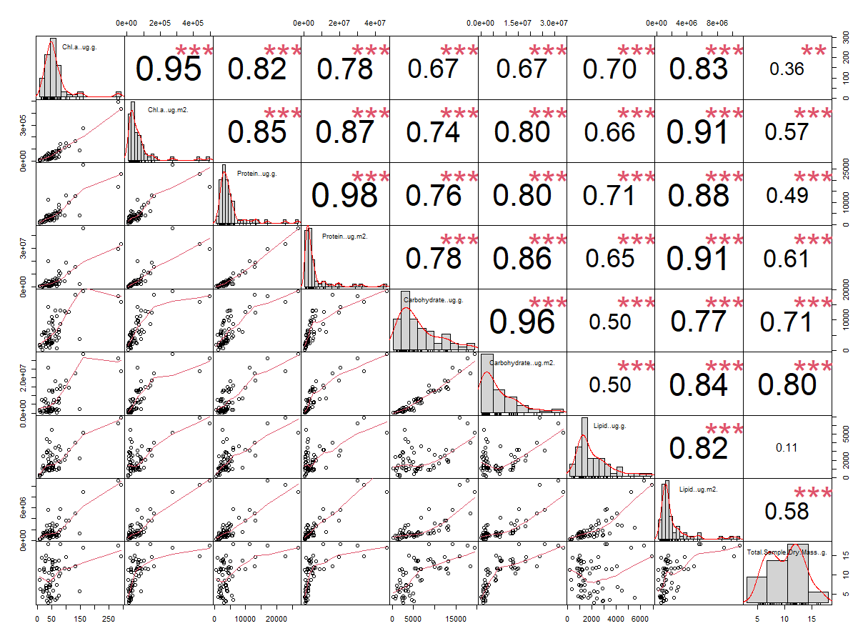

Supplementary Table 1. Ranking of models relating macronutrient content (protein, carbohydrate, lipid) in intertidal biofilm to measures of biomass (chlorophyll a), Site and Season/year of collection on the Fraser River Delta, British Columbia, Canada. Model no. refers to the model number, AIC = Akaike’s Information Criterion, ∆AICc = the difference in AIC between each model and the model with the minimum AIC, df = number of parameters, w = Akaike weight. Values in bold designate the most parsimonious model for each macronutrient.
Model no. | Model parameters | AIC | ∆AIC | df | w
Protein
1 | Biomass (Chl a) + Season + Site | 1198.0 | 6.2 | 6 | 0.03
2 | Biomass (Chl a) + Season + Site + interaction between Chl a and Season | 1196.6 | 4.8 | 7 | 0.07
3 | Biomass (Chl a) + Season + Site + interaction between Chl a and Site | 1191.8 | 0.0 | 7 | 0.76
4 | Biomass (Chl a) + Season + Site + interactions between Chl a and both Site and Season | 1195.2 | 3.4 | 10 | 0.14
Carbohydrate
1 | Biomass (Chl a) + Season + Site | 1162.0 | 17.8 | 6 | 0.00
2 | Biomass (Chl a) + Season + Site + interaction between Chl a and Season | 1163.4 | 19.3 | 7 | 0.00
3 | Biomass (Chl a) + Season + Site + interaction between Chl a and Site | 1163.4 | 19.2 | 7 | 0.00
4 | Biomass (Chl a) + Season + Site + interactions between Chl a and both Site and Season | 1144.2 | 0.0 | 10 | 1.00
Lipid
1 | Biomass (Chl a) + Season + Site | 1069.0 | 3.2 | 6 | 0.14
2 | Biomass (Chl a) + Season + Site + interaction between Chl a and Season | 1065.9 | 0.0 | 7 | 0.68
3 | Biomass (Chl a) + Season + Site + interaction between Chl a and Site | 1070.0 | 4.1 | 7 | 0.09
4 | Biomass (Chl a) + Season + Site + interactions between Chl a and both Site and Season | 1069.7 | 3.9 | 10 | 0.10

Supplementary Table 2. Parameter values for best-supported general linear models (see Supplementary Table 1) relating macronutrient content (protein, carbohydrate, lipid) in intertidal biofilm to measures of biomass (chlorophyll a), Site and Season/year of collection on the Fraser River Delta, British Columbia, Canada.
Variable | Estimate | SE | t-value | P
Protein
Intercept | 1898.75 | 937.71 | 2.025 | 0.050
Chlorophyll-a | 71.33 | 5.42 | 13.149 | 0.000
Season [Northward 2021] | -295.34 | 443.69 | -0.666 | 0.509
Site [Iona Foreshore] | -459.45 | 1259.81 | -0.365 | 0.718
Interaction - Chlorophyll-a:Site[Iona Foreshore] | -39.71 | 13.28 | -2.991 | 0.004
Station SD | 2190.51
Residual SD | 1529.36
Carbohydrate
Intercept | 227.25 | 1285.53 | 0.177 | 0.860
Chlorophyll-a | 82.60 | 25.36 | 3.257 | 0.002
Season_Site [Brunswick Point_Southward 2020] | 9280.00 | 1306.20 | 7.105 | 0.000
Season_Site [Iona Foreshore_Northward 2021] | 1564.49 | 1475.18 | 1.061 | 0.293
Season_Site [Iona Foreshore_Southward 2020] | 2368.06 | 1563.59 | 1.515 | 0.135
Interaction - Chlorophyll-a:Season_Site [Brunswick Point_Southward 2020] | -52.57 | 24.91 | -2.111 | 0.039
Interaction - Chlorophyll-a:Season_Site [Iona Foreshore_Northward 2021] | -69.23 | 27.93 | -2.478 | 0.016
Interaction - Chlorophyll-a:Season_Site [Iona Foreshore_Southward 2020] | 37.62 | 31.97 | 1.177 | 0.244
Station SD | 1089.36
Residual SD | 1320.46
Lipid
Intercept | 998.64 | 309.50 | 3.227 | 0.002
Chlorophyll-a | 20.00 | 2.60 | 7.693 | 0.000
Season [Northward 2021] | 1044.28 | 417.40 | 2.502 | 0.015
Site [Iona Foreshore] | -697.33 | 239.91 | -2.907 | 0.005
Interaction - Chlorophyll-a:Season [Northward 2021] | -15.54 | 6.70 | -2.318 | 0.024
Station SD | 0.00
Residual SD | 896.67

Supplementary Figure 2. Area calculations for shorebird surveys
Brunswick Point (Total intertidal area: 1.55km²; Danger zone (pink): 0.639 km²; Proportion: 41.2%)
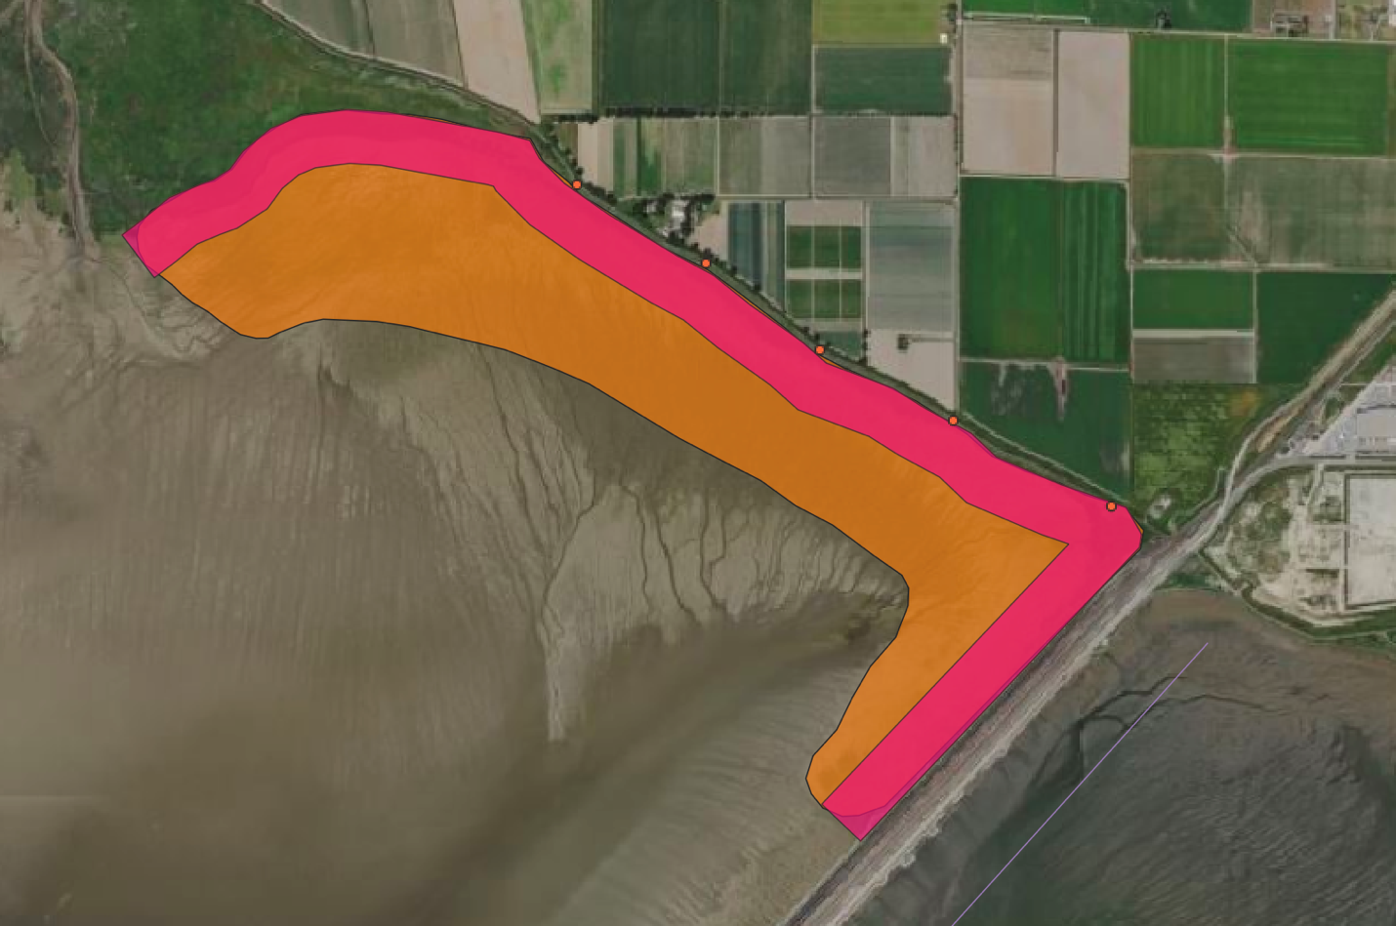

Iona Foreshore (Total intertidal area: 1.77km² (excluding sewage ponds): Danger zone (pink): 0.731 km²; Proportion: 41.1%)
