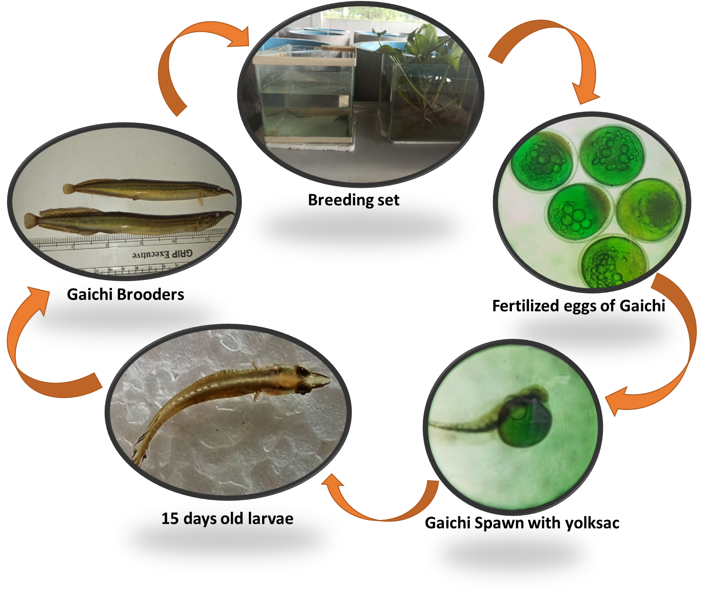
Graphical Abstract: Breeding and Larval development of Gaichi, Macrognathus aculeatus.

