Supplementary Material for
An electrochemical aptasensor based on catalytic hairpin self-assembly and co-amplification of AuPd/Fe-MOF and Au/Cu₂O for ultrasensitive detection of Cd²⁺
Jintao He ª, Baozhong Zhang ^{a,b*}, Panpan Tian ª, Ying Li ª, Xiaolong Liu ª，
Xinyue Ma ª, Min Lin ª，Huina Zhu ª, Hanyu Chen ª, Liping Li ^{a,b}, Baoshan He ^{c,**}
ª College of Environmental Engineering, Henan University of Technology, Lianhua Road 100#, Zhengzhou, 450001, Henan Province, People’s Republic of China
^{b} Henan International Joint Laboratory of Environmental Pollution, Remediation and Grain Quality Security, Zhengzhou, Henan 450001, China
^{c} School of Food Science and Technology, Henan University of Technology, Lianhua Road 100#, Zhengzhou, 450001, Henan Province, People’s Republic of China

Apparatus
Electrochemical measure was carried out on CHI760E Electrochemical Workstation (Shanghai CH Instrument Co., Ltd., China). All measurements were conducted by using a conventional three-electrode cell containing a 3 mm-diameter Au working electrode, a platinum counter electrode and a saturated calomel reference electrode.

All samples were studied with X-ray diffraction (XRD, CuKɑ radiation, D/max 2550VB X-ray diffractometer, Rigaku, Japan), Scanning electron microscopy (SEM, ZEISS GeminiSEM 300 and Sigma 300, Germany). Aptasensor was incubated by constant temperature and humidity chamber (Shanghai Yiheng Technology Instrument Co., Ltd., China).

Fig S1. XRD spectra of Cu₂O and Au/Cu₂O

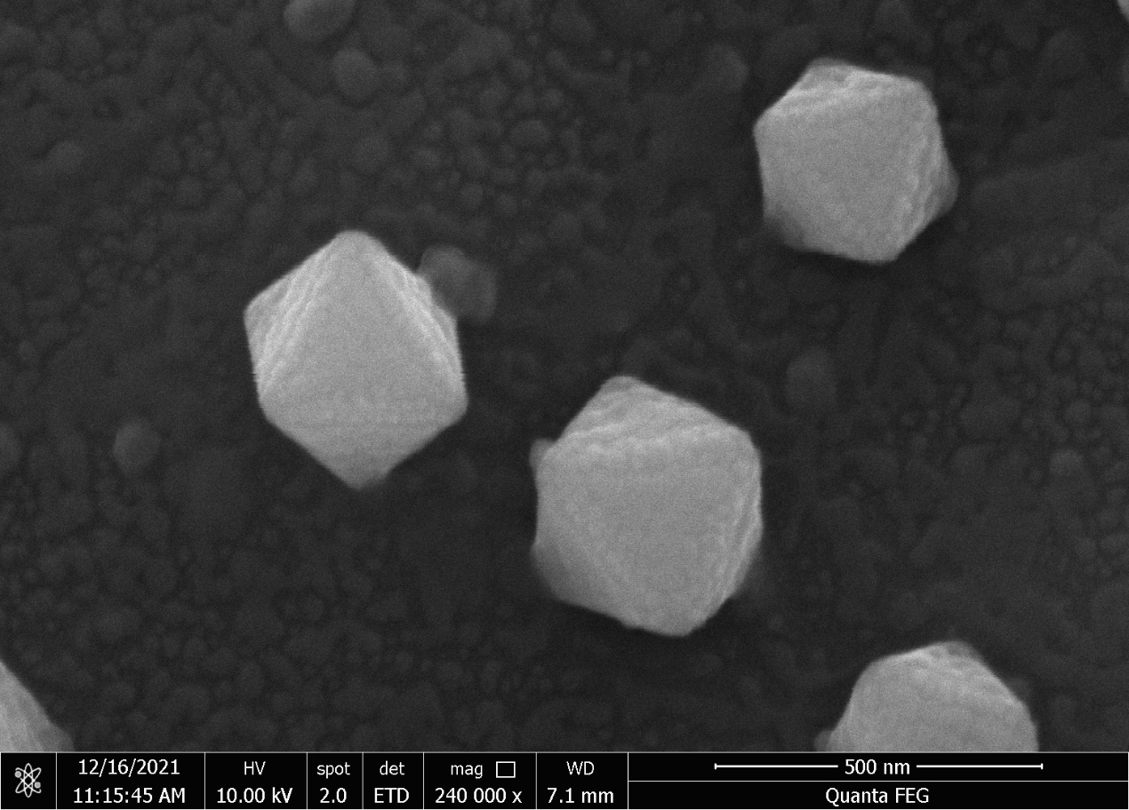
Fig S2 SEM image of Cu₂O

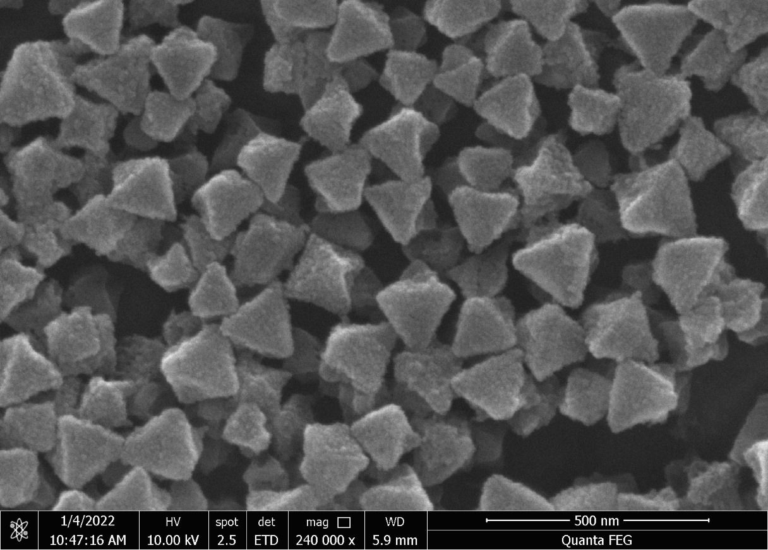
Fig S3 SEM image of Fe-MOF

* Corresponding author phone: 86-0371-67756982; e-mail: zb-z01@163.com. ** Corresponding author phone: +86-037167758022; e-mail: hebaoshan@126.com.

