Supplementary Tab. 1: Reasons for Exclusion after Abstract Screening
Author, Year | Reason | Notes
Mitropoulos et al., 2013 | No primary data | Comment
Pauls et al., 2012 | No primary data | Comment
Oulton et al., 2015 | No primary data | Systematic Review
Shreves et al., 2018 | No primary data | Review
Lemoyne et al., 2019 | No primary data | Review
Shreves et al., 2018b | No primary data | Review
Bramsted et al., 2002 | Not DPW as topic | Cardiac Implants
Cornillon et al., 2016 | Not DPW as topic | Palliative care patient’s reasons for consultation
Kupensky et al., 2015 | Not DPW as topic | Palliative care consults in the ED
Mogul et al., 2019 | Not DPW as topic | Palliative care consults in the ED
Marco et al., 1997 | Not DPW as topic | Ethical decision-making during CPR
Saliba et al., 2000 | Not DPW as topic | EMS transport for nursing home residents
Nemiroff et al., 2019 | Not DPW as topic | EMS transport for nursing home residents
Fassmer et al., 2020 | Not DPW as topic | EMS transport for nursing home residents
Rubins, 2020 | Not ED as setting | Entire hospital
Del Olmo et al., 2019 | Not ED as setting | ICU
Trunkey et al., 2000 | Not ED as setting | Not limited to ED
Hack et al., 2016 | Not ED as setting | Not limited to ED
Dexter, 2003 | No access to publication | Corresponding author could not be reached

Supplementary Tab. 2: Reasons for Exclusion after Full Text Analysis.
Author, Year | Reason | Notes
Gaw et al. 2012 | No access to publication | Corresponding author could not be reached
Siegrist et al. 2018 | Not DPW as topic | Which End of Life Decision was made

Supplementary Fig. 1: Possession of DPW by study methods. Written survey (orange) vs. oral survey (green). Not included are studies that only analysed patient records.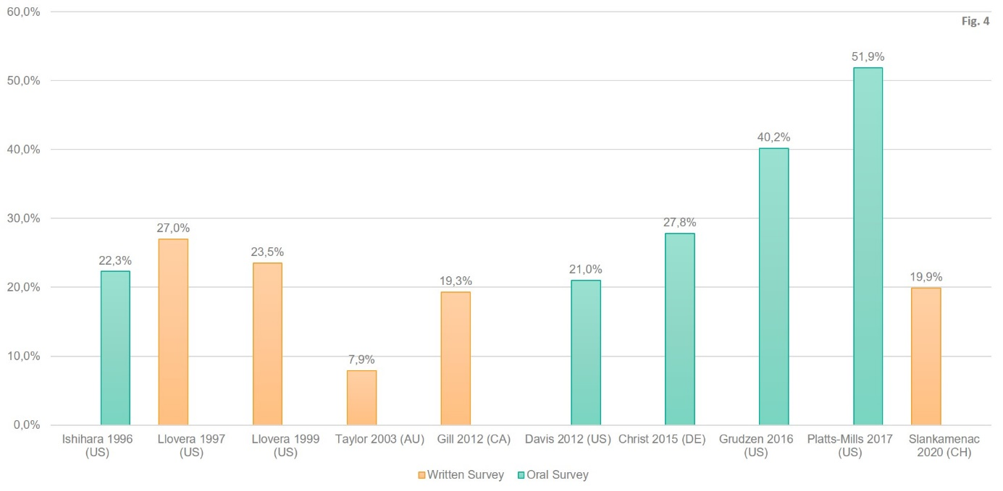

Supplementary Tab. 3: Overview of included studies, sorted by year of publication.
 | Time, Setting | Inclusion / Exclusion Criteria | G/H | n | Age [years] | Female | Country | Methods | Definition DPW | Possesion DPW | Availability DPW
Ishihara et al. 1996 (19) | 1994, academic ED | I: ≥65 Y. or severe chronic illness  E: SB, ICQ | H | 238 | M 67 (IQR 51-75) | 57% | US | Design unclear, oral Survey | AD reported | 22.3% | 5.0% (22.6%)
Llovera et al. 1997 (20) | 1995/96, academic ED, 24/7 | I: ≥18 Y.  E: ICQ, SB | G | 511 | ∅ 53 (SD ±20) | 52.1% | US | Design unclear, written Survey | AD reported | 27% | -/-
Llovera 1999 (16) | 1997, ED, representative shifts | I: ≥18 Y.  E: ICQ, SB, RC | G | 476 | ∅ 49 (SD ±20) | 50% | US | Prospective,written Survey | AD reported | 23.5% | -/-
Lahn et al. 2001 (5) | No year, 2 urban EDs | I: NH residents  E: none | H | 715 | ∅ 79 (SD ±13) | 65% | US | Prospective, Analysis of patient records | AD/DNR available (HCP excluded by us) | -/- | 33.4%
Taylor et al. 2003 (24) | 2001, academic ED, weekdays, by daytime | I: ≥60 Y.  E: ICQ, SB | H | 403 | M 73.3 (IQR 60-91) | 40.7% | AU | Design unclear, written Survey | AD reported (HCP excluded by us) | 7.9% | -/-
Gill et al. 2012 (27) | 2008, academic ED, by daytime | I: ≥70 Y., CC+  E: ICQ without proxy available | H | 280 | ∅ 80.6 | 55% | CA | Prospective, written Survey | AD reported / available | 19.3% | 1.1%  (5.6%)
Davis et al. 2012 (15) | 2011, ED, by daytime | I: Treated by study physician  E: none | G | 309 | M 60 | 47% | US | Design unclear, oral Survey | AD reported / available | 21% | 1% (4.6%)
Street et al. 2015 (25) | 2011, 3 EDs | I: ≥65 Y.  E: none | H | 300 | ∅ 86.2 (SD ±6.5) | 67.7% | AU | Retrospective, matched cohort study, Analysis of patient records | ACP reported / available | 13.7% | 13.3% (97.6%)
Christ et al. 2015 (26) | 2014, ED | I: Hospitalized, ≥18 Y.  E: Pregnant, legal proxy, RC, critically ill | G | 496 | ∅ 64.9 (SD ±18.8) | 53.8% | DE | Prospective, oral Survey | AD reported / available | 27.8% | 3.2% (11,6%)
Grudzen et al. 2016 (18) | 2012, adult & geriatric ED | I: ≥65 Y., ESI >1, able to walk, CC+  E: SB, CI | H | 682 | ∅ 75.8 (SD ±8.0) | 58.1% | US | Design unclear, oral Survey + Analysis of patient records | AD reported or in records | 40.2% | 1.7% (4.4%)
Platts-Mills et al. 2017 (17) | 2016, academic ED | I: ≥75 Y. or ≥65. Y. with high risk of death  E: SB, CI | H | 104 | Not reported | 44.2% | US | Prospective, oral Survey + Analysis of patient records | AD reported (DNR, POLST, HCP excluded by us) | 51.9% | 4.8% (9.3%)
Moman et al. 2017 (21) | 2014, ED | I: >55 Y., hospitalized  E: none | H | 927 | M 75 (IQR 65-84) | 45% | US | Retrospective, Cohort study, Analysis of patient records | AD in records | -/- | 42%
Ballou et al. 2019 (22) | 2012-17, academic surgical ED | I: >65 Jahre  E: none | H | 3342 | ∅ 78.1 (SD k.a.) | 45.7% | US | Retrospective, Cohort study, Analysis of patient records | AD or POLST in records | -/- | 14.2%
Slankamenac et al. 2020 (28) | 2017, academic ED, 24/7 | I: ≥18 Y.  E: SB, CI, no time availbale, analphabetism, critically ill | G | 292 | M 46 (IQR 29-63) | 49.3% | CH | Prospective, written Survey + 60-day Follow-Up via E-Mail | AD reported / available | 19.9% | 0.3%  (1,7%)
Chua et al. 2020 (23) | 2018, ED | I: NH residents >75 Y.  E: none | H | 80 | ∅ 87.9 (SD ±4.7) | 61.7% | AU | Prospective, Analysis of patient records | ACP available | -/- | 48.8%
Osman et al. 2020 (10) | 2019, ED | I: ≥65 Y.  E: none | H | 300 | ∅ 78 (SD ±8.1) | 50.7% | AU | Retrospective, Analysis of patient records | ACP presence (ambiguous) | -/- | 38.7%
Columns: 1. Study; 2. Time period and setting; 3. Inclusion (I) and Exclusion (E) criteria; 4. Classification as general population (G) or high-risk (H); 5. Sample size (n); 6. Mean age with standard deviation (SD) or Median with inter quartile range (IQR); 7. Percentage of female subjects; 8. Country; 9. Study design and methodology; 10. Definition of DPW used; 11. Rate of having DPW; 12. Rate of DPW being available at ED as percentage of the overall sample and (in brackets) of patients possessing DPW
Abbreviations: Median (M); Nursing Home (NH); Emergency Department (ED); Speech barrier (SB); Cognitive impairment (CI); Inability to complete questionnaire (ICQ); Reduced level of consciousness (RC); Capability to consent (CC+); Emergency Severity Index (ESI); Manchester Triage Score (MTS), Physician Orders for Life-Sustaining Treatment, a form of advance care planning used in the US (POLST).

Supplementary Tab. 4: Predictors with positive (+), none (o) or negative (–) correlation with possession of DPW

Predictor |  | + | o | –
SOCIODEMOGRAPHIC ASPECTS
Age | Higher Age | (5,16,17,20,22,24,26,28)
Gender | Female | (5,19,22) | (16,20)
Ethnicity | “White” (vs. “Non-White”) | (5,16,17)
Ethnicity | “African American” (vs. “Hispanic”) | (16)
Religion | Catholic |  |  | (16)
Education | Higher Education | (24) | (28)
Civil status | Single |  |  | (28)
Civil status | Widdowed | (16,28)
Civil status | Having children | (16) | (28)
Geography | Nationality of country, the study was in (CH) | (28)
Geography | Born in the country, the study was in (AU) | (24)
MEDICAL ASPECTS
Comorbi-dities | Comorbidities in general | (16,22,28) | (19)
Comorbi-dities | Neurodegenerative disease | (22,25)
Comorbi-dities | Malignant disease | (28)
Comorbi-dities | Charlson Comorbidity Score | (25)
Comorbi-dities | Life-threatening comorbidity (self-assessed) | (16)
Comorbi-dities | General health “bad” (self-assessed) | (20,24)
Acute situation | Higher Glasgow-Coma-Scale at Triage |  |  | (22)
Acute situation | Fall as reason for ED visit | (22)
Acute situation | Arriving via ambulance | (26)
Acute situation | Accompanied by someone to the ED |  |  | (25)
HEALTH CARE SYSTEMIC ASPECTS
Hospital | Number of hospital days in the last 12 months | (28)
Nursing Care | Nursing home residents | (25)
Nursing Care | Supervised living situation | (28)
Outpatient Care | Having a primary care physician | (16,20) | (17) | (28)
Outpatient Care | Having a primary care physician, connected to the study institution | (17)
Outpatient Care | Having a specialist physician | (16,28)

Platts-Mills et al. reported possession rates for AD, DNR, POLST and HCP separately, without being mutually exclusive. Therefore, no exact possession rate can be calculated for the category [AD, DNR or POLST]; the true value must lie between 51.9% and 58.7%. The lowest extreme is assumed in the following.

