Supplementary Material
Acclimation of electroactive biofilms under different operating conditions: Comprehensive analysis from architecture, composition, and metabolic activity

Han Ma¹, Xing Dong¹, Yi Yan¹, Ke Shi¹, Hao Wang¹, Haoyun Lu¹, Jianliang Xue^{1, 2, 3}, Yanlu Qiao^{1, 2, 3}, Dongle Cheng^{1, 2, 3}, Qing Jiang^{1, 2, 3*}
1. College of Safety and Environmental Engineering, Shandong University of Science and Technology, Qingdao, Shandong 266590, China;
2. Institute of Yellow River Delta Earth Surface Processes and Ecological Integrity, Shandong University of Science and Technology;
3. Shandong Provincial Key Laboratory of Eco-Environmental Science for Yellow River Delta, Binzhou University, Binzhou, Shandong, 256600, China
Corresponding Author: Qing Jiang. E-mail: qingjiang2021@126.com.

Table S1. EIS for EAB under different conditions.
 | Rs (Ω) | Rct (Ω) | Rd (Ω) | R_{total} (Ω)
N1 | 1.10×10⁻⁷ | 3.58 | 1.08 | 4.66
N2 | 0.01 | 95.88 | 6.90 | 102.79
N3 | 4.47×10⁻⁶ | 39.22 | 5.06 | 44.28
N4 | 6.08×10⁻⁷ | 5.14 | 3.08 | 8.22

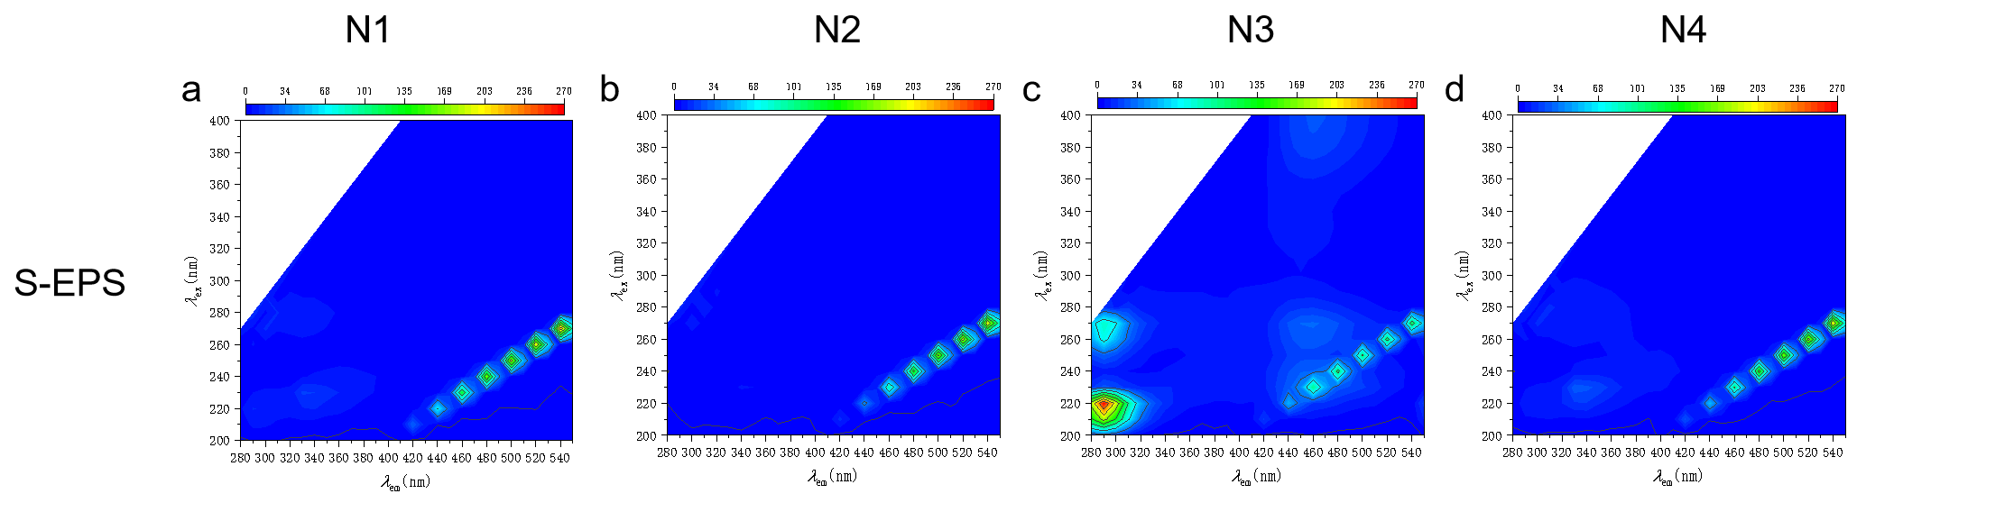
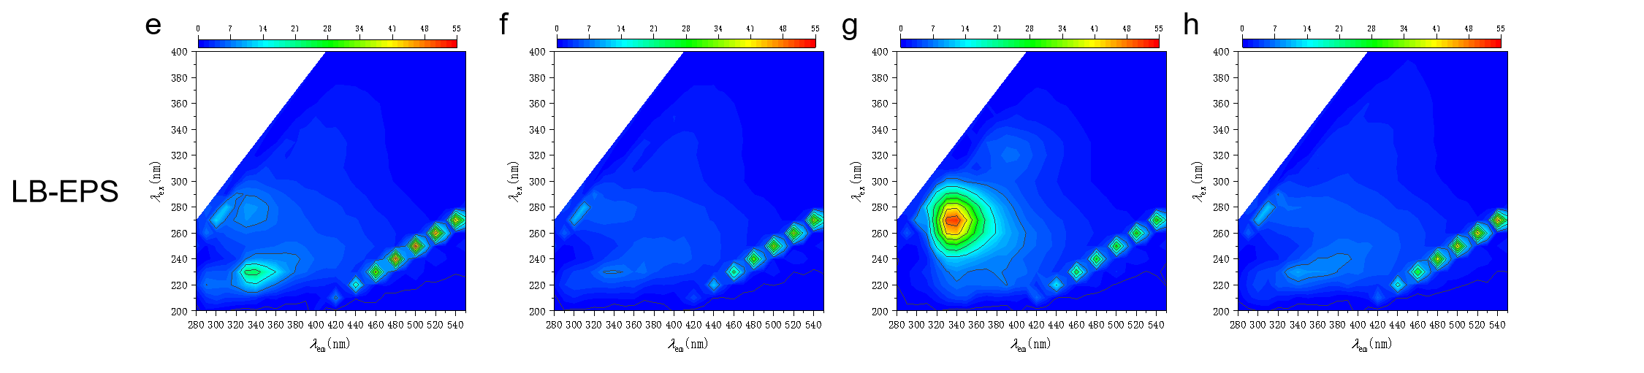
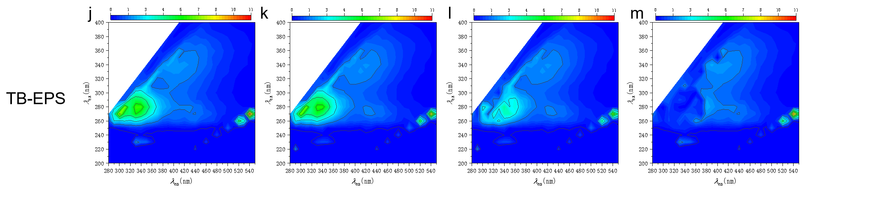
Fig. S1. Three-dimensional fluorescence of S-EPS, LB-EPS and TB-EPS at N1, N2, N3 and N4 conditions.
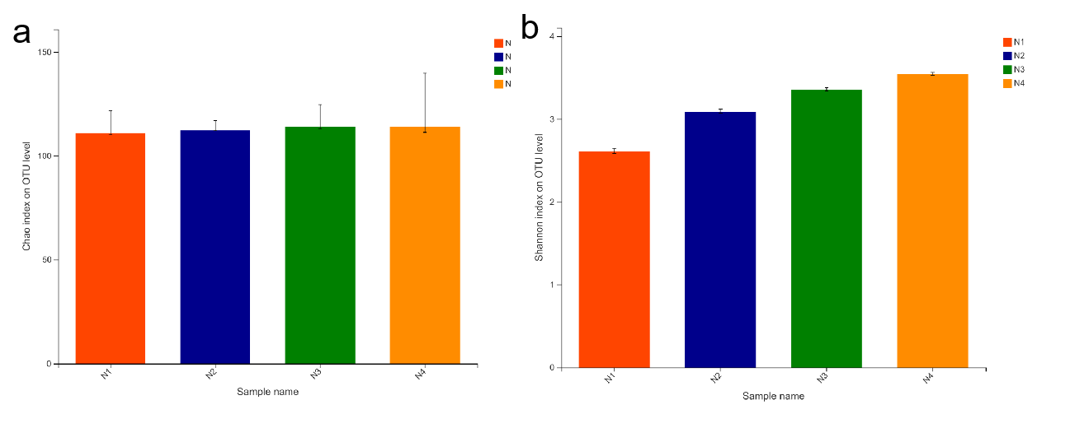
Fig. S2. Chao (a) and shannon (b) under N1, N2, N3 and N4 conditions

