Supplementary Information

Extended Data Fig. 1. SteatoSITE architecture schematic.
A schematic representation of the data sources and integration undertaken to construct the SteatoSITE data commons.
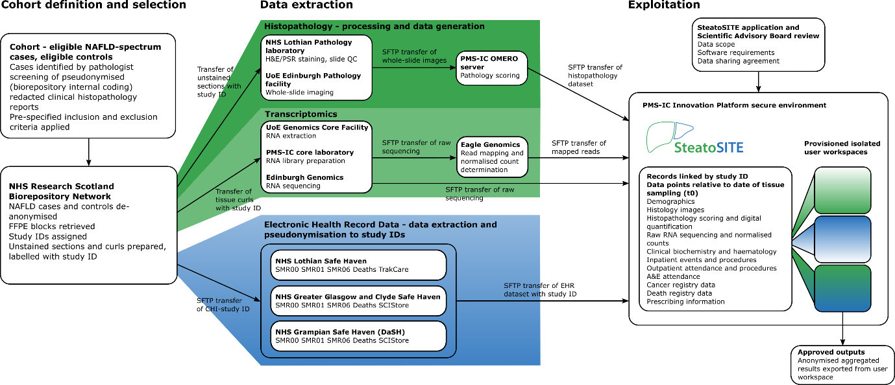

Extended Data Fig. 2. Additional histopathological analyses.
a, Clinical follow-up depth (in days) according to specimen type. b, Clinical assessment of the presence or absence of a histological diagnosis of steatohepatitis versus NASH-CRN stage. c, A representative whole-slide image of a PSR-stained section with the associated tissue mask and applied classifier showing PSR-positive (red) and fat droplets (purple) from the QuPath quantitative pathology pipeline; only pixels present within the tissue mask are used for PSR and fat quantitation. d, The amount of steatosis from image quantification versus NAS steatosis assigned scores. e, The PSR percentage from image quantification versus assigned NASH-CRN scores. f, The PSR percentage from image quantification versus assigned modified Ishak scores. g, Count of presence or absence of HCC in resection cases versus assigned NASH-CRN stage.
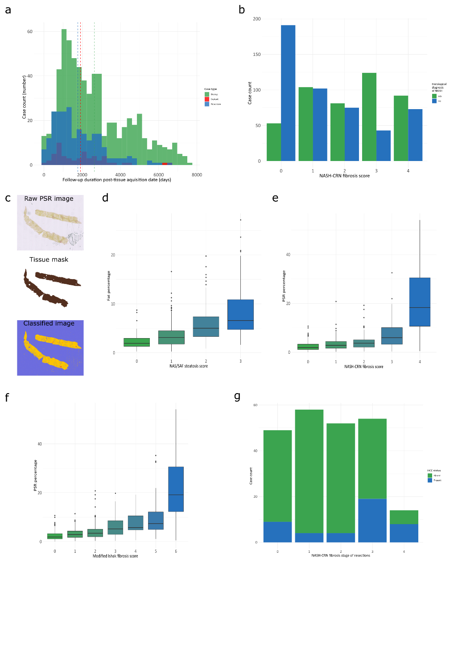

Extended Data Fig. 3. Validation of normal liver transcriptome.
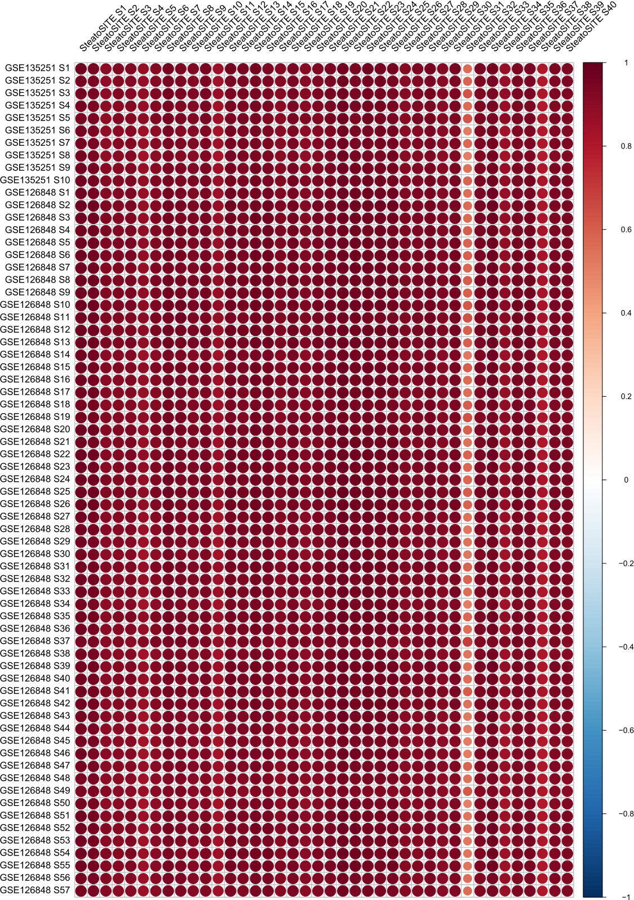
Correlation (corrplot) of transcriptomic profiles of normal SteatoSITE samples (n = 40) with published normal liver reference data (n = 57). The colour scale corresponds to the strength and direction of correlations.

Extended Data Fig. 4. SteatoSITE RNA-seq summary heatmap.
Unsupervised clustering using the RNA-seq data from the SteatoSITE cohort using the log expression of the top 100 most expressed genes across all samples.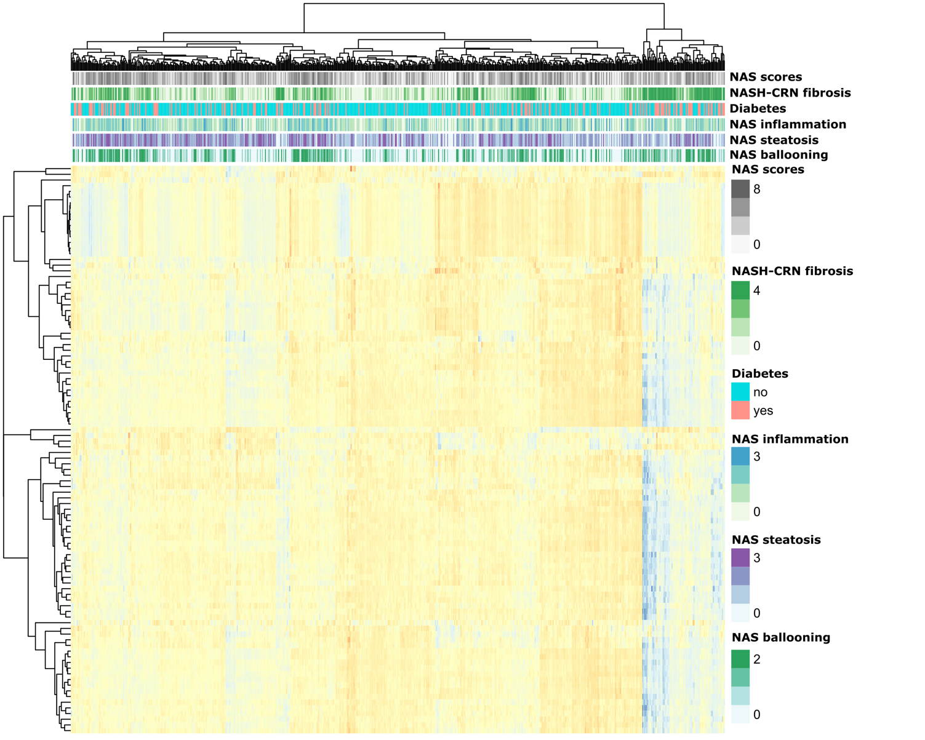

Extended Data Fig. 5. SteatoSITE RNA-seq gene ontology analysis.
a, GO terms molecular function (MF) for F0/1 vs control. b, GO terms MF for F2 vs control. c, GO terms MF for F3 vs control. d, GO terms MF F4 vs control.
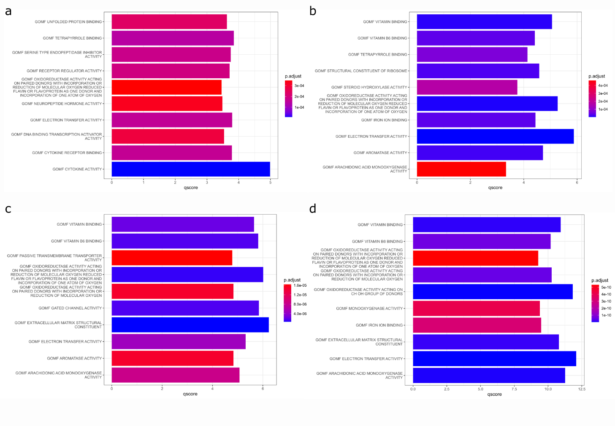

Extended Data Fig. 6. SteatoSITE RNA-seq according to NAS scores
a, UpSet plot of differentially assessed genes (DEGs), showing DEGs belonging to individual sets (according to NAFLD activity score (NAS) ≤ 2, NAS 3/4 and NAS ≥ 5) and the intersection of DEGs across all NAS sets. Set sizes are presented as bars and their composition is described by the bottom panel. b, Top 10 molecular functions (gene ontology (GO) terms) based on the differentially expressed genes of NAS ≤ 2; c, NAS 3/4; d, NAS ≥ 5.
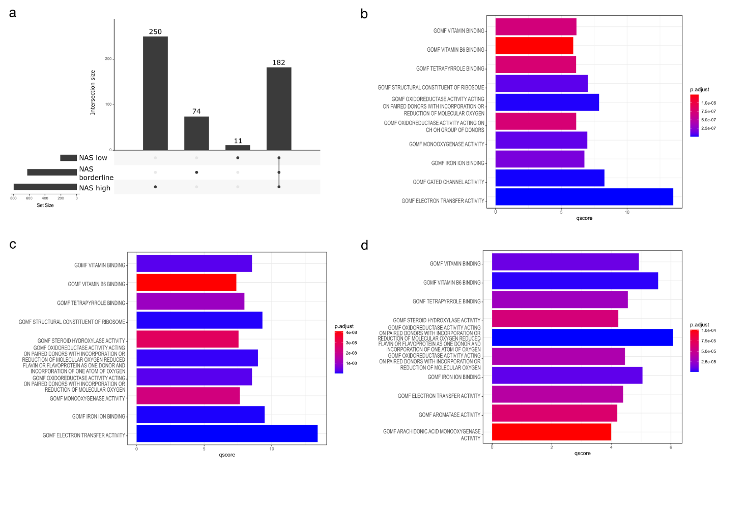

Extended Data Fig. 7. Correlation of scar-associated macrophage numbers with NAFLD activity score components.
Scar-associated macrophage numbers determined by multiplex immunofluorescence correlated positively with assigned components of the NAFLD activity score (n=43). Spearman’s rho and P-value indicated for ballooning (a), steatosis (b), and inflammation (c).
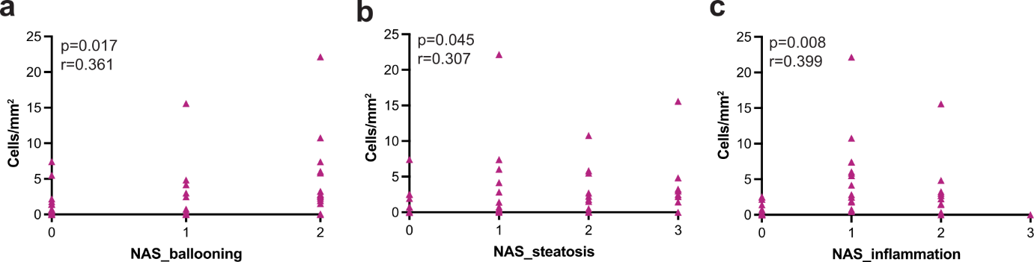

Extended Data Fig. 8. Regularised COX regression model.
a, Plot of the optimal value of logarithmic lambda and the cross-validation error. b, Coefficient values across the logarithmic lambda. c, Risk-values and their distributions. The horizontal dashed line indicates the median risk-value.
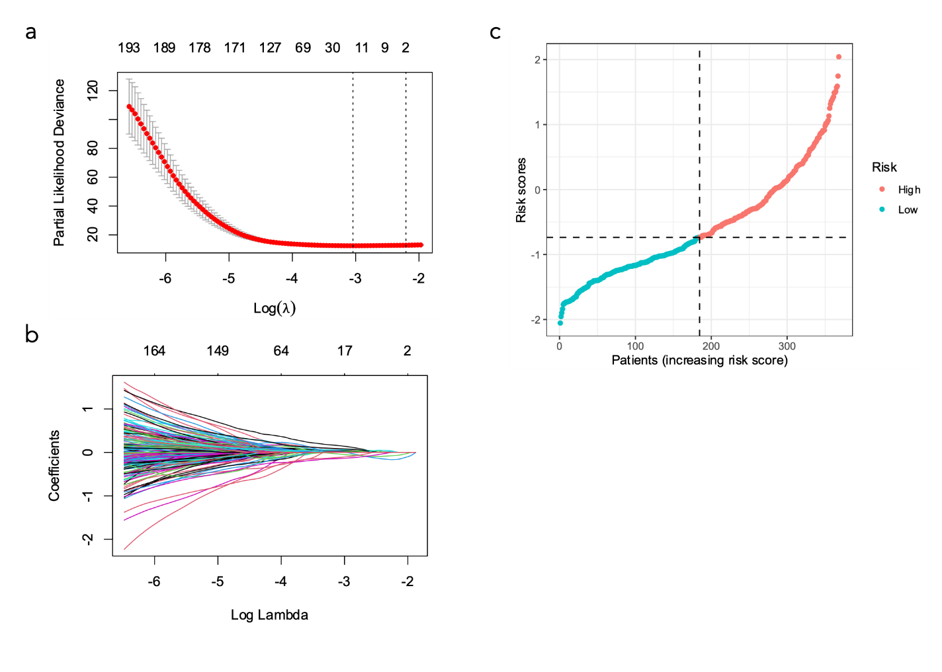

Extended Data Fig. 9. Gene expression of the prognostic signature across the fibrotic stages.
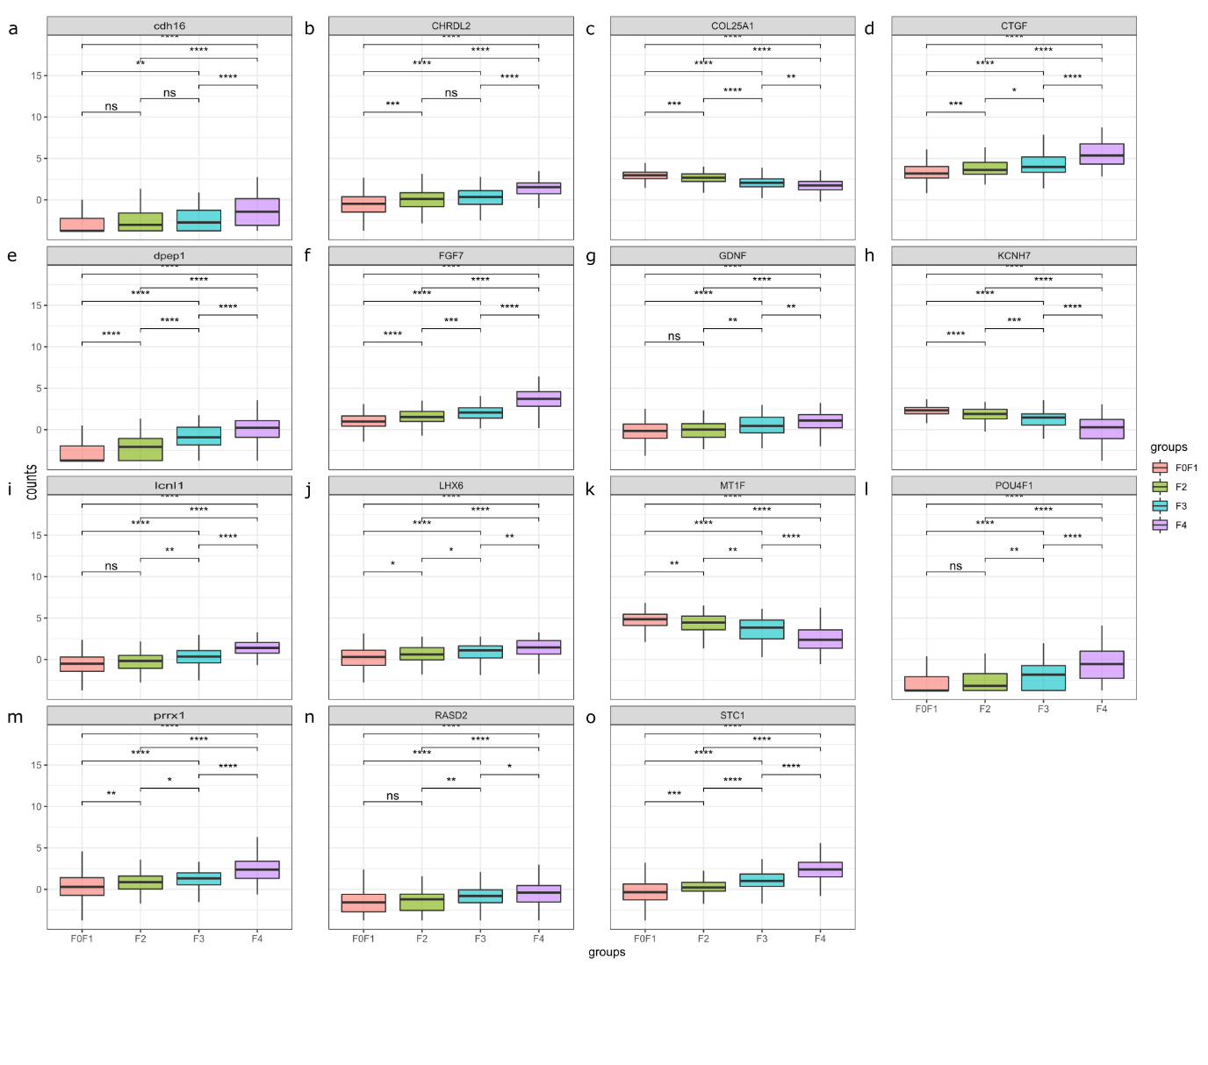

Extended Data Fig. 10. Additional predictive and personalisation value of estimated THRB regulon activity in F0 and F1 stage disease.
a, In histologically identical low-risk fibrosis stages (F0 and F1 biopsy cases), low THRB activity identifies patients at high risk of progression to a hepatic decompensation event; log rank test P-value. b, Example individual 2-tailed gene set enrichment plots of target genes in the THRB regulon (left, Benjamini and Hochberg (false discovery rate) adjusted P-values) from two patients with identical F0 stage (no scarring) on PSR stained sections (right), where the patient with low THRB differential regulon activity (top, blue) progressed to a hepatic decompensation event 3000 days after biopsy in contrast to a patient with high THRB regulon activity who did not experience a decompensation event during the 4400 days until censoring (bottom, red). Scale bars, 2 mm.
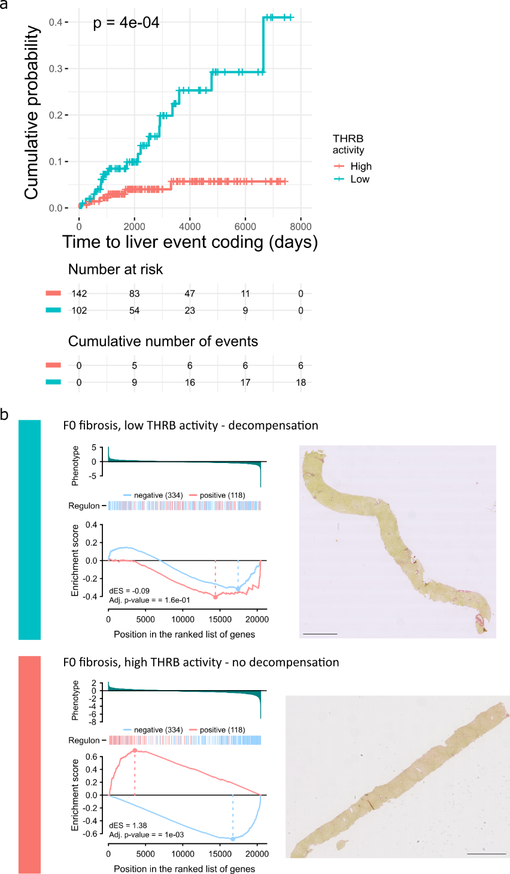

Extended Data Fig. 11. Correlations between the main principal components and the clinical data.
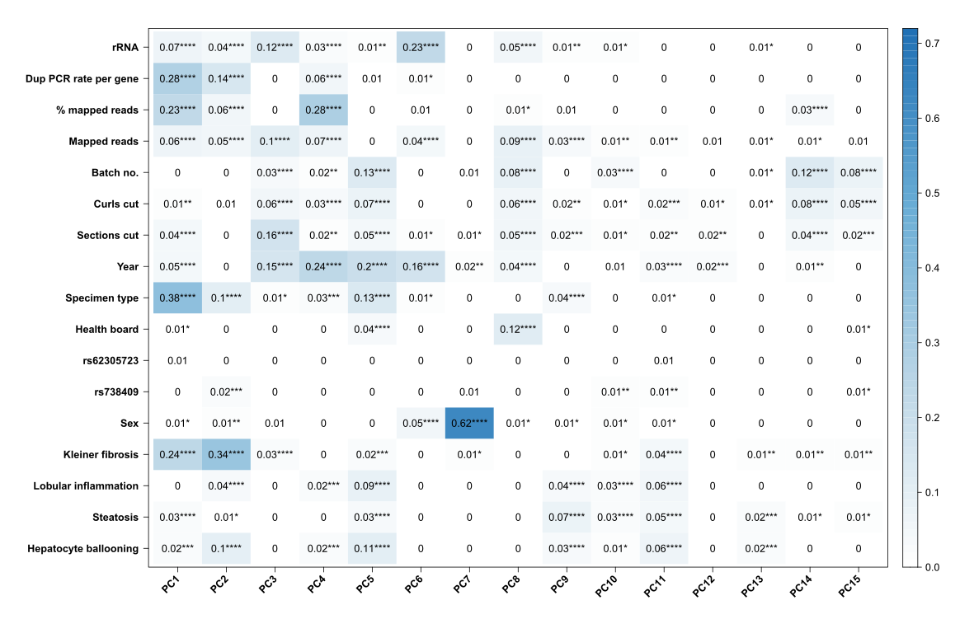

Supplementary Table 1. SteatoSITE clinical data variable list.
A list of the variables retrieved from electronic health records and national data sources.

Supplementary Table 2. Pathology harmonisation exercise metrics.
Metrics of observer agreement for scored histological features after the scoring harmonisation exercise undertaken by the three pathologists on 20 cases.

Supplementary Table 3. Fibrosis stage and all-cause mortality in patients with biopsy-confirmed NAFLD.
Cox regression was used to estimate the hazard ratio (HR) and 95% confidence interval (CI) for the outcome of all-cause mortality according to NASH-CRN fibrosis stage at inclusion.

Supplementary Table 4. Fibrosis stage and new-onset hepatic decompensation events in patients with biopsy-confirmed NAFLD.
Cox regression on the cause-specific hazard and Fine-Gray regression for proportional hazards modelling of the subdistribution hazard were used to estimate the hazard ratio (HR) and 95% confidence interval (CI) for the outcome of hepatic decompensation according to NASH-CRN fibrosis stage at inclusion, with all-cause mortality as a competing risk. The incidence of individual decompensation events is based on patients who did not have that event at or before the tissue sampling date.

Supplementary Table 5. Follow-up periods in cases used for modelling of time-to-decompensation by fibrosis stage.
Median period in days of time until hepatic decompensation or censoring (end of follow-up or death) and interquartile range by fibrosis stage for biopsy cases used for modelling of time-to-decompensation.

Supplementary Table 6. Variant callset.
RNA-seq variant calling for disease-associated SNPs in each sample. Genotypes of SNPs “rs738409”, “rs72613567”, “rs58542926” and “rs641738” are shown.

