Supporting Information
Cell membrane vesicles derived from hBMSCs and hUVECs enhance bone regeneration
Dandan Wang , Yaru Guo, Boon Chin Heng, Xuehui Zhang, Yan Wei, Ying He, Mingming Xu , Bin Xia & Xuliang Deng
Table of contents
Supplementary Figure 1: CD90 immunocytochemical staining images of human umbilical vein endothelial cells.
Supplementary Figure 2: CD31 immunocytochemical staining images of bone marrow mesenchymal stem cells.
Supplementary Figure 3: Changes in the fibrous cytoskeletal framework of hBMSCs (a) and hUVECs (b) after treatment with CB for 30 minutes. The formation of spherical cell capsules were observed around the cells.
Supplementary Figure 4: The quantitative migration area analysis of hUVECs (*P＜0.05, n=3).
Supplementary Figure 5: Realtime-PCR and western blot analysis showed that ephrinB2 gene expression levels and protein expression levels of transfected cells were downregulated after lentivirus transfection (***P＜0.001, n=3).
Supplementary Figure 6: Representative images and analysis of tube formation at 4 and 8 h after hUVECs were co-cultured with BMSC-CMVs and BMSC-CMVs (EFNB2-shRNA).
Supplementary Figure 7: BMSC-CMVs (EFNB2-shRNA) fluorescence emission (green) in hUVECs were lower, as compared to BMSC-CMVs fluorescence emission in Fig. 3f. The scale bar = 20 μm.
Supplementary Figure 8: Representative images of Matrigel plugs with hUVECs, hUVECs+BMSC-CMVs and hUVECs+BMSC-CMVs (EFNB2-shRNA) at 4 days after subcutaneous injection in nude mice.
Supplementary Figure 9: Immunohistochemistry staining images for detection of CD31 expression within the calvaria defects of the four groups, at 4 weeks and 8 weeks post-implantation respectively.

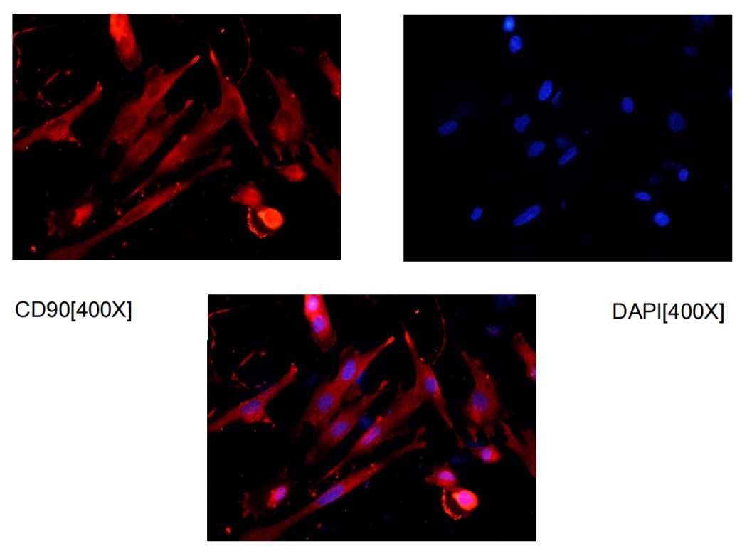

Supplementary Figure 1: CD90 immunocytochemical staining images of human umbilical vein endothelial cells.

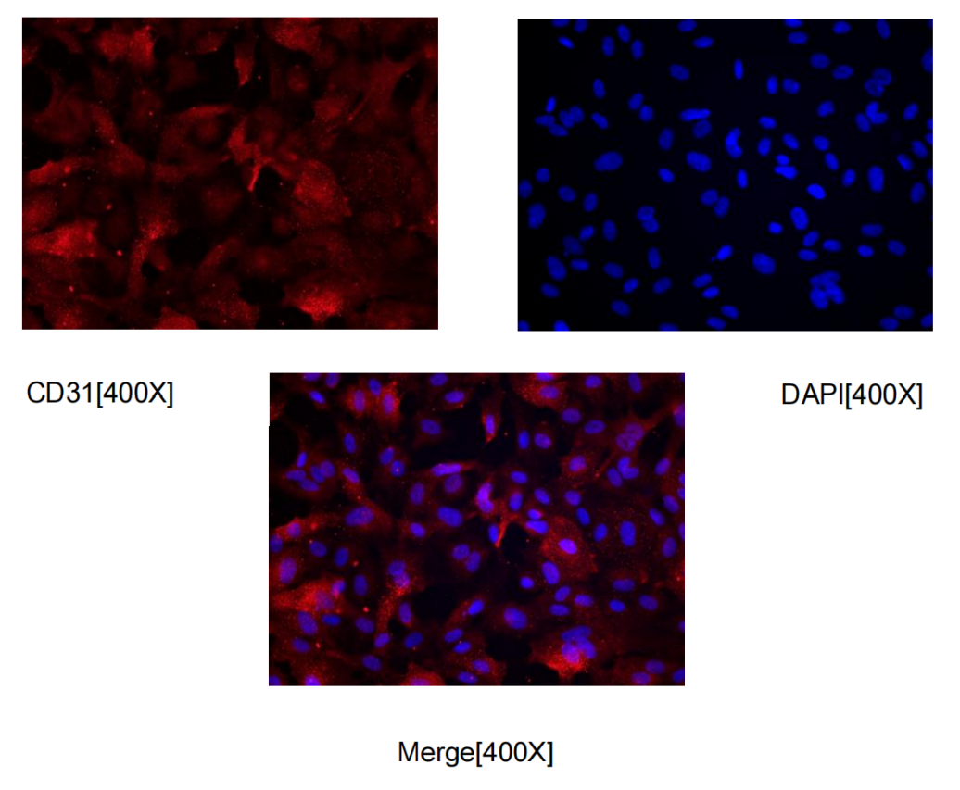

Supplementary Figure 2: CD31 immunocytochemical staining images of bone marrow mesenchymal stem cells.

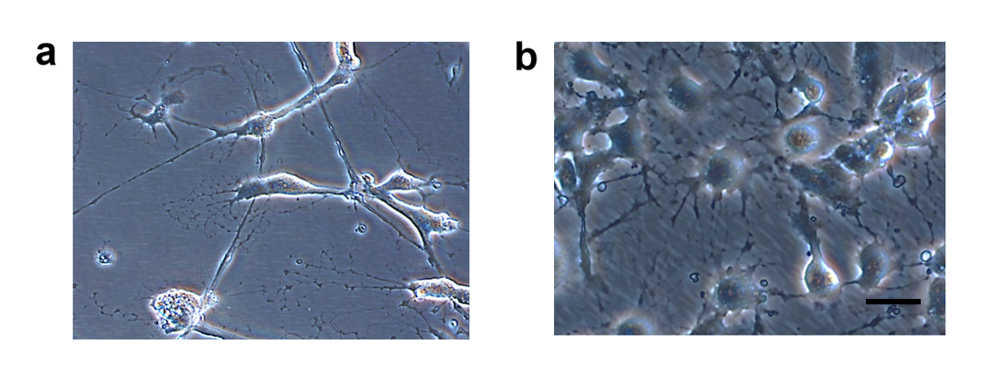
Supplementary Figure 3: Changes in the fibrous framework of hBMSCs (a) and hUVECs (b) after treatment with CB for 30 minutes. The formation of spherical cell capsules were observed around the cells. The scale bar = 50 μm.

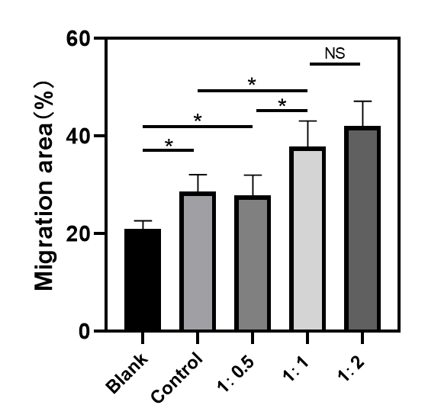
Supplementary Figure 4: The quantitative migration area analysis of hUVECs (*P＜0.05, n=3).

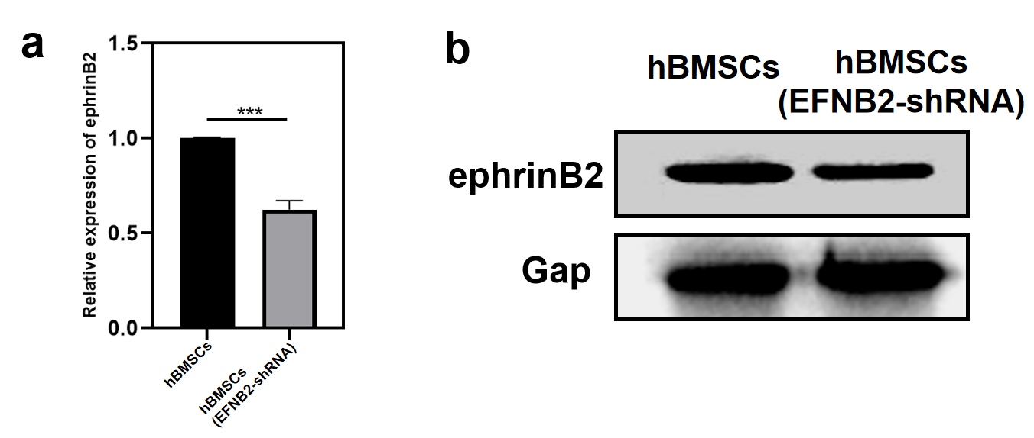
Supplementary Figure 5: Realtime-PCR and western blot analysis showed that ephrinB2 gene expression levels and protein expression levels of transfected cells were downregulated after lentivirus transfection (***P＜0.001, n=3).

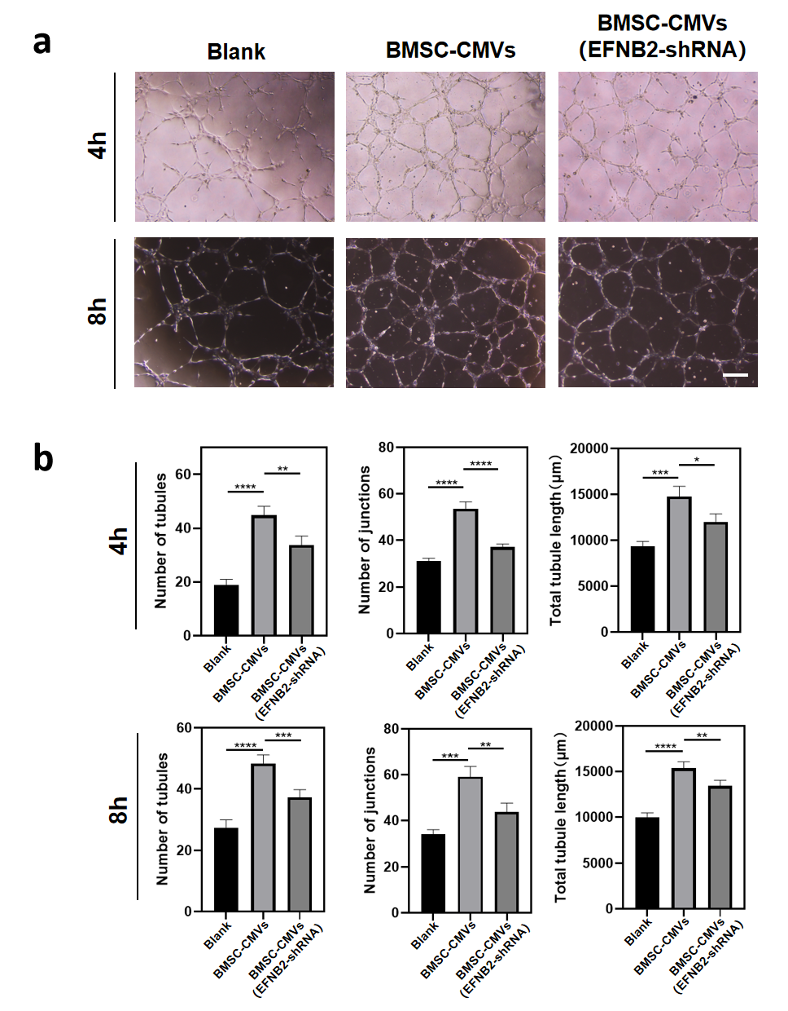
Supplementary Figure 6: Representative images and analysis of tube formation at 4 and 8 h after hUVECs were co-cultured with BMSC-CMVs and BMSC-CMVs (EFNB2-shRNA). a. Representative images of tube formation at 4 and 8 h after hUVECs were seeded on Matrigel and co-cultured with BMSC-CMVs and BMSC-CMVs (EFNB2-shRNA) respectively; untreated hUVECs were utilized as a blank. b. Number of tubules, number of junctions and total tubule lengths in each group at 4 and 8 h in Supplementary Fig. 7a were quantified using Image Pro Plus 6.0 software (*P＜0.05, **P＜0.01, ***P＜0.001, ****P＜0.0001, n=3).
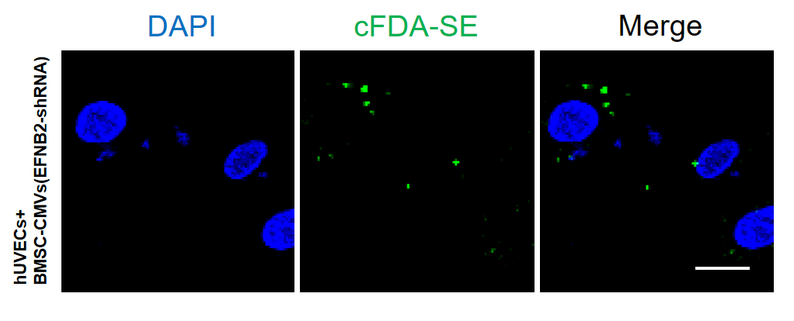
Supplementary Figure 7: BMSC-CMVs (EFNB2-shRNA) fluorescence emission (green) in hUVECs were lower, as compared to BMSC-CMVs fluorescence emission in Fig. 5f. The scale bar = 20 μm.

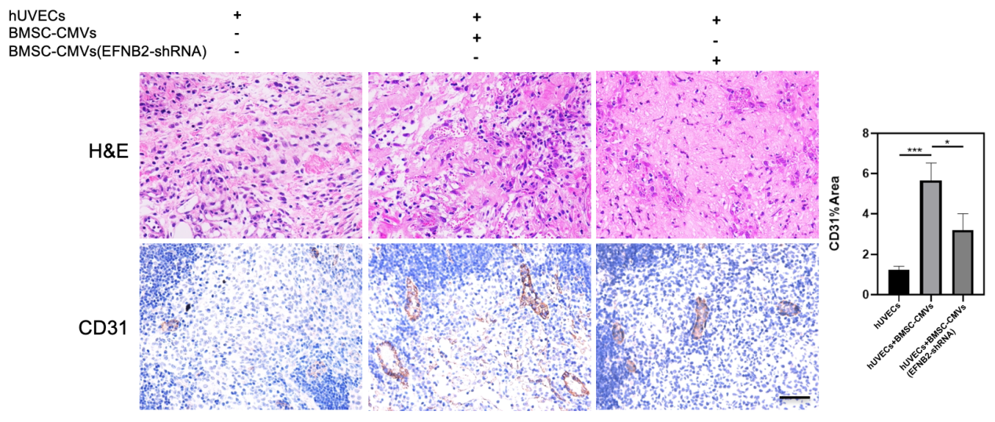
Supplementary Figure 8: Representative images of Matrigel plugs with hUVECs, hUVECs+BMSC-CMVs and hUVECs+BMSC-CMVs (EFNB2-shRNA) at 4 days after subcutaneous injection in nude mice. Hematoxylin/eosin staining and immunohistochemistry staining images for detection of CD31 expression within the three groups. The scale bar = 100 µm. CD31 area% were quantified using Image J software (*P＜0.05, ***P＜0.001, n=6).

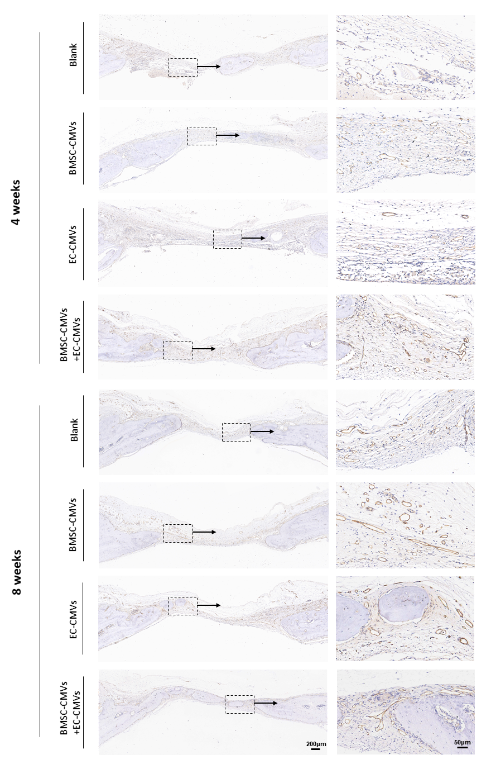
Supplementary Figure 9: Immunohistochemical staining images for detection of CD31 expression within the calvaria defects of the four groups at 4 and 8 weeks post-implantation respectively. The images on the right showed a higher magnification of the boxed region in the images on the left.

