Electronic Supplementary Material (ESI) for Food Analytical Methods

Electronic Supplementary Material

A fluorescent probe based on aptamer gold nanoclusters for rapid detection of mercury ions

Ying Wang ¹, Shan Luo ¹, Ruina Jiang ¹, Quanyong Dong ¹, Yingying Sun ¹, Xin Qiao ¹, Sili Yi ², *, Qian Wen ¹, *
¹ National Engineering Laboratory for Deep Processing of Rice and By-products, Hunan Key Laboratory of Processed Food for Special Medical Purpose, Hunan Key Laboratory of Forestry Edible Sources Safety and Processing, College of Food Science and Engineering, Central South University of Forestry and Technology, Changsha 410004, People's Republic of China. Hunan Provincial Key Laboratory of Food Safety Monitoring and Early Warning, Hunan Institute Food Quality Supervision Inspection and Research, Changsha 410004, People's Republic of China.
² School of Chemistry and Materials Science, Huaihua University, Huaihua, 418000, PR China.
*Corresponding Author. E-mail address: ysl@hhtc.edu.cn, wenqian_1104@163.com

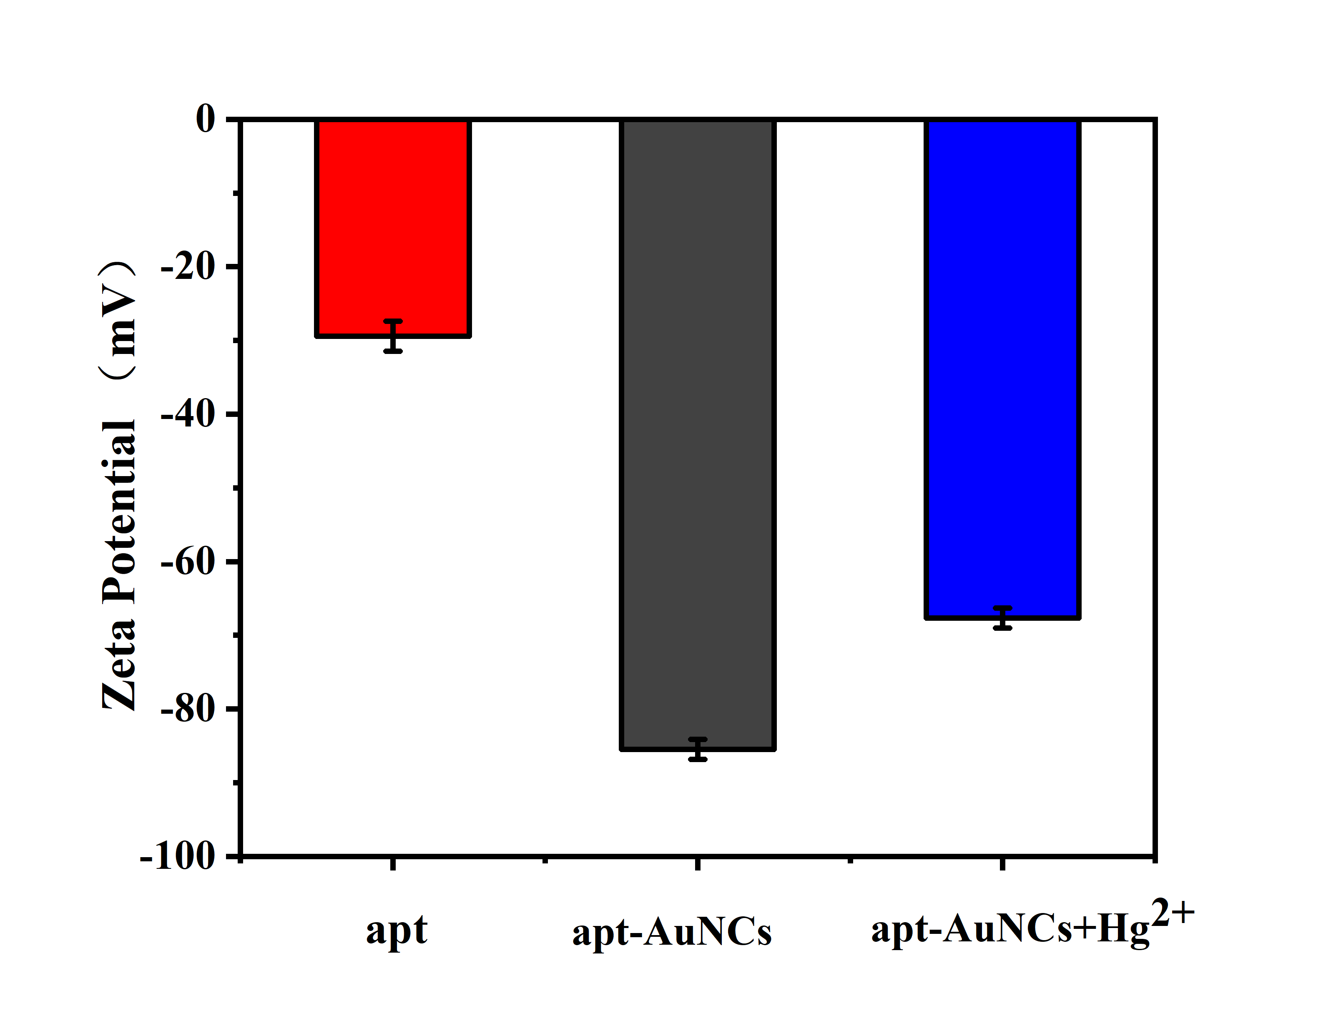
Fig. S1. Zeta-potential changes of apt-AuNCs solutions treated in the presence of or in the absence of Hg²⁺.

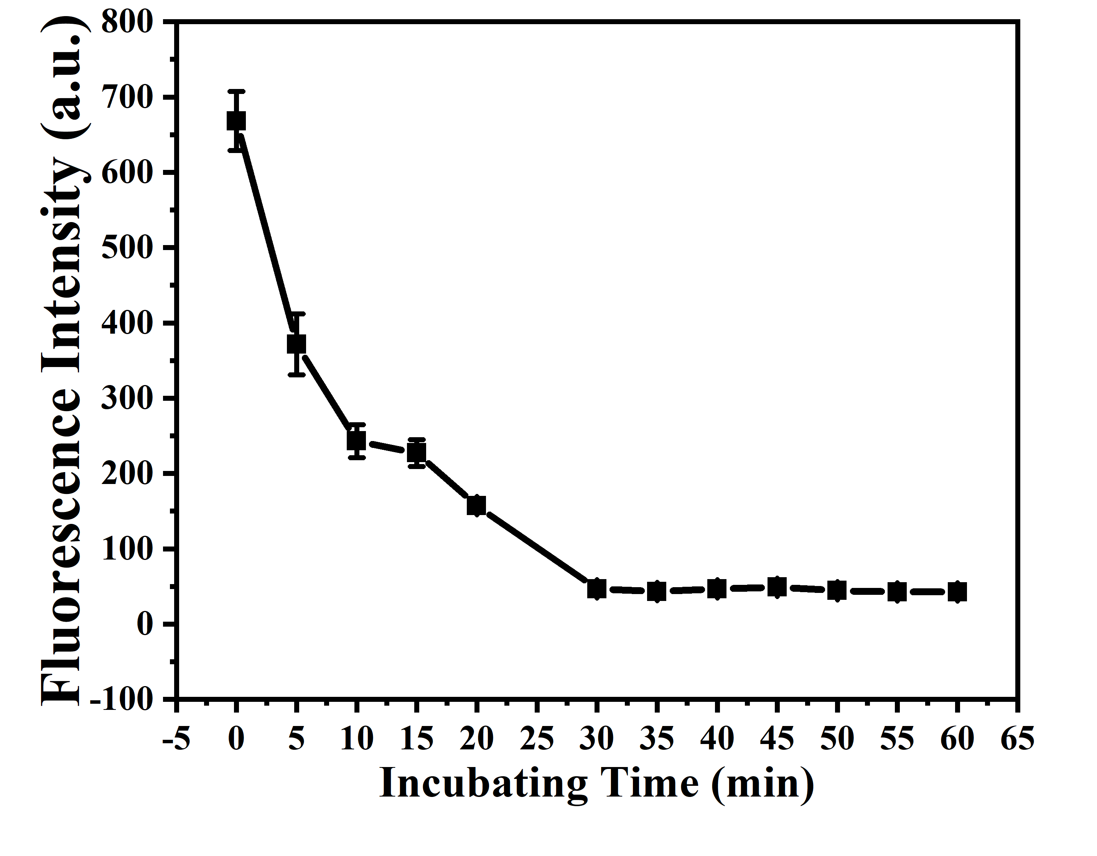
Fig. S2. Optimization of incubation Time.

