Extended Data

Development of a Natural Product Optimization Strategy for inhibitors against the cell wall synthesis enzyme MraY, a promising antibacterial target

Kazuki Yamamoto,^{1,2*} Toyotaka Sato,^{3,4,5} Aili Hao,⁶ Kenta Asao,¹ Rintaro Kaguchi,¹ Shintaro Kusaka,¹ Ruddarraju Radhakrishnam Raju,¹ Daichi Kazamori,⁷ Kiki Seo,⁷ Satoshi Takahashi,^{8,9} Motohiro Horiuchi,^{3,4,5} Shin-ichi Yokota,¹⁰ Seok-Yong Lee,⁶ and Satoshi Ichikawa,^{1,2,11*}

Extended Data Fig. 1. Peptidoglycan biosynthesis pathway.
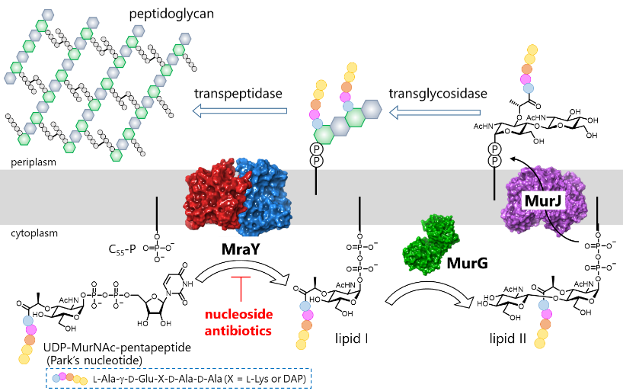
β-Lactams inhibit transpeptidases such as penicillin-binding proteins (PBPs). Vancomycin binds to the D-Ala-D-Ala terminal of lipid II and inhibits transpeptidation and transglycosidation reaction. MraY is an enzyme located upstream of peptidoglycan biosynthesis.

Extended Data Fig. 2. Structures of hydrazine fragments.
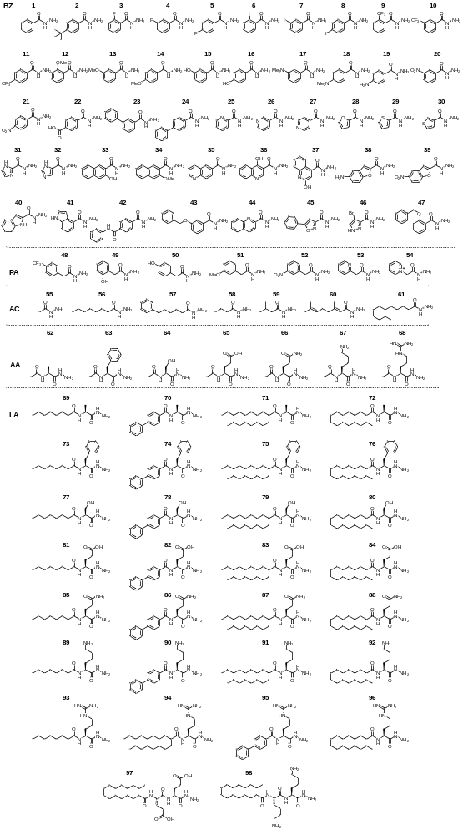
Extended Data Table 1. Antibacterial activity of stable analogues against drug-resistant strains and clinically isolated strains.
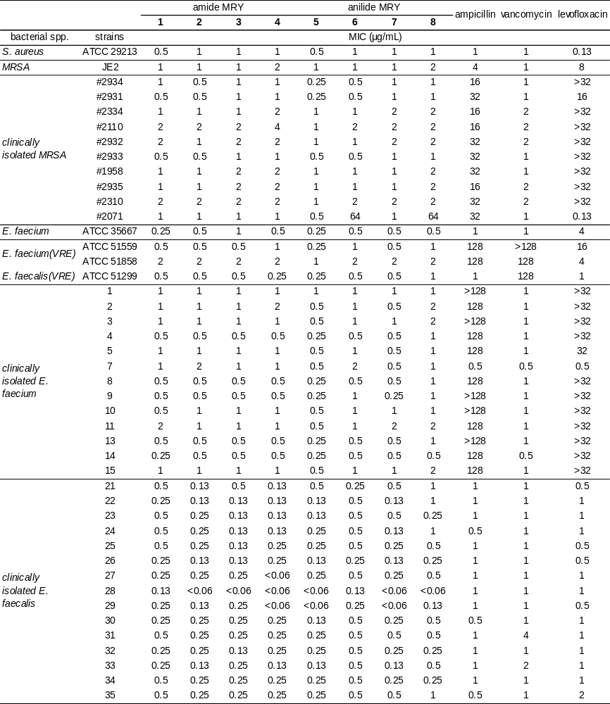
Experimental details are shown in Methods of main text. These MIC values were determined in a single trial. MIC values against S. aureus ATCC 29213 and E. faecium ATCC 35667 strains were identical to Table 1. Drug breakpoint: S. aureus; vancomycin ≥16 µg/mL, levofloxacin ≥4 µg/mL, enterococci; ampicillin ≥16 µg/mL, vancomycin ≥32 µg/mL, levofloxacin ≥8 µg/mL [M100 Performance Standards for Antimicrobial Susceptibility Testing, 30th Edition (CLSI)].
Extended Data Fig. 3. TEM images.
a) DMSO (×16800) | (×16800) | (×16800)
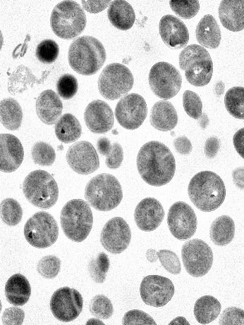 | 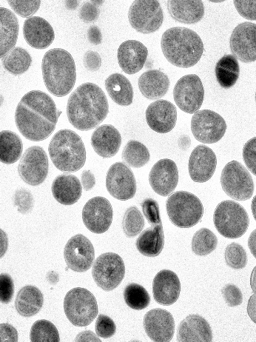 | 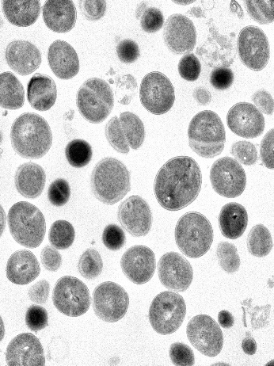
b) 2 (×16800) | (×16800) | (×16800)
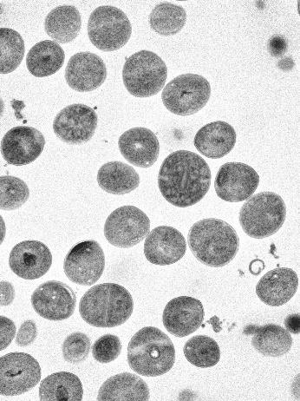 | 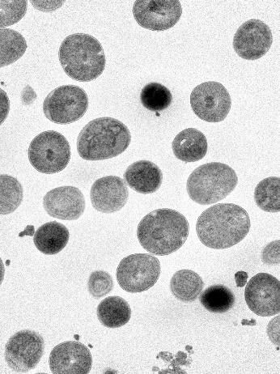 | 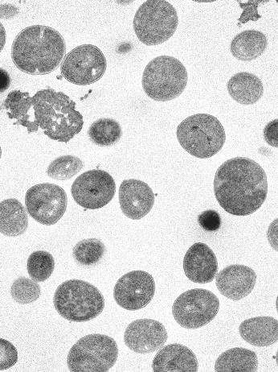
(×16800) | (×63200) | (×211000)
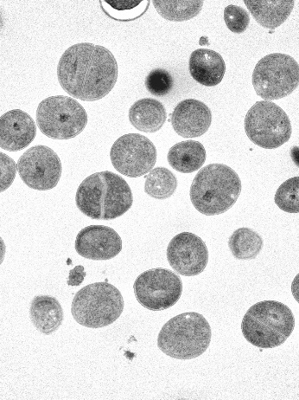 | 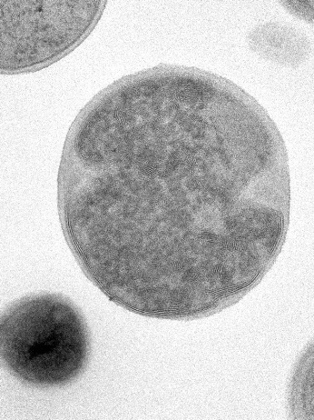 | 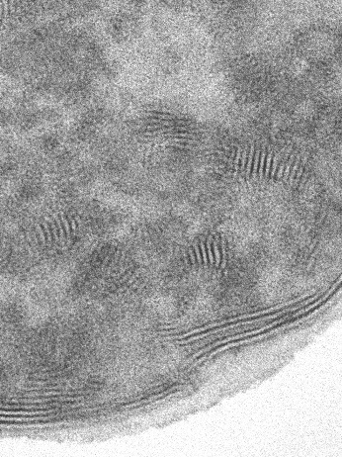
c) vancomycin (×16800) | (×16800) | (×63200)
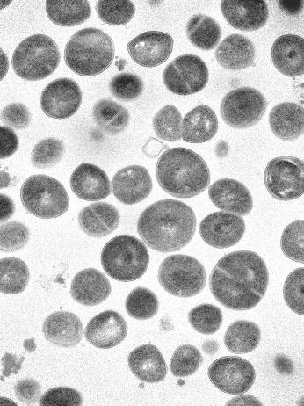 | 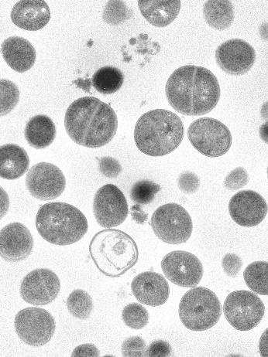 | 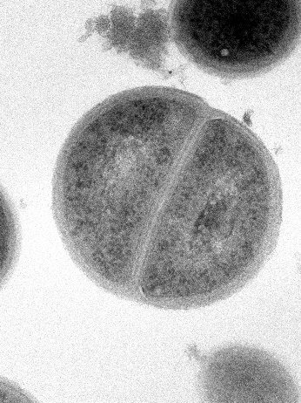
S. aureus (10⁹ cfu/mL) was treated with 64 μg/mL of 2 and 32 μg/mL of vancomycin for 3 h. Abnormal membrane-like structures were shown in bacterial cells treated with 2. These morphological changes were not observed in cells treated with vancomycin.

Extended Data Table 2. Cryo-EM data collection, refinement, and validation statistics
 | MraY_{AA}-NB7-2 | MraY_{AA}-NB7-3
 | (EMD, PDB) | (EMD, PDB)
Data collection and processing
Magnification | 81,000 | 81,000
Voltage (kV) | 300 | 300
Electron exposure (e–/Å²) | 60 | 60
Defocus range (μm) | -2.0 to -0.8 | -1.8 to -0.8
Pixel size (Å) | 1.08 | 1.08
Symmetry imposed | C2 | C2
Initial particle images (no.) | 1,385,116 | 1,010,303
Final particle images (no.) | 220,165 | 68,364
Map resolution (Å) | 2.88 | 2.70
FSC threshold | 0.143 | 0.143
Refinement
Initial model used (PDB code) | 5CKR | 5CKR
Model resolution (Å) | 2.88 | 2.70
FSC threshold | 0.143 | 0.143
Map sharpening B factor (Å²) | -30 | -30
Model composition
Nonhydrogen atoms | 7220 | 7224
Protein residues | 930 | 930
Ligands | 2 | 2
Water | 6 | 6
B factors (Å²)
Protein | 90.75 | 66.77
Ligand | 90.69 | 67.03
R.m.s. deviations
Bond lengths (Å) | 0.003 | 0.004
Bond angles (°) | 0.631 | 0.582
Validation
MolProbity score | 1.11 | 1.07
Clashscore | 3.16 | 2.81
Poor rotamers (%) | 0 | 0.28
Ramachandran plot
Favored (%) | 98.05 | 98.92
Allowed (%) | 1.95 | 1.08
Disallowed (%) | 0 | 0

Extended Data Fig. 4. Cryo-EM data processing.
a) representative micrograph and 2D classification for MraY-NB7-2.
b) local resolution estimation for MraY-NB7-2.
c) phenix and cryoSPARC reported Fourier shell correlations, and particle angular distribution for the final map of MraY-NB7-2.
d) cryo-EM density corresponding to MraY TM1-10 for MraY-NB7-2 (map threshold = 0.25).
e) processing workflow for MraY-NB7-2.
f) representative micrograph and 2D classification for MraY-NB7-3.
g) local resolution estimation for MraY-NB7-3.
h) phenix and cryoSPARC reported Fourier shell correlations, and particle angular distribution for the final map of MraY-NB7-3.
i) cryo-EM density corresponding to MraY TM1-10 for MraY-NB7-3 (map threshold = 0.25).
j) processing workflow for MraY-NB7-3.

Extended Data Fig. 5. Detailed complex structure of MraY_{AA}-2 and MraY_{AA}-3.
a) Cryo-EM density of 2 is shown in green mesh. Two map thresholds are shown (Dark green, 0.32; Bright green, 0.2)
b) Cryo-EM density of 3 is shown in pink mesh. Two map thresholds are shown (Salmon, 0.35; Pink, 0.21)
c) Structural overlay of MraY_{AA} bound to 2 (green), 3 (pink), carbacaprazymin (light blue), capuramycin (orange), 3′-hydroxymureidomycin A (purple), sphaerimicin-1 (deep red), and muramycin D2 (light teal), and MraY_{CB} bound to tunicamycin (yellow) viewed from the cytoplasm.
d) Electrostatic surface representation of the binding site with 2 (green), 3 (pink), and muramycin D2 (MD2, light teal) overlay. MD2 occupies TM9b/Loop E pocket while analogues 2 and 3 occupies the TM4/5 groove. Electrostatics calculated with APBS⁶⁸.

