Table 1. MraY inhibitory and antibacterial activity against ESKAPE pathogens
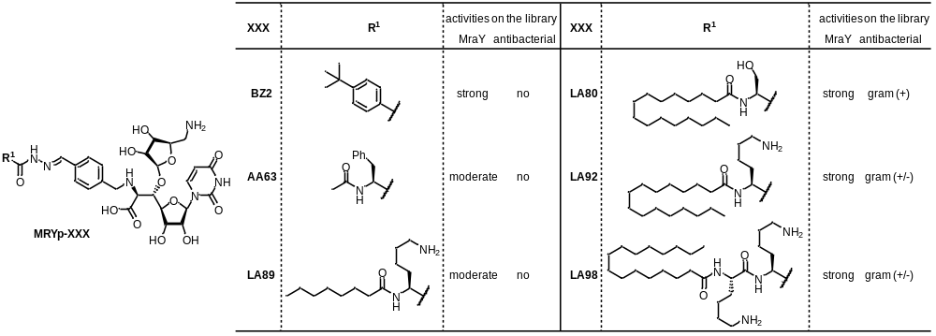
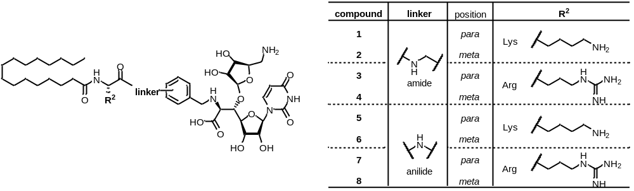
 | IC₅₀ for MraY_{SA} (nM) | MIC (μg/mL)
 | IC₅₀ for MraY_{SA} (nM) | S. aureus | E. faecium | P. aeruginosa | K. pneumoniae | E. cloacae | A. baumannii | E. coli
 | IC₅₀ for MraY_{SA} (nM) | ATCC 29213 | ATCC 35667 | ATCC 27853 | ATCC 13883 | ATCC 13047 | ATCC 19606 | ATCC 25922
MRYp-BZ2 | 2.4 | 128 | 64 | >128 | >128 | >128 | >128 | >128
MRYp-AA63 | 67 | >128 | >128 | >128 | >128 | >128 | >128 | >128
MRYp-LA89 | 120 | >128 | >128 | >128 | >128 | >128 | >128 | >128
MRYp-LA80 | 7.4 | 2 | 0.5 | >128 | >128 | >128 | >128 | >128
MRYp-LA92 | 5.0 | 1 | 1 | >128 | 16 | 64 | 8 | 16
MRYp-LA98 | 7.8 | 1 | 2 | 16 | 4 | 8 | 8 | 4
1 | 6.0 | 0.5 | 0.25 | 8 | 4 | 8 | 4 | 4
2 | 5.9 | 1 | 0.5 | 16 | 8 | 8 | 4 | 4
3 | 4.0 | 1 | 1 | 32 | 4 | 8 | 4 | 4
4 | 5.0 | 1 | 0.5 | 32 | 4 | 16 | 4 | 4
5 | 3.1 | 0.5 | 0.25 | 32 | 4 | 8 | 4 | 4
6 | 3.7 | 1 | 0.5 | 32 | 4 | 8 | 2 | 4
7 | 1.7 | 1 | 0.5 | 128 | 4 | 16 | 4 | 8
8 | 1.8 | 1 | 0.5 | 128 | 4 | 32 | 4 | 8
colistin |  | >128 | >128 | 1 | 4 | >128 | 0.5 | 1
vancomycin |  | 1 | 1 | >128 | >128 | >128 | >128 | >128
MICs were determined by a microdilution broth method as recommended by the CLSI with cation-adjusted Mueller-Hinton broth. Serial two-fold dilutions of each compound were made in appropriate broth, and the plates were inoculated with 5 × 10⁴ CFU of each strain in a volume of 0.1 mL. Plates were incubated at 35 °C for 20 h and then MICs were scored (n = 3).

