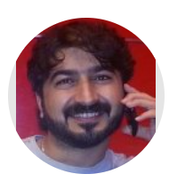 | Heamn N. Abduljabbar: Lecturer fetal echocardiography. Universiti Putra Malaysia UPM, Malaysia, Salahaddin University/Erbil, Shaqlawa, Iraq. Research interest in Ultrasound scanning, Radiology, Medical Image Processing.  (e-mail: heamn.abduljabbar@su.edu.krd).
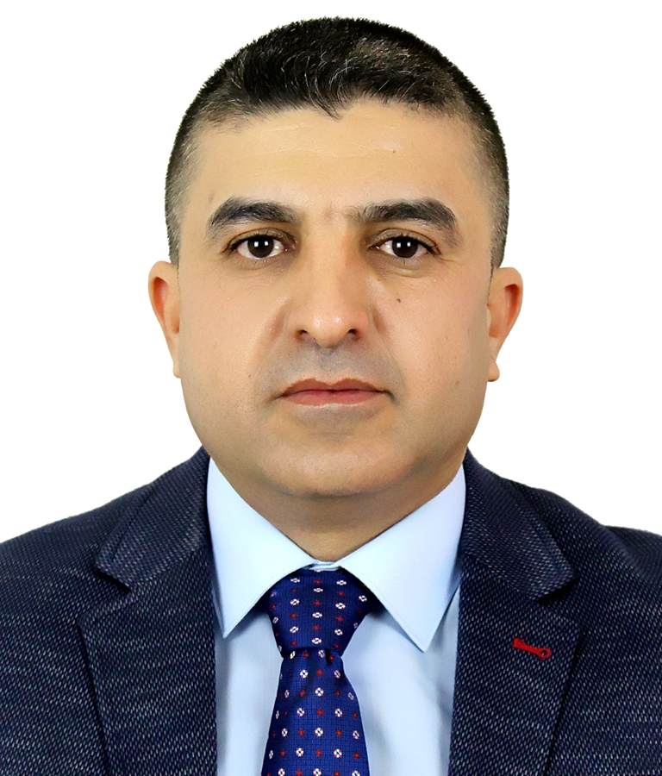 | Ameer Sardar Kwekha Rashid: Assistant professor in Business Information Technology, University of Sulaimani, Sulaimani-Iraq, Research Interests in Machine Learning, Deep learning, Artificial Intelligence, Internet of Things (IoT), Computer network, Computer Science, and Knowledge Management Systems.  (e-mail: ameer.rashid@univsul.edu.iq).
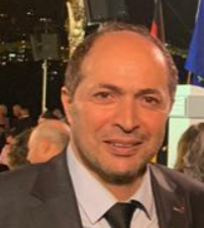 | Kifah Tout: Professor in Bioinformatics, Lebanese University, Tripoli-Lebanon, Research Interests in Bioinformatics, Artificial Intelligence, Machine Learning, Deep learning, Computer network, and Computer Science.  (e-mail: ktout@ul.edu.lb).
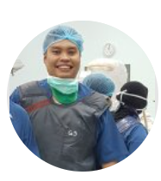 | Ezamin Abdulrahim: Associate Prof. in medical and Clinical Radiology/Neuroradiology & Neoinnervation, UPM, Malaysia. Research interest in Radiology, Medicine, Interventional, and Neurology.  (e-mail: ezamin@upm.edu.my)
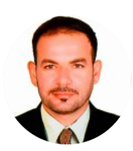 | Bilal Alhayani (Bilal Öztürk): Assistant professor in Electronics and Communication, İstanbul Gelişim University, Istanbul, Turkey, Research Interests in Image processingimage transmissionImage compressionMIMOCopperative communication.  (e-mail: bilalhayani10@gmail.com)
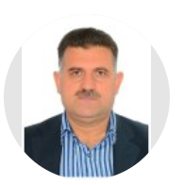 | Haidar Jalal Ismail: Professor in Physics, College of Education, Salahaddin University-Erbil. Research interest in Biophysics Medical Image processing, and Radiation,  (e-mail: haidar.ismail@su.edu.krd)
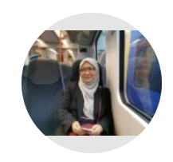 | Syamsiah bt. Mashohor: Associate Professor in Computer and Communication Systems Engineering, Universiti Putra Malaysia UPM, Malaysia, Research interest in Artificial intelligence and image processing.  (e-mail: syamsiah@upm.edu.my)
 | Subapriya Suppiah: Associate Professor, Clinical Radiology/Radionuclide Imaging, Universiti Putra Malaysia UPM, Malaysia, Research Interests in radiology, Neuroscience, Molecular Imaging neuroimaging, and behavioural imaging.  (e-mail: subapriya@upm.edu.my)
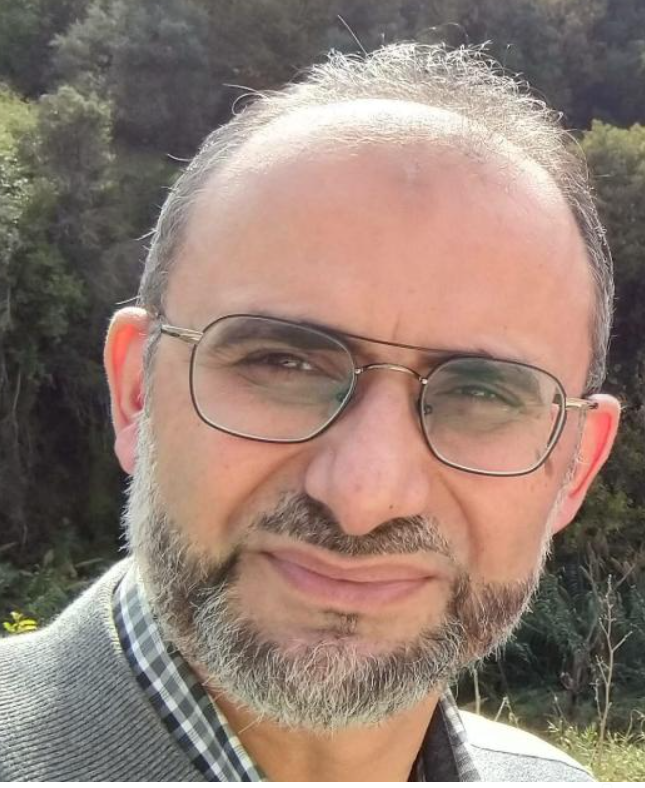 | Ammar Yakan: Professor in Business Information Technology, CDI College, Montreal - Canada, Research Interests in Machine Learning, Deep learning, Artificial Intelligence, Internet of Things (IoT), Computer network, Computer Science, and Knowledge Management Systems.  (e-mail: ammar.yakan@yahoo.ca).

