Supplementary Material
Supplementary Figures

Supplementary Fi.1 (A) Representative photomicrographs of BM-MSCs and LPS pre-MSCs in culture showing similar fusiform and triangular morphologies. Scale bar 100μm. (B) LPS pre-MSCs differentiated into osteocytes, chondrocytes and adipocytes. (C) Characteristic cell surface markers of LPS pre-MSCs were detected by flow cytometry. (D), (E) After appropriate lipopolysaccharide stimulation, Live-Amcyan staining flow analysis showed no significant difference in the mortality of MSCs between the two groups (n = 3). Data are presented as mean ± SD. ns P>0.05

Supplementary Fig.2 The markers (HSP90B1, CD63, TSG101, CD9) of exosomes analyzed by western blot. Full-length blots are presented in Supplementary Figure 2. Blots: Origin images of Western blots; White: Origin images of transferred PVDF membranes; Merge: The origin images of which blots merged with the PVDF membrane. The blots marked in red are the parts cropped.

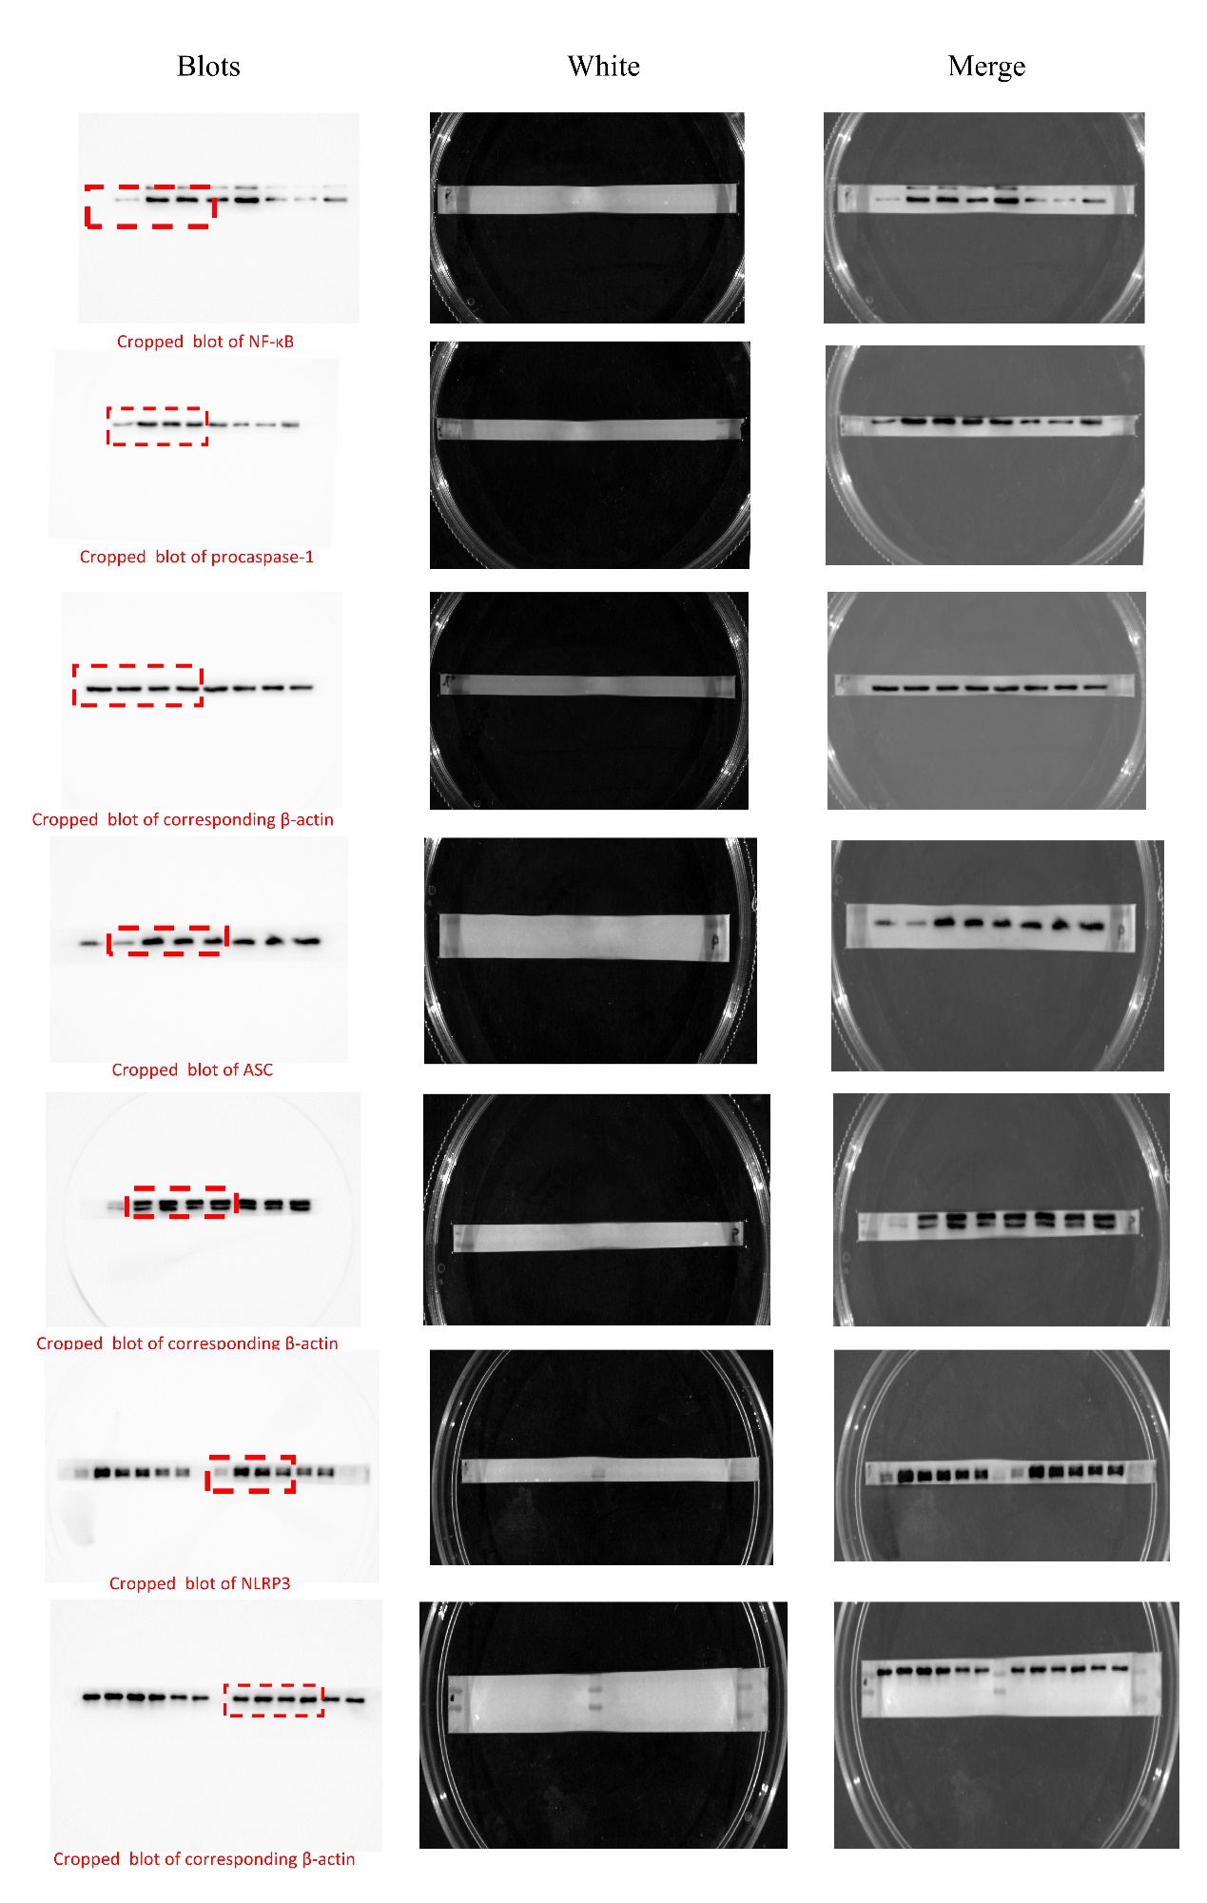

Supplementary Fi. 3 BMDM cells were pretreated with LPS (100ng/m) for 3h before culturing with LPS pre-Exo for 24h. Protein expression of NF-κB, NLRP3, Procaspase-1 and ASC in macrophages of each group was analyzed by western blot. Full-length blots are presented in Supplementary Figure 2. Blots: Origin images of Western blots; White: Origin images of transferred PVDF membranes; Merge: The origin images of which blots merged with the PVDF membrane. The blots marked in red are the parts cropped.

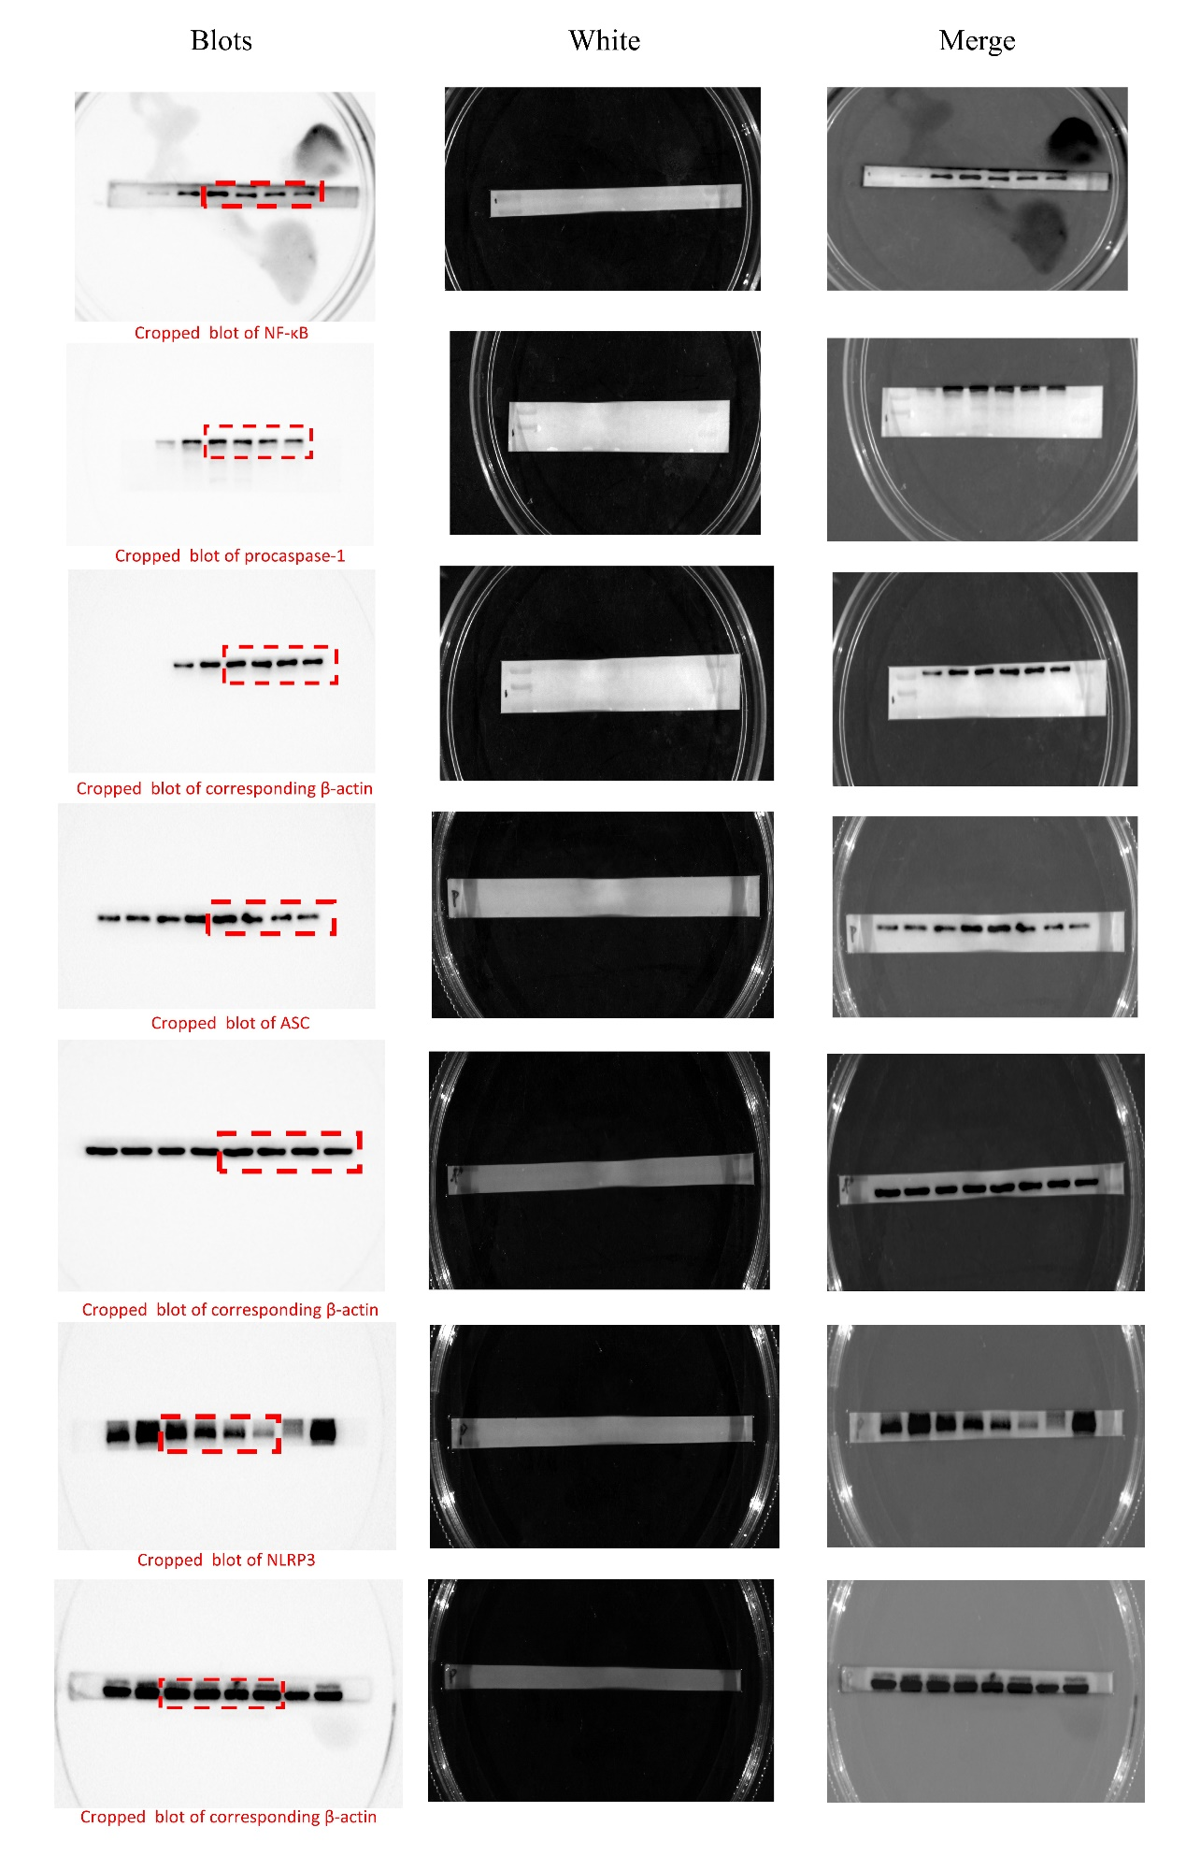

Supplementary Fig.4 BMDM cells were pretreated with LPS (100ng/m) for 3h before culturing with LPS pre-Exo for 48h. Protein expression of NF-κB, NLRP3, Procaspase-1 and ASC in macrophages of each group was analyzed by western blot. Blots: Origin images of Western blots; White: Origin images of transferred PVDF membranes; Merge: The origin images of which blots merged with the PVDF membrane. The blots marked in red are the parts cropped.

