Supplemental information

Design of a Wankel pump constant pressure grouting system based on Fuzzy PID Method

Supplemental Figures

Fig.S1.

The real-time volume of Wankel pump: The value of Vβ is a sinusoidal curve with a period of 3π, as shown in Figure 2.
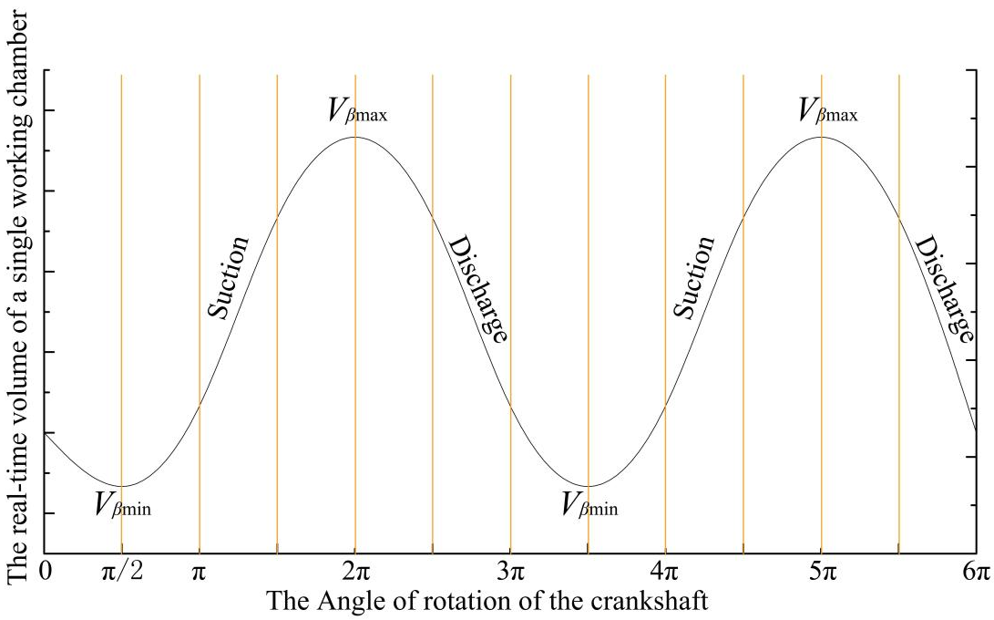
Figure 1. Arbitrary working chamber area.
Fig.S2.

PID control: As shown in Figure 2, Pset (t) is the target pressure of pressure sensor ③, and P3 (t) is the output value, which is the measured value of pressure sensor ③ after the CVT adjustment.
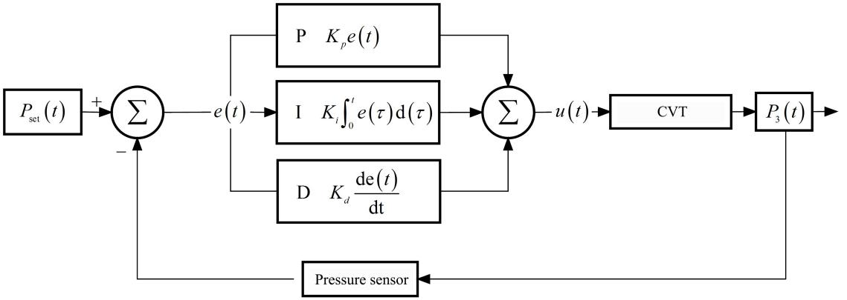
Figure 2. PID control principle.
Fig.S3.

Fuzzy control: Fuzzy controller combines fuzzy control theory with PID controller, as shown in Figure 3.
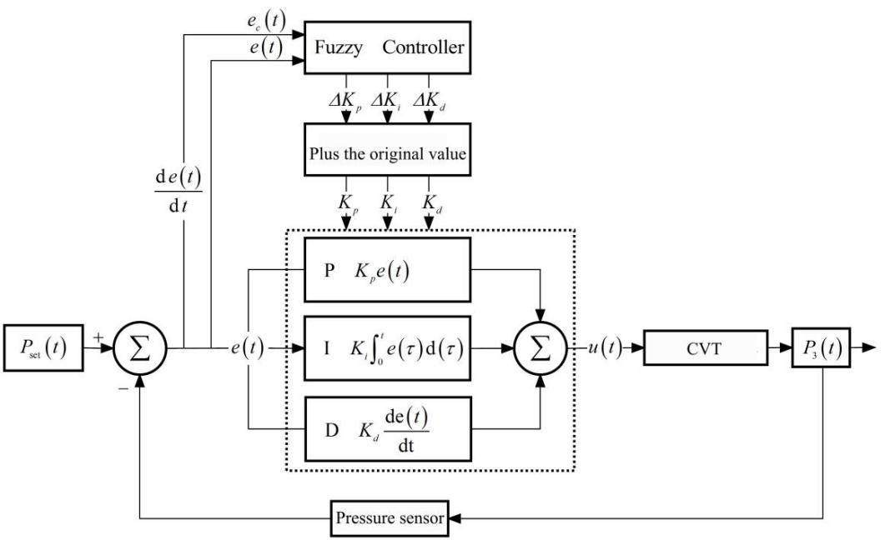
Figure 3. Fuzzy control principle.
Fig.S4.

The input value is fuzzy processed, and 7 languages are used in SDUZJ system, which are {negative-large, negative-medium, negative-small, zero, positive-small, median, cp}={NB, NM, NS, O, PS, PM, PB}. Membership function is triangular shape, and the fuzzy theory domain of e and ec is {-3, -2, -1, O, +1, +2, +3}. The domains of Kp, Ki and Kd are {0.3, 0.2, 0.1, O, + 0.1, + 0.2, + 0.3}, {0.06, 0.04, 0.02, O, + 0.02, + 0.04, + 0.06} and {3, 2, 1, O, + 1, + 2, + 3} respectively, as shown in Figure 6.
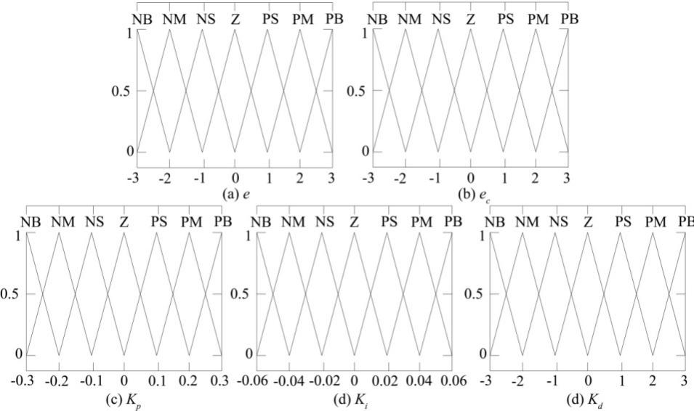
Figure 4. Membership function of input and output.
Fig.S5.

42.5R cement grout with water cement ratio of 1:1 was selected and P unit was controlled by SDUZJ system for system test. The test system is shown in Figure 5.
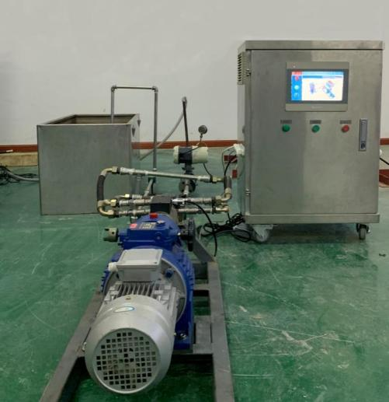
Figure 5. Test system of SDUZJ system.

