Supplementary Information for

Quantifying complex urban spillover effects via physics-based deep learning
Tong Liu, Chao Fan, Takahiro Yabe

This file includes:
1. Supplementary Methods 1
1.1 Node Construction 1
1.2 Edge Construction 3
2. Supplementary Figures 4
3. Supplementary Tables 15
4. Supplementary References 17

1. Supplementary Methods

1.1 Node Construction
In the first example of spillover in the environmental system, we construct a weighted, undirected gridded graph. Each node represents a 540m $×$ 540m land parcel. The node features are carefully selected based on existing evidence, meaning they have been identified as key factors influencing land surface temperatures. Our selected features include (1) different types of land covers^{1–4}, i.e., built-up cover, tree cover, grassland cover, shrubland cover and open water cover; (2) land morphology factors^{5–7}, i.e., elevation, slope and aspect; (3) anthropogenic factors⁸, i.e., street length, street intersection density, building footprint density and point of interest (POI) density.
To examine our model within the context of the social system, we build an unweighted, undirected graph where each node corresponds to a census tract area. Similarly, the selected node features are factors that are identified to have significant influences on visitor flow by current literature, which include (1) land covers^{9,10}, (2) land morphology factors¹¹, (3) characteristics of street grid networks¹¹, (4) point of interest (POI) density¹², and (5) demographic and socioeconomic characteristics^{13,14}.
Figure S1 shows the spatial and quantitative distribution of node features and the correlation analysis of node features and corresponding land surface temperatures (LST). In Figure S1 C, we can see that LST exhibits relatively weak positive correlations with factors that reflect the intensity of human activities, including POI density ($r=0.11$), intersection density ($r=0.03$), building density ($r=0.09$), and built-up cover ($r=0.07$). In contrast, it shows moderate negative correlations with vegetation covers, including tree cover ($r=-0.29$), shrub cover ($r=-0.31$), and grass cover ($r=-0.45$). The remaining factors, including open water cover ($r=-0.13$), slope ($r=-0.46$), and elevation ($r=-0.13$), display weak to moderate negative correlations with LST.
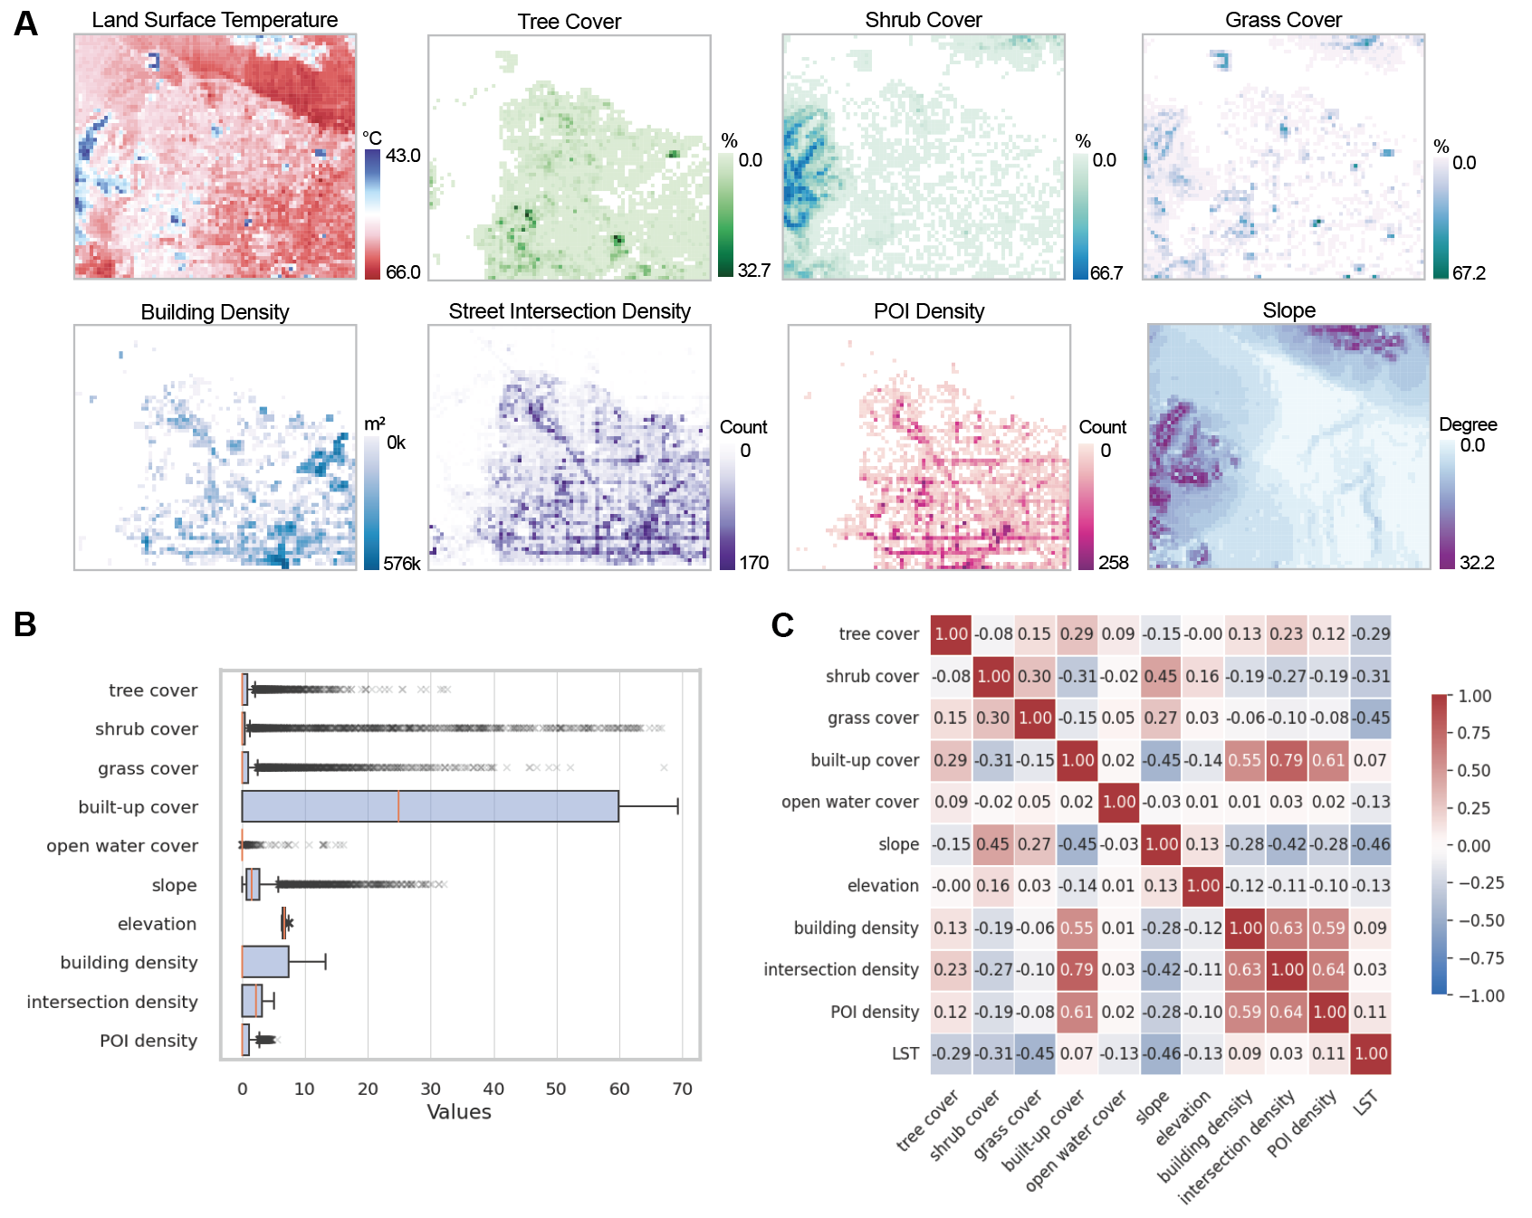Figure S1. Rescale the original node label and node features into the 540-m unified spatial resolution and employ logarithmic ($\log_{e}$) transformation to normalize the anthropogenic factors. A. Spatial distribution of (1) vegetation covers, including tree cover, shrub cover, and grass cover; (2) anthropogenic factors, including building footprint density, street intersection density, and POI density; (3) other factors, including built-up cover and slope, and the outcome variable (LST). B. Quantitative distribution of the numerical features (or node inputs). C. Correlation matrix of all numerical features and the outcome variable (LST). The numbers in the boxes represent Pearson’s correlation coefficients. The colors of boxes represent the magnitude of positive (red colors) and negative (blue colors) correlations.

1.2 Edge Construction
Regarding the quantification of spillover in the environmental system, each edge connecting two adjacent nodes corresponds to an edge weight that is determined based on the land morphology factor. Specifically, if two parcels form a convex shape (as shown in the section view in Figure S2), the edge linking them is associated with a lower rate of air flow, while if they form a concave shape, the edge is associated with a higher rate of air flow (derived based on ref.⁵).
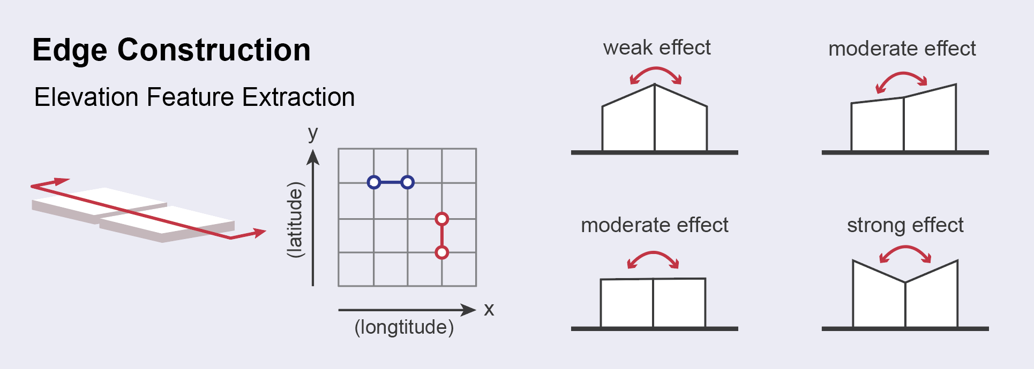
Figure S2. Illustration of the edge construction procedure.

The edge weight is calculated based on slope gradient ($G$) and aspect ($A$), which can be written as
$$tanG=\sqrt{{(\frac{∂z}{∂x})}^{2}+{(\frac{∂z}{∂y})}^{2}}$$ | (1)
$$tanA=-\frac{∂z}{∂y}/\frac{∂z}{∂x}$$ | (2)
where $∂x$ and $∂y$ are the differences in distance measured along the longitudinal and latitudinal axes, respectively. $∂z$ represents the difference in elevation. Since $G$ and $A$ can be extracted from the digital elevation model (DEM) data, we can get the values of $\frac{∂z}{∂x}$ and $\frac{∂z}{∂y}$ using the above equations. If two nodes are longitudinally linked along X-axis (see blue-colored dots in Figure S2), we calculate their $\frac{∂z}{∂x}$. If two nodes are latitudinally linked along Y-axis (see red-colored dots in Figure S2), we calculate their $\frac{∂z}{∂y}$. Then, we compute the differences in $\frac{∂z}{∂x}$ or $\frac{∂z}{∂x}$ of two adjacent nodes ($i$ and $j$), namely $∆z_{ij}.$ We let the concave morphology corresponds to greater positive values of $∆z_{ij}$ along Y-axis and greater negative values of $∆z_{ij}$ along X-axis than the flat plane. The weights associated with it should indicate a higher rate of air flow. Mathematically, the edge weight can be written as
$w_{ij}=1-∆z_{ij}$, if two nodes linked along Y-axis | (3)
$w_{ij}=1-(-∆z_{ij})$, if two nodes linked along X-axis | (4)

2. Supplementary Figures
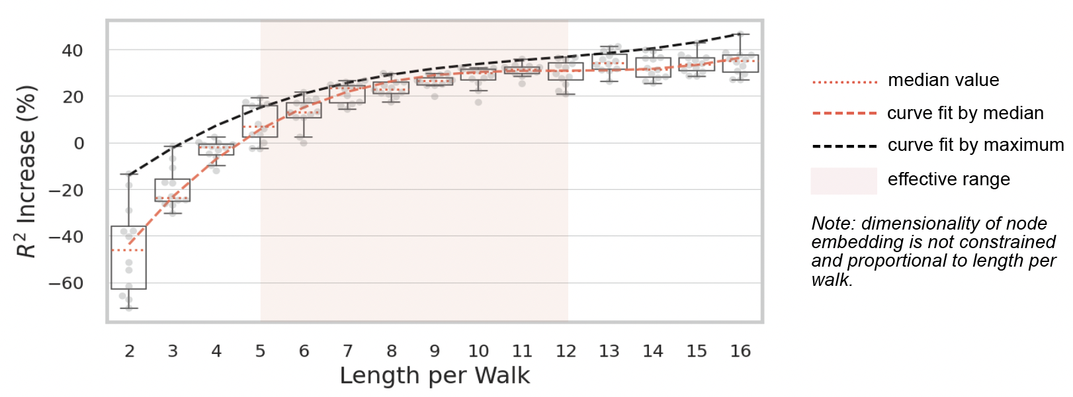
Figure S3. Optimization of neighbor sampling parameter without constraints on dimensionality (LST prediction in Las Vegas). The dimensionality of new node embedding is proportional to the length per walk. The gray dots denote the model training results with different settings of the neighbor sampling parameter (ranging from 2 to 16). In each setting, we repeat the model training 12 times. The orange dotted line denotes the median value of model performance measured by the R-square increase. The orange dashed line represents the curve fit by the median model performance value. The black dashed line represents the curve fit by the maximum model performance value. The orange-colored area denotes the effective range of length per walk. The lower bound of this range is determined by the lowest value of length per walk parameter that result in a median increase of the R-square above 0. The upper bound is determined by the length per walk at which the model converges and further increase in length are unlikely to significantly improve the R-square value.

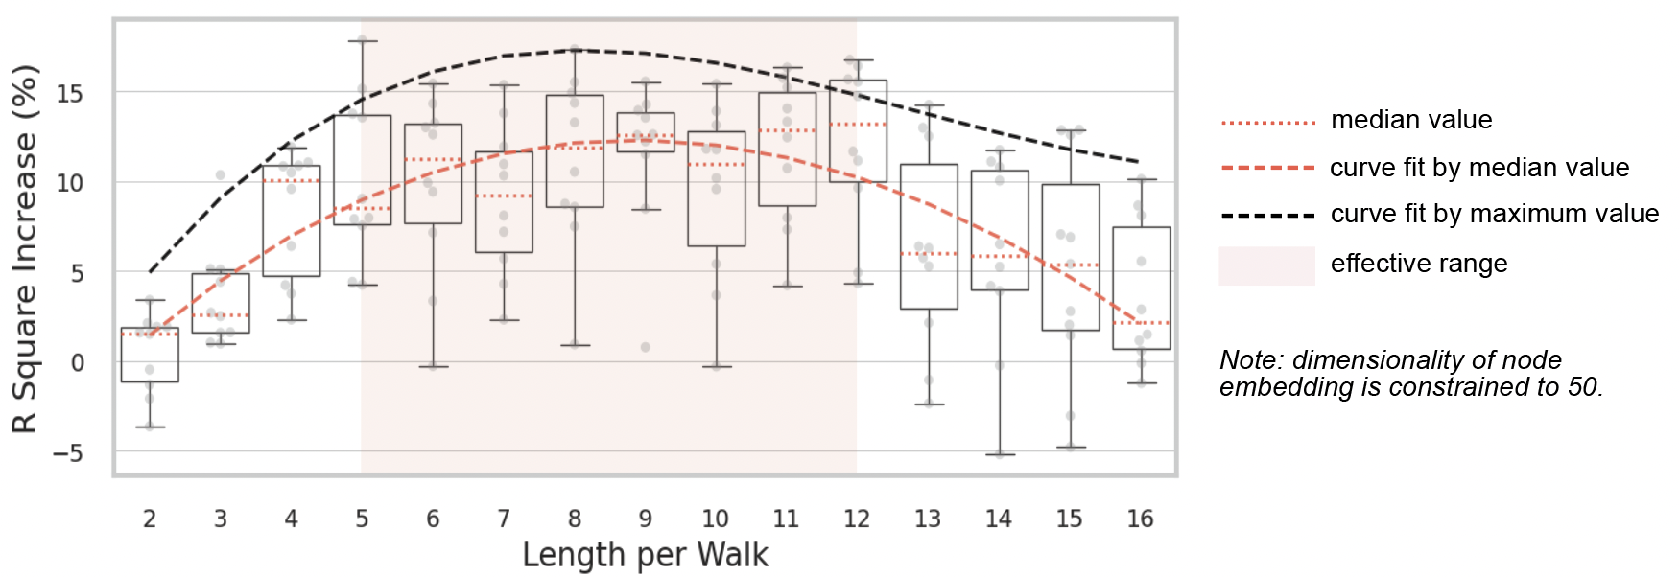
Figure S4. Optimization process of neighbor sampling parameter with dimensionality constrained to 50 (LST prediction in Las Vegas). The new node embedding is constrained to have a dimensionality of 50. The gray dots denote the model training results with different settings of the neighbor sampling parameter (ranging from 2 to 16). In each setting, we repeat the model training 10 times. The orange dotted line denotes the median value of model performance measured by the R-square increase. The orange dashed line represents the curve fit by the median model performance value. The black dashed line represents the curve fit by the maximum model performance value. The orange-colored area denotes the same effective range as shown in Figure S3. It aligns well with the optimal range of length per walk under the given constraints.
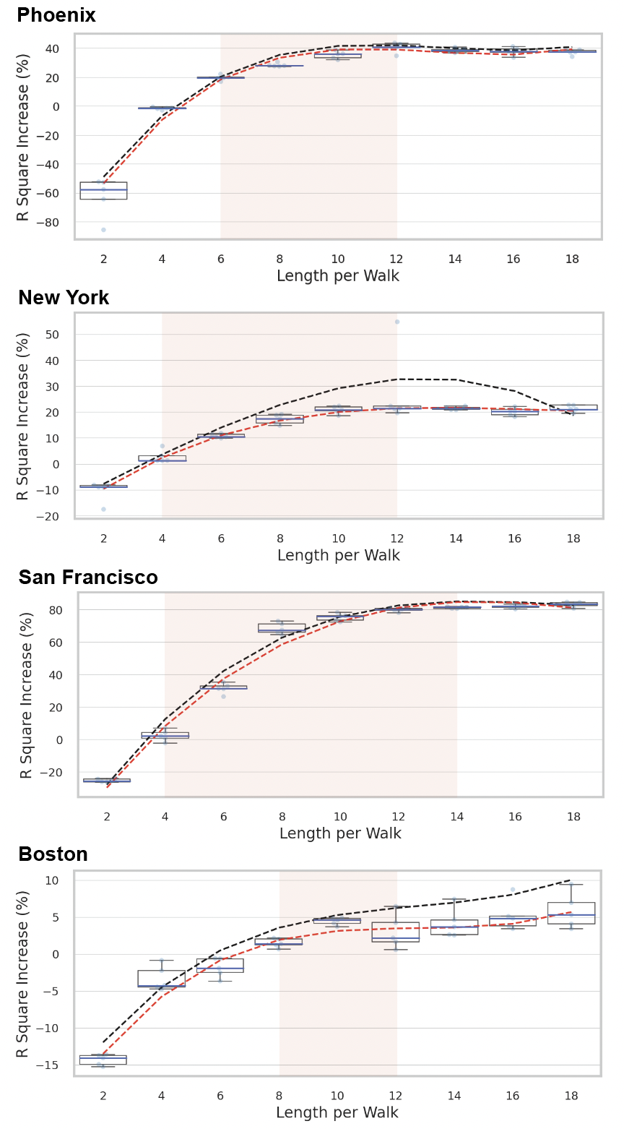
Figure S5. Model training and optimization process of neighbor sampling parameter (LST prediction in Phoenix, New York, San Francisco, and Boston). The dimensionality of new node embedding is not constrained. The dots denote the model training results with different settings of the neighbor sampling parameter (ranging from 2 to 18). In each setting, we repeat the model training 6 times with different learning rates. The blue line in the box denotes the median value of model performance (measured by the R-square increase). The orange dashed line represents the polynomial curve fit by the median model performance. The black dashed line represents the polynomial curve fit by the maximum model performance. The orange-colored area denotes the effective range of length per walk. The lower bound of this range is determined by the lowest value of length per walk parameter that result in a median increase of the R-square above 0. The upper bound is determined by the length per walk at which the model converges and further increase in length are unlikely to significantly improve the R-square value.

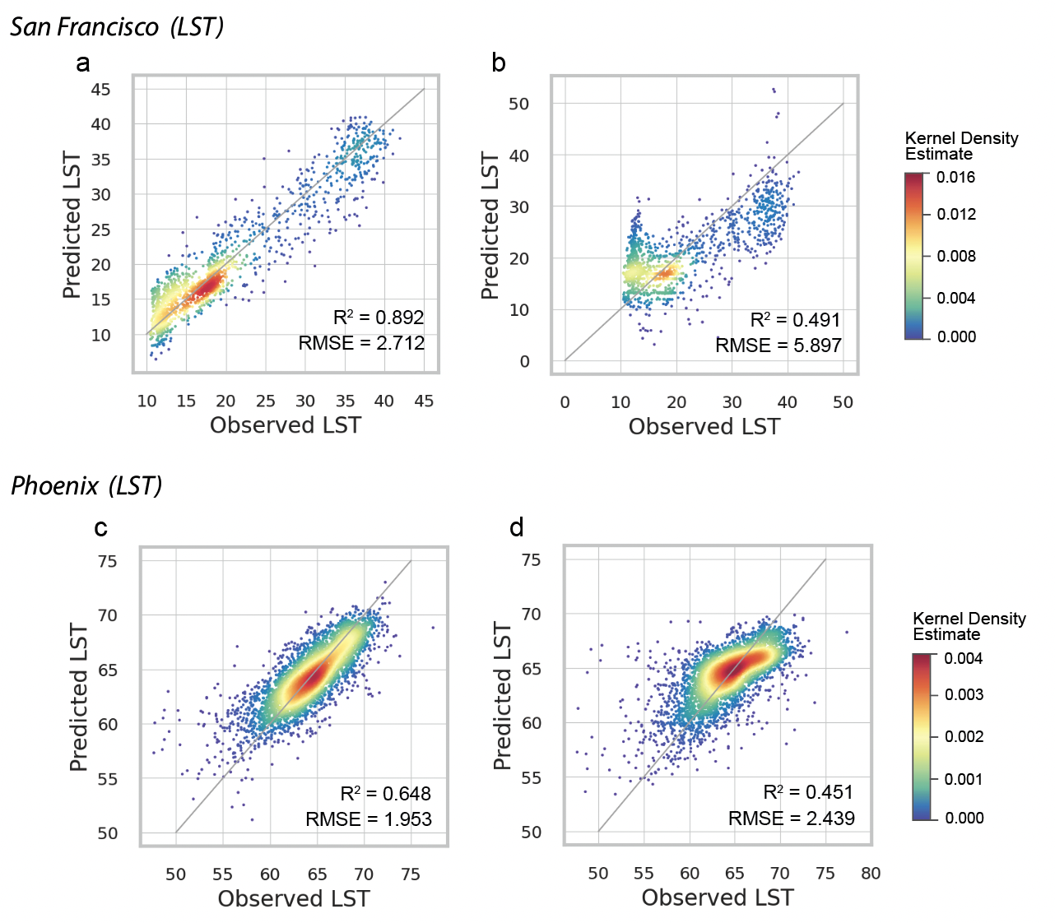

Figure S6. Model prediction performance evaluation (LST prediction in San Francisco and Phoenix). a and b. Prediction performance of the DRD model and the non-spillover model in San Francisco. c and d. Prediction performance of the DRD model and the non-spillover model in Phoenix. The warmer or cooler colored dots represent the higher or lower density of data points indicated by the kernel density estimation (KDE) function. The solid gray line denotes the perfect estimation with no error. The area above and below the solid gray line represents overestimation and underestimation, respectively.
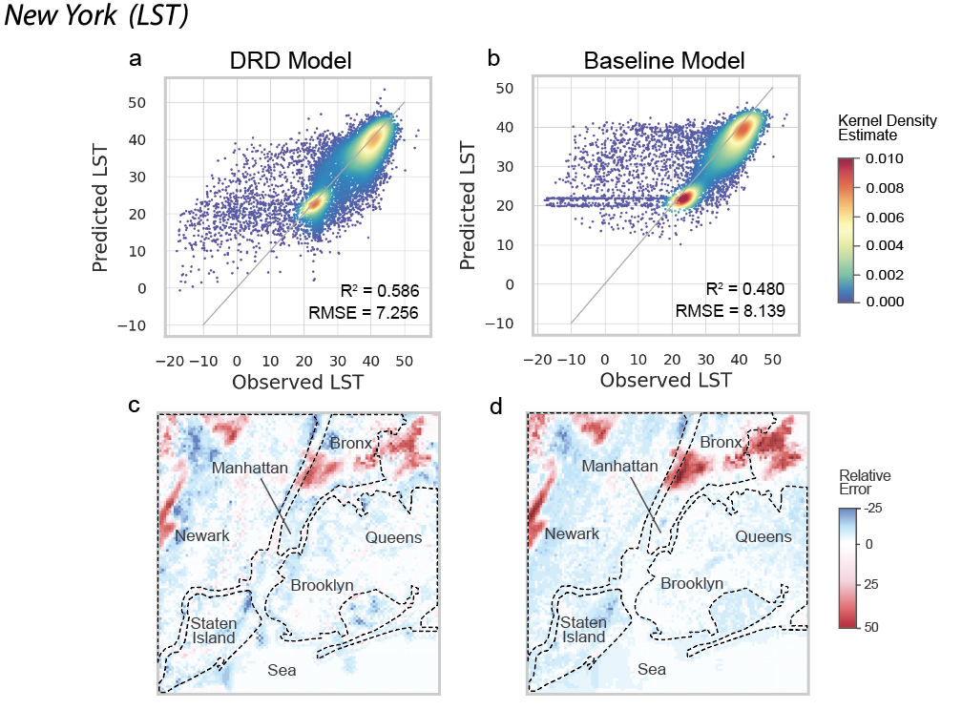
Figure S7. Model prediction performance evaluation (LST prediction in New York). a and b. Prediction performance of the DRD model and the non-spillover model. The warmer or cooler colored dots represent the higher or lower density of data points indicated by the kernel density estimation (KDE) function. The solid gray line denotes the perfect estimation with no error. The area above and below the solid gray line represents overestimation and underestimation, respectively. c and d. Spatial distribution of the relative prediction error of the DRD model and the non-spillover model. The darker blue colors represent the greater underestimation. The darker red colors represent the greater overestimation.

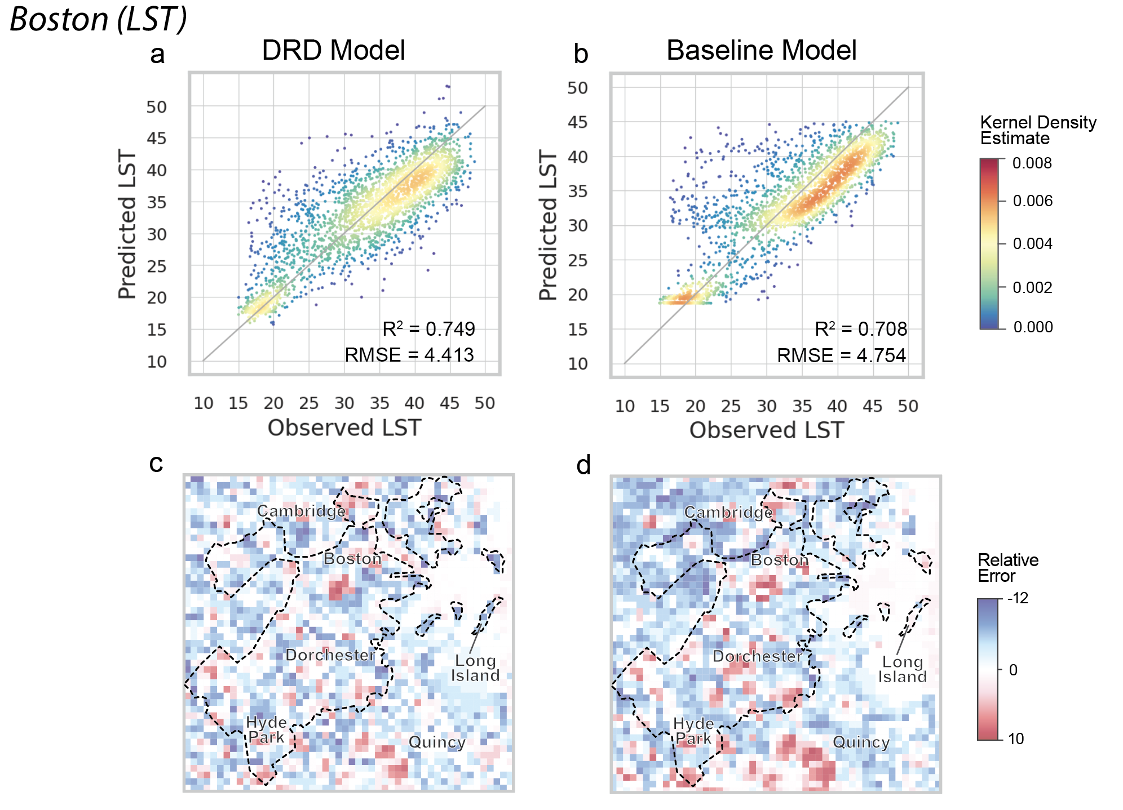
Figure S8. Model prediction performance evaluation (LST prediction in Boston). a and b. Prediction performance of the DRD model and the non-spillover model. The warmer or cooler colored dots represent the higher or lower density of data points indicated by the kernel density estimation (KDE) function. The solid gray line denotes the perfect estimation with no error. The area above and below the solid gray line represents overestimation and underestimation, respectively. c and d. Spatial distribution of the relative prediction error of the DRD model and the non-spillover model. The darker blue colors represent the greater underestimation. The darker red colors represent the greater overestimation.

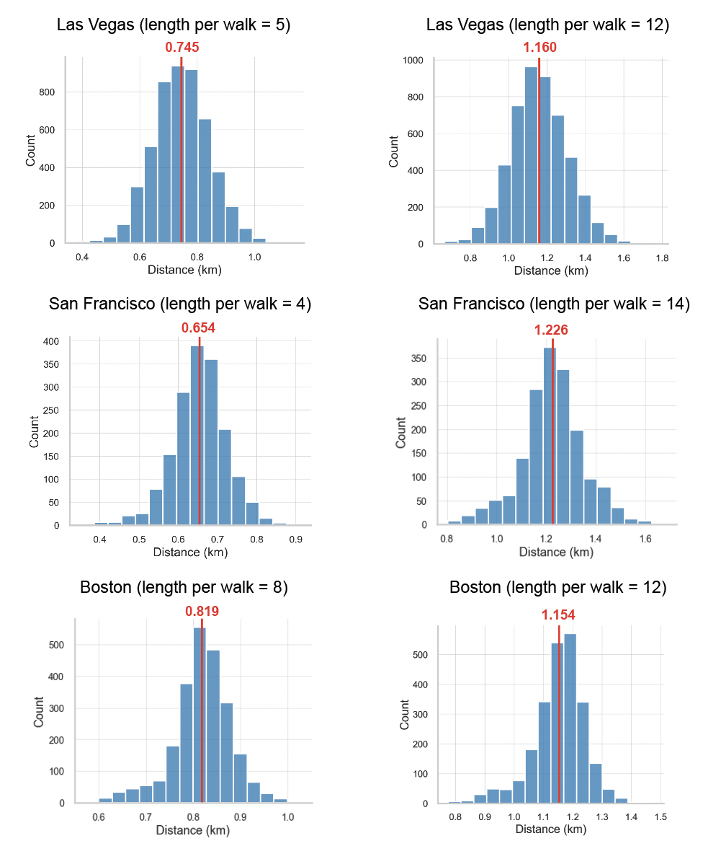

Figure S9. Random walk simulation for Las Vegas, San Francisco, and Boston. The travel distance of the random walker is calculated as the radius of gyration. For each city, we repeat the simulation for each node by 100 times to ensure the normal distribution of the radius gyration outcomes. The red line denotes the average radius of gyration, indicating the average travel distance per walk for the given length.
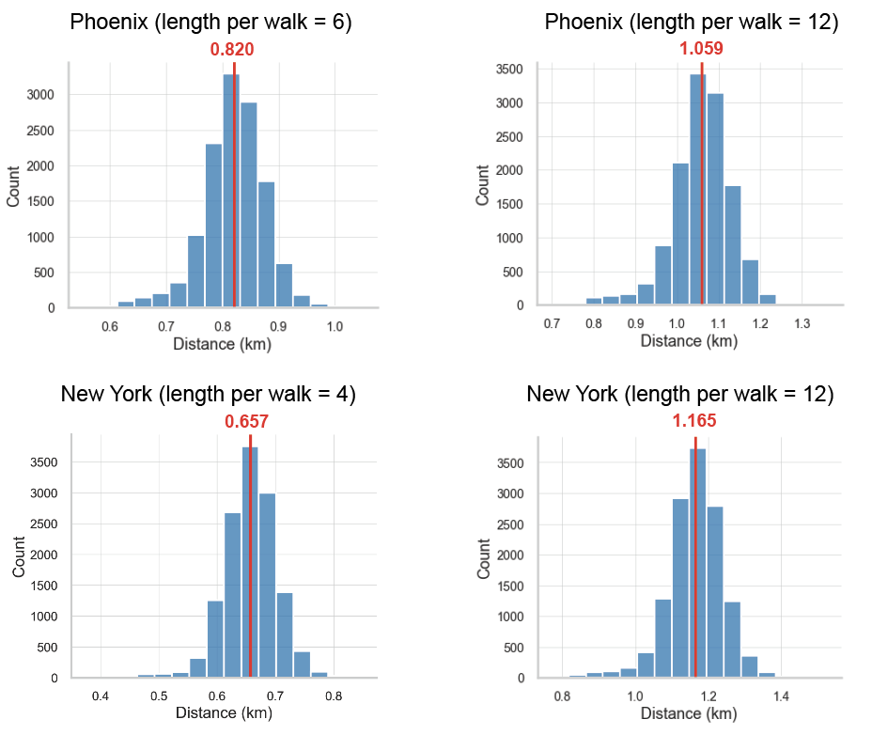
Figure S10. Random walk simulation for Phoenix and New York. The travel distance of the random walker is calculated as the radius of gyration. For each city, we repeat the simulation for each node by 100 times to ensure the normal distribution of the radius gyration outcomes. The red line denotes the average radius of gyration, indicating the average travel distance per walk for the given length.
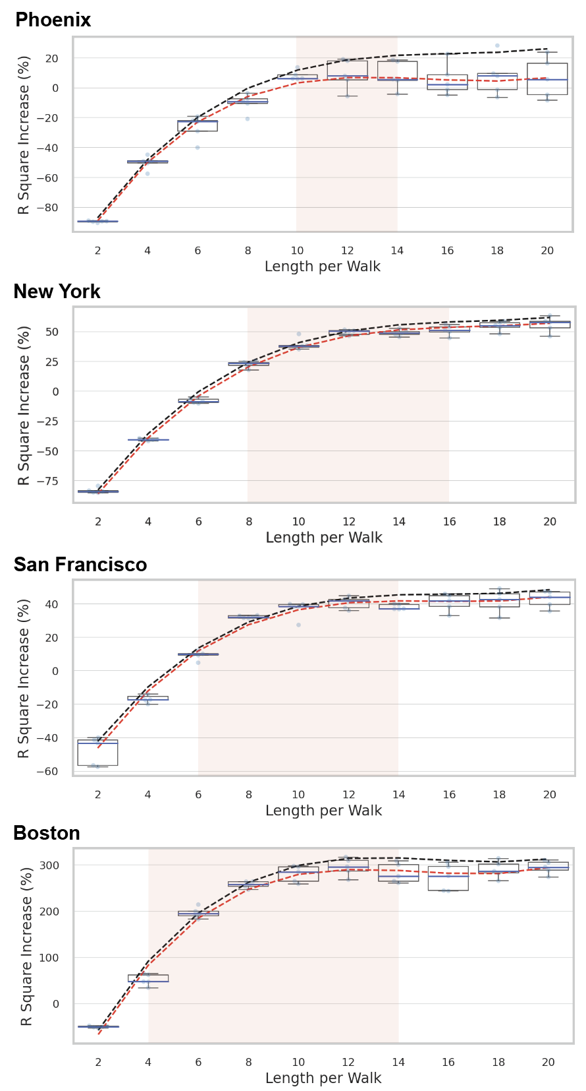
Figure S11. Optimization process of neighbor sampling parameter (visitor flow prediction in Phoenix, New York, San Francisco and Boston). The dimensionality of new node embedding is not constrained. The dots denote the model training results with different settings of the neighbor sampling parameter (ranging from 2 to 20). In each setting, we repeat the model training 6 times with different learning rates. The blue line in the box denotes the median value of model performance (measured by the R-square increase). The orange dashed line represents the polynomial curve fit by the median model performance. The black dashed line represents the polynomial curve fit by the maximum model performance. The orange-colored area denotes the effective range of length per walk.
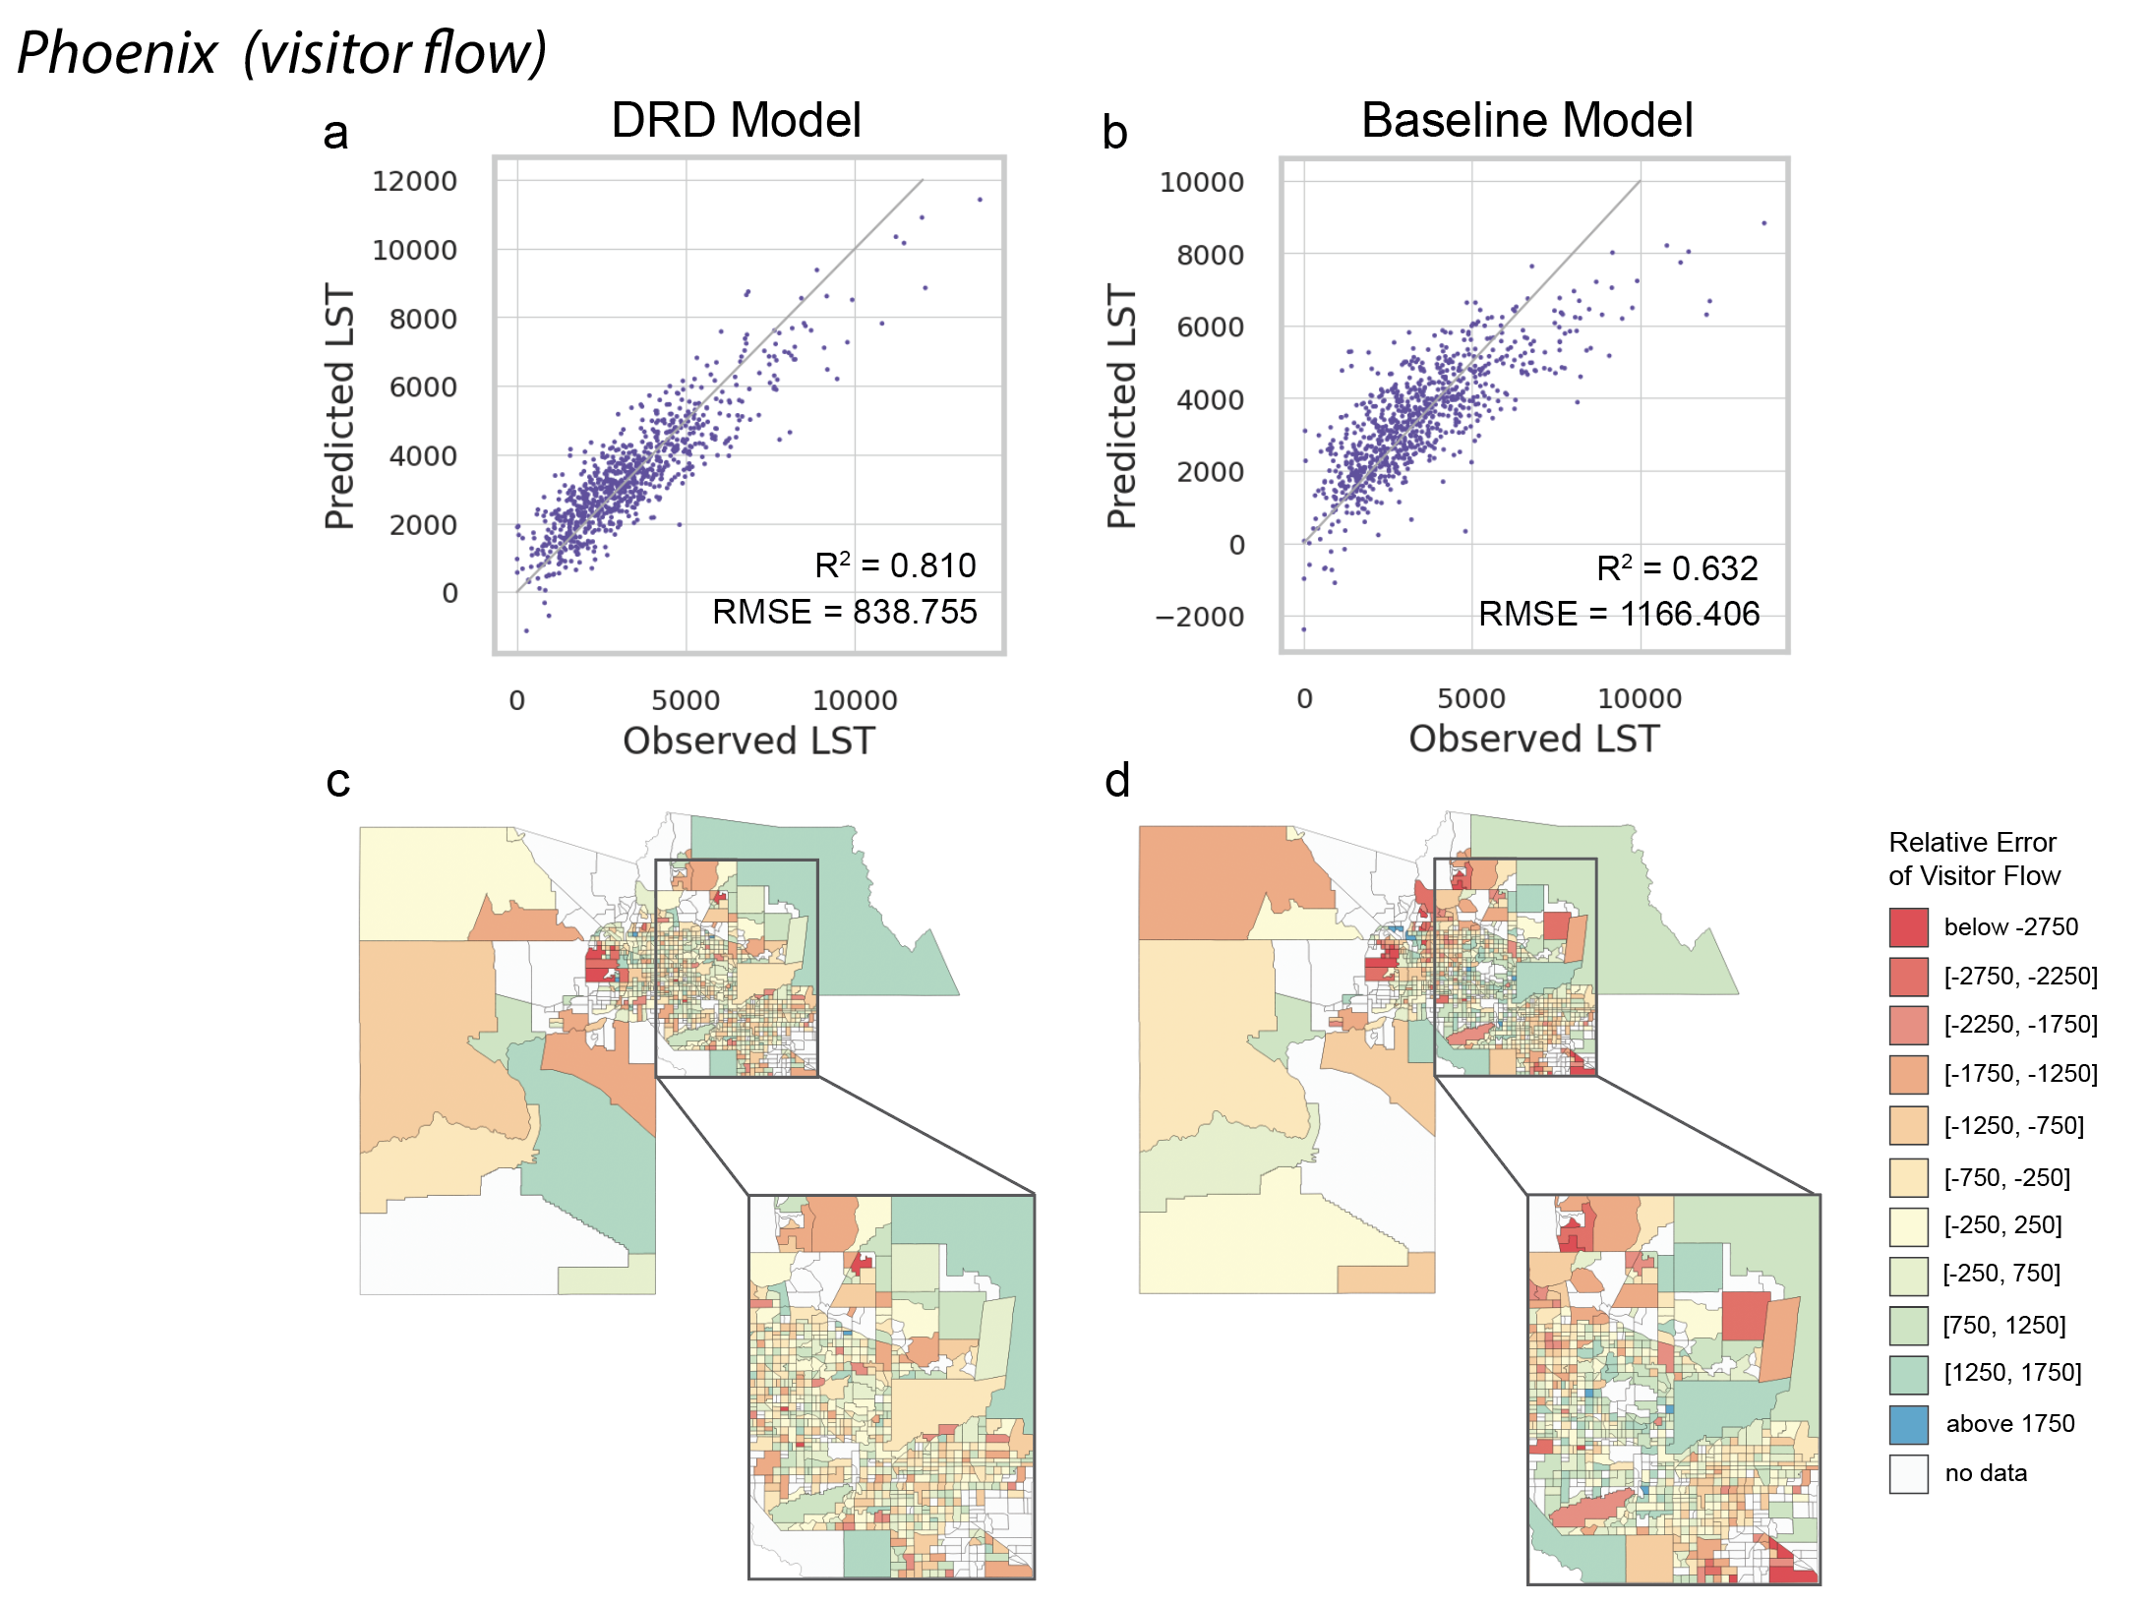
Figure S12. Model prediction performance evaluation (visitor flow prediction in Phoenix). a and b. Prediction performance of the DRD model and the non-spillover model. The gray solid line denotes the perfect estimation with no error. The area above and below the gray solid line represents overestimation and underestimation, respectively. c and d. Spatial distribution of the relative prediction error of the DRD model and the non-spillover model. The cooler colors represent the positive relative errors and overestimation. The warmer colors represent the negative relative errors and underestimation.

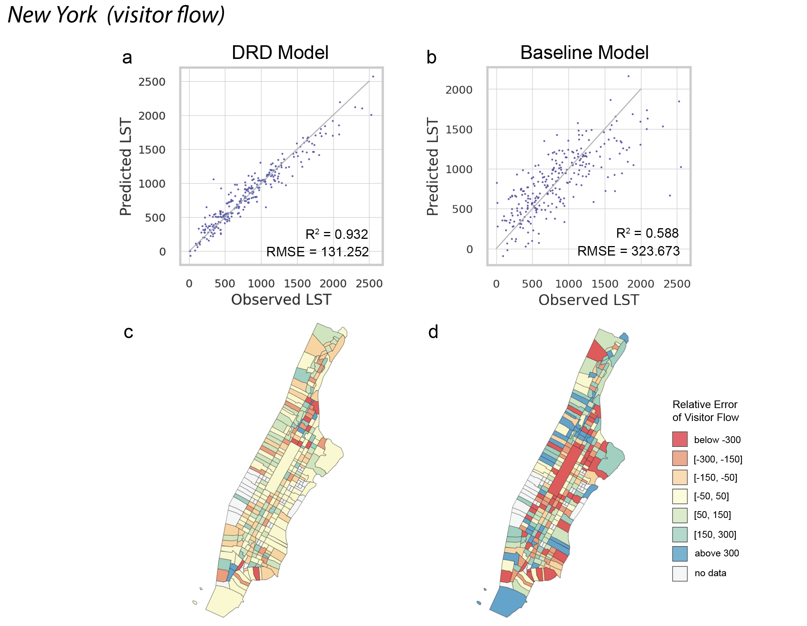
Figure S13. Model prediction performance evaluation (visitor flow prediction in New York). a and b. Prediction performance of the DRD model and the non-spillover model. The gray solid line denotes the perfect estimation with no error. The area above and below the gray solid line represents overestimation and underestimation, respectively. c and d. Spatial distribution of the relative prediction error of the DRD model and the non-spillover model. The cooler colors represent the positive relative errors and overestimation. The warmer colors represent the negative relative errors and underestimation.

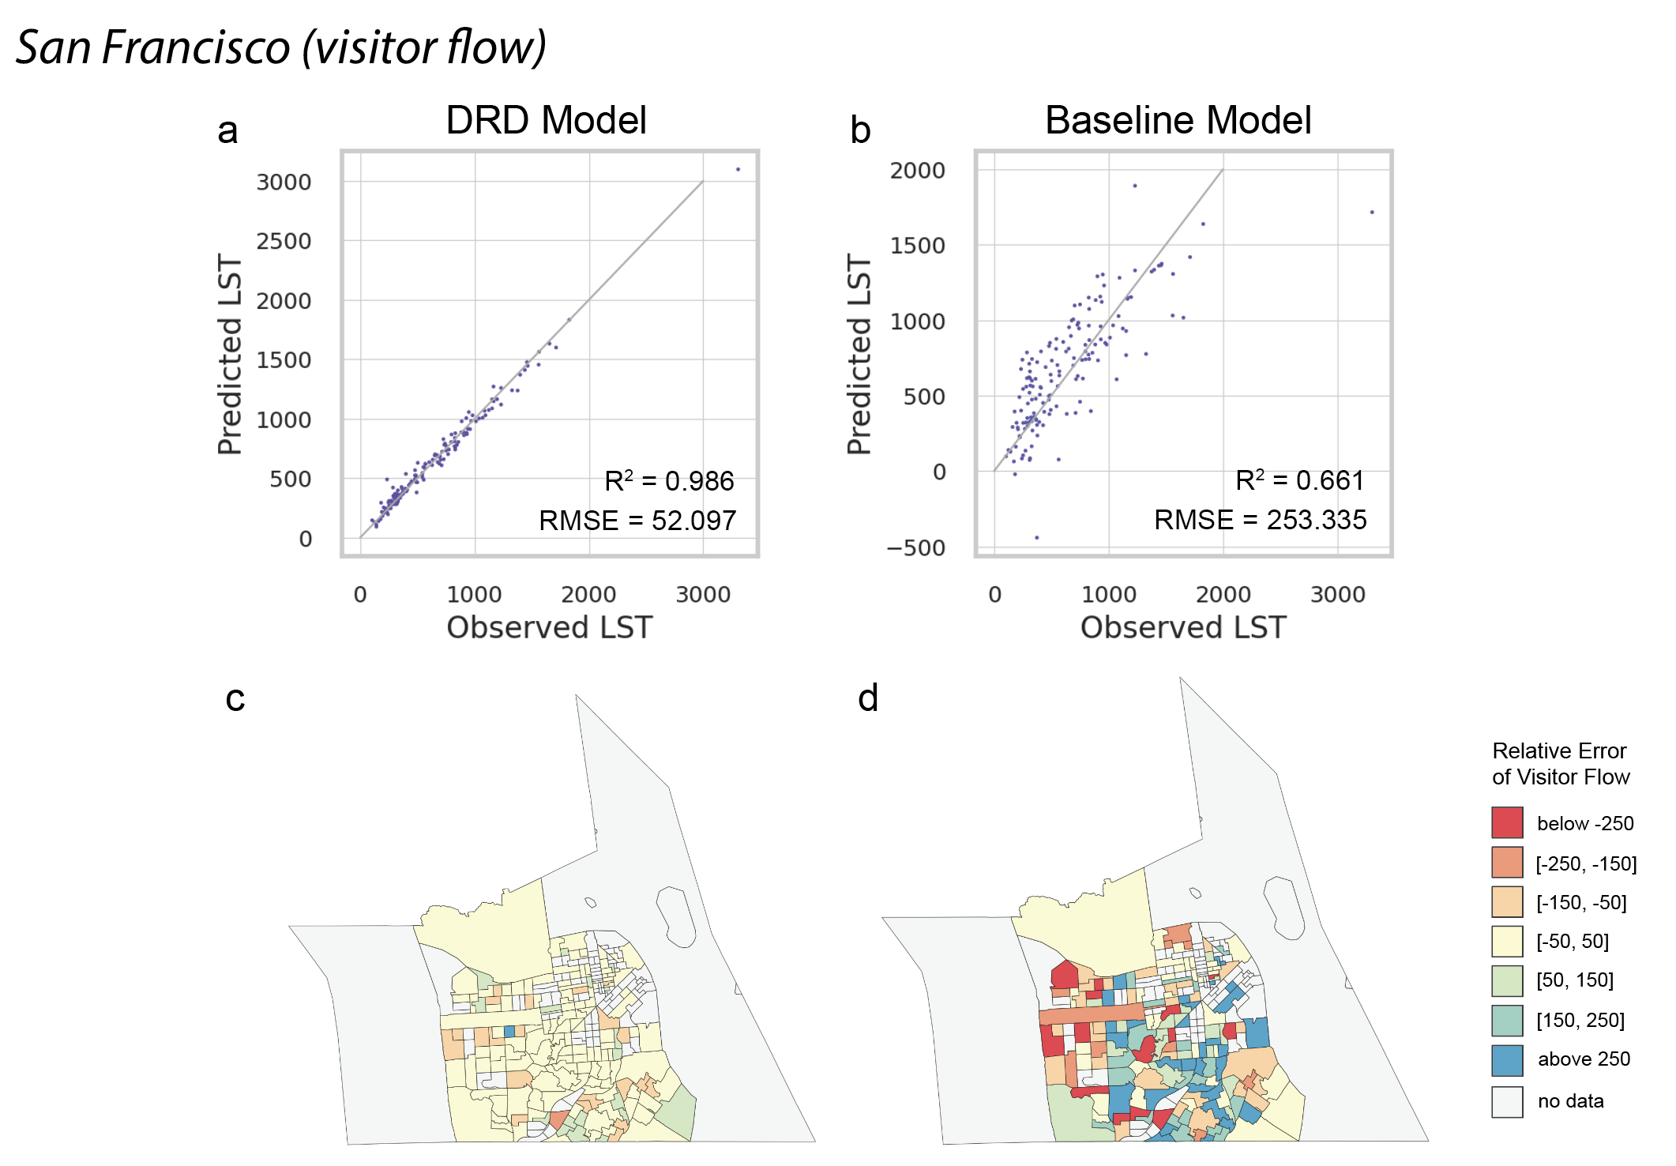
Figure S14. Model prediction performance evaluation (visitor flow prediction in San Francisco). a and b. Prediction performance of the DRD model and the non-spillover model. The gray solid line denotes the perfect estimation with no error. The area above and below the gray solid line represents overestimation and underestimation, respectively. c and d. Spatial distribution of the relative prediction error of the DRD model and the non-spillover model. The cooler colors represent the positive relative errors and overestimation. The warmer colors represent the negative relative errors and underestimation.

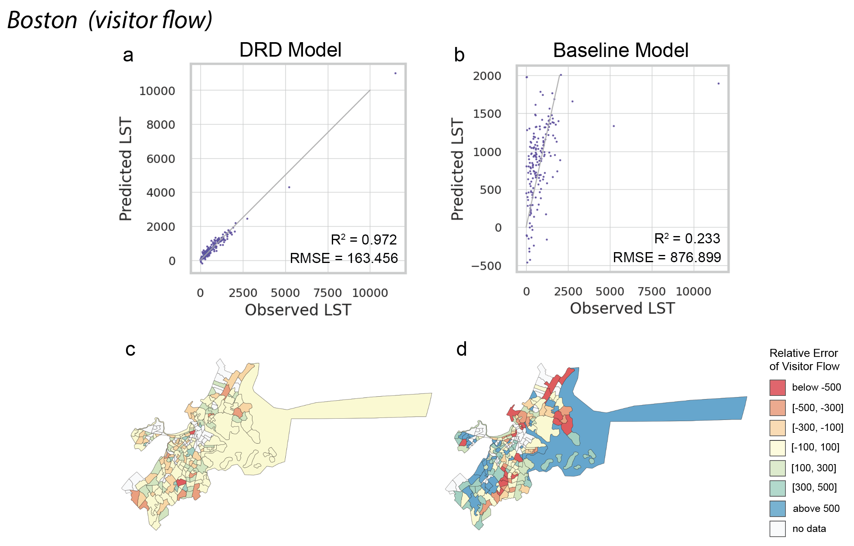
Figure S15. Model prediction performance evaluation (visitor flow prediction in Boston). a and b. Prediction performance of the DRD model and the non-spillover model. The gray solid line denotes the perfect estimation with no error. The area above and below the gray solid line represents overestimation and underestimation, respectively. c and d. Spatial distribution of the relative prediction error of the DRD model and the non-spillover model. The cooler colors represent the positive relative errors and overestimation. The warmer colors represent the negative relative errors and underestimation.

3. Supplementary Tables

Table S1. Feature importance ranking of the Deep Random Diffusion (DRD) model for predicting land surface temperature (LST) at the parcel level in Las Vegas.
Feature Name | R-square decrease ($∆R^{2}$) | $∆R^{2}$ ranking
Elevation | 1.3356 | 1
Slope | 0.8378 | 2
Built-up cover | 0.6780 | 3
Shrubland cover | 0.2245 | 4
Street intersection density | 0.1791 | 5
Grassland cover | 0.1606 | 6
South aspect | 0.1527 | 7
Tree cover | 0.1243 | 8
East aspect | 0.0672 | 9
Building density | 0.0621 | 10
Note: top ten features corresponded with greatest $∆R^{2}$ are selected to be displayed in the table.

Table S2. Feature importance ranking of the non-spillover model for predicting land surface temperature (LST) at the parcel level in Las Vegas.
Feature Name | Regression coefficient | R-square decrease ($∆R^{2}$) | $∆R^{2}$ ranking
Elevation | -0.4714 | 1.0444 | 1
Slope | -0.3387 | 0.3036 | 2
South aspect | 2.1499 | 0.0806 | 3
Grassland cover | -0.1521 | 0.0717 | 4
Tree cover | -0.3006 | 0.0713 | 5
Street intersection density | -0.2836 | 0.0498 | 6
POI density | 0.3175 | 0.0187 | 7
Open water cover | -0.4297 | 0.0088 | 8
Southeast aspect | 0.5805 | 0.0087 | 9
Southwest aspect | 1.2945 | 0.0064 | 10
Note: top ten features corresponded with greatest $∆R^{2}$ are selected to be displayed in the table.

Table S3. Feature importance ranking of the DRD model for predicting visitor flow at the census tract level in Las Vegas (Clark County, Nevada).
Feature Name | R-square decrease ($∆R^{2}$) | $∆R^{2}$ ranking
Total population | 37.7597 | 1
Income | 20.3852 | 2
Street intersection density | 18.9344 | 3
Total POI | 11.9064 | 4
Built-up cover | 11.1985 | 5
White population | 8.8187 | 6
Grocery POI | 7.2440 | 7
Street length | 6.8818 | 8
Building footprint density | 4.3131 | 9
Restaurant POI | 4.2309 | 10
Note: top ten features corresponded with greatest $∆R^{2}$ are selected to be displayed in the table.

Table S4. Feature importance ranking of the non-spillover model for predicting visitor flow at the census tract level in Las Vegas (Clark County, Nevada).
Feature Name | Regression coefficient | R-square decrease ($∆R^{2}$) | $∆R^{2}$ ranking
Total population | 71.6376 | 3.6011 | 1
Income | 29.4792 | 0.4164 | 2
Street intersection density | 12.7539 | 0.0468 | 3
Total POI | -27.1916 | 0.0301 | 4
Building footprint density | 31.6440 | 0.0292 | 5
Restaurant POI | 32.3013 | 0.0275 | 6
Manufacture POI | 21.5362 | 0.0106 | 7
Built-up cover | -11.5036 | 0.0034 | 8
Trucking POI | 13.6450 | 0.0033 | 9
White population | -2.6243 | 0.0024 | 10
Note: top ten features corresponded with greatest $∆R^{2}$ are selected to be displayed in the table.

4. Supplementary References

1. Tran, D. X. et al. Characterizing the relationship between land use land cover change and land surface temperature. ISPRS Journal of Photogrammetry and Remote Sensing 124, 119–132 (2017).
2. Zhao, J. et al. Assessing the thermal contributions of urban land cover types. Landscape and Urban Planning 204, 103927 (2020).
3. Tan, J., Yu, D., Li, Q., Tan, X. & Zhou, W. Spatial relationship between land-use/land-cover change and land surface temperature in the Dongting Lake area, China. Sci Rep 10, 9245 (2020).
4. Yang, J. et al. Understanding land surface temperature impact factors based on local climate zones. Sustainable Cities and Society 69, 102818 (2021).
5. Guo, A. et al. Divergent impact of urban 2D/3D morphology on thermal environment along urban gradients. Urban Climate 45, 101278 (2022).
6. Li, Y., Schubert, S., Kropp, J. P. & Rybski, D. On the influence of density and morphology on the Urban Heat Island intensity. Nat Commun 11, 2647 (2020).
7. Zhou, L. et al. Understanding the effects of 2D/3D urban morphology on land surface temperature based on local climate zones. Building and Environment 208, 108578 (2022).
8. Song, J. et al. Effects of building density on land surface temperature in China: Spatial patterns and determinants. Landscape and Urban Planning 198, 103794 (2020).
9. Lee, M. & Holme, P. Relating Land Use and Human Intra-City Mobility. PLoS ONE 10, e0140152 (2015).
10. Van der Geest, K., Vrieling, A. & Dietz, T. Migration and environment in Ghana: a cross-district analysis of human mobility and vegetation dynamics. Environment and Urbanization 22, 107–123 (2010).
11. Xia, C., Zhang, A., Wang, H. & Yeh, A. G. O. Predicting the expansion of urban boundary using space syntax and multivariate regression model. Habitat International 86, 126–134 (2019).
12. Yuan, J., Zheng, Y. & Xie, X. Discovering regions of different functions in a city using human mobility and POIs. in Proceedings of the 18th ACM SIGKDD international conference on Knowledge discovery and data mining 186–194 (ACM, 2012). doi:10.1145/2339530.2339561.
13. Xu, Y., Belyi, A., Bojic, I. & Ratti, C. Human mobility and socioeconomic status: Analysis of Singapore and Boston. Computers, Environment and Urban Systems 72, 51–67 (2018).
14. Luo, F., Cao, G., Mulligan, K. & Li, X. Explore spatiotemporal and demographic characteristics of human mobility via Twitter: A case study of Chicago. Applied Geography 70, 11–25 (2016).

