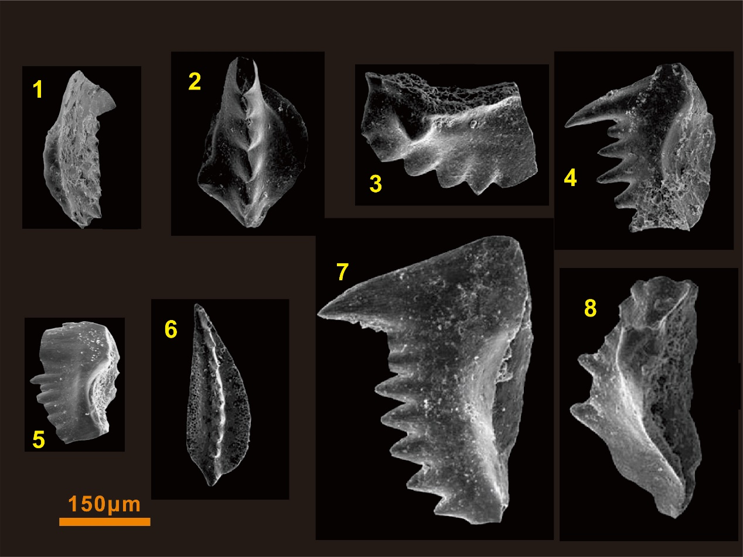
Fig. S1. Conodont morphologies and identification from the studied interval. 1: H. typicalis, 2: Ng. krystyni, 3: Ns. kummeli, 4: Ns. dieneri, 5: Ns. waageni, 6: Ns. pingdingshanensis, 7: Ns. homeri, 8: Ns. anhuinensis. The description and zonation strategy followed previous studies, including Shen and Mei, 2010; Shen et al., 2011; Yuan et al., 2014. Photo numbering was corresponding to location labels in the Fig. 2.

