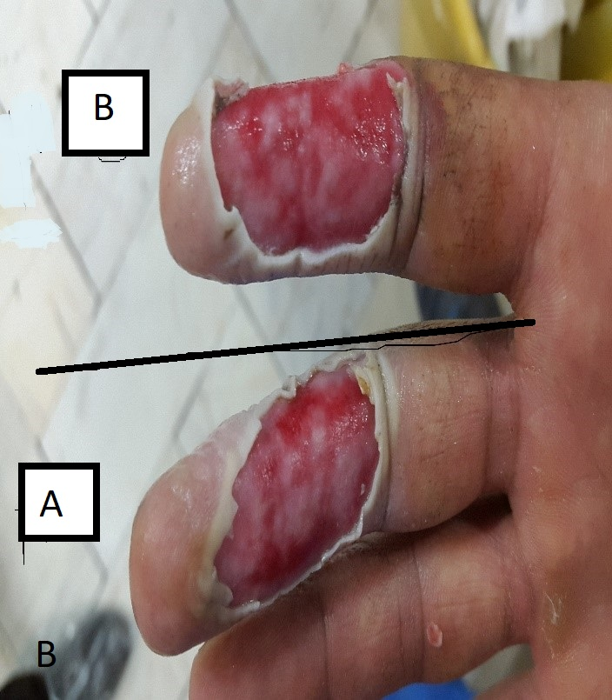
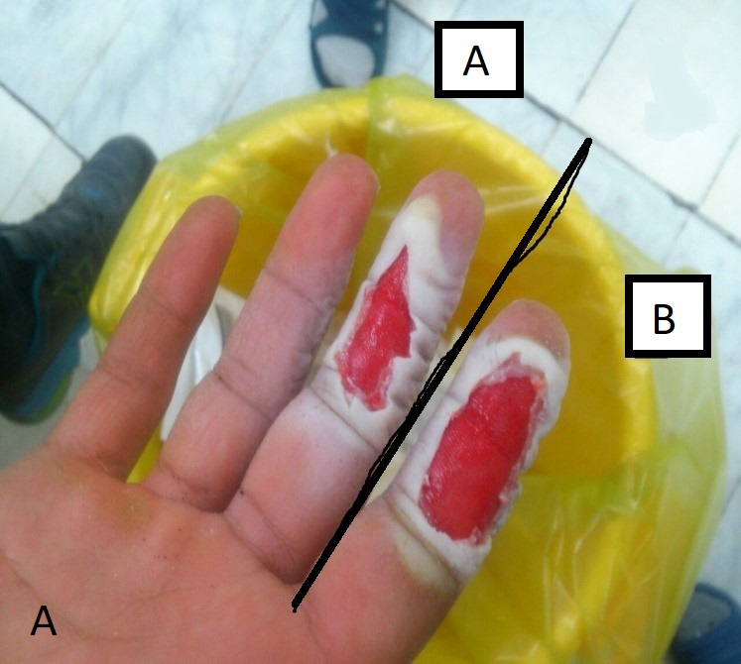

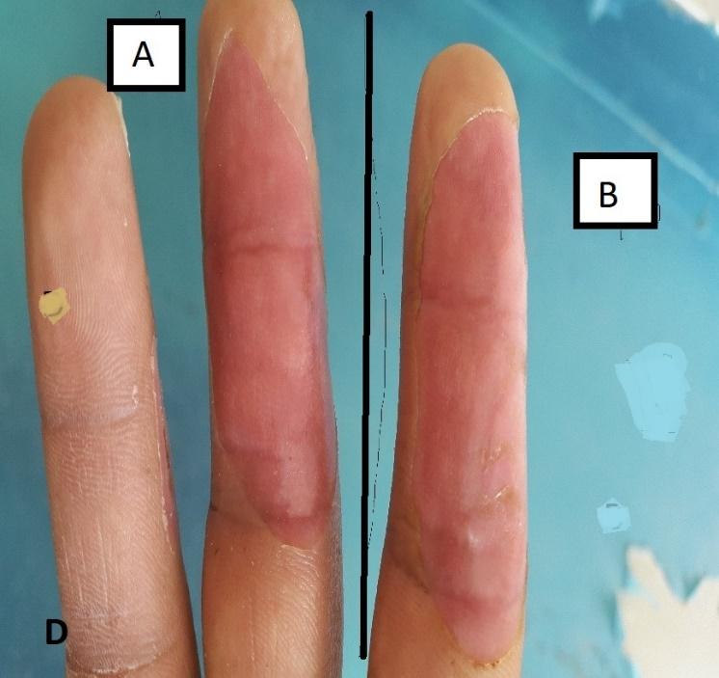
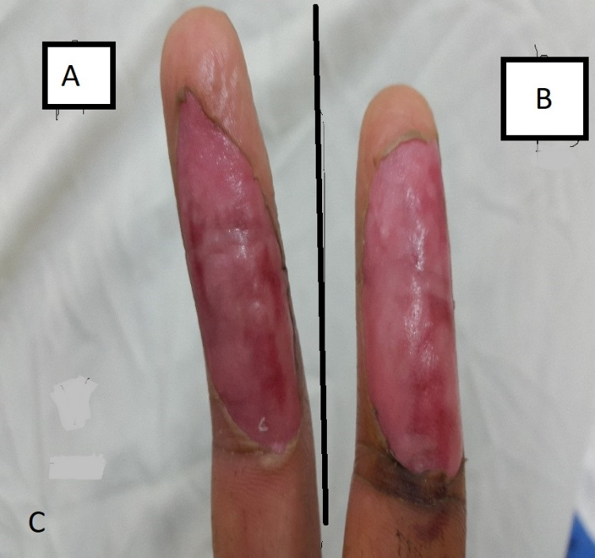

Figure S1: These 4 Figurs were taken from one of 30 research samples. In these photos, the index finger has received vitamin C and the third finger is the control sample. In other words, part B has received vitamin C
A) On the first day, the wound is debridement and everything is equal. Dressing with vitamin C and silver started from this stage
B) This photo was taken on the third day and almost everything is the same, the index finger that received vitamin C is not superior
C) This image was taken on the seventh day and the index finger or area B has more epithelial tissue
D) This photo was taken on the fourteenth day and the epithelial tissue volume and healing in the index finger or area B is greater

