Supplementary file 3: Saliva sample collection during the study period, evolution of vaccination coverage during the study period and geographical distribution of the sample

Figure A3.1 Number of saliva samples collected per week*
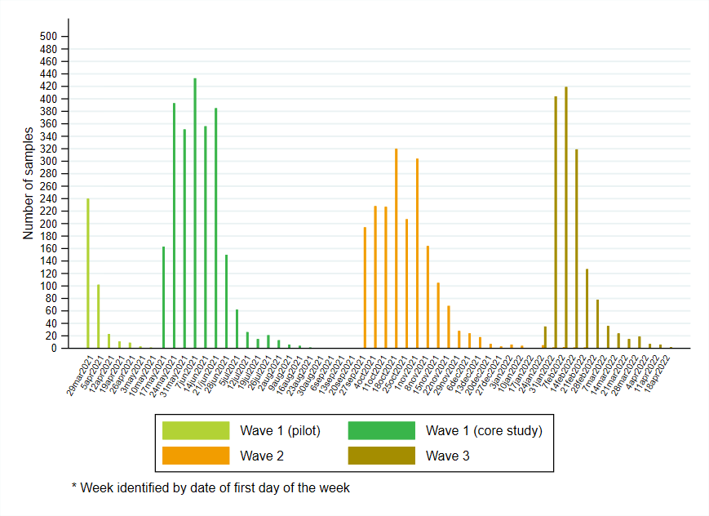
Figure A3.2 Evolution of vaccination coverage (% of total population) and weekly number of new COVID-19 infections in Belgium during the SalivaHIS study period

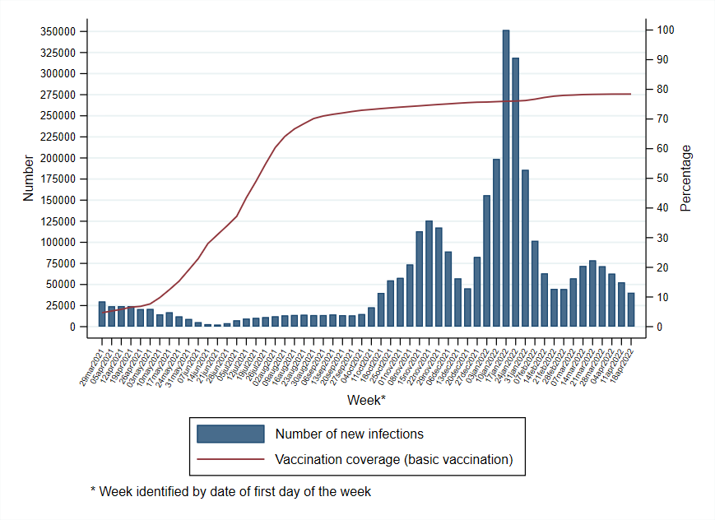=

Figure A3.3 Belgian municipalities with at least one participant to the 3 waves of the study period
