Supplementary materials

Sexually dimorphic traits are associated with subsistence strategy in African faces from the Sahel/Savannah belt
Karel Kleisner¹*, Šimon Pokorný¹, Viktor Černý^{2,3}
¹ Department of Philosophy and History of Science, Faculty of Science, Charles University, Prague, Czech Republic
² Department of Anthropology and Human Genetics, Faculty of Science, Charles University, Prague, Czech Republic
³ Archaeogenetics Laboratory, Institute of Archaeology of the Academy of Sciences of the Czech Republic, Prague, Czech Republic

*Corresponding author: karel.kleisner@natur.cuni.cz

Table S1. Summary of the results of Procrustes ANOVA that investigated the effect of sex, mode of subsistence, subsistence-sex interaction, varying effect of population, and its interaction with sex on facial shape.
 | Df | SS | MS | F | Z | p-value
pop.C1_FvsP | 1 | 0.01848 | 0.018475 | 3.2626 | 2.6297 | 0.005
pop.C2_CADvsNLS | 1 | 0.00437 | 0.004373 | 0.772 | -0.3447 | 0.623
pop.C3_ARAvsFUL | 1 | 0.01057 | 0.010567 | 1.866 | 1.5067 | 0.073
sex | 1 | 0.06551 | 0.065506 | 11.568 | 6.2193 | 0.001
pop.C1_FvsP:sex | 1 | 0.01460 | 0.014601 | 2.579 | 2.0815 | 0.017
pop.C2_CADvsNLS:sex | 1 | 0.00591 | 0.005905 | 1.043 | 0.3034 | 0.381
pop.C3_ARAvsFUL:sex | 1 | 0.00844 | 0.008438 | 1.490 | 1.0145 | 0.155
Residuals | 432 | 2.44627 | 0.005663
Total | 439 | 2.64381

Legend: pop.C1_FvsP – contrast between Farmers and Pastoralists (=Subsistence), pop.C2_CADvsNLS – contrast between Chadic and Nilo-Saharan populations, pop.C3_ARAvsFUL – contrast between Arab and Fulani populations. Df – degrees of freedom, SS – sum of squares, MS – mean squares.

Table S2. Summary of model coefficients showing the results of the joint impact of sex (factor) and subsistence scores (continuous variable) on sexual shape dimorphism (SShD).
 | Estimate | Std. Error | t-value | p-value
(Intercept) | -7.348e-04 | 5.993e-05 | -12.261 | <2e-16
Subsistence scores | 4.071e-01 | 9.824e-02 | 4.144 | 4.1e-05
Sex(men) | 1.081e-03 | 7.303e-05 | 14.805 | <2e-16
Subsistence:Sex(men) | 2.353e-01 | 1.190e-01 | 1.977 | 0.0487

Table S3. ANOVA table showing the statistics of a model that investigated the effect of sex, mode of subsistence, and their interaction on SShD.
 | Df | SS | MS | F-value | p-value
Sex | 1 | 1.4874e-04 | 1.4874e-04 | 244.8572 | <2e-16
Subsistence | 1 | 1.1840e-06 | 1.1840e-06 | 1.9488 | 0.1634
Sex:Subsistence | 1 | 4.9900e-07 | 4.9900e-07 | 0.8214 | 0.3653
Residuals | 436 | 2.6484e-04 | 6.0700e-07

Df – degrees of freedom, SS – sum of squares, MS – mean squares

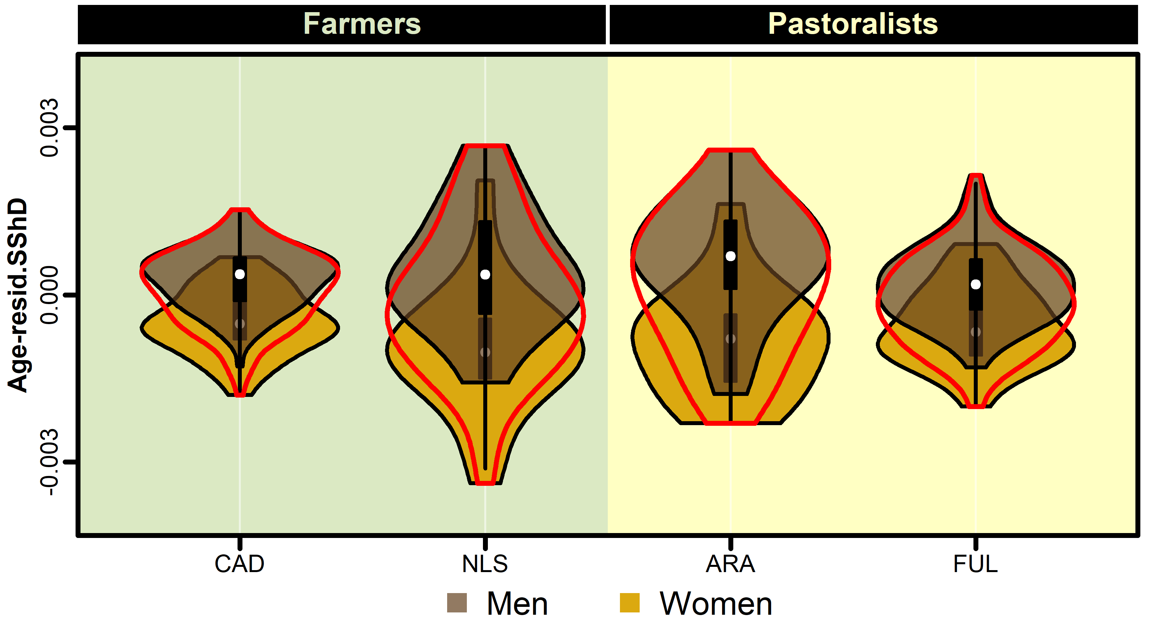
Figure S1. The range and variation of age-residualised values of SShD. A comparison with Figure 1 shows that age of individuals has no significant effect on the shape and range of the violin plots.

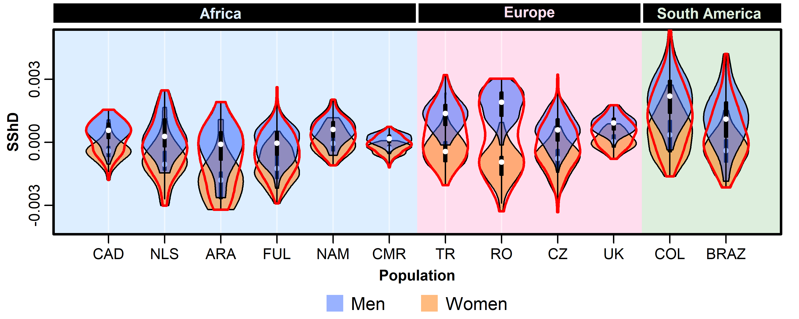
Figure S2: Violin plots comparing the range and variation of sexual shape dimorphism (SShD) across 12 populations (CAD – Chadic farmers, NLS – Nilo-Saharan farmers, ARA – Arab pastoralists, FUL – Fulani pastoralists, NAM – Namibia, CMR – Cameroon, TR – Turkey, RO – Romania, CZ – Czechia, UK – United Kingdom, COL – Colombia, BRAZ – Brazil). The results on eight populations came from a study of Kleisner et al (2021); landmark configuration was adapted so to correspond to the configuration in the present study, and SShD scores recalculated to enable a comparison of all populations. White points indicate medians, black rectangles represent interquartile ranges.

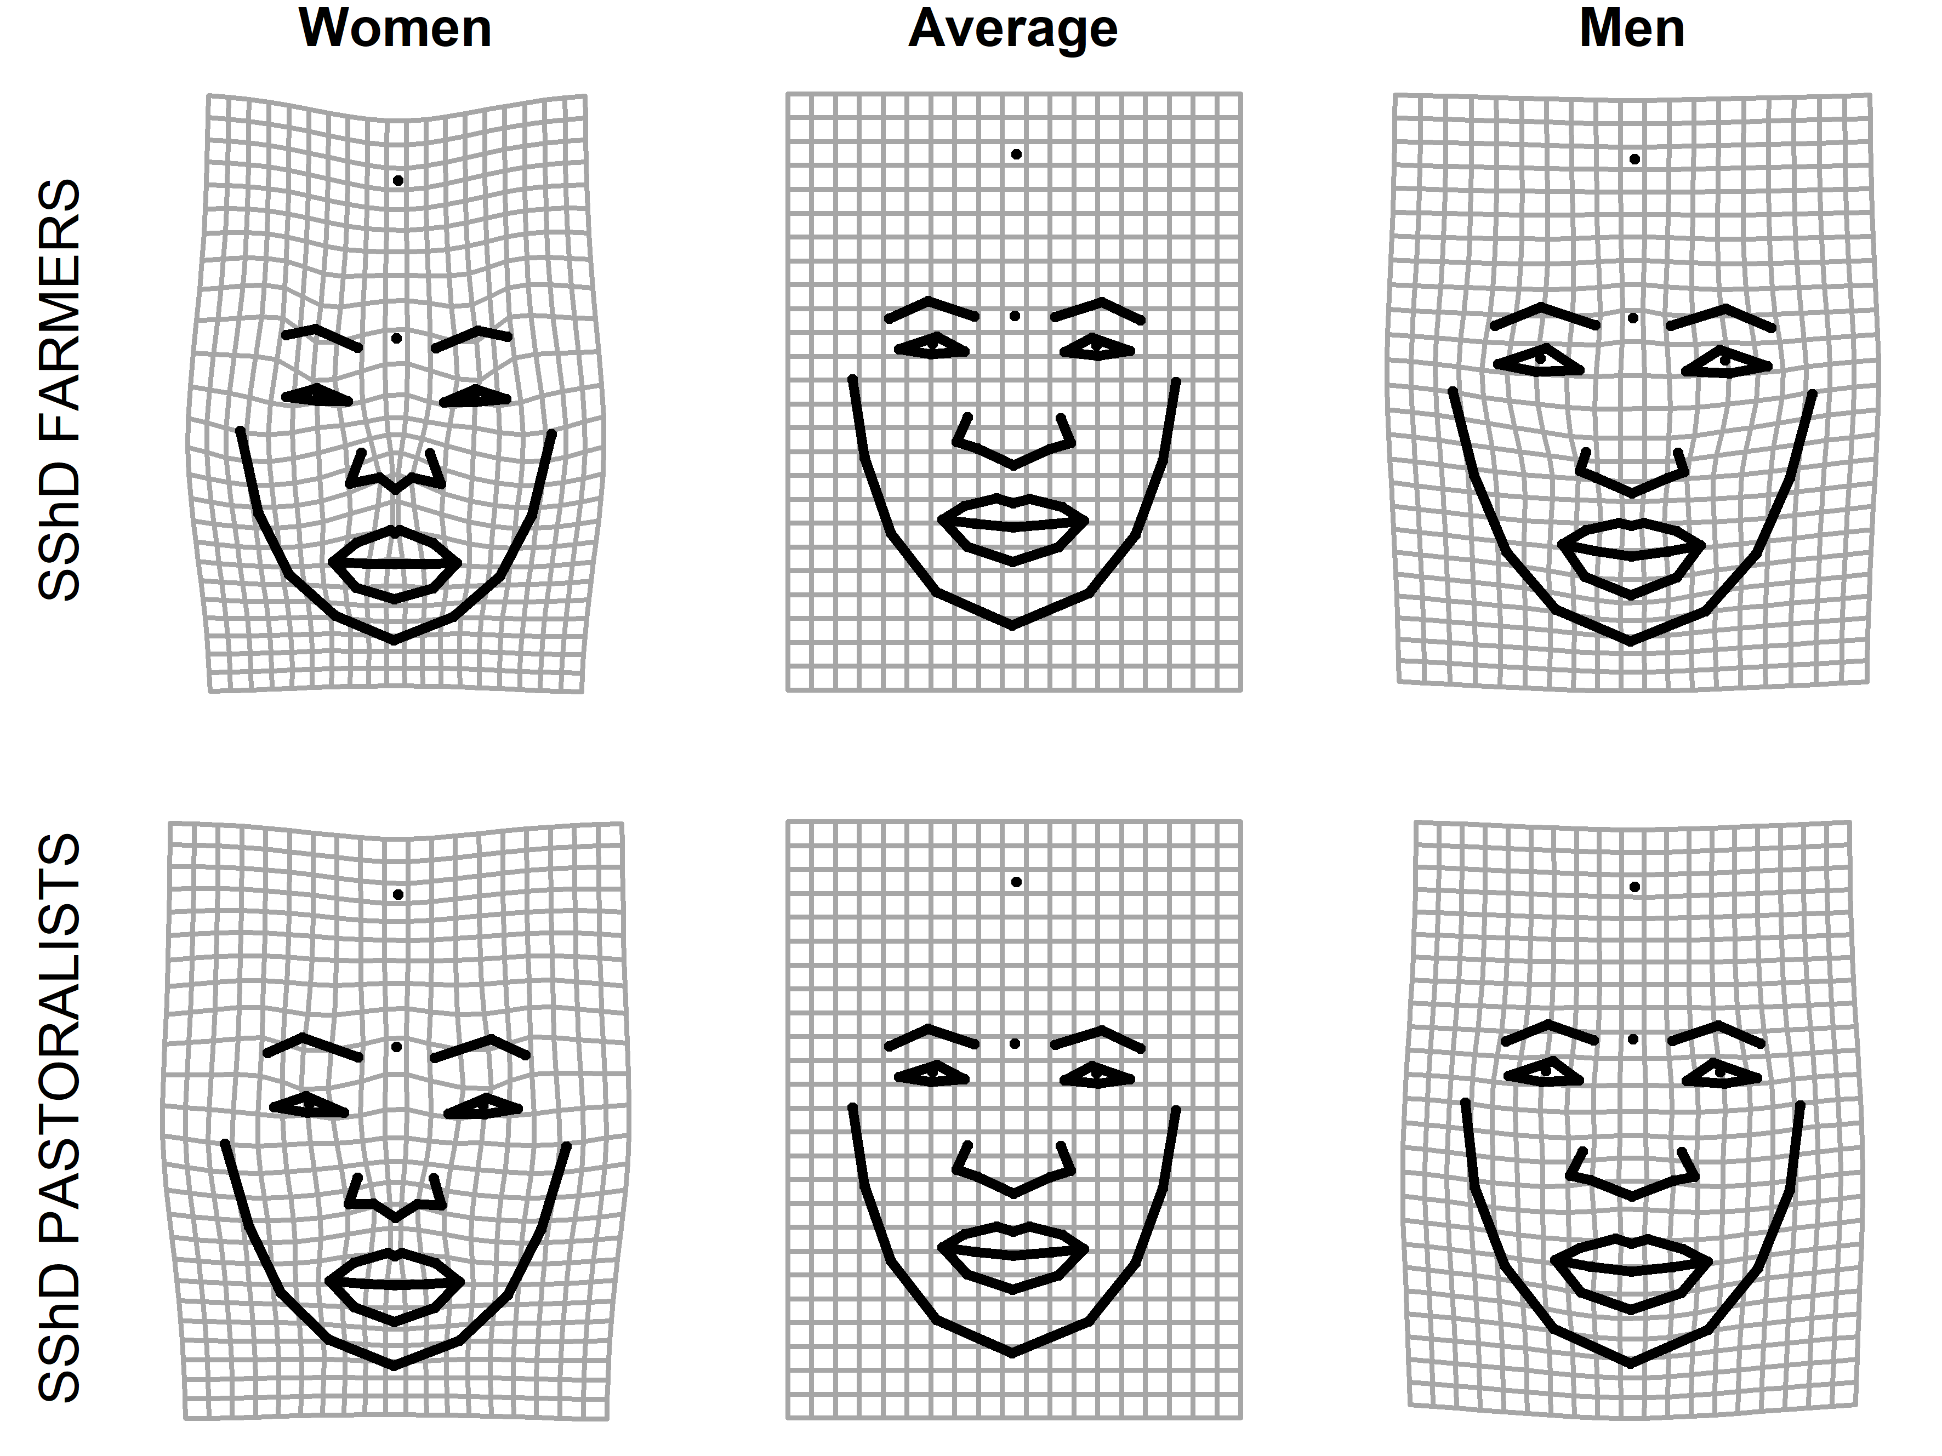
Figure S3. Thin plate splines demonstrating shape differences between male and female faces compared to the average facial configuration for farmers (upper panel) and pastoralists (lower panel). The magnitude of shape changes is five times exaggerated for ease of interpretation.

Table S4. Trajectory analysis, path distances (1,000 permutations)
Observed path distance |  |  | Pairwise absolute differences in path distances
 |  |  | contrast | d | UCL (95%) | Z | p
CAD | 0.031 |  | CAD:NLS | 0.0062 | 0.014 | 0.369 | 0.383
NLS | 0.037 |  | CAD:ARA | 0.0083 | 0.015 | 0.681 | 0.258
ARA | 0.039 |  | CAD:FUL | 0.0029 | 0.010 | -0.229 | 0.599
FUL | 0.033 |  | NLS:ARA | 0.0021 | 0.015 | -0.816 | 0.784
 |  |  | NLS:FUL | 0.0034 | 0.015 | -0.347 | 0.641
 |  |  | ARA:FUL | 0.0055 | 0.015 | 0.0864 | 0.482
UCL = Upper Compatibility Limit for H0 (no difference)

Table S5. Pairwise correlations between trajectories and respective angles (1,000 permutations)
Contrasts | r | Angle | UCL (95%) | Z | p
CAD:NLS | 0.725 | 43.478 | 58.188 | 0.351 | 0.367
CAD:ARA | 0.707 | 45.000 | 59.547 | 0.501 | 0.314
CAD:FUL | 0.691 | 46.313 | 44.635 | 1.761 | 0.038
NLS:ARA | 0.432 | 64.391 | 66.250 | 1.526 | 0.066
NLS:FUL | 0.394 | 66.803 | 55.384 | 2.504 | 0.005
ARA:FUL | 0.693 | 46.101 | 54.862 | 0.920 | 0.190
UCL = Upper Compatibility Limit for H0 (same direction)

